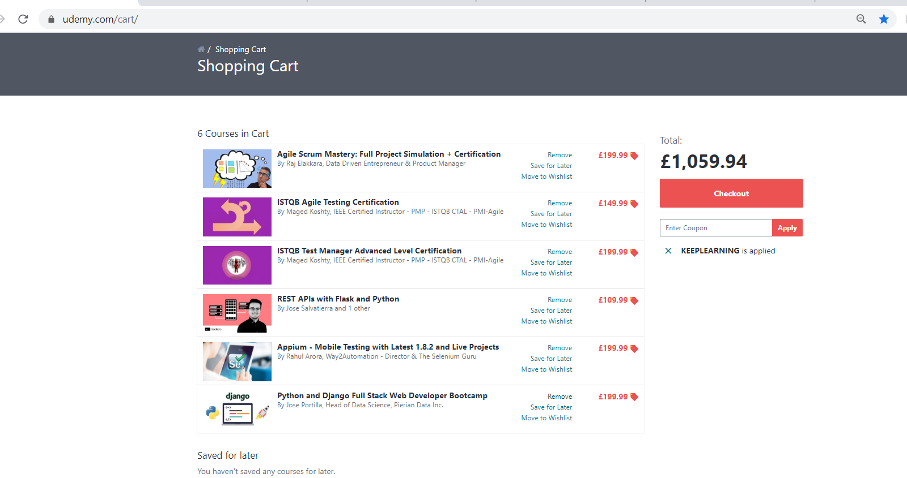

And type java -version

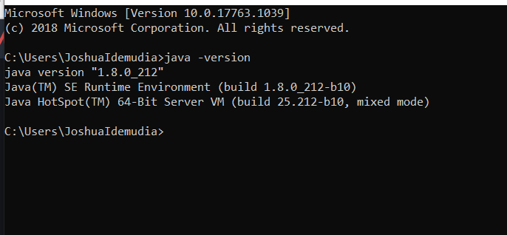

This means java has been successfully installed.

Quick, two things

1. 1.When I sent u numerous text messages, u read them and ignored my messages. Did I go on?
2. 2.Fortunately in my case I have had a pile of shit day so when I dnt respond I expect u to understand I got shit to handle and will get back to u. Lets not discuss this again

Now we create our first java project

Note test cases are just classes like.

So we create test case and introduction is like the suite

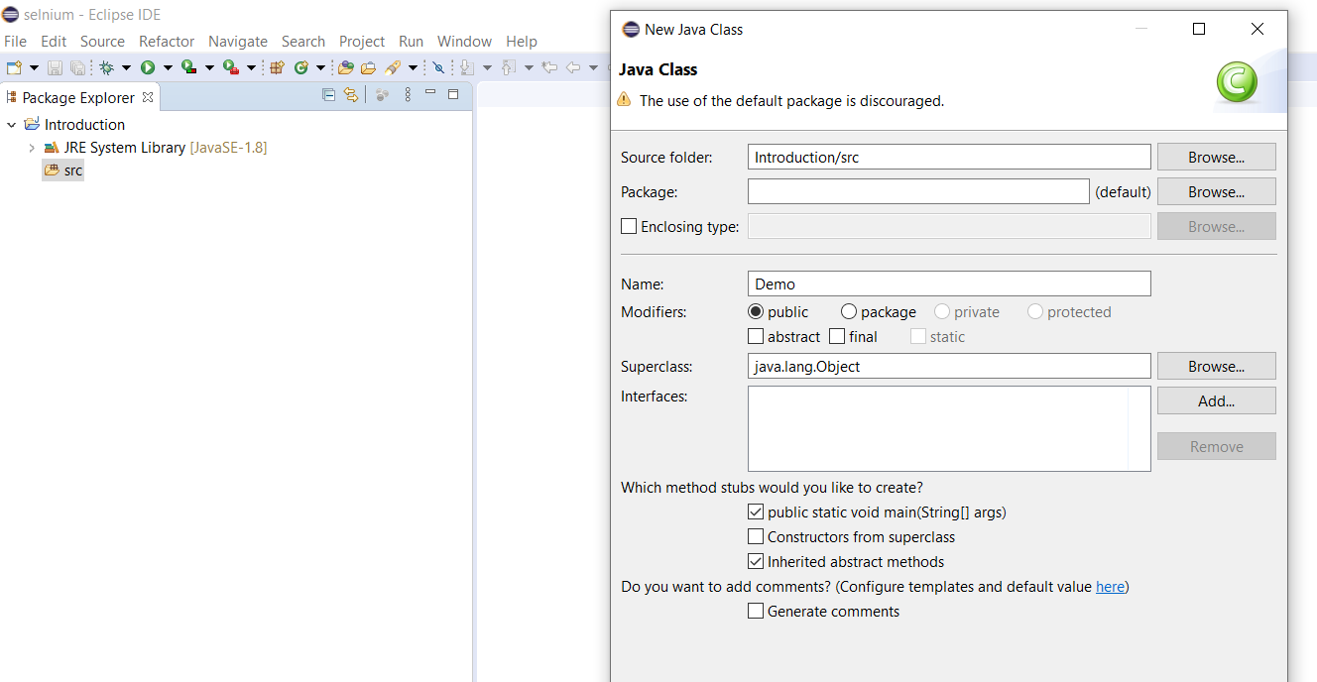

Here we made it public void and clicked the public void check box

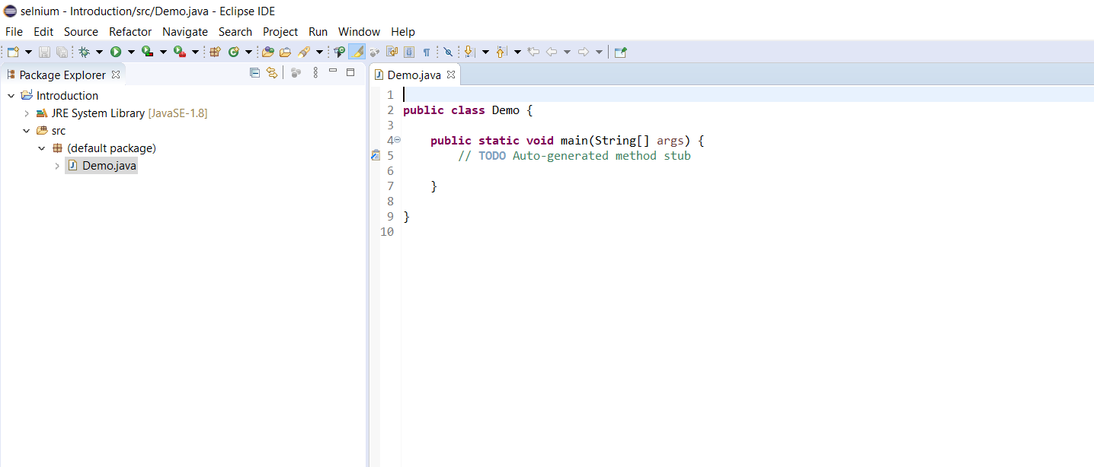

Now we need to download selenium and create connection between the project to execute the test case

So here we download it from selenium and copy all the jar after extracting them to the library build path.

Next we create driver object for chrome driver

Now back to selenium page and go to java api doc

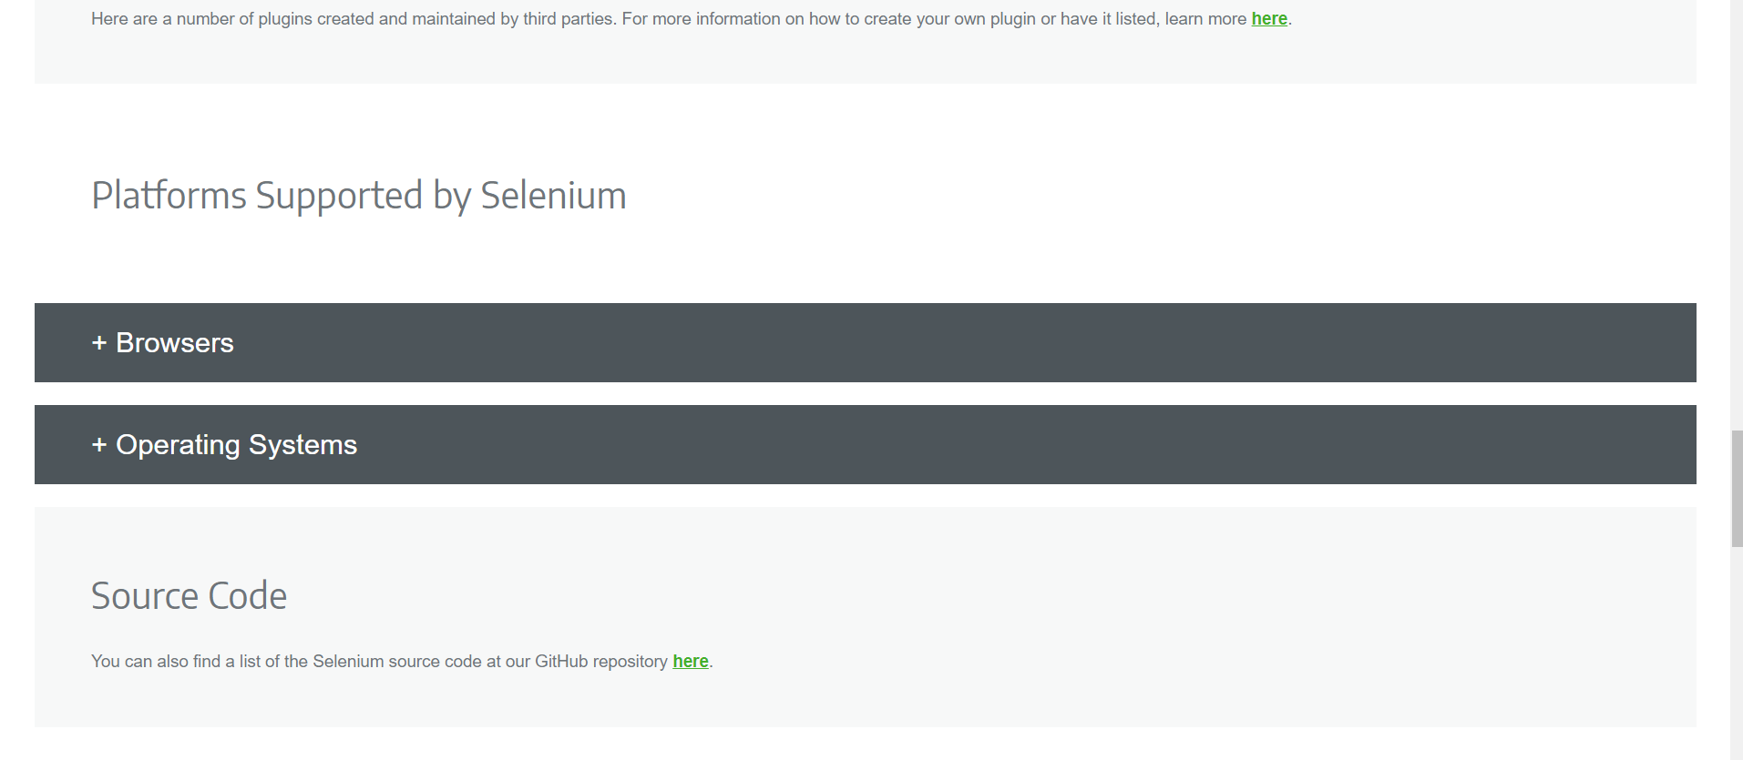

Scroll and click browser

So create object for chrome driver class

ChromeDriver Driver= **new** ChromeDriver();

Now put your cursor on it and import chrome webdriver

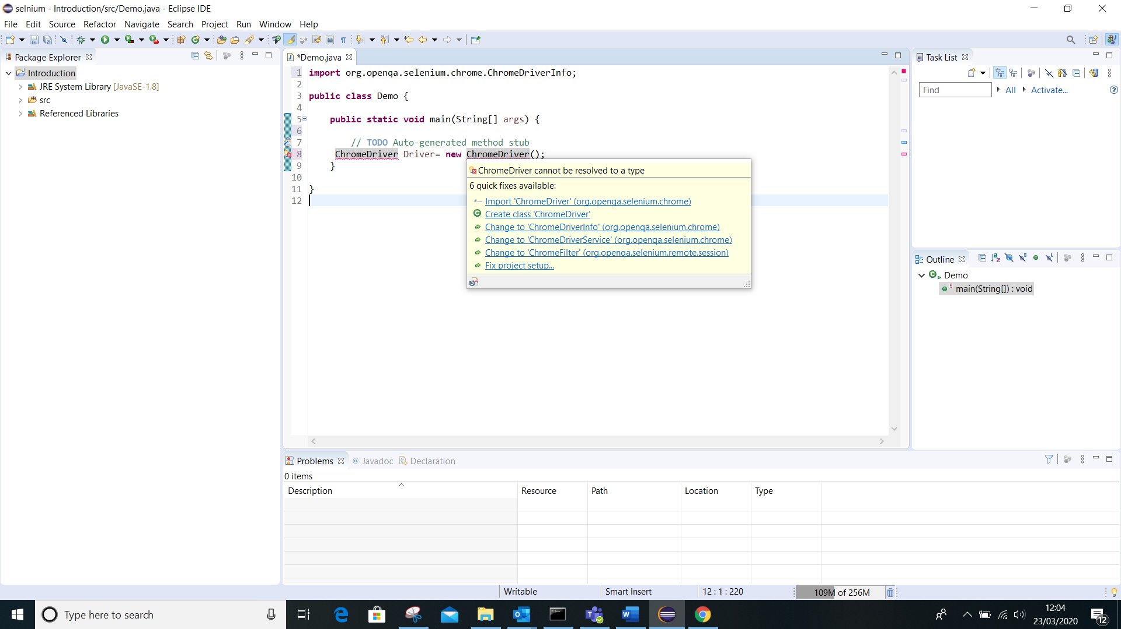

To chek google version click the ellipse and then click help then about google.

After go back to chrome documentation and click the relevant version

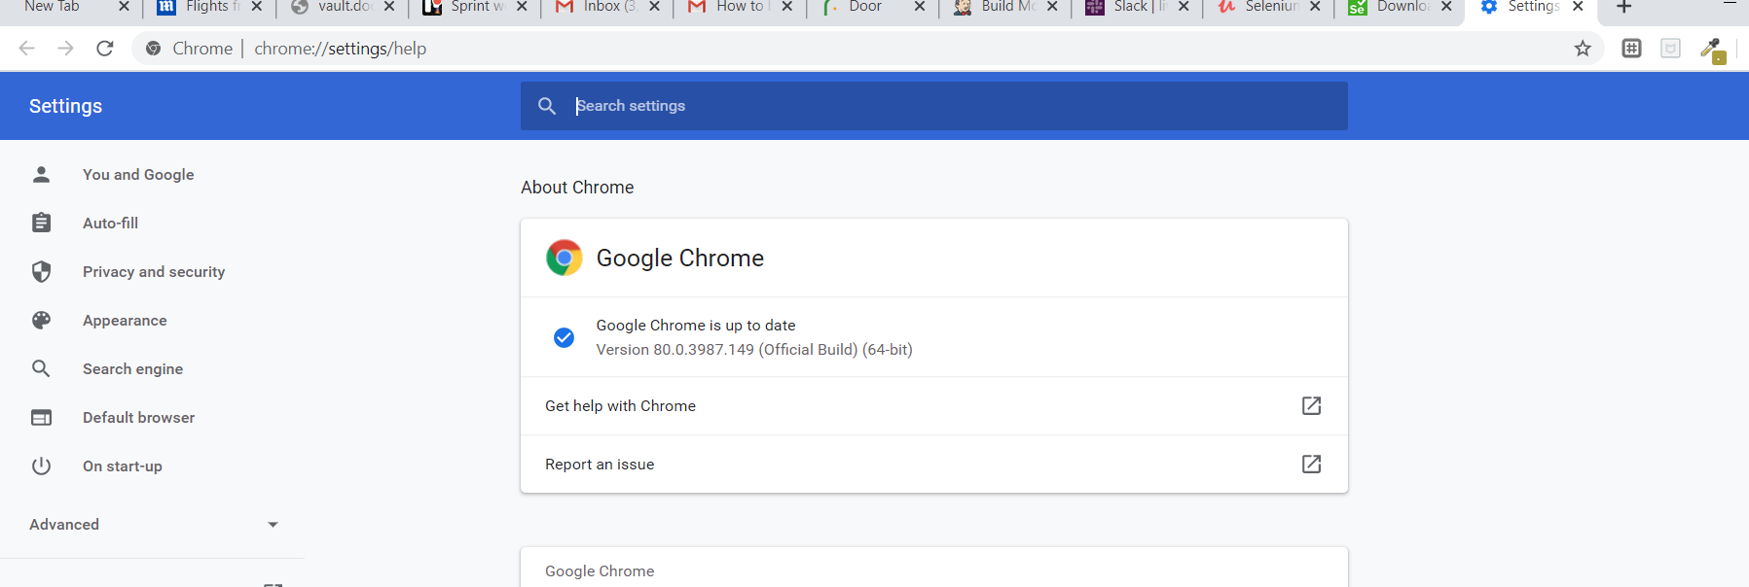

So download chrome driver version 80

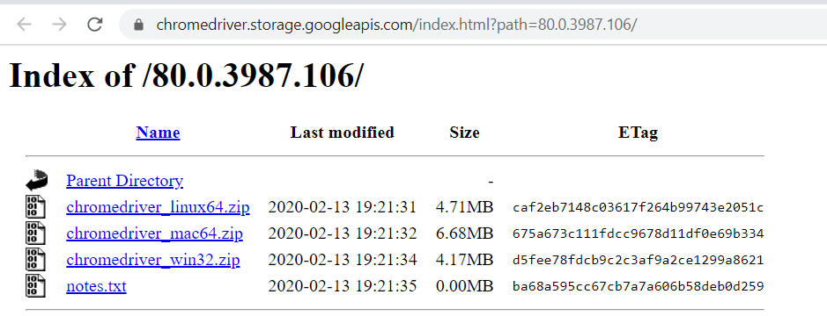

So download it extract it and save it in the c.

C:\Chrome.

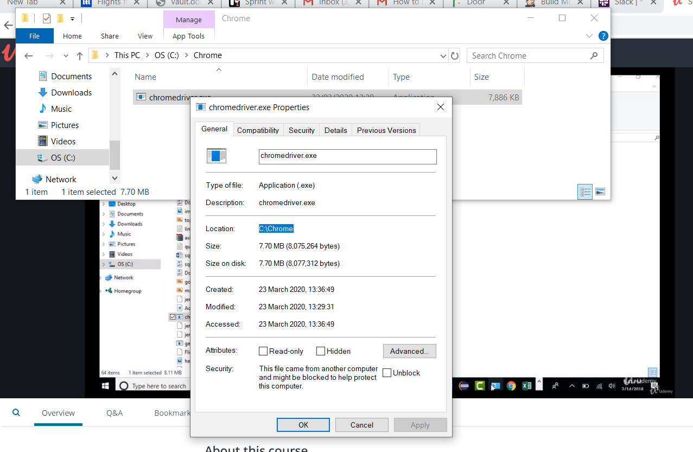

So the full path is

C:\Chrome\chromedriver.exe

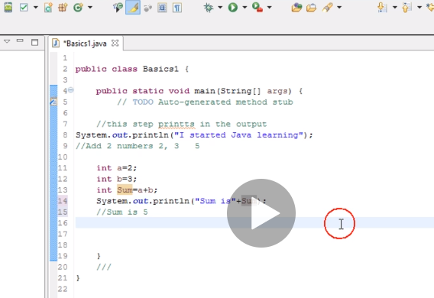

To run another file from a single file

**import** org.openqa.selenium.WebDriver;

**import** org.openqa.selenium.chrome.ChromeDriver;

**public** **class** Demo {

**public** **static** **void** main(String[] args) {

// **TODO** Auto-generated method stub

System.*setProperty*("webdriver.chrome.driver", "C:\\Chrome\\chromedriver.exe");

WebDriver driver= **new** ChromeDriver();

driver.get("http://google.com");

System.***out***.println(driver.getTitle());

Basic1 m=**new** Basic1(); //(this brings the class to your main class and creates a key m….to access any method in that class, next step is the key.anymethod in that class)

// now after creating a method for the class to call it is

//clasobject.method name

m.validateheader();

}

}

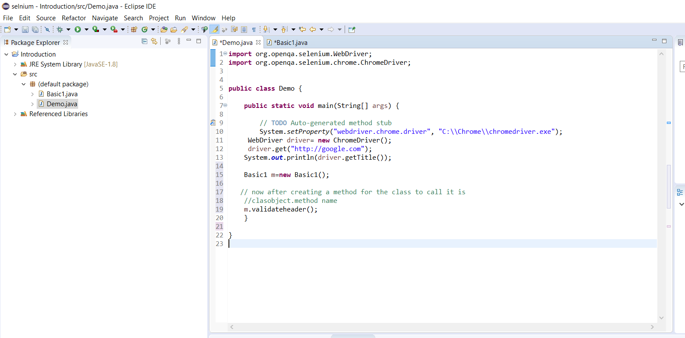

Take note initially it was public void will return nothing but to return something you have to change it based on the return type

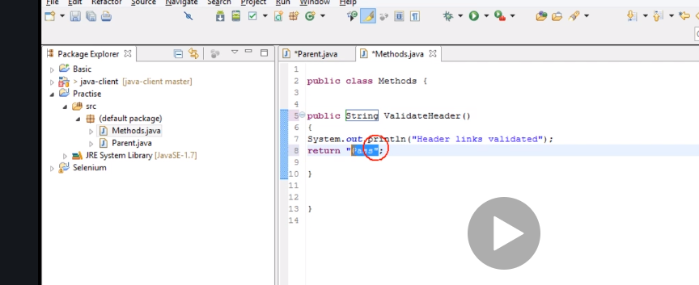

By making this change I can now call it into my parent class which showed error before but now shows fine

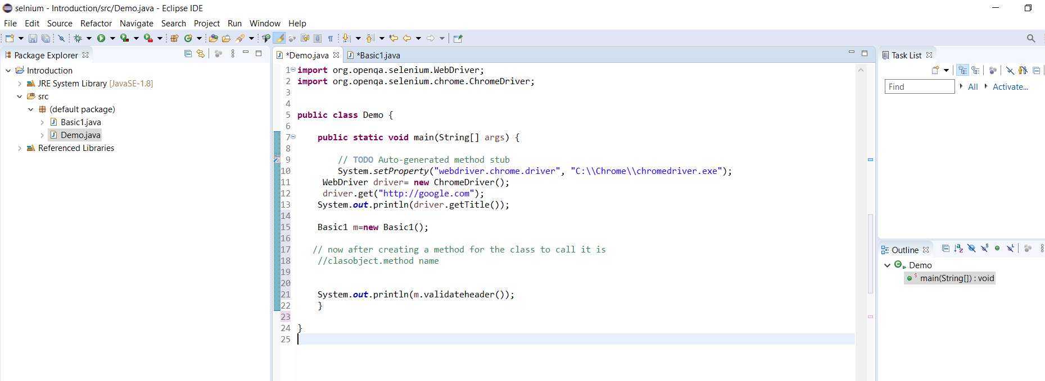

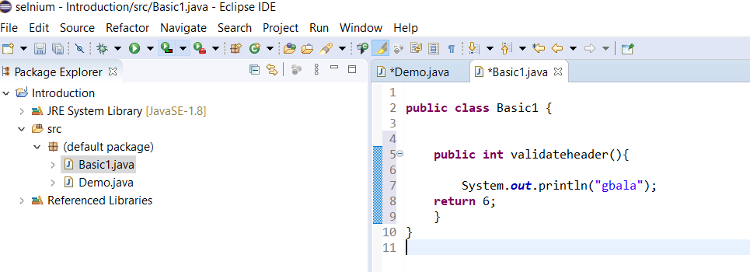

Now this is whats happening….. it will priny gbala but also it will print 2 beacause

m.validatingheader is now equals to what you have in the method and a return value so m.validating holds 2 values.

When u do

S=m.validateheader ….. s is 2 and gbala.

We can do samething with string

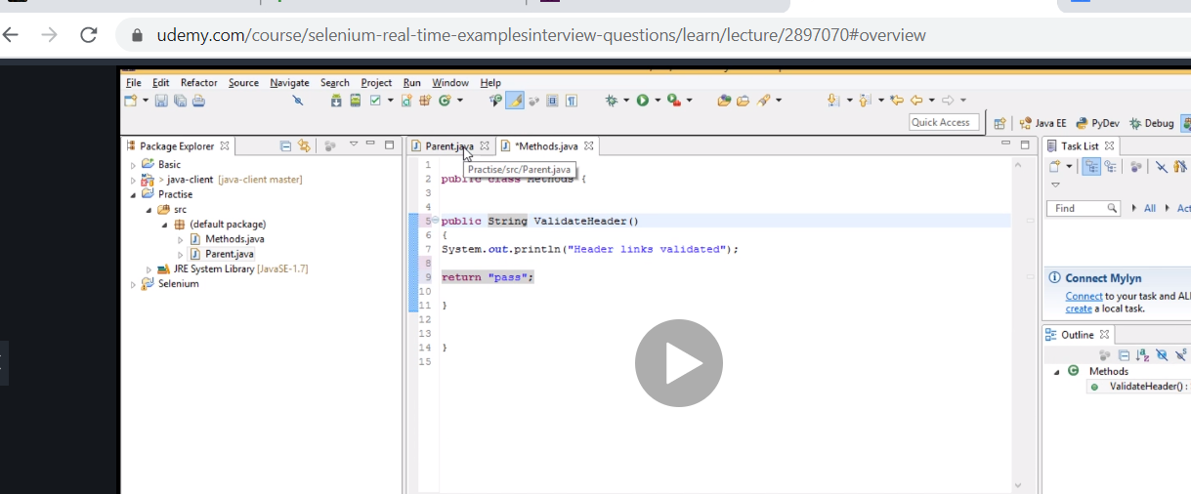

Do this to validate your browser

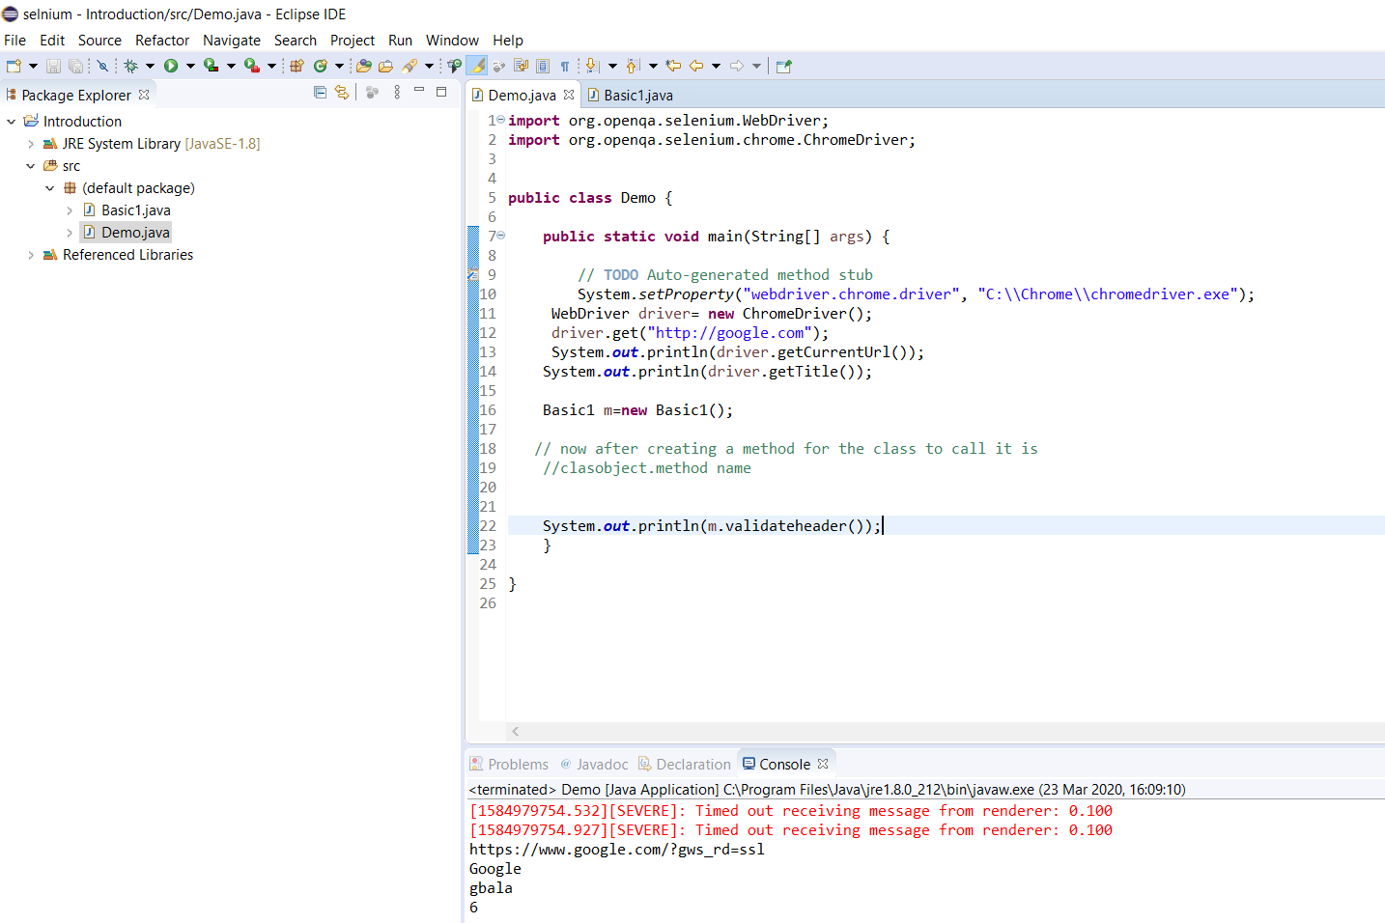

**import** org.openqa.selenium.WebDriver;

**import** org.openqa.selenium.chrome.ChromeDriver;

**public** **class** Demo {

**public** **static** **void** main(String[] args) {

// **TODO** Auto-generated method stub

System.*setProperty*("webdriver.chrome.driver", "C:\\Chrome\\chromedriver.exe");

WebDriver driver= **new** ChromeDriver();

driver.get("http://google.com");

System.***out***.println(driver.getCurrentUrl());

System.***out***.println(driver.getTitle());

Basic1 m=**new** Basic1();

// now after creating a method for the class to call it is

//clasobject.method name

System.***out***.println(m.validateheader());

}

}

In addition you may need to grab page source…..remember this comes handy when dealing with frames….

**import** org.openqa.selenium.WebDriver;

**import** org.openqa.selenium.chrome.ChromeDriver;

**public** **class** Demo {

**public** **static** **void** main(String[] args) {

// **TODO** Auto-generated method stub

System.*setProperty*("webdriver.chrome.driver", "C:\\Chrome\\chromedriver.exe");

WebDriver driver= **new** ChromeDriver();

driver.get("http://google.com");

System.***out***.println(driver.getCurrentUrl());

System.***out***.println(driver.getTitle());

System.***out***.println(driver.getPageSource());

Basic1 m=**new** Basic1();

// now after creating a method for the class to call it is

//clasobject.method name

System.***out***.println(m.validateheader());

}

}

Now final code with most of the webdriver methods for eclipse

**import** org.openqa.selenium.WebDriver;

**import** org.openqa.selenium.chrome.ChromeDriver;

**public** **class** Demo {

**public** **static** **void** main(String[] args) {

// **TODO** Auto-generated method stub

System.*setProperty*("webdriver.chrome.driver", "C:\\Chrome\\chromedriver.exe");

WebDriver driver= **new** ChromeDriver();

driver.get("http://google.com");

driver.get("http://yahoo.com");

driver.navigate().back();

System.***out***.println(driver.getCurrentUrl());

System.***out***.println(driver.getTitle());

System.***out***.println(driver.getPageSource());

Basic1 m=**new** Basic1();

// now after creating a method for the class to call it is

//clasobject.method name

System.***out***.println(m.validateheader());

driver.close();

driver.quit();

}

}

Now locators and elements now

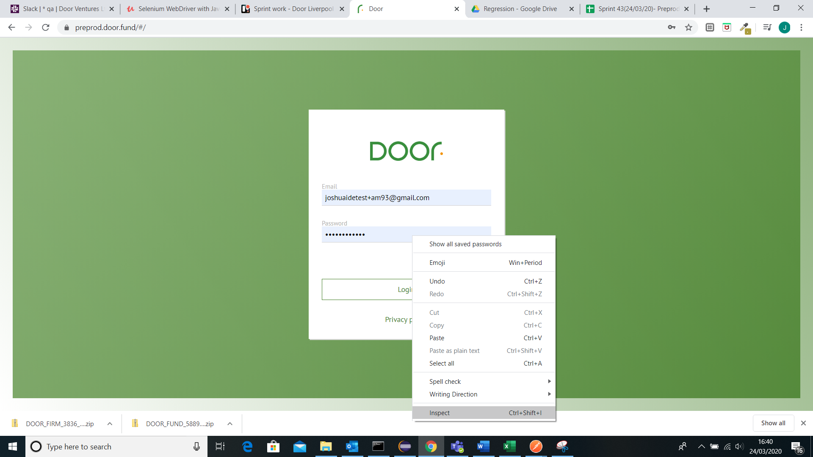

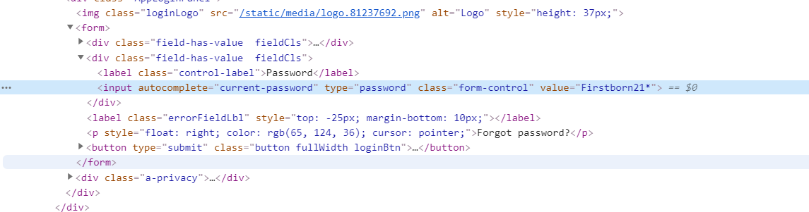

The input is the tag and the others are attrbutes

These are the locators

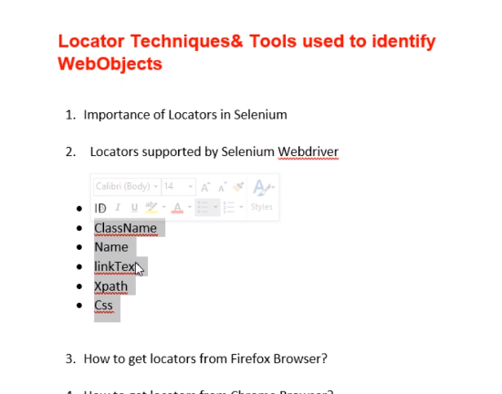

We cant find the first 3 so we shall use xpath or css

If you see alphanumeric ID=2-0 u stay away because it may vary on every refresh

That’s why css or xpath are the best

Link text is so easy



Every object with anchor a is a link. Just copy the link name and automate with it

Note class name with space will not work. Class name without space works fine.

Also if two boxes have same field, selenium only catch first index from top left. So in such case we need to

Now fuck chromepath and all that bullshit

There is a way to get xpath….inspect the object…then right click the blue element select and go to copy, and then select the xpath.

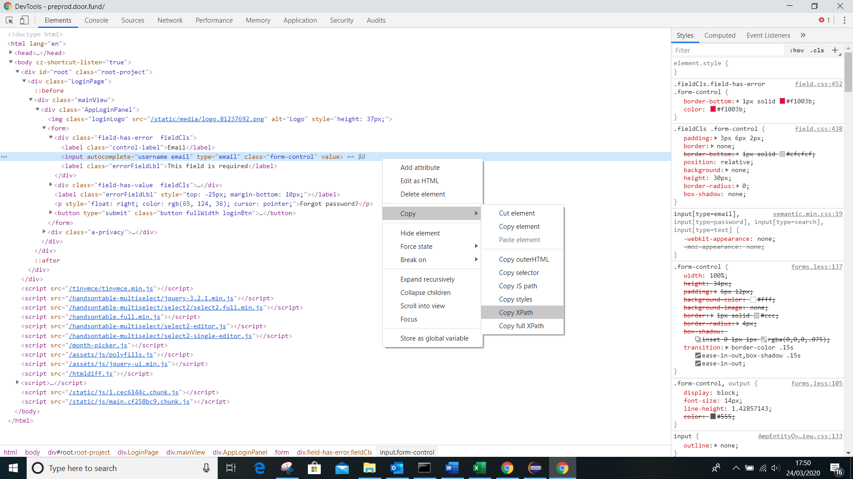

//*[@id="root"]/div/div/div/form/div[1]/input

//*[@id="root"]/div/div/div/form/div[2]/input

now remember to change the double quotes to single quotes so

//*[@id=’root’]/div/div/div/form/div[1]/input

Now take note after finding the xpath ….there is a way to check if the xpath is actually correct

1. Copy the xpath
2. Change double column to single
3. Now click on sonsole and at the bottom type $x(“”)

$x(“//*[@id=’root’]/div/div/div/form/div[1]/input”) and press enter

1. This will show u the object. If it doesn’t show you the object then obviously the xpath is wrong.

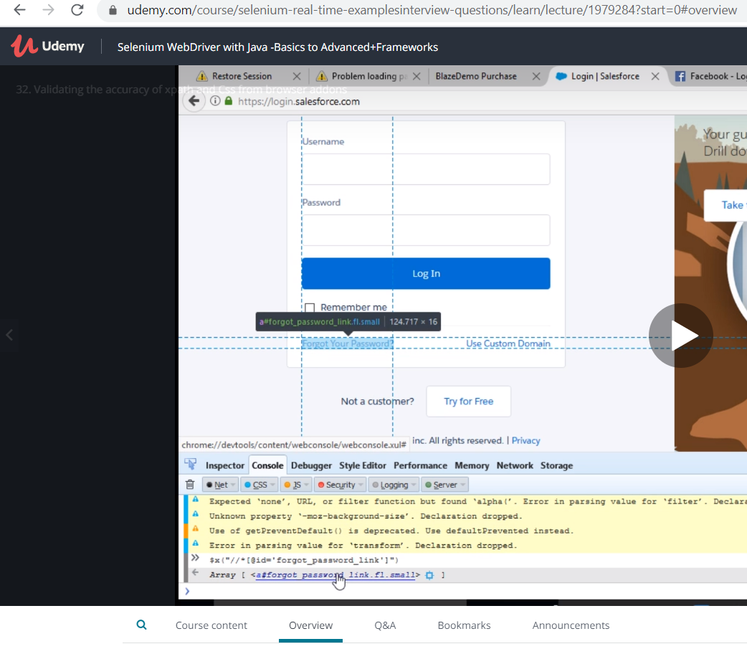

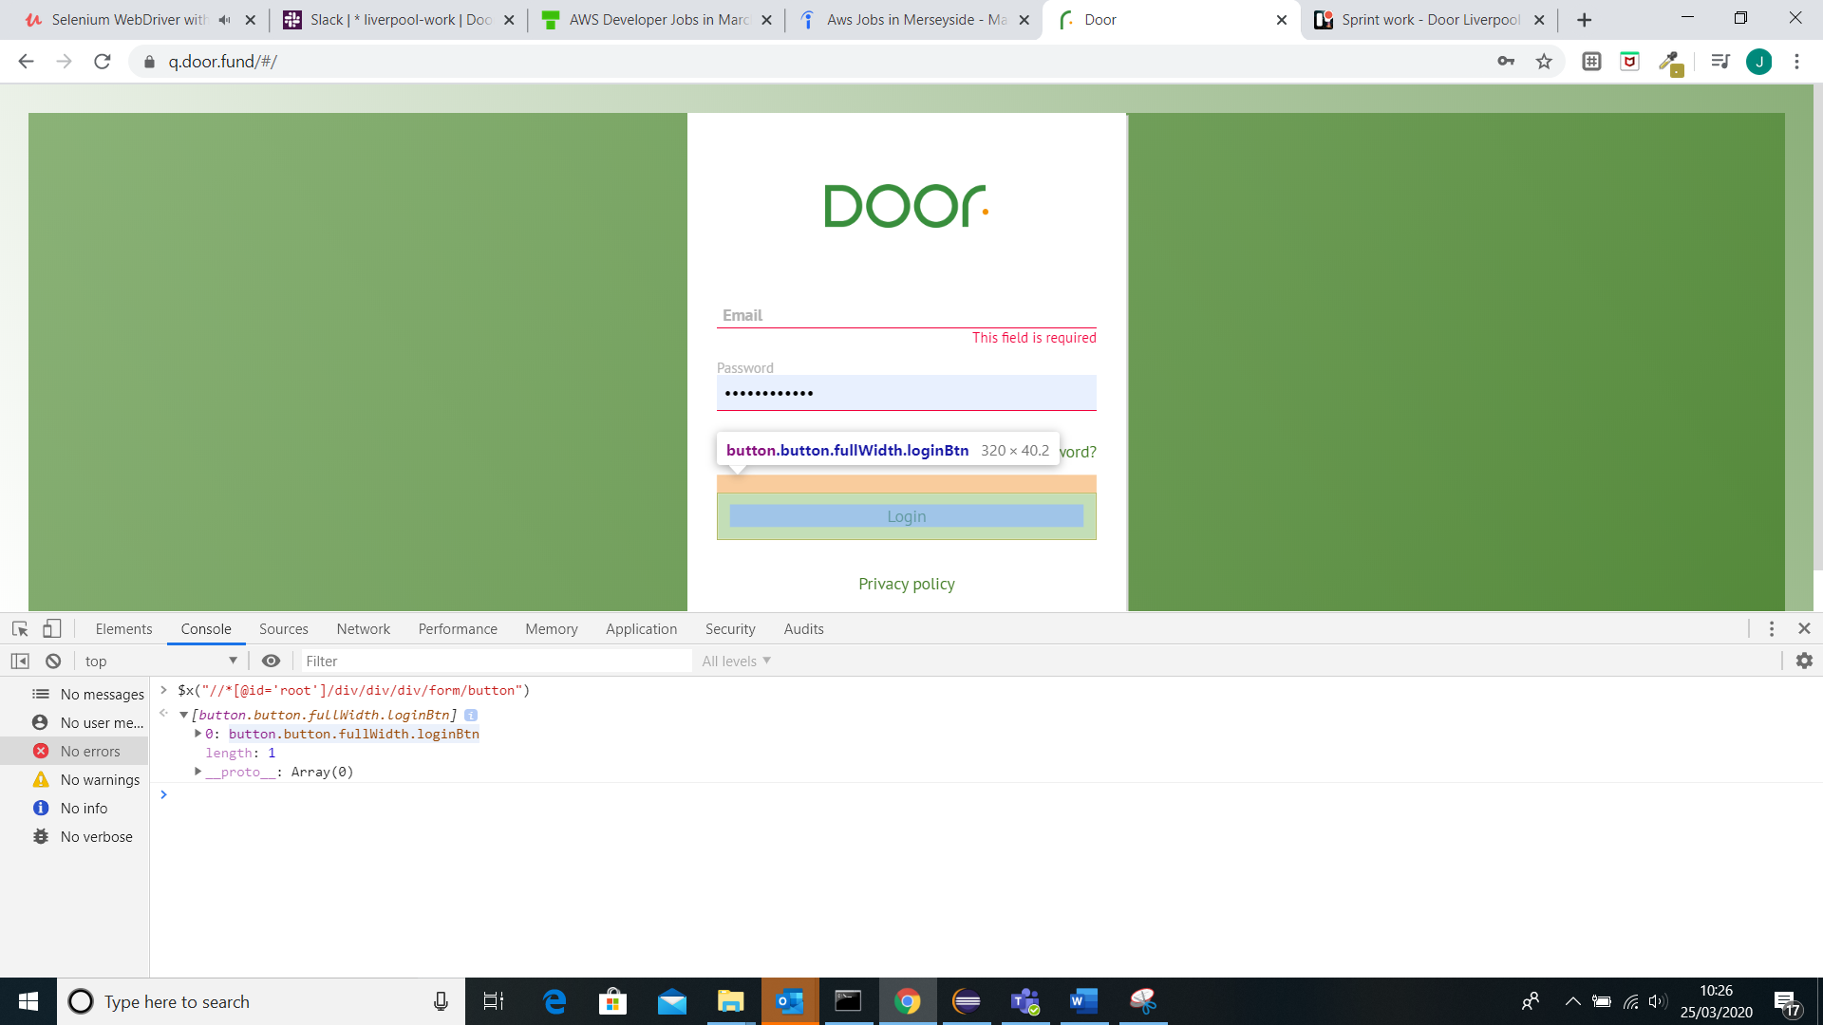

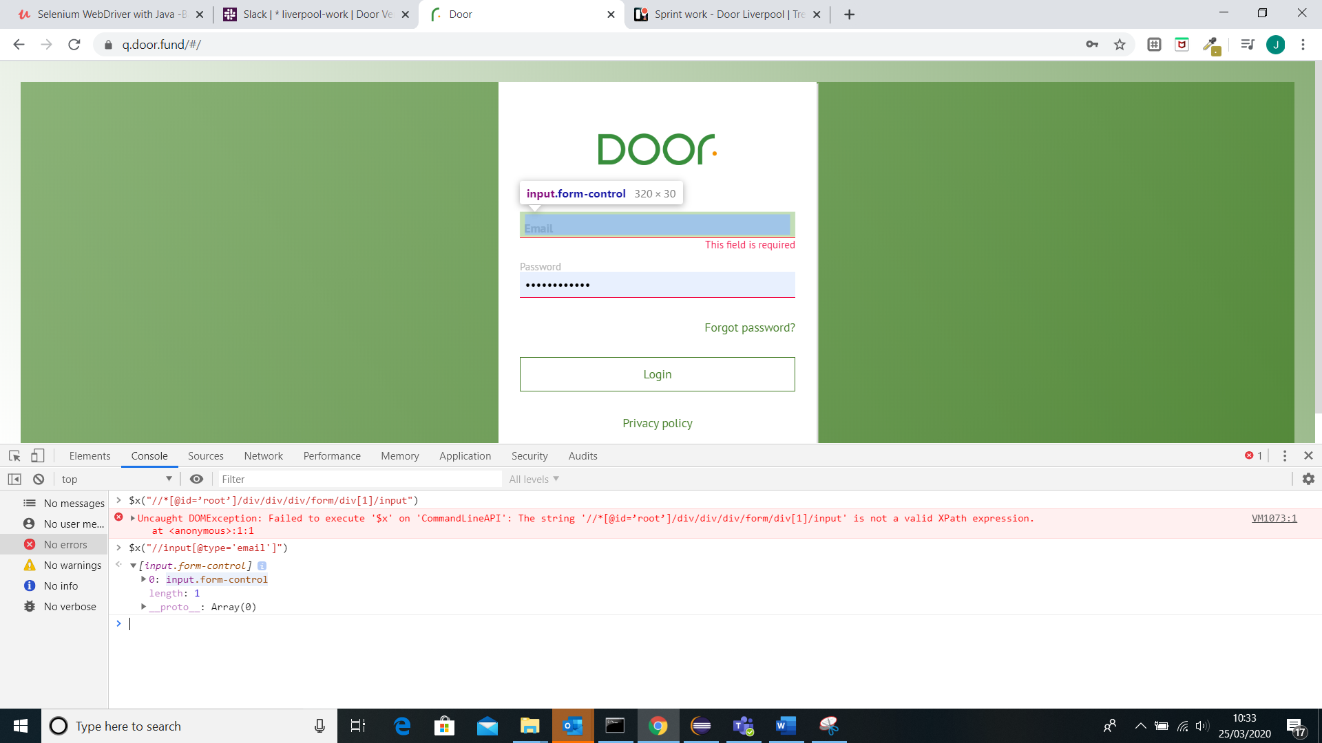

Now observe

We created another class for sales force.

Here we logged in with email and password and clicked log in but the idea is to validate the error message when user fails to log in

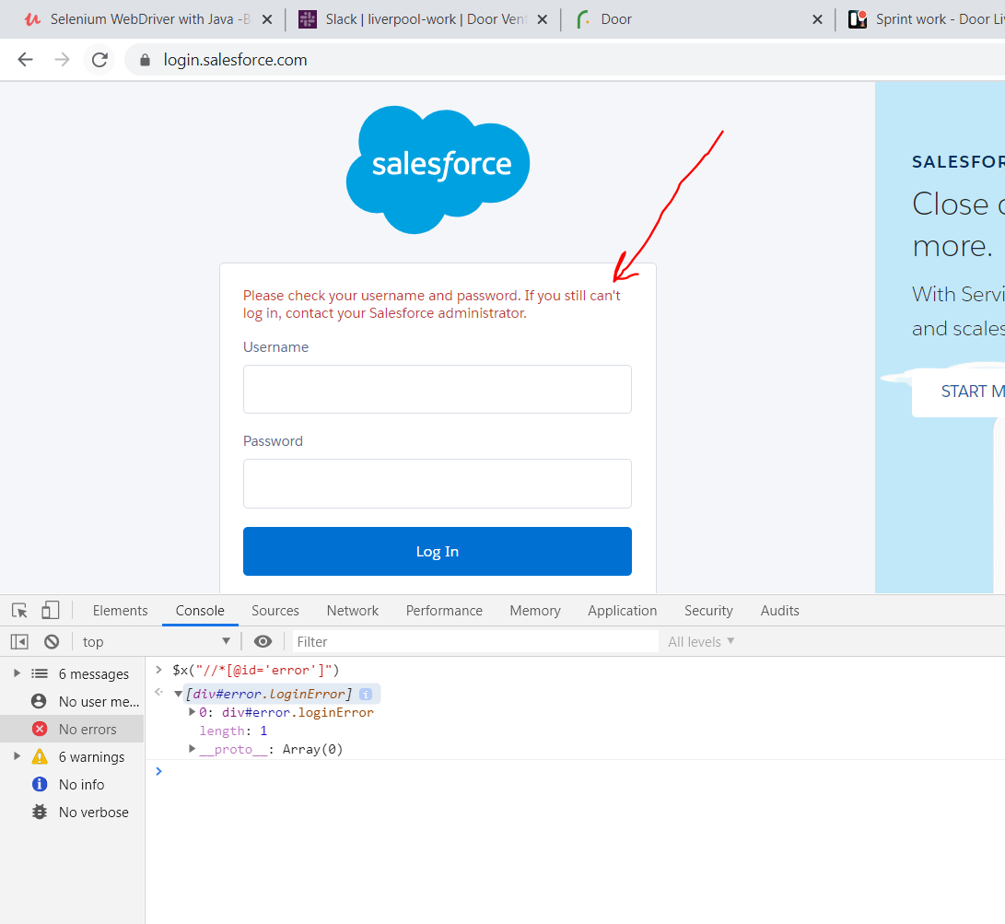

The code is below

**import** org.openqa.selenium.By;

**import** org.openqa.selenium.WebDriver;

**import** org.openqa.selenium.chrome.ChromeDriver;

**public** **class** Salesforce {

**public** **static** **void** main(String[] args) {

// **TODO** Auto-generated method stub

System.*setProperty*("webdriver.chrome.driver", "C:\\Chrome\\chromedriver.exe");

WebDriver driver= **new** ChromeDriver();

// driver.get("http://google.com");

// driver.get("http://yahoo.com");

// driver.navigate().back();

driver.get("https://login.salesforce.com/?locale=uk");

driver.findElement(By.*xpath*("//input[@type='email']")).sendKeys("goat");

driver.findElement(By.*xpath*("//input[@type='password']")).sendKeys("goat");

driver.findElement(By.*xpath*("//*[@id='Login']")).click();

System.***out***.println(driver.findElement(By.*xpath*("//*[@id='error']")).getText());

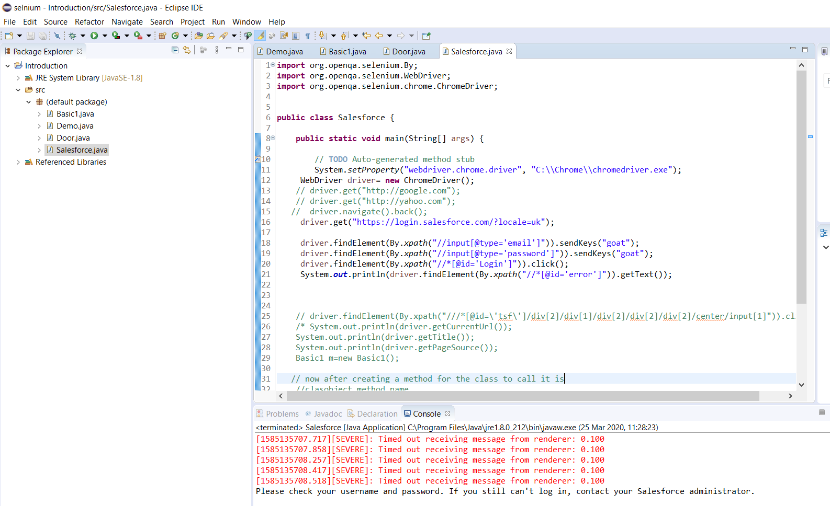

Now let us learn how to build our own xpath or just copy it like normal if you can

Fist copy outer html of the sales force site in chrome

<input class="input r4 wide mb16 mt8 password" type="password" id="password" name="pw" onkeypress="checkCaps(event)" autocomplete="off">

Now…. The input is called tagname. Everything on the left is called attribute and on the right of it is the value

Input-tag name

Attribute: class type id name

Value: input r4 wide mb16 mt8 password password password pw

So therefore the sybtax for the xpath for this email is

//tagname[@attribute=’value’]

With that in mind let us create a log in button xpath for facebook

Now we shall copy and create another class facebook

<input value="Log In" aria-label="Log In" data-testid="royal_login_button" type="submit" id="u_0_b">

Now we can clearly see ,this must be the xpath we will try it in the console

//input[@value=’Log in’]

//input[@value=’Log in’]

Also you can also use * to replace input as tag

Regular expression

So in the case where the xpath is changing we use

//tagname[contains(@attribute,’value’)]

//input[contains(@name,’username’)]

//*[@value=’Log in’]

//*[@id="u_0_b"]

For css samething only

tagname[attribute=’value’]

remember to check css

$(“”)

In case of css instead of using * you can leave it blank

Also tagname.classname can be used for css

For css regular expression

tagname[attribute=’value’]

input[@name*=’username’]

here we have used css for sales force using regular expression

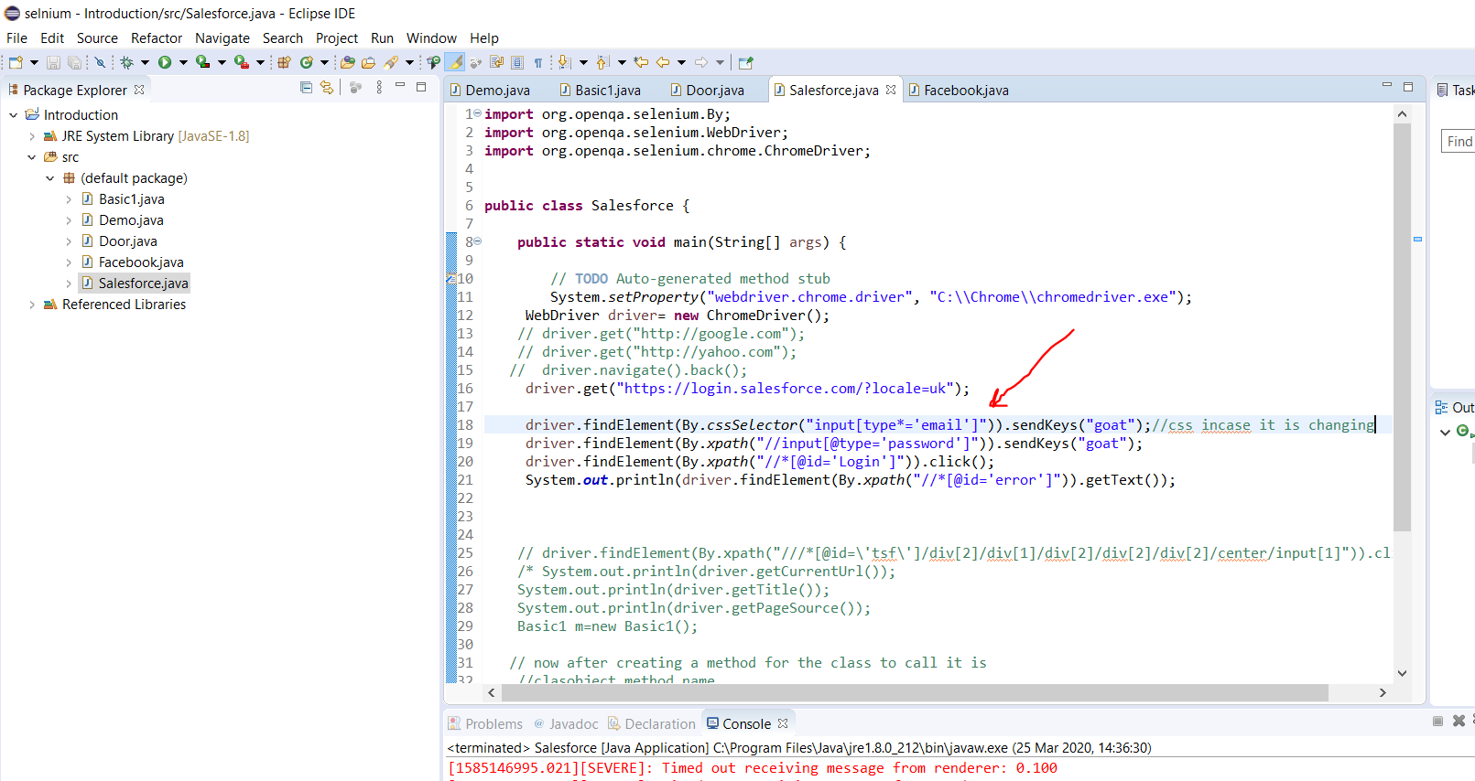

**import** org.openqa.selenium.By;

**import** org.openqa.selenium.WebDriver;

**import** org.openqa.selenium.chrome.ChromeDriver;

**public** **class** Salesforce {

**public** **static** **void** main(String[] args) {

// **TODO** Auto-generated method stub

System.*setProperty*("webdriver.chrome.driver", "C:\\Chrome\\chromedriver.exe");

WebDriver driver= **new** ChromeDriver();

// driver.get("http://google.com");

// driver.get("http://yahoo.com");

// driver.navigate().back();

driver.get("https://login.salesforce.com/?locale=uk");

driver.findElement(By.*cssSelector*("input[type*='email']")).sendKeys("goat");//css incase it is changing

driver.findElement(By.*xpath*("//input[@type='password']")).sendKeys("goat");

driver.findElement(By.*xpath*("//*[@id='Login']")).click();

System.***out***.println(driver.findElement(By.*xpath*("//*[@id='error']")).getText());

Now we find xpath with parent child transverse.

If you click an arrow and the child disappears then u know that is the parent arrow. The down arrow is a parent to the right arrow.

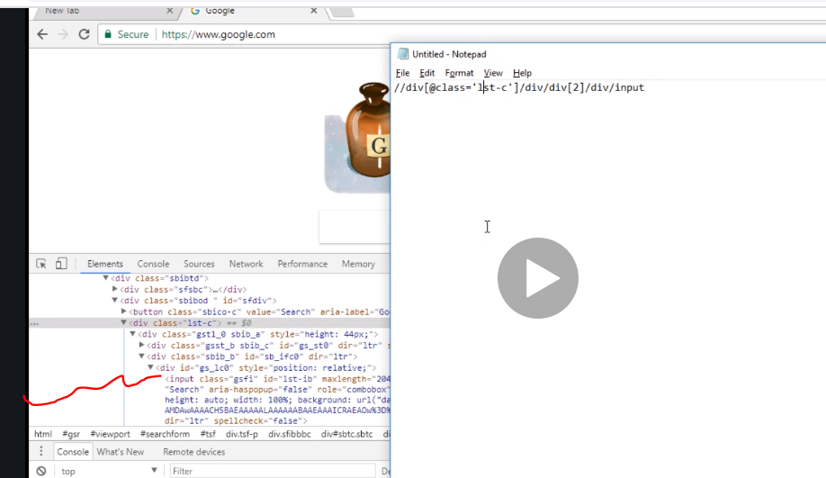

//div[@class=’a4bIc’] if ound out though that if you have div/div the first div is actually

[0] and the second is actually [1]

Also hou can identify xpath by text

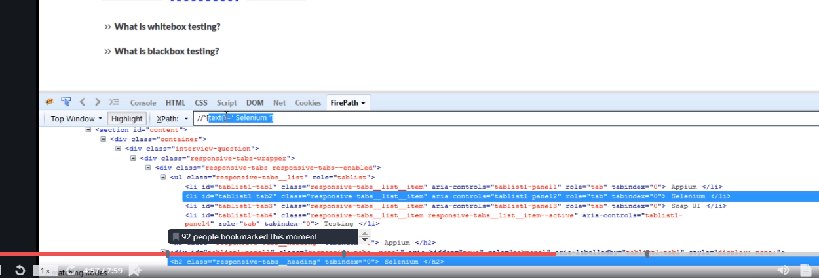

Remember to leave space depending if there is space if not no space

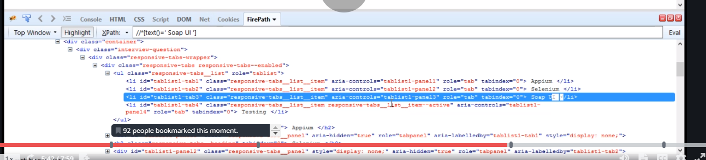

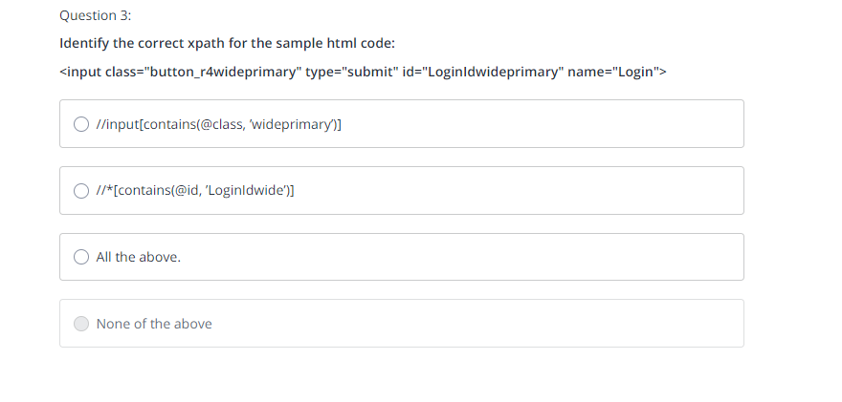

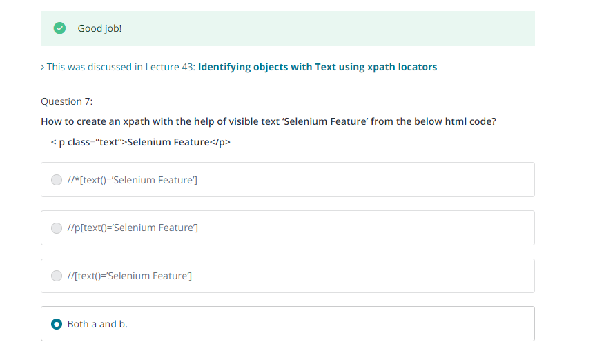

Starting on dropdowns and radio buttons

Static dropdown have tag as select and preloaded.

Now we created a new class….spicejet to practice

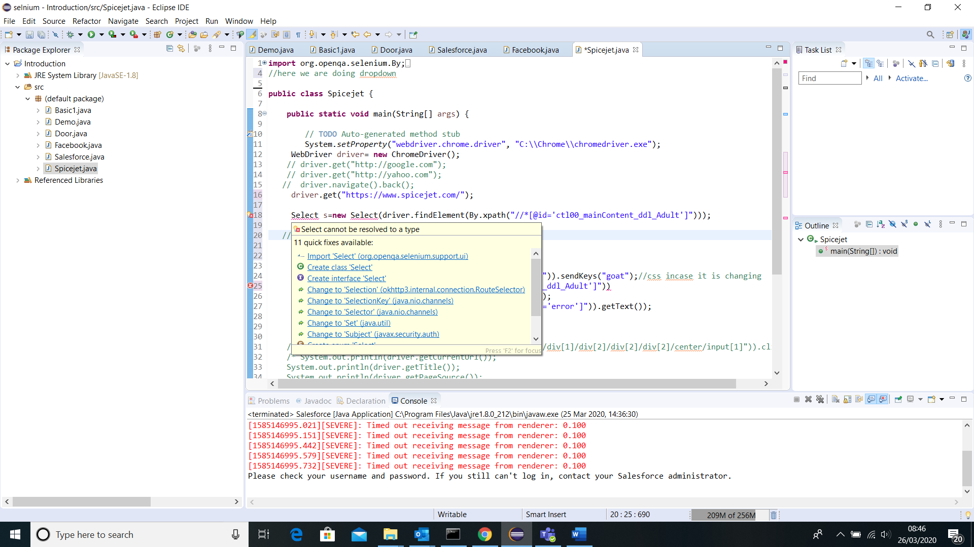

Import select package

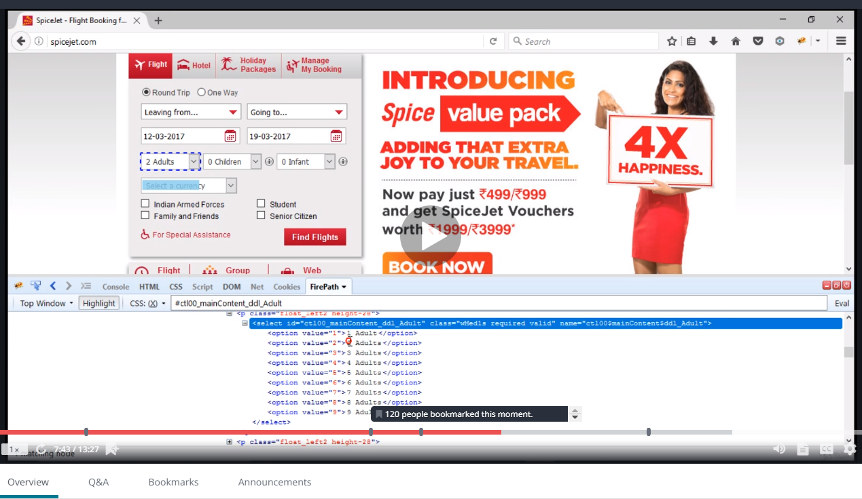

To select 2, go to the node expand, see the value number …go back to eclipse and do s.by value and use 2.

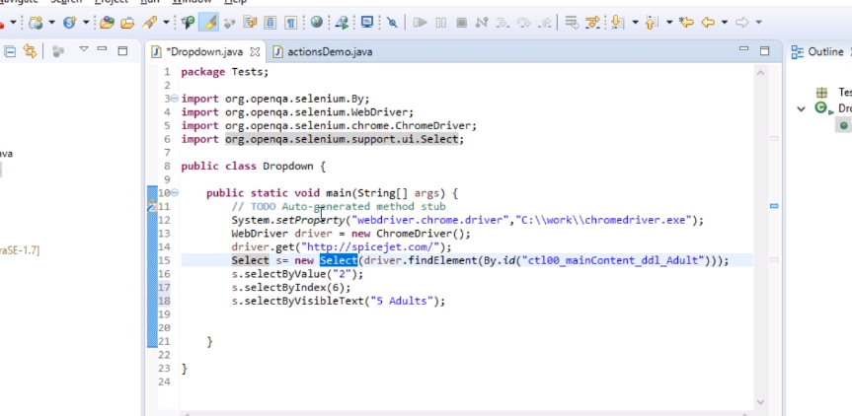

You can also use the above.

Dynamic is not like static

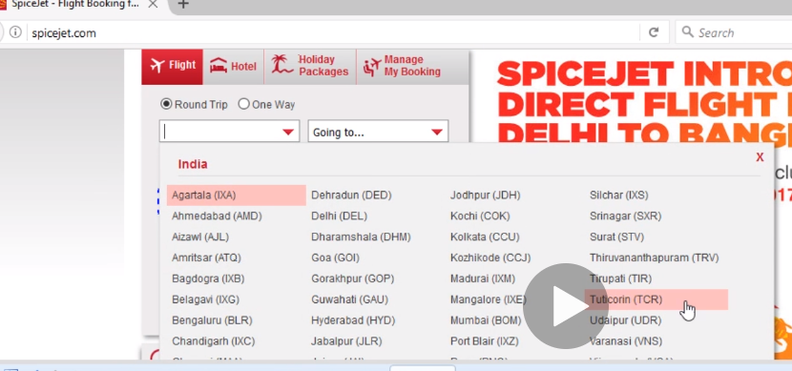

In this case instead of select…we see input id

Now take note of this….. looping UI

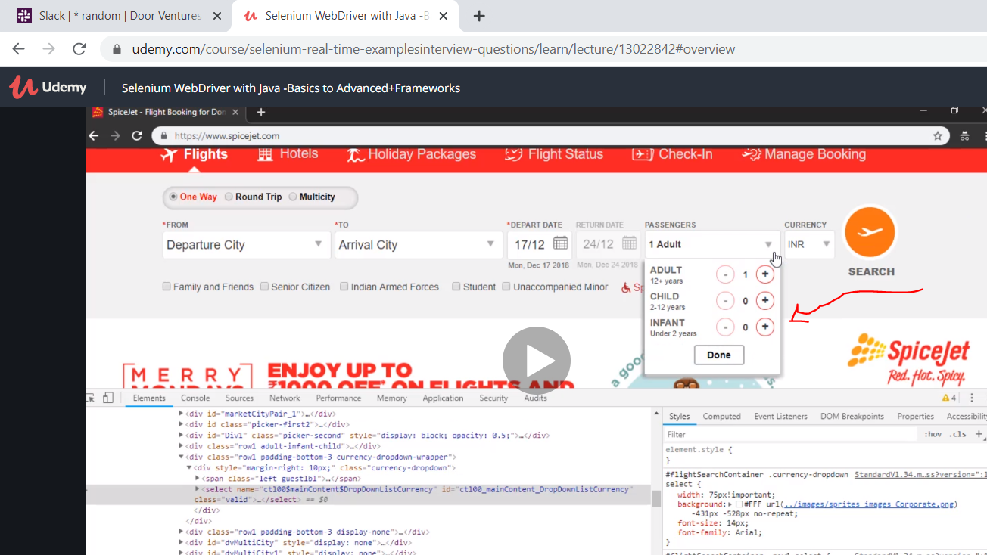

How we do this same procedure but now we dnt want to click the + five times. We use a while loop

While(true)

This condition runs till it becomes false. Once it is false then it comes out of the loop

So first we need to have a variable

Int i=1 initialise

Then a condition

While(i<5)

{

driver.findElement(By.*xpath*("//*[@id='Login']")).click();

i++;

}

I++ says increase till the condition is met and then come out of the loop and continue with the code.

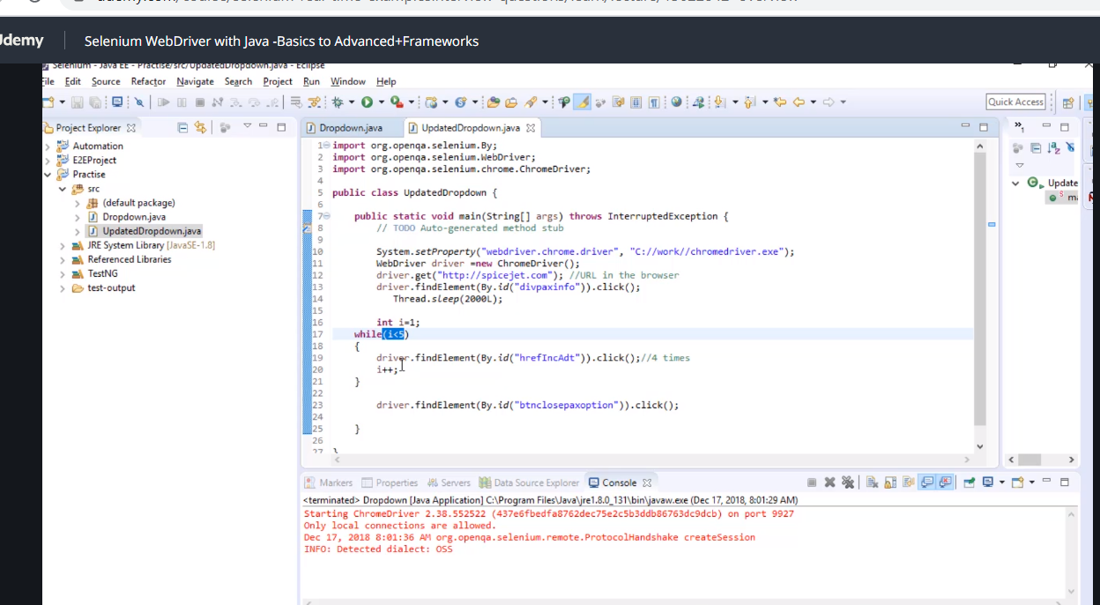

He used thread 2000l so it gives selenium time.

Now using for loop is same thing only all wrapped on the top with for loop

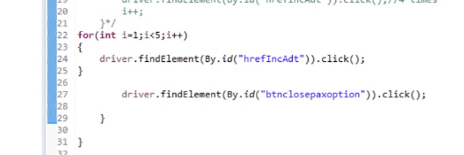

Now we used gettext to show before and after so before the loop it shows the value and after the loop it shows the new value

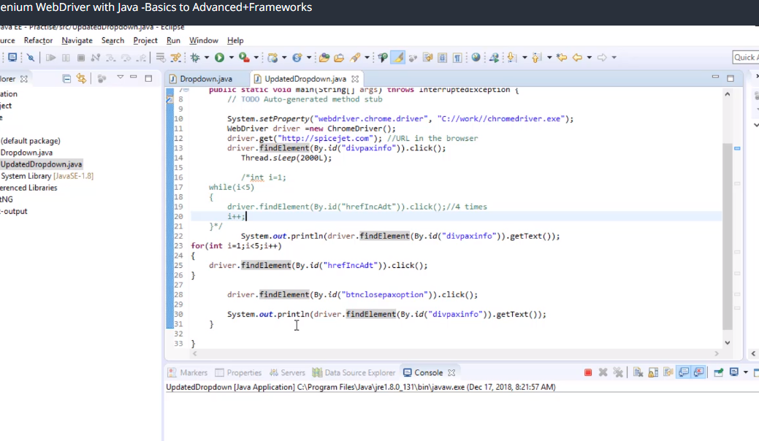

Dynamic dropdown load based on users actions

Now we are using the spicejet here once again to demonstrate dynamic dropdown

Also note when u have a situation with two of the same xpath….what you need to do is wrap the xpath and put it in bracket and put 2.

(xpath)[2]

**import** org.openqa.selenium.By;

**import** org.openqa.selenium.WebDriver;

**import** org.openqa.selenium.chrome.ChromeDriver;

**import** org.openqa.selenium.support.ui.Select;

//here we are doing dropdown

**public** **class** Spicejet {

**public** **static** **void** main(String[] args) **throws** InterruptedException {

// **TODO** Auto-generated method stub

System.*setProperty*("webdriver.chrome.driver", "C:\\Chrome\\chromedriver.exe");

WebDriver driver= **new** ChromeDriver();

// driver.get("http://google.com");

// driver.get("http://yahoo.com");

// driver.navigate().back();

driver.get("https://www.spicejet.com/");

driver.findElement(By.*xpath*("//*[@id='divpaxinfo']")).click();

Select s=**new** Select(driver.findElement(By.*xpath*("//*[@id='ctl00_mainContent_ddl_Adult']")));

s.selectByValue("3");

driver.findElement(By.*xpath*("//*[@id='ctl00_mainContent_ddl_originStation1_CTXT']")).click();

driver.findElement(By.*xpath*("//*[@id='dropdownGroup1']/div/ul[1]/li[5]/a")).click();

Thread.*sleep*(2000);

driver.findElement(By.*xpath*(" (//*[@id='dropdownGroup1']/div/ul[2]/li[5]/a)[2]")).click();

}

}

Here we used thread to buy time.

Now pay attention instead of using index there is another way…… use parent child…so find the xpath that contains the child which is what we want and then have both xpath parent and child side by side but u must give space

(parent xpath) (child xpath)

Now we create a new class make my trip

Now we use auto suggestive dropdown

Quick note so we use WebElement source to save a web function instead of repeating it over and over makes it cleaner.

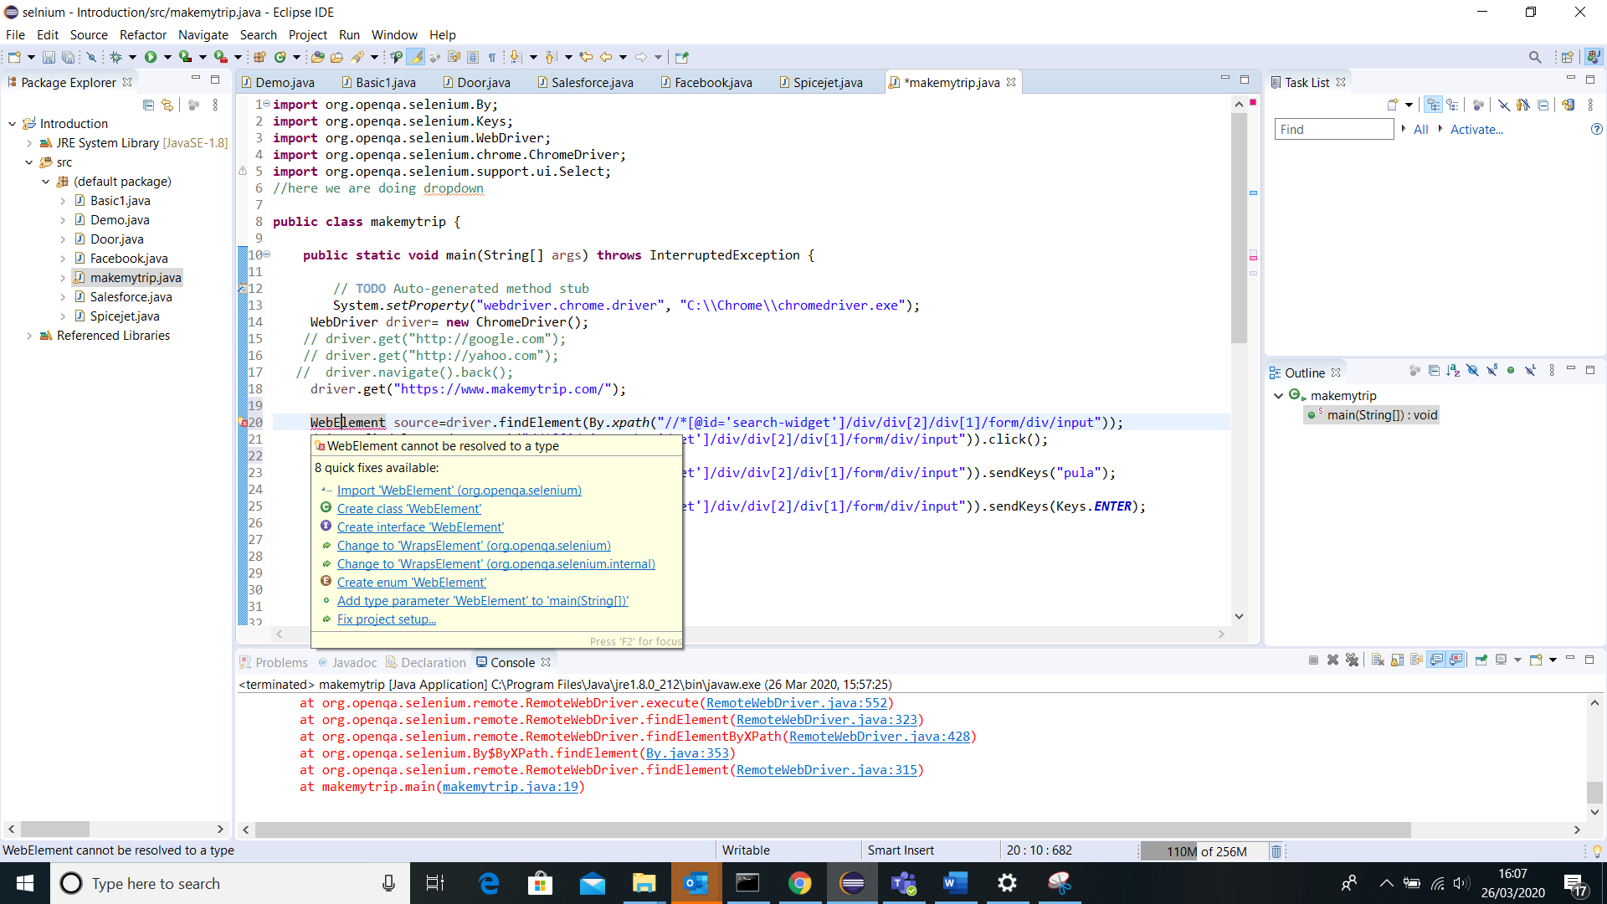

Remember to import it.

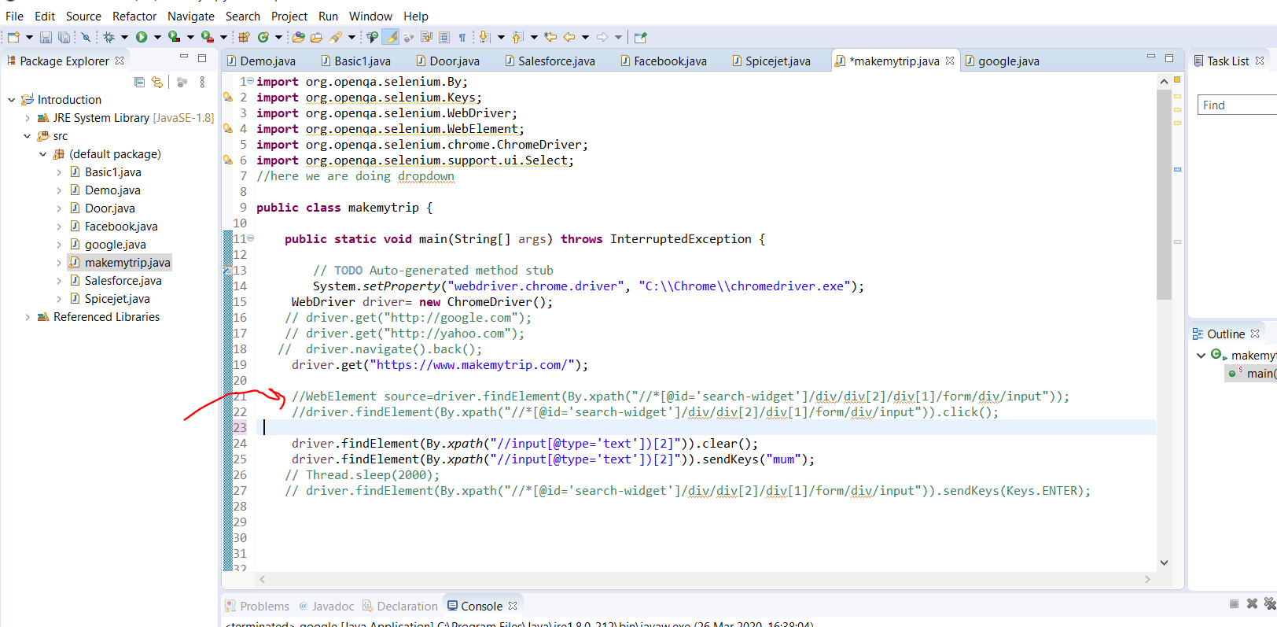

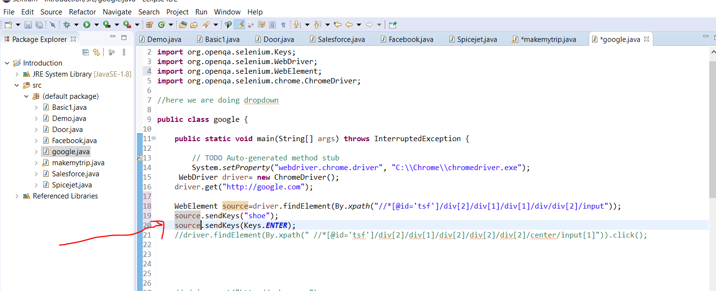

Now we decided to use anther class google instead to demonstrate auto suggestion search. We also created a variable ….source.. to store web element and avoid it looking messy….. we also created a for loop to pick the 6th element from the search

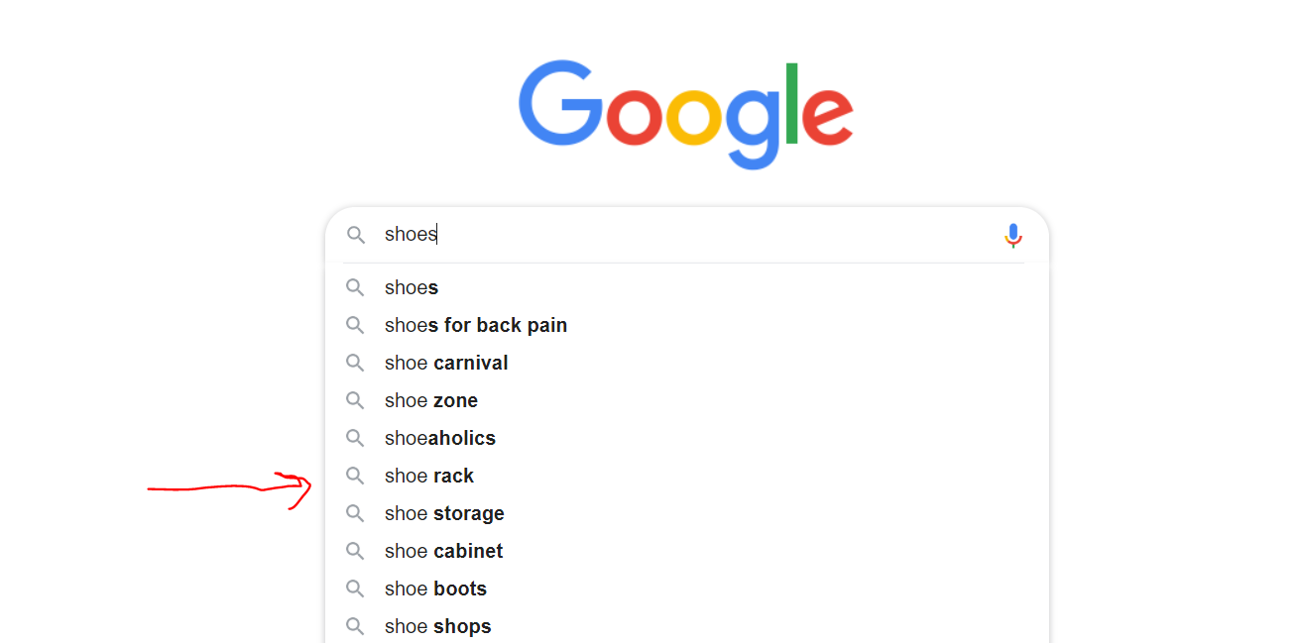

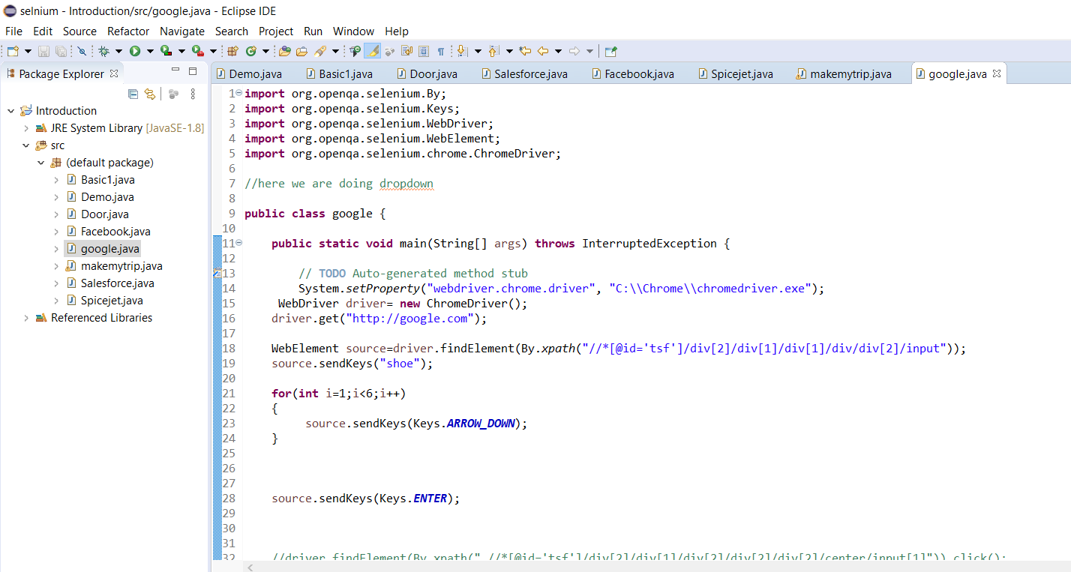

**import** org.openqa.selenium.By;

**import** org.openqa.selenium.Keys;

**import** org.openqa.selenium.WebDriver;

**import** org.openqa.selenium.WebElement;

**import** org.openqa.selenium.chrome.ChromeDriver;

//here we are doing dropdown

**public** **class** google {

**public** **static** **void** main(String[] args) **throws** InterruptedException {

// **TODO** Auto-generated method stub

System.*setProperty*("webdriver.chrome.driver", "C:\\Chrome\\chromedriver.exe");

WebDriver driver= **new** ChromeDriver();

driver.get("http://google.com");

WebElement source=driver.findElement(By.*xpath*("//*[@id='tsf']/div[2]/div[1]/div[1]/div/div[2]/input"));

source.sendKeys("shoe");

**for**(**int** i=1;i<6;i++)

{

source.sendKeys(Keys.***ARROW_DOWN***);

}

source.sendKeys(Keys.***ENTER***);

}

}

Now to do check boxes we go back to spicejet

Note after click a checkbox….. do same thing but use is selected to tell if it is selected.

In addition to find out how many checkboxex

Find a locator common to them and create an xpath. When you check the xpath t will show you all the checkboxes

Now once you create the xpath….wriite the code but this time it is not find element but elements

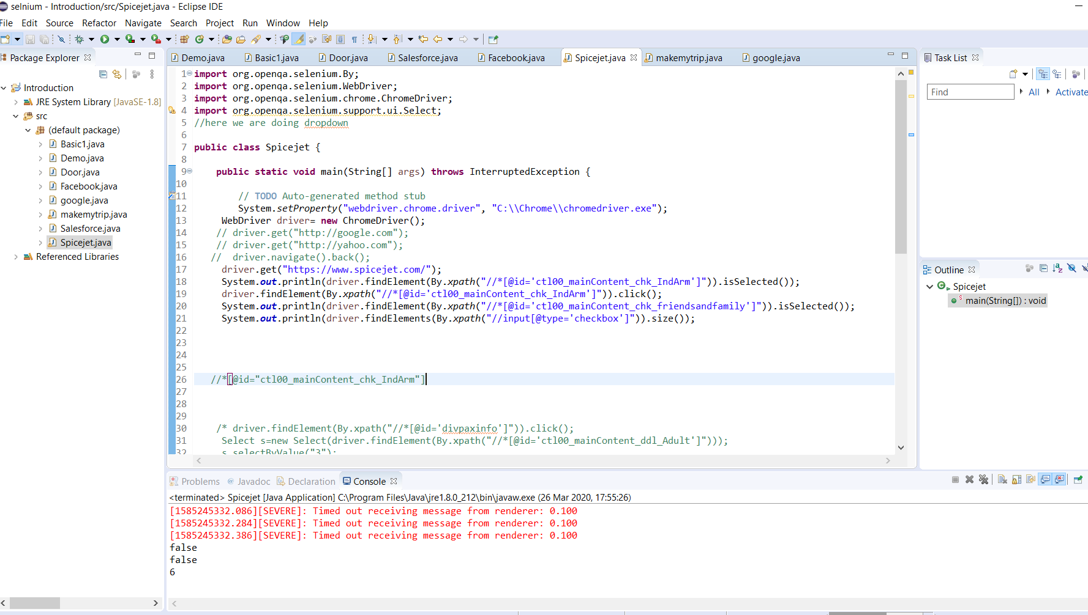

Now to start assertion we download testng jars

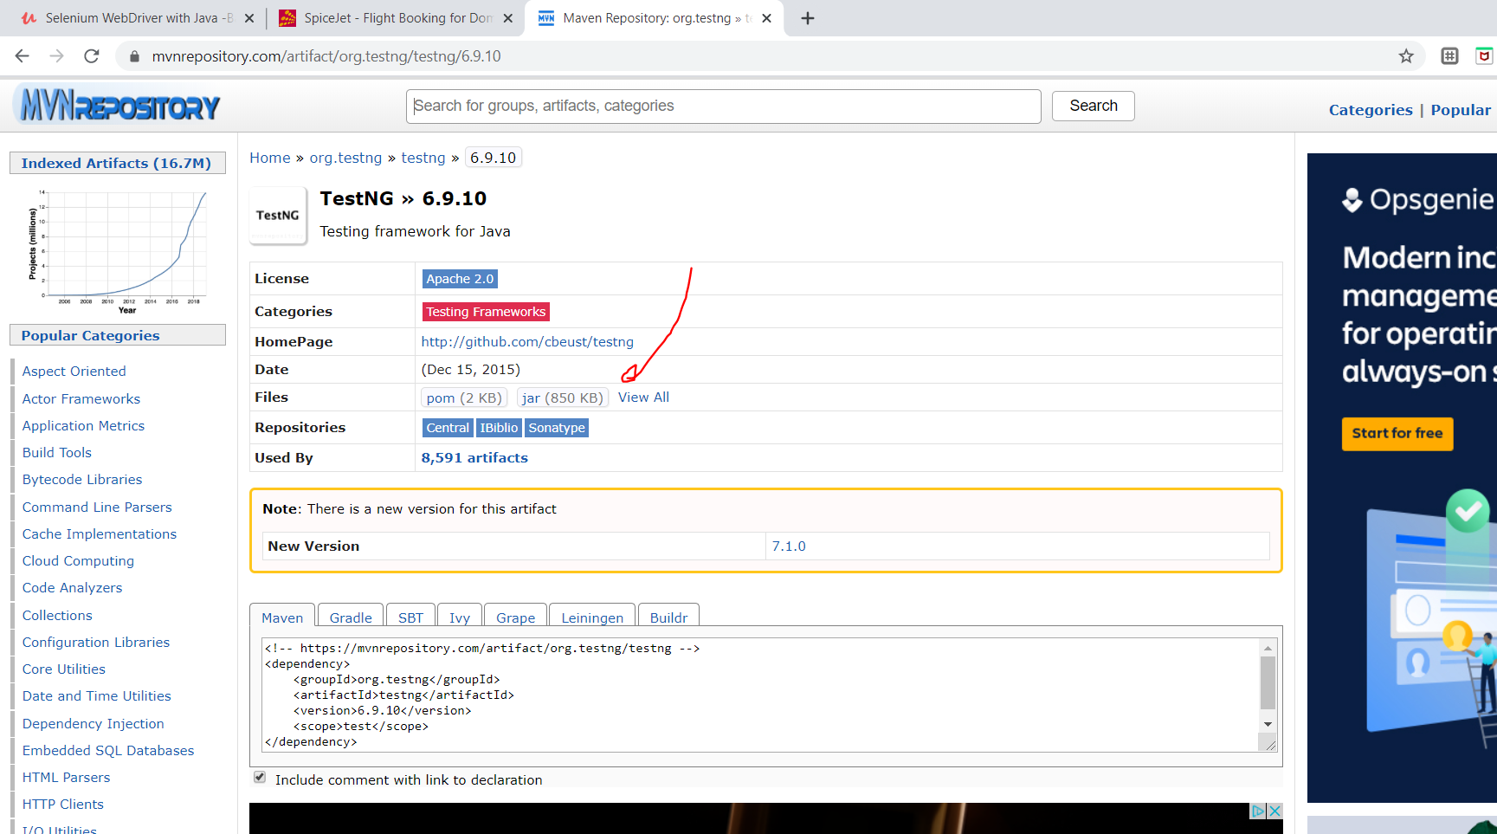

Download the jar and apply it to your build path.

Now if you want it to be true use assert true and if you want false use assert assert false.

Here we knew it was false but we used assert.true and it failed in devastating fashion

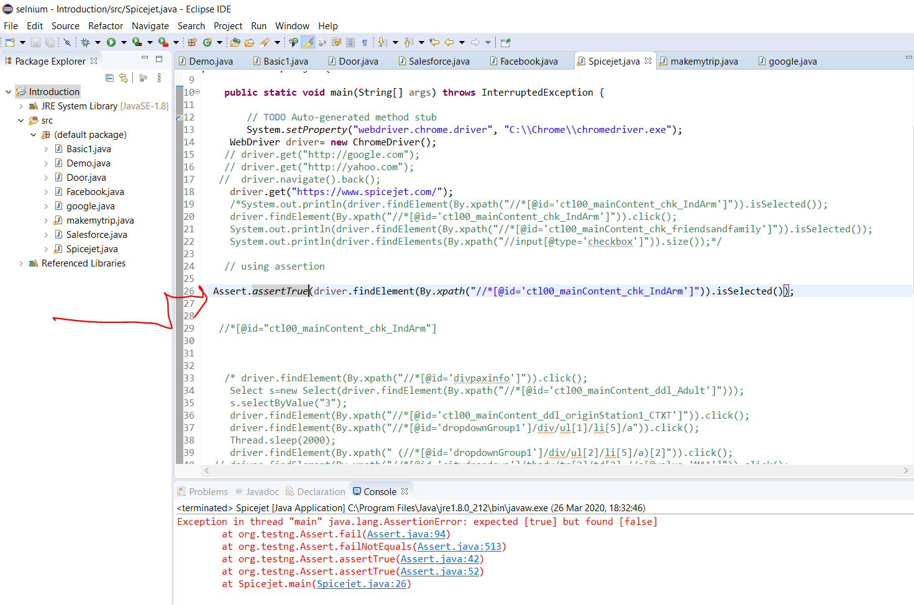

Another assertion is equal compare two get tet before and after

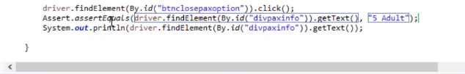

So if the result is not 5 it fails

Note if the class has space its useless. The only way to use it is to put . in it

Note also to know if stuff is enabled we do this

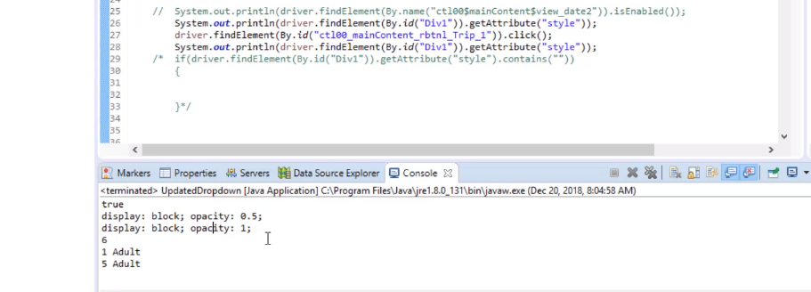

Adding assertion

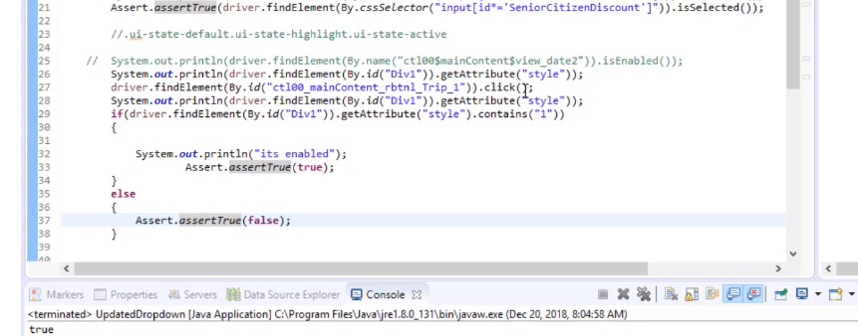

This is an example of assertion equal to

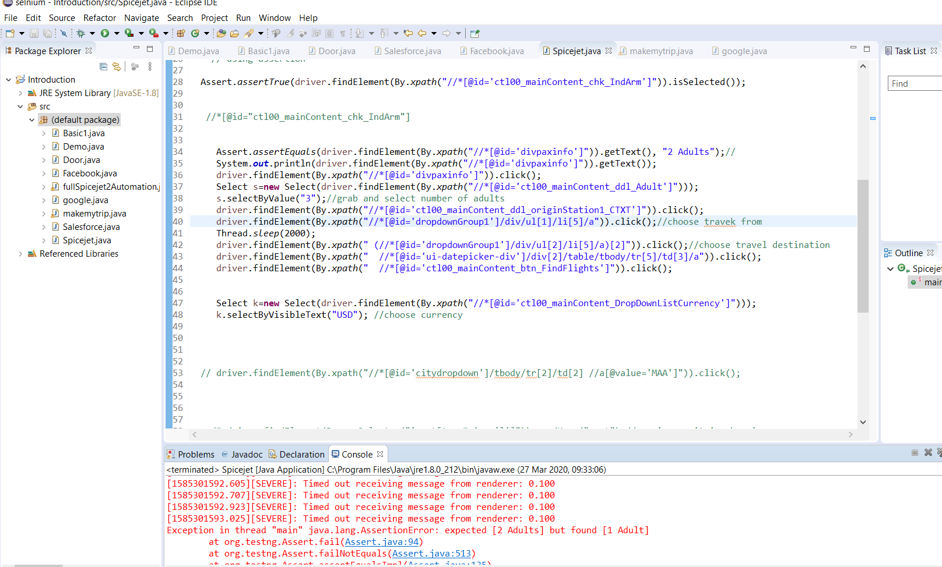

Line 34…it failed and crashe but if we make it 1 adult it will pass

Now note we used the get attribute method to check if something is enabled or not.

Take note this is important to test if an element is disabled. When disabled it should not be clickable. Now developers added something to the code to differentiate when it is clicked and not clicked.

This is when it is a one way journey obviously return should be grayed out

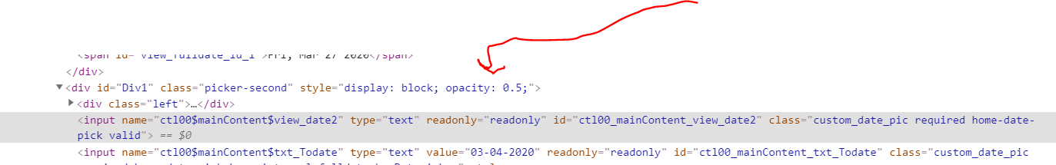

Now lets change it to round trip still without changing the inspect …we did the inspect and just switched between one way and round trip

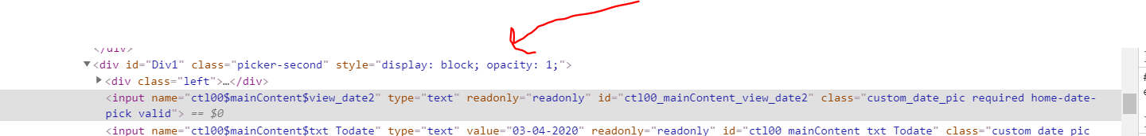

See its 1 when enabled and 0.5 when disabled. Hence we shall use get attribute to test it.

Now we will use the id and the attribute which is style to check if it is enabled or not

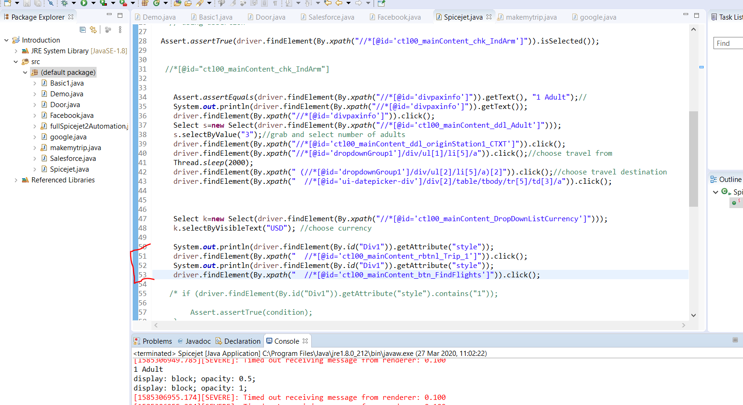

We decided to print the output here to compare the change.

Now we want to create a condition so if it is enabled or not enabled fail

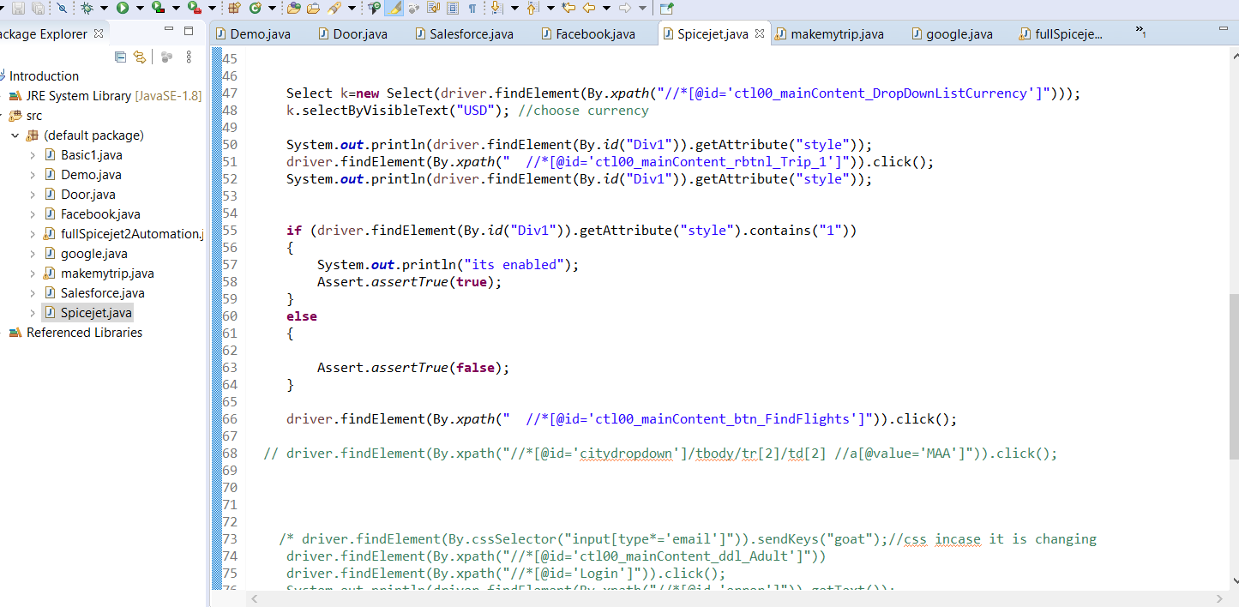

At the end of the day we deleted full automation spicejet and used just spice jet to show all

**import** org.openqa.selenium.By;

**import** org.openqa.selenium.WebDriver;

**import** org.openqa.selenium.chrome.ChromeDriver;

**import** org.openqa.selenium.support.ui.Select;

**import** org.testng.Assert;

//here we are doing dropdown

**public** **class** fullSpicejet2Automation {

**public** **static** **void** main(String[] args) **throws** InterruptedException {

// **TODO** Auto-generated method stub

System.*setProperty*("webdriver.chrome.driver", "C:\\Chrome\\chromedriver.exe");

WebDriver driver= **new** ChromeDriver();

// driver.get("http://google.com");

// driver.get("http://yahoo.com");

// driver.navigate().back();

driver.get("https://www.spicejet.com/");

/*System.out.println(driver.findElement(By.xpath("//*[@id='ctl00_mainContent_chk_IndArm']")).isSelected());

driver.findElement(By.xpath("//*[@id='ctl00_mainContent_chk_IndArm']")).click();

System.out.println(driver.findElement(By.xpath("//*[@id='ctl00_mainContent_chk_friendsandfamily']")).isSelected());

System.out.println(driver.findElements(By.xpath("//input[@type='checkbox']")).size());*/

// using assertion

Assert.*assertTrue*(driver.findElement(By.*xpath*("//*[@id='ctl00_mainContent_chk_IndArm']")).isSelected());

//*[@id="ctl00_mainContent_chk_IndArm"]

/* driver.findElement(By.xpath("//*[@id='divpaxinfo']")).click();

Select s=new Select(driver.findElement(By.xpath("//*[@id='ctl00_mainContent_ddl_Adult']")));

s.selectByValue("3");

driver.findElement(By.xpath("//*[@id='ctl00_mainContent_ddl_originStation1_CTXT']")).click();

driver.findElement(By.xpath("//*[@id='dropdownGroup1']/div/ul[1]/li[5]/a")).click();

Thread.sleep(2000);

driver.findElement(By.xpath(" (//*[@id='dropdownGroup1']/div/ul[2]/li[5]/a)[2]")).click();

// driver.findElement(By.xpath("//*[@id='citydropdown']/tbody/tr[2]/td[2] //a[@value='MAA']")).click();

/* driver.findElement(By.cssSelector("input[type*='email']")).sendKeys("goat");//css incase it is changing

driver.findElement(By.xpath("//*[@id='ctl00_mainContent_ddl_Adult']"))

driver.findElement(By.xpath("//*[@id='Login']")).click();

System.out.println(driver.findElement(By.xpath("//*[@id='error']")).getText());

// driver.findElement(By.xpath("///*[@id=\'tsf\']/div[2]/div[1]/div[2]/div[2]/div[2]/center/input[1]")).click();

/* System.out.println(driver.getCurrentUrl());

System.out.println(driver.getTitle());

System.out.println(driver.getPageSource());

Basic1 m=new Basic1();

// now after creating a method for the class to call it is

//clasobject.method name

System.out.println(m.validateheader());

driver.close();

driver.quit();*/

}

}

Now handling java Alerts.

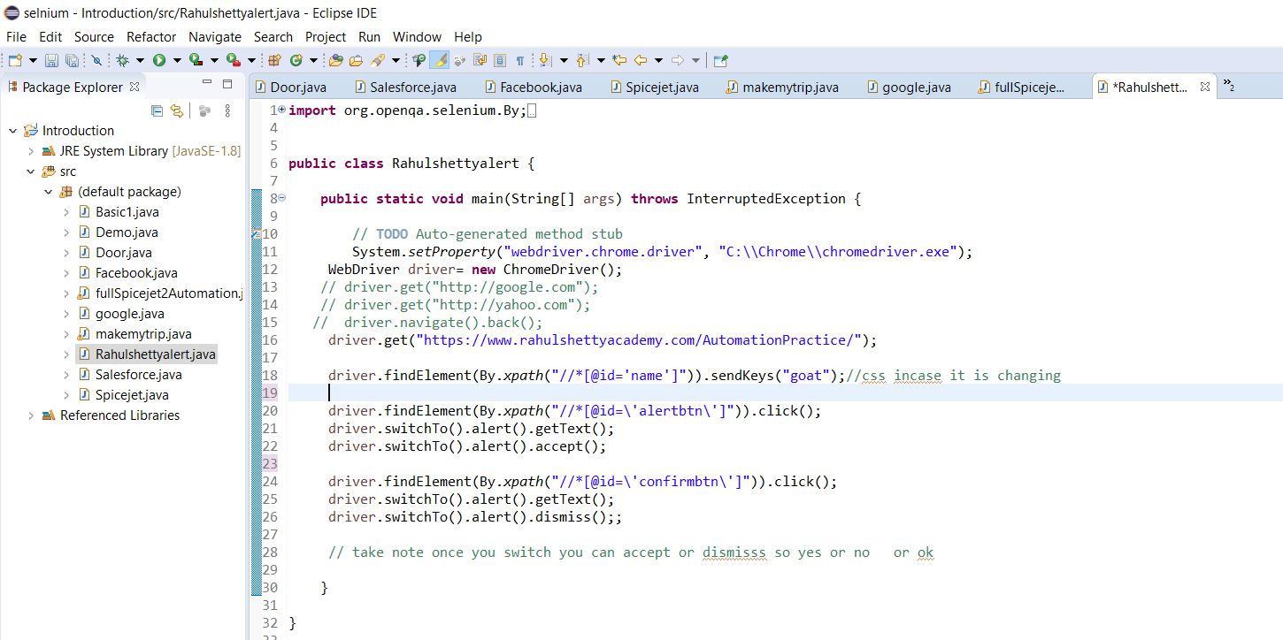

Now you have to basically switch to alert use accept or dismiss as yes or no simple

Here is the complete code

**import** org.openqa.selenium.By;

**import** org.openqa.selenium.WebDriver;

**import** org.openqa.selenium.chrome.ChromeDriver;

**public** **class** Rahulshettyalert {

**public** **static** **void** main(String[] args) **throws** InterruptedException {

// **TODO** Auto-generated method stub

System.*setProperty*("webdriver.chrome.driver", "C:\\Chrome\\chromedriver.exe");

WebDriver driver= **new** ChromeDriver();

// driver.get("http://google.com");

// driver.get("http://yahoo.com");

// driver.navigate().back();

driver.get("https://www.rahulshettyacademy.com/AutomationPractice/");

driver.findElement(By.*xpath*("//*[@id='name']")).sendKeys("goat");//css incase it is changing

driver.findElement(By.*xpath*("//*[@id=\'alertbtn\']")).click();

driver.switchTo().alert().getText();

driver.switchTo().alert().accept();

driver.findElement(By.*xpath*("//*[@id=\'confirmbtn\']")).click();

driver.switchTo().alert().getText();

driver.switchTo().alert().dismiss();;

// take note once you switch you can accept or dismisss so yes or no or ok

}

}

Autofomat a code.

After doing a code you want it to be clean so you do a control +shift +F

Now you have to follow camelCase standards

And class should start with capital Joshidemudia

Variable /methodname name always start with small leter joshTash

So before you push your code into branch for merging make sure you check it is in good format.

To debug

Right click and click debug

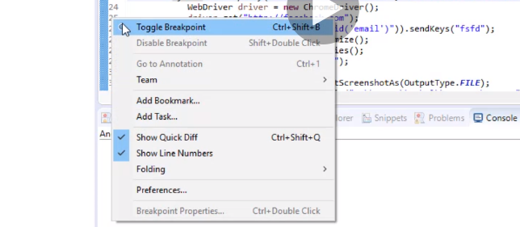

Now lets try a situation where all the products have the same name.

First thing we do, write the xpath that calls all 30 products and this is when we use find elements and list.

//div[@class='product']

Now next thing we do we save the elements in a list. Remember WebElement stores anything browser related so we have to save it to a list this time since its not just one item.

Also remember to download list and elements library.

List<WebElement> Products=driver.findElements(By.*xpath*("//div[@class='product']"));

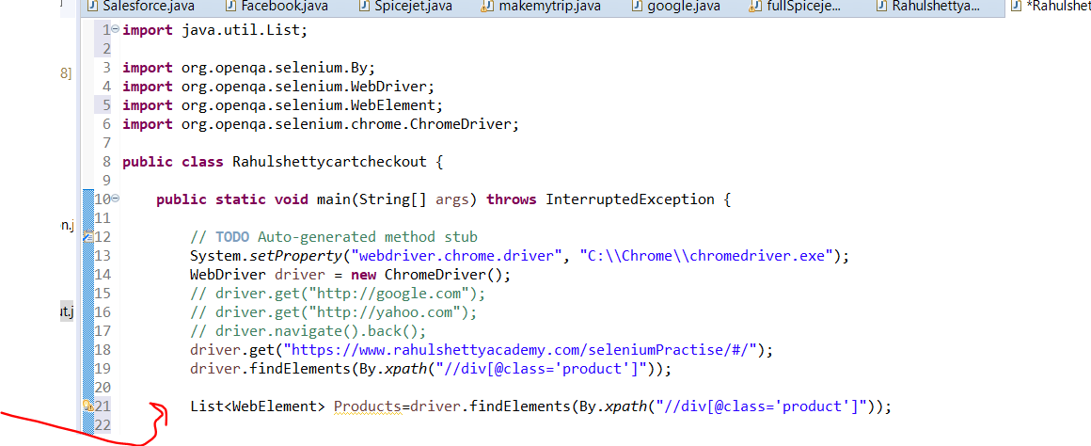

Now we do a for loop to repeat 30 times and everytime get the name of the product.

We also created a variable to handle this names.

After doing that we created condition .

**import** java.util.List;

**import** org.openqa.selenium.By;

**import** org.openqa.selenium.WebDriver;

**import** org.openqa.selenium.WebElement;

**import** org.openqa.selenium.chrome.ChromeDriver;

**public** **class** Rahulshettycartcheckout {

**public** **static** **void** main(String[] args) **throws** InterruptedException {

// **TODO** Auto-generated method stub

System.*setProperty*("webdriver.chrome.driver", "C:\\Chrome\\chromedriver.exe");

WebDriver driver = **new** ChromeDriver();

// driver.get("http://google.com");

// driver.get("http://yahoo.com");

// driver.navigate().back();

driver.get("https://www.rahulshettyacademy.com/seleniumPractise/#/");

//driver.findElements(By.xpath("//div[@class='product']"));

List<WebElement> Products=driver.findElements(By.*xpath*("//div[@class='product']"));

**for**(**int** i=0;i<Products.size();i++)

{

String name=Products.get(i).getText();

**if**(name.contains("Cucumber"))

{

driver.findElement(By.*xpath*("//div[@class='product']")).click();

**break**;

}

}

//div[@class='product']

}

}

Now if you want to click maybe broccoli or more than just the cucumber the we create array and convert it to array list

Now even if you add more vegetables to the string it appears in the list and will be treaded based on the condition

Now its also important to format your array so only the exact word shows

We use a method called split.

So broccoli-1kg if split is by(-) it divides it into two and makes broccoli the only name.

When you use split since it divides into to, u need to convert it into array string not just string anymore

We have to say name[0] means hold the first half and also we do a method called trim to remove space because if there is space in broccoli it will faill. After doing that we just create another normal string to hold the new trimmed value.

Next after the three vegetables are selected, we dnt want the code running unnecessary 30 times remember we cant use break so

We create another r variable

Int j

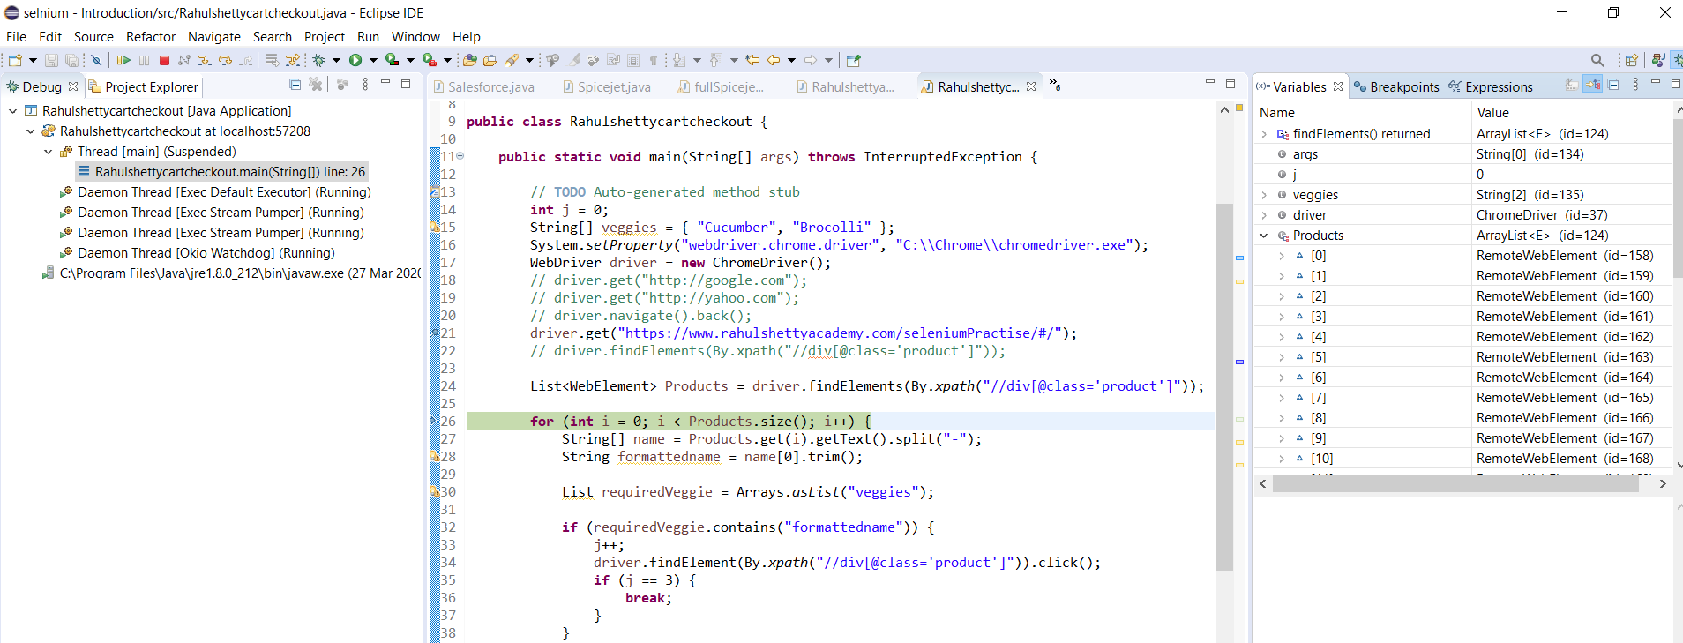

Now we are debugging. Its actually very good cos it shows you whats happening and what the variables are holding. As you can see…it pulled my products code and the list contains 30 product.

So the first Xpath copied all the product

The second xpath copied all the buttons

The condtion and variables then helped to tell selenium what to do

**import** java.util.Arrays;

**import** java.util.List;

**import** org.openqa.selenium.By;

**import** org.openqa.selenium.WebDriver;

**import** org.openqa.selenium.WebElement;

**import** org.openqa.selenium.chrome.ChromeDriver;

**public** **class** Rahulshettycartcheckout {

**public** **static** **void** main(String[] args) **throws** InterruptedException {

// **TODO** Auto-generated method stub

System.*setProperty*("webdriver.chrome.driver", "C:\\Chrome\\chromedriver.exe");

WebDriver driver = **new** ChromeDriver();

**int** j=0;

String[] itemsNeeded={"Cucumber","Brocolli","Beetroot"};

// driver.get("http://google.com");

// driver.get("http://yahoo.com");

// driver.navigate().back();

driver.get("https://www.rahulshettyacademy.com/seleniumPractise/#/");

// driver.findElements(By.xpath("//div[@class='product']"));

List<WebElement> Products = driver.findElements(By.*cssSelector*("h4.product-name"));

**for** (**int** i = 0;i<Products.size();i++)

{

String[] name=Products.get(i).getText().split("-");

String formattedName=name[0].trim();

List itemsNeededList = Arrays.*asList*(formattedName);

**if** (itemsNeededList.contains(formattedName)) {

j++;

driver.findElement(By.*xpath*("//button[text()='ADD TO CART']")).click();

**if** (j == 3) {

**break**;

}

}

}

// div[@class='product']

}

}

Instead of j==3 another way is

**if** (j == itemsNeeded.length)

also now when we used add by text it selects the wrong vegetable because once it clicks on something it becomes added and disappears so the index is wrong.

So instead we used the parent and transversed to the child infact it was wrong the first one. Below is the correct code

**import** java.util.Arrays;

**import** java.util.List;

**import** org.openqa.selenium.By;

**import** org.openqa.selenium.WebDriver;

**import** org.openqa.selenium.WebElement;

**import** org.openqa.selenium.chrome.ChromeDriver;

**public** **class** Rahulshettycartcheckout {

**public** **static** **void** main(String[] args) **throws** InterruptedException {

// **TODO** Auto-generated method stub

System.*setProperty*("webdriver.chrome.driver", "C:\\Chrome\\chromedriver.exe");

WebDriver driver = **new** ChromeDriver();

**int** j=0;

String[] itemsNeeded={"Cucumber","Brocolli","Beetroot","Carrot"};

// driver.get("http://google.com");

// driver.get("http://yahoo.com");

// driver.navigate().back();

driver.get("https://www.rahulshettyacademy.com/seleniumPractise/#/");

// driver.findElements(By.xpath("//div[@class='product']"));

Thread.*sleep*(3000);

List<WebElement> Products = driver.findElements(By.*xpath*("// div[@class='product']"));

**for** (**int** i = 0;i<Products.size();i++)

{

String[] name=Products.get(i).getText().split("-");

String formattedName=name[0].trim();

List itemsNeededList = Arrays.*asList*(itemsNeeded);

**if** (itemsNeededList.contains(formattedName)) {

j++;

driver.findElements(By.*xpath*("//div[@class='product-action']/button")).get(i).click();

**if** (j == itemsNeeded.length) {

**break**;

}

}

}

//*[@id='root']/div/div[1]/div/div[1]/div[3]/button

//button[text()='ADD TO CART']

//div[@class='product-action']/button

// div[@class='product']

}

}

We didn’t really need the thread.sleeep



Synchronization in selenium…….

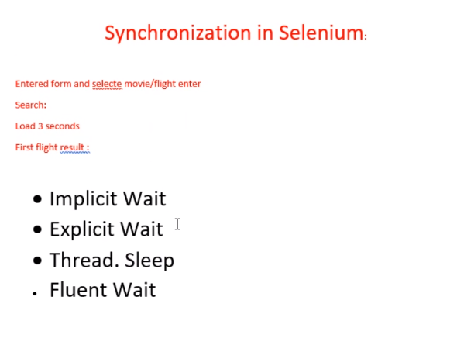

Implicit wait: you define this at the top after you set your chrome driver….3 sec is ideal time

So you do this on a gloabal level before throwing any exception.

So after clicking it will wait for the dom for 3 seconds…. Now if it finds it in one seconds it will come out of the wait and start working.

Explicit wait…its not global it can target a specific element. In the real world u can combine both.

Thread.sleep: this is java sleep. it doesn’t listen to dom and it doesn’t come out till after 5 secs. It just holds it. This is why thread.sleep should not be used. Can be used for quick check and pass

Now we created shetywait class for this. Also to declare reusable methods it has to be outside the main method

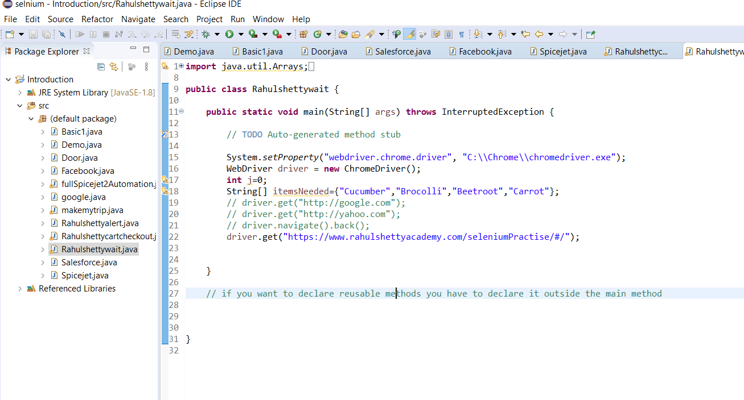

Now here we are making the code cleaner

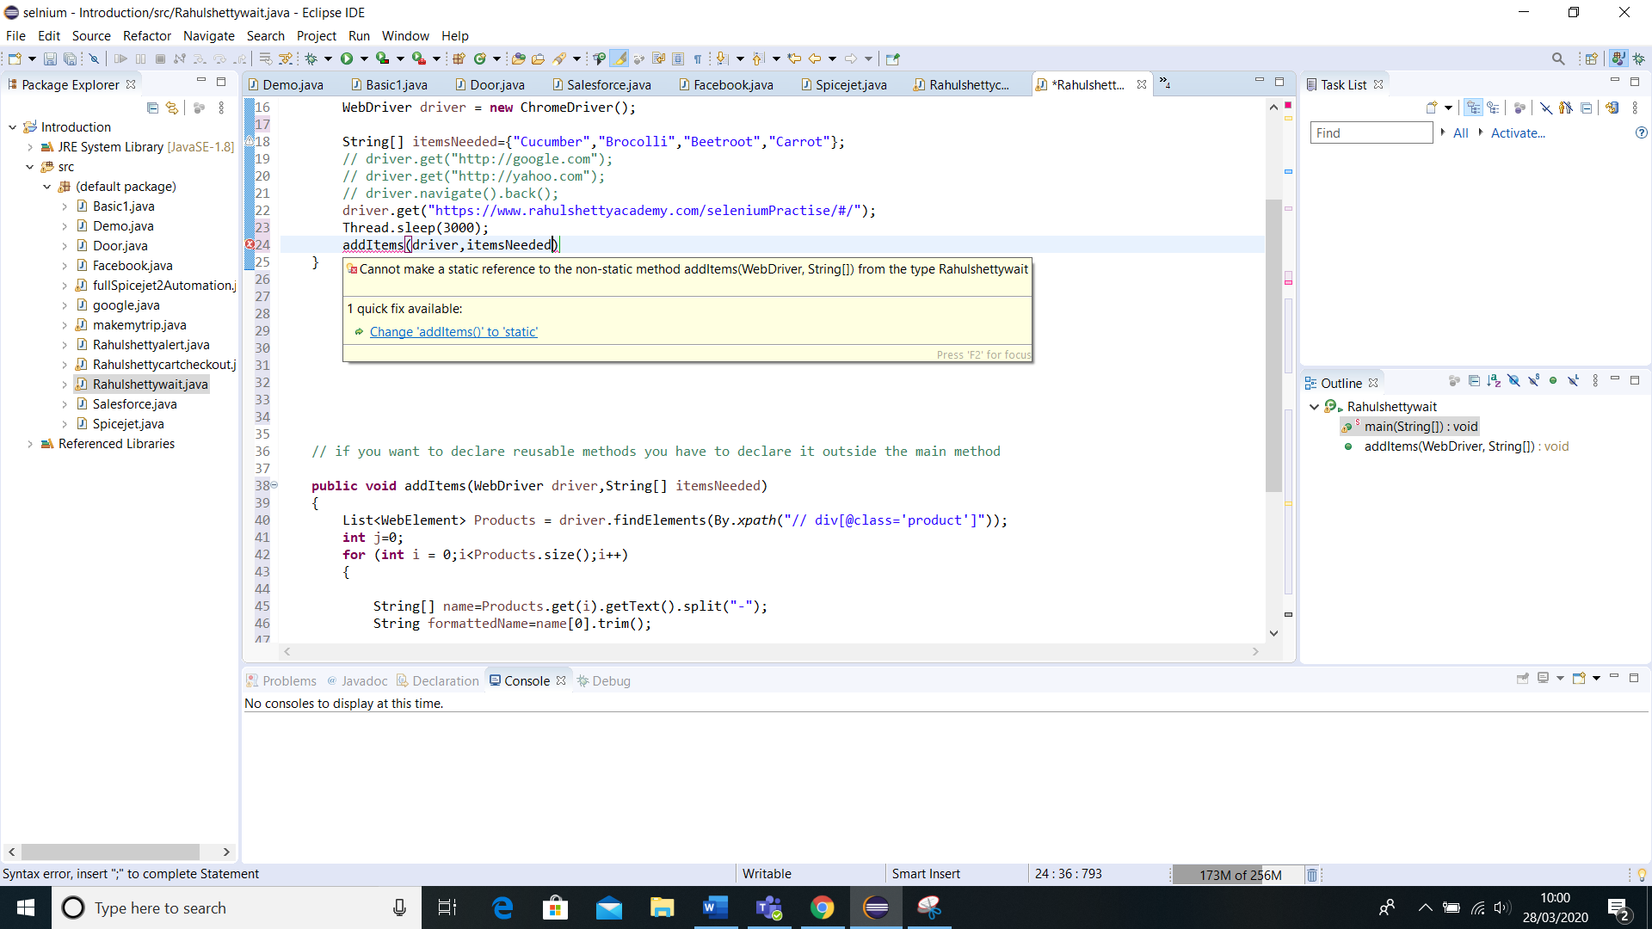

If a method is static you can access the method without creating an object

Just extra note of writing xpath with text

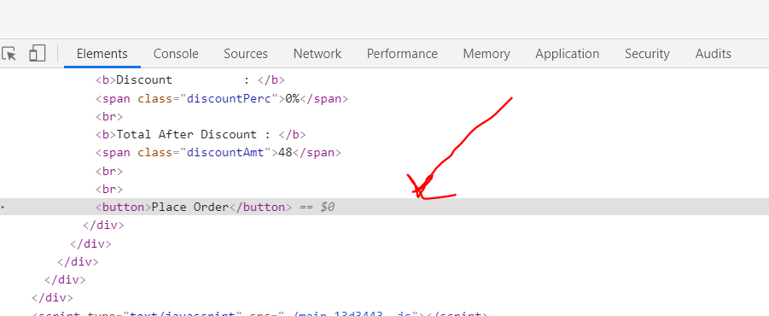

//button[text()='Place Order']

Why is it if we used the rahulshettycardclass we only select one item but when we refactore it we got everything with rahulwait??

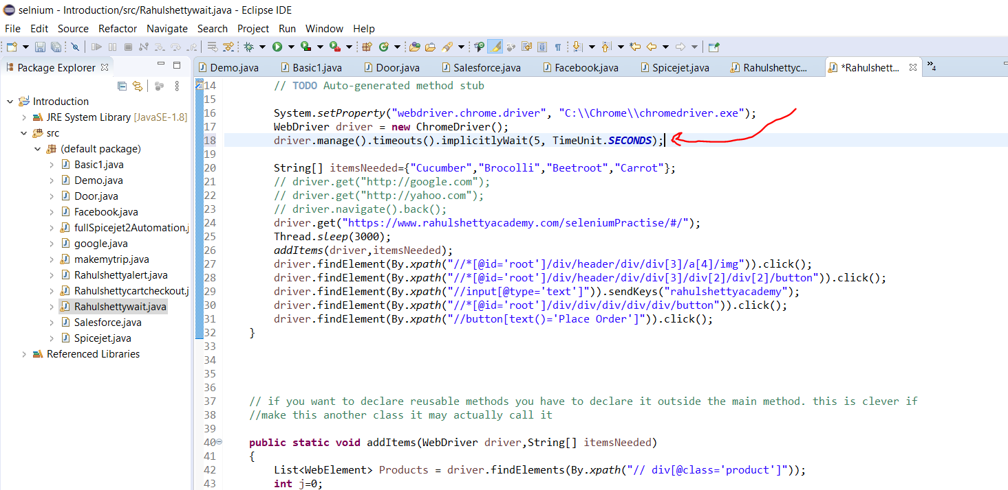

Implicit wait as seen above

Take note, when you check the xpath….it actually gives you the css at the bottom

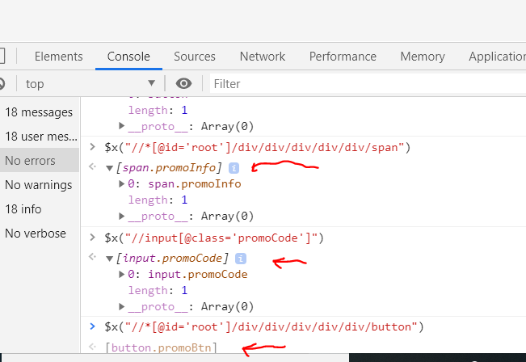

Using css

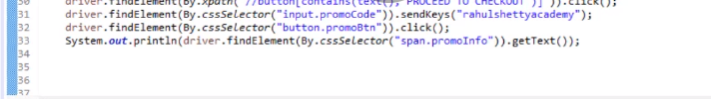

You have to be very careful sometimes the code is not wrong but it just doesn’t work hence maybe why cssSelector may come in useful

**import** java.util.Arrays;

**import** java.util.List;

**import** java.util.concurrent.TimeUnit;

**import** org.openqa.selenium.By;

**import** org.openqa.selenium.WebDriver;

**import** org.openqa.selenium.WebElement;

**import** org.openqa.selenium.chrome.ChromeDriver;

**public** **class** Rahulshettywait {// we have cleaned the rahulshettycart card and now applying waits

**public** **static** **void** main(String[] args) **throws** InterruptedException {

// **TODO** Auto-generated method stub

System.*setProperty*("webdriver.chrome.driver", "C:\\Chrome\\chromedriver.exe");

WebDriver driver = **new** ChromeDriver();

driver.manage().timeouts().implicitlyWait(5, TimeUnit.***SECONDS***);

String[] itemsNeeded={"Cucumber","Brocolli","Beetroot","Carrot"};

// driver.get("http://google.com");

// driver.get("http://yahoo.com");

// driver.navigate().back();

driver.get("https://www.rahulshettyacademy.com/seleniumPractise/#/");

//Thread.sleep(3000);

*addItems*(driver,itemsNeeded);

driver.findElement(By.*xpath*("//*[@id='root']/div/header/div/div[3]/a[4]/img")).click();

driver.findElement(By.*xpath*("//*[@id='root']/div/header/div/div[3]/div[2]/div[2]/button")).click();

driver.findElement(By.*xpath*("//input[@class='promoCode']")).sendKeys("rahulshettyacademy");

driver.findElement(By.*cssSelector*("button.promoBtn")).click();

System.***out***.println(driver.findElement(By.*cssSelector*("span.promoInfo")).getText());

driver.findElement(By.*xpath*("//button[text()='Place Order']")).click();

}

// if you want to declare reusable methods you have to declare it outside the main method. this is clever if

//make this another class it may actually call it

**public** **static** **void** addItems(WebDriver driver,String[] itemsNeeded)

{

List<WebElement> Products = driver.findElements(By.*xpath*("// div[@class='product']"));

**int** j=0;

**for** (**int** i = 0;i<Products.size();i++)

{

String[] name=Products.get(i).getText().split("-");

String formattedName=name[0].trim();

List itemsNeededList = Arrays.*asList*(itemsNeeded);

**if** (itemsNeededList.contains(formattedName)) {

j++;

driver.findElements(By.*xpath*("//div[@class='product-action']/button")).get(i).click();

**if** (j == itemsNeeded.length) {

**break**;

}

}

}

}

}

Now with explicit wait

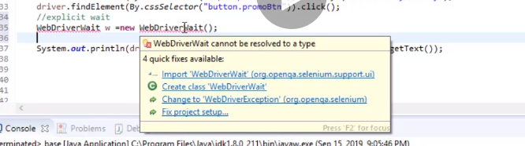

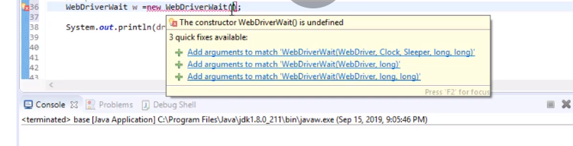

Two arguments, driver and seconds to wait.



Obviously add;

Take note this is a locator

By.*cssSelector*("span.promoInfo")

This is web element

driver.findElement(By.*cssSelector*("span.promoInfo"))

now we commented out the implicit wait and have now used explicit wait as below

**import** java.util.Arrays;

**import** java.util.List;

**import** java.util.concurrent.TimeUnit;

**import** org.openqa.selenium.By;

**import** org.openqa.selenium.WebDriver;

**import** org.openqa.selenium.WebElement;

**import** org.openqa.selenium.chrome.ChromeDriver;

**import** org.openqa.selenium.support.ui.ExpectedConditions;

**import** org.openqa.selenium.support.ui.WebDriverWait;

**public** **class** Rahulshettywait {// we have cleaned the rahulshettycart card and now applying waits

**public** **static** **void** main(String[] args) **throws** InterruptedException {

// **TODO** Auto-generated method stub

System.*setProperty*("webdriver.chrome.driver", "C:\\Chrome\\chromedriver.exe");

WebDriver driver = **new** ChromeDriver();

//driver.manage().timeouts().implicitlyWait(5, TimeUnit.SECONDS);

WebDriverWait w=**new** WebDriverWait(driver, 5);

String[] itemsNeeded={"Cucumber","Brocolli","Beetroot","Carrot"};

// driver.get("http://google.com");

// driver.get("http://yahoo.com");

// driver.navigate().back();

driver.get("https://www.rahulshettyacademy.com/seleniumPractise/#/");

//Thread.sleep(3000);

*addItems*(driver,itemsNeeded);

driver.findElement(By.*xpath*("//*[@id='root']/div/header/div/div[3]/a[4]/img")).click();

driver.findElement(By.*xpath*("//*[@id='root']/div/header/div/div[3]/div[2]/div[2]/button")).click();

w.until(ExpectedConditions.*visibilityOfElementLocated*(By.*xpath*("//input[@class='promoCode']")));

driver.findElement(By.*xpath*("//input[@class='promoCode']")).sendKeys("rahulshettyacademy");

driver.findElement(By.*cssSelector*("button.promoBtn")).click();

w.until(ExpectedConditions.*visibilityOfElementLocated*(By.*cssSelector*("span.promoInfo")));

System.***out***.println(driver.findElement(By.*cssSelector*("span.promoInfo")).getText());

driver.findElement(By.*xpath*("//button[text()='Place Order']")).click();

}

// if you want to declare reusable methods you have to declare it outside the main method. this is clever if

//make this another class it may actually call it

**public** **static** **void** addItems(WebDriver driver,String[] itemsNeeded)

{

List<WebElement> Products = driver.findElements(By.*xpath*("// div[@class='product']"));

**int** j=0;

**for** (**int** i = 0;i<Products.size();i++)

{

String[] name=Products.get(i).getText().split("-");

String formattedName=name[0].trim();

List itemsNeededList = Arrays.*asList*(itemsNeeded);

**if** (itemsNeededList.contains(formattedName)) {

j++;

driver.findElements(By.*xpath*("//div[@class='product-action']/button")).get(i).click();

**if** (j == itemsNeeded.length) {

**break**;

}

}

}

}

}

Fluent wait

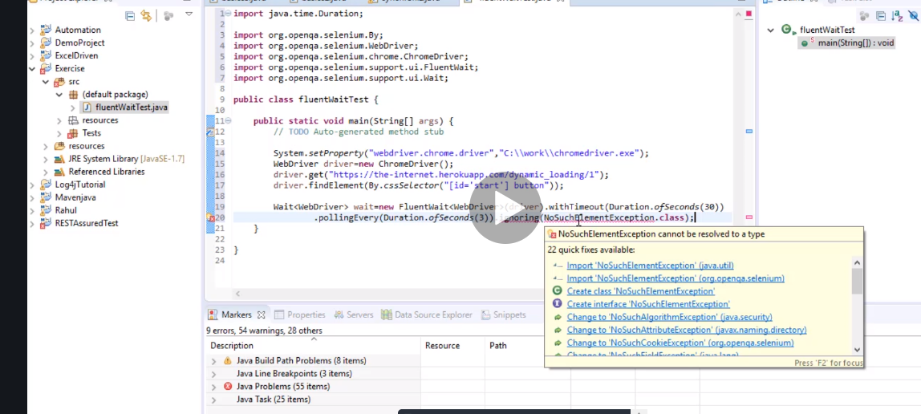

So what fluent wait does, it has 30 sec…if you poll for 3 sec it means every 3 sec it checks if your element has arrived after 30 sec then it ends basically. It just checks every 3 seconds within 30 sec so 10 times.

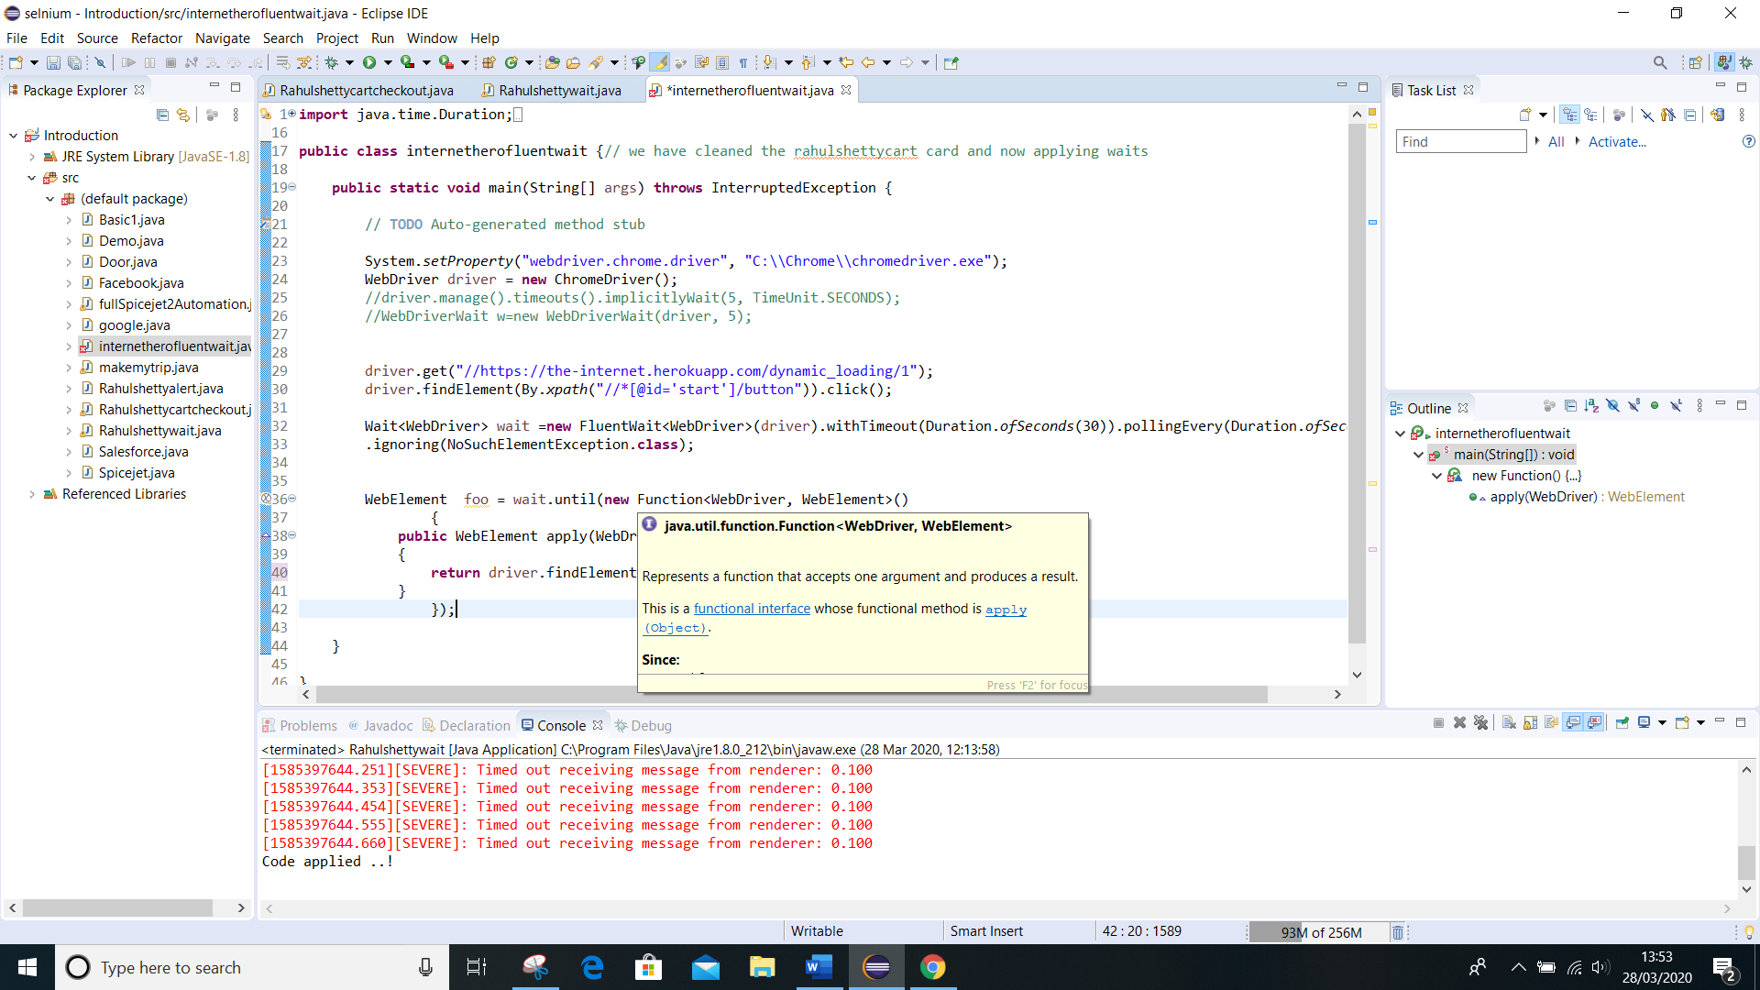

Import that

With fluent wait its good to write it as a loop

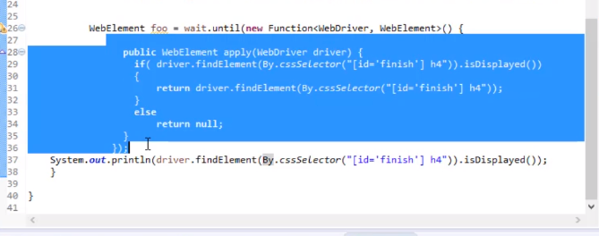

You have to design it yourself.

# Action class

Notice how chrome does css for us

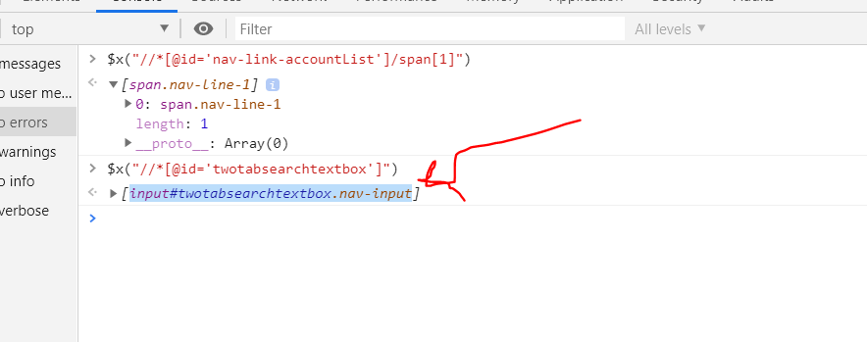

Just remove the square brackets

input#twotabsearchtextbox.nav-input

just copy and paste in your double bracket. Bingo

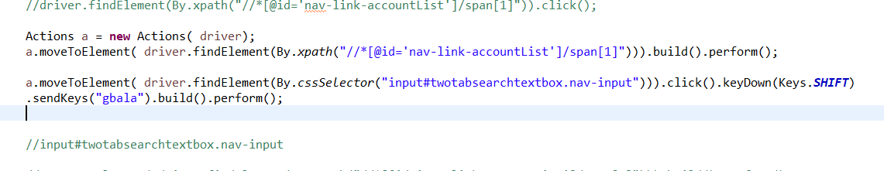

Handling multiple windows using facebook class

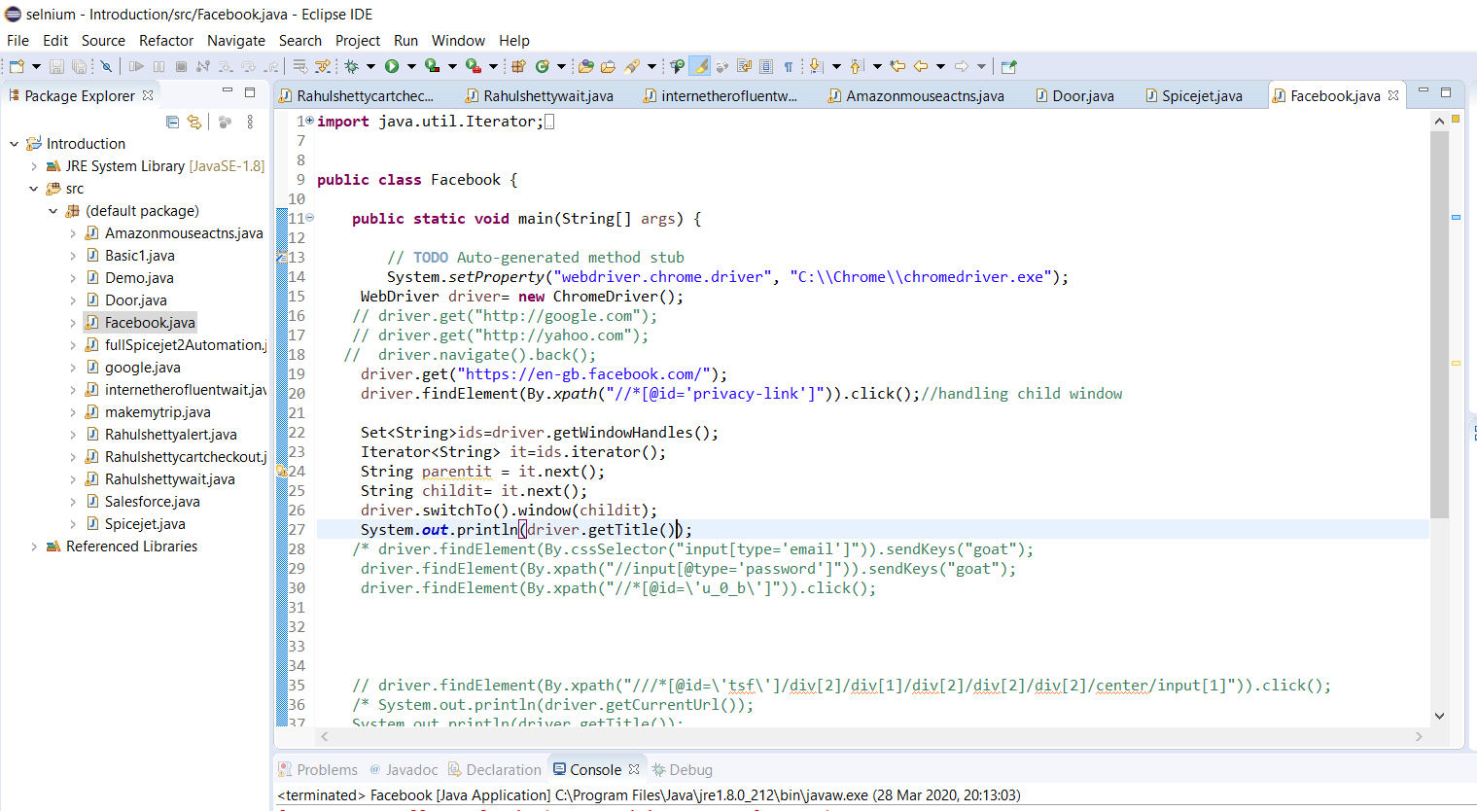

This is the code

**import** java.util.Iterator;

**import** java.util.Set;

**import** org.openqa.selenium.By;

**import** org.openqa.selenium.WebDriver;

**import** org.openqa.selenium.chrome.ChromeDriver;

**public** **class** Facebook {

**public** **static** **void** main(String[] args) {

// **TODO** Auto-generated method stub

System.*setProperty*("webdriver.chrome.driver", "C:\\Chrome\\chromedriver.exe");

WebDriver driver= **new** ChromeDriver();

// driver.get("http://google.com");

// driver.get("http://yahoo.com");

// driver.navigate().back();

driver.get("https://en-gb.facebook.com/");

driver.findElement(By.*xpath*("//*[@id='privacy-link']")).click();//handling child window

Set<String>ids=driver.getWindowHandles();

Iterator<String> it=ids.iterator();

String parentit = it.next();

String childit= it.next();

driver.switchTo().window(childit);

System.***out***.println(driver.getTitle());

/* driver.findElement(By.cssSelector("input[type='email']")).sendKeys("goat");

driver.findElement(By.xpath("//input[@type='password']")).sendKeys("goat");

driver.findElement(By.xpath("//*[@id=\'u_0_b\']")).click();

// driver.findElement(By.xpath("///*[@id=\'tsf\']/div[2]/div[1]/div[2]/div[2]/div[2]/center/input[1]")).click();

/* System.out.println(driver.getCurrentUrl());

System.out.println(driver.getTitle());

System.out.println(driver.getPageSource());

Basic1 m=new Basic1();

// now after creating a method for the class to call it is

//clasobject.method name

System.out.println(m.validateheader());

driver.close();

driver.quit();*/

}

}

Now how to handle frames.

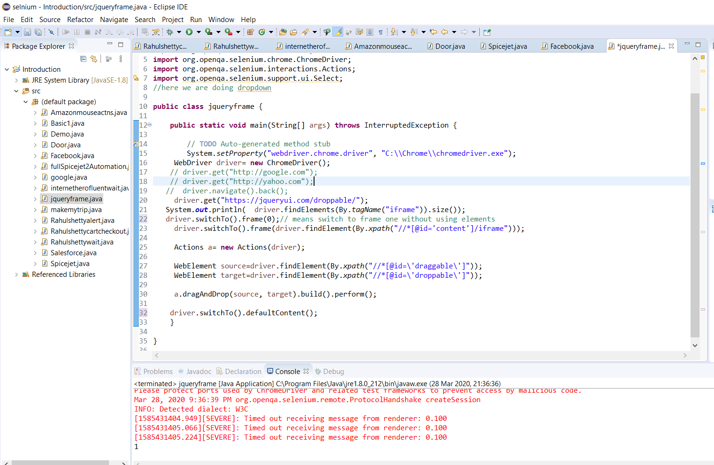

You can also switch to frame index 1 or 0 ….instead of using element. Just do findelelemnts with tgname frames and get size. Its added in the code. Remember to swtch back to window…default content.

Code for handling frame

**import** org.openqa.selenium.By;

**import** org.openqa.selenium.Keys;

**import** org.openqa.selenium.WebDriver;

**import** org.openqa.selenium.WebElement;

**import** org.openqa.selenium.chrome.ChromeDriver;

**import** org.openqa.selenium.interactions.Actions;

**import** org.openqa.selenium.support.ui.Select;

//here we are doing dropdown

**public** **class** jqueryframe {

**public** **static** **void** main(String[] args) **throws** InterruptedException {

// **TODO** Auto-generated method stub

System.*setProperty*("webdriver.chrome.driver", "C:\\Chrome\\chromedriver.exe");

WebDriver driver= **new** ChromeDriver();

// driver.get("http://google.com");

// driver.get("http://yahoo.com");

// driver.navigate().back();

driver.get("https://jqueryui.com/droppable/");

System.***out***.println( driver.findElements(By.*tagName*("iframe")).size());

driver.switchTo().frame(0);// means switch to frame one without using elements

driver.switchTo().frame(driver.findElement(By.*xpath*("//*[@id='content']/iframe")));

Actions a= **new** Actions(driver);

WebElement source=driver.findElement(By.*xpath*("//*[@id=\'draggable\']"));

WebElement target=driver.findElement(By.*xpath*("//*[@id=\'droppable\']"));

a.dragAndDrop(source, target).build().perform();

driver.switchTo().defaultContent();

}

}

Stilldnt understand how to find it this way

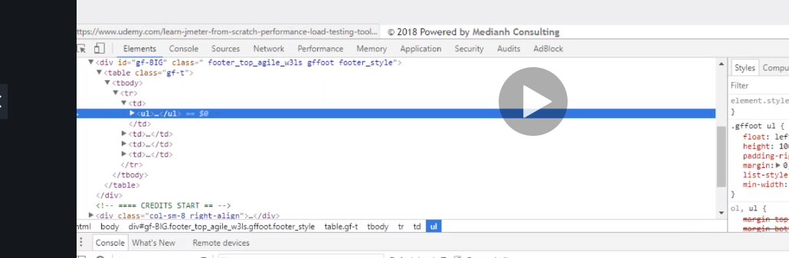

//*[@id='gf-BIG']/table/tbody/tr/td[1]/ul

Here we are taking portion of the webpage and finding element from a portion of the driver by storing them in variables

import org.openqa.selenium.By;

import org.openqa.selenium.Keys;

import org.openqa.selenium.WebDriver;

import org.openqa.selenium.WebElement;

import org.openqa.selenium.chrome.ChromeDriver;

//this involves counting a specific area on the webpage.limiting webdriver scope by selecting an area

public class Countlinks {

public static void main(String[] args) throws InterruptedException {

// TODO Auto-generated method stub

System.setProperty("webdriver.chrome.driver", "C:\\Chrome\\chromedriver.exe");

WebDriver driver= new ChromeDriver();

driver.get("https://www.rahulshettyacademy.com/AutomationPractice/");

System.out.println(driver.findElements(By.tagName("a")).size());

WebElement bottomLinks= driver.findElement(By.xpath("//*[@id='gf-BIG']"));

System.out.println(bottomLinks.findElements(By.tagName("a")).size());

WebElement columnLinks= driver.findElement(By.xpath("//*[@id='gf-BIG']/table/tbody/tr/td[1]/ul"));

System.out.println(bottomLinks.findElements(By.tagName("a")).size());

}

}

Note

cTL+ click opens things in new tab

now we want to click all links and grab all the titles of the link

**import** java.util.Iterator;

**import** java.util.Set;

**import** org.openqa.selenium.By;

**import** org.openqa.selenium.Keys;

**import** org.openqa.selenium.WebDriver;

**import** org.openqa.selenium.WebElement;

**import** org.openqa.selenium.chrome.ChromeDriver;

//this involves counting a specific area on the webpage.limiting webdriver scope by selecting an area

**public** **class** Countlinks {

**public** **static** **void** main(String[] args) **throws** InterruptedException {

// **TODO** Auto-generated method stub

System.*setProperty*("webdriver.chrome.driver", "C:\\Chrome\\chromedriver.exe");

WebDriver driver= **new** ChromeDriver();

driver.get("https://www.rahulshettyacademy.com/AutomationPractice/");

System.***out***.println(driver.findElements(By.*tagName*("a")).size());

WebElement bottomLinks= driver.findElement(By.*xpath*("//*[@id='gf-BIG']"));

System.***out***.println(bottomLinks.findElements(By.*tagName*("a")).size());

WebElement columnLinks= driver.findElement(By.*xpath*("//*[@id='gf-BIG']/table/tbody/tr/td[1]/ul"));

System.***out***.println(columnLinks.findElements(By.*tagName*("a")).size());

// now we want to click all 5 links and grab their names/title page

**for**(**int** i=1;i<columnLinks.findElements(By.*tagName*("a")).size();i++)

{

String clicklink = Keys.*chord*(Keys.***CONTROL***,Keys.***ENTER***);

columnLinks.findElements(By.*tagName*("a")).get(i).sendKeys(clicklink);

}

//get handler for the chrome pages

Set<String> swtch= driver.getWindowHandles();

Iterator<String> cazoo=swtch.iterator();

**while**(cazoo.hasNext())

{

driver.switchTo().window(cazoo.next());

System.***out***.println(driver.getTitle());

}

}

}

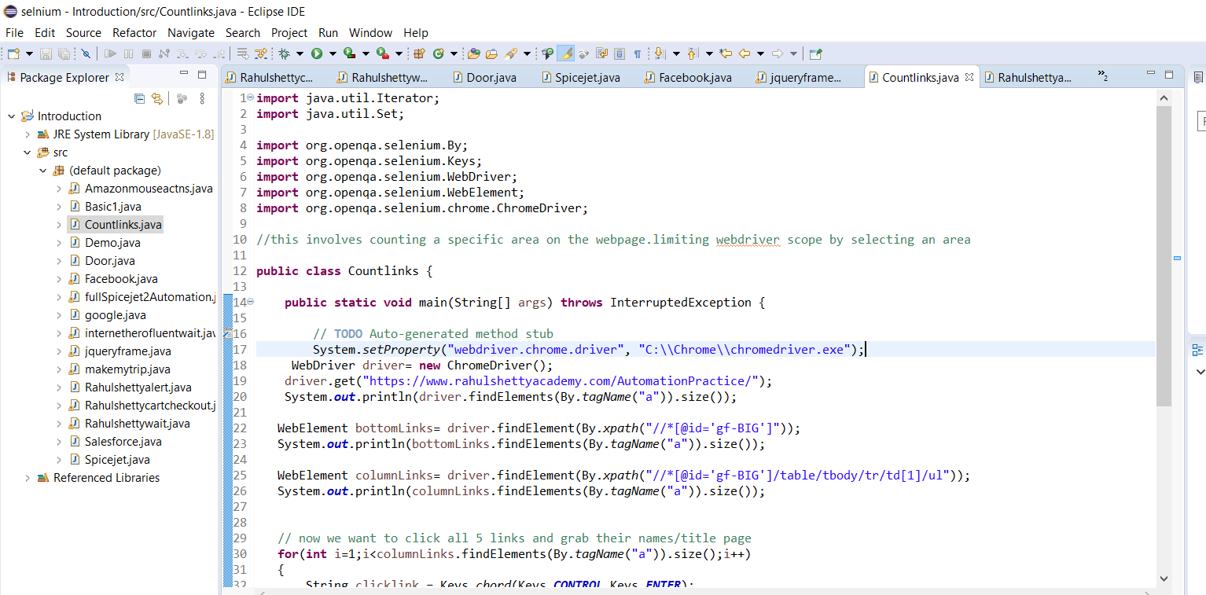

Just extra note

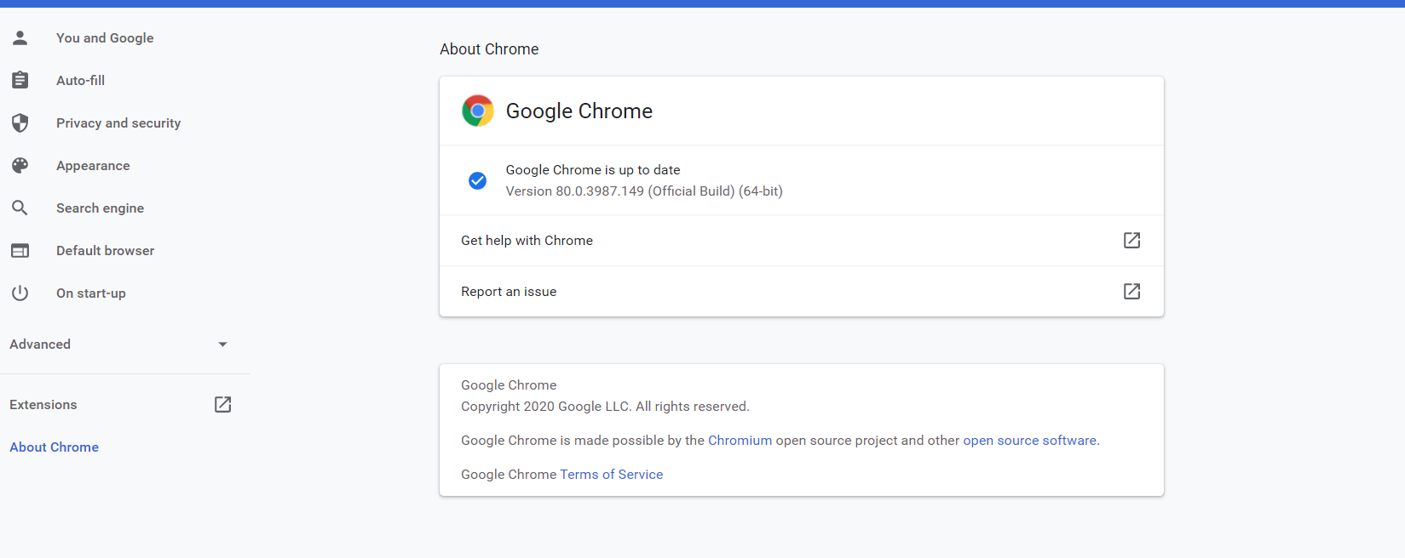

Now we will create another path2usa

Now for date we use contain to get every element belonging to that class

//td[contains(@class,'day')]

if you select i=2 it will only return 2 but if u make it i...it returns all. so if you want to select2 this is how

to do it

remember i=0 index is 0 which means start from 0. Also you can extract text b tagname(tr)

**import** java.util.Iterator;

**import** java.util.List;

**import** java.util.Set;

**import** org.openqa.selenium.By;

**import** org.openqa.selenium.Keys;

**import** org.openqa.selenium.WebDriver;

**import** org.openqa.selenium.WebElement;

**import** org.openqa.selenium.chrome.ChromeDriver;

//this involves counting a specific area on the webpage.limiting webdriver scope by selecting an area

**public** **class** Path2usa {

**public** **static** **void** main(String[] args) {

// **TODO** Auto-generated method stub

System.*setProperty*("webdriver.chrome.driver", "C:\\Chrome\\chromedriver.exe");

WebDriver driver= **new** ChromeDriver();

driver.get("https://www.path2usa.com/travel-companions");

driver.findElement(By.*xpath*("//*[@id='travel_date']")).click();

//we want to take the dates into one list

List<WebElement> dates=driver.findElements(By.*className*("day"));

//or you can use this //td[contains(@class,'day')] or

//System.out.println(dates.size());

//or int count1=dates.size();

**int** count=driver.findElements(By.*className*("day")).size();

**for**(**int** i=0;i<count;i++)

{

//if you select i=2 it will only return 2 but if u make it i...it returns all. so if you want to select2 this is how

//to do it

String text=driver.findElements(By.*className*("day")).get(i).getText();

**if**(text.equalsIgnoreCase("30"))

{

driver.findElements(By.*className*("day")).get(i).click();

**break**;

}

}

Take note about while loop….

While(true)

{

}

It will continur to loop till the condition becomes false. So once condition is true …it goes in and continues till condition is false.

Unlike for loop you use a break and you tell it how many times to run.

Hence we use!

While(! Means make a false condtion true in order to go into the bracket)

{

}

**import** java.util.Iterator;

**import** java.util.List;

**import** java.util.Set;

**import** org.openqa.selenium.By;

**import** org.openqa.selenium.Keys;

**import** org.openqa.selenium.WebDriver;

**import** org.openqa.selenium.WebElement;

**import** org.openqa.selenium.chrome.ChromeDriver;

//this involves counting a specific area on the webpage.limiting webdriver scope by selecting an area

**public** **class** Path2usa {

**public** **static** **void** main(String[] args) **throws** InterruptedException {

// **TODO** Auto-generated method stub

System.*setProperty*("webdriver.chrome.driver", "C:\\Chrome\\chromedriver.exe");

WebDriver driver= **new** ChromeDriver();

driver.get("https://www.path2usa.com/travel-companions");

driver.findElement(By.*xpath*("//*[@id='travel_date']")).click();

//we want to take the dates into one list

List<WebElement> dates=driver.findElements(By.*xpath*("//td[contains(@class,'day')]"));

// ! thats just crazy make a false true...now we check if the date is december obivously we know its not its actually

//march but the ! makes it true and when it is actually true it becomes false amazing it then selects december

//

**while**(!driver.findElement(By.*xpath*(" /html/body/div[4]/div[1]/table/thead/tr[1]/th[2]")).getText().contains("December"))

{

driver.findElement(By.*xpath*("/html/body/div[4]/div[1]/table/thead/tr[1]/th[3]")).click();

}

//

//System.out.println(dates.size());

//or int count1=dates.size();

**int** count=driver.findElements(By.*xpath*("//td[contains(@class,'day')]")).size();

**for**(**int** i=0;i<count;i++)

{

//if you select i=2 it will only return 2 but if u make it i...it returns all. so if you want to select2 this is how

//to do it

String text=driver.findElements(By.*xpath*("//td[contains(@class,'day')]")).get(i).getText();

**if**(text.equalsIgnoreCase("30"))

{

driver.findElements(By.*xpath*("//td[contains(@class,'day')]")).get(i).click();

**break**;

}

}

}

}

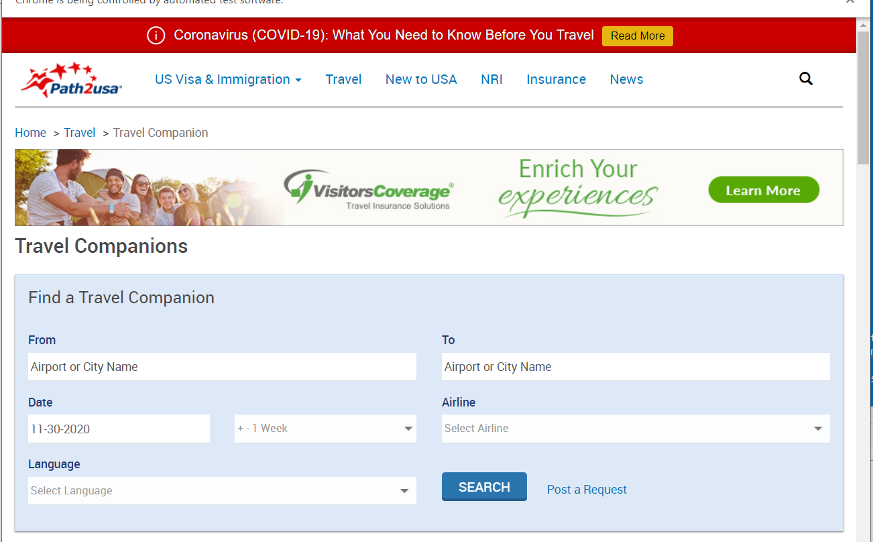

Now we are starting with handling tables

We create a new class called cricbuzz for handling tables

Take note

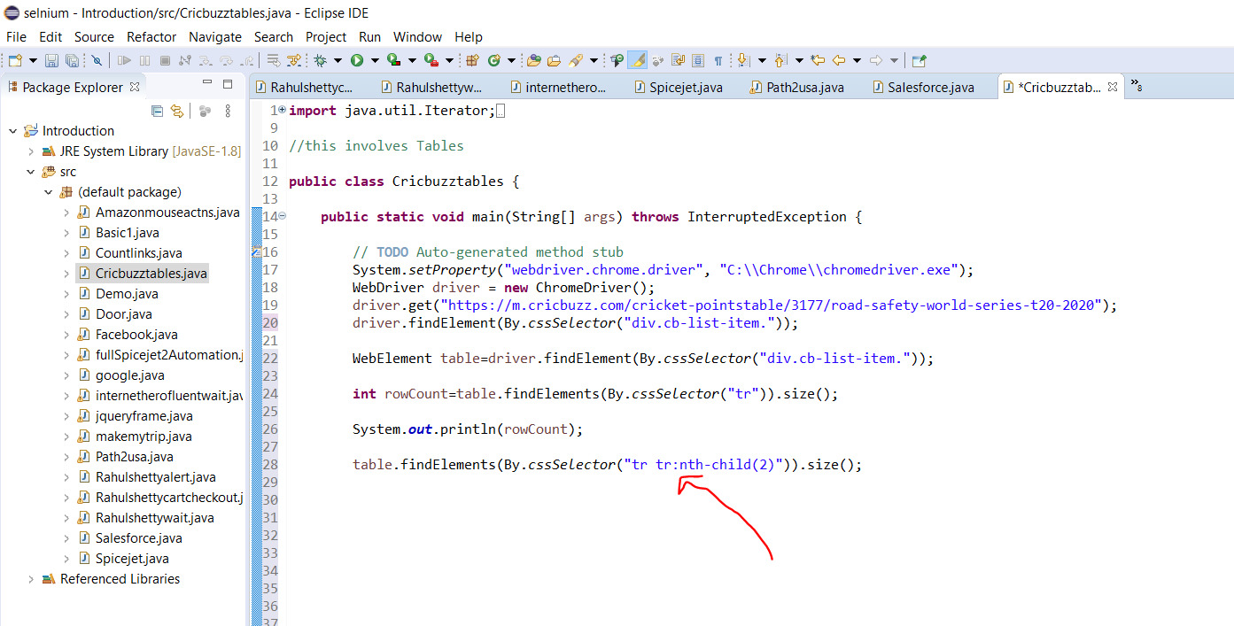

We used css to grab a parent css with children so basically we grabbed a role and in order to select a number in the role we did (parent ccs go in and grab child). That’s it

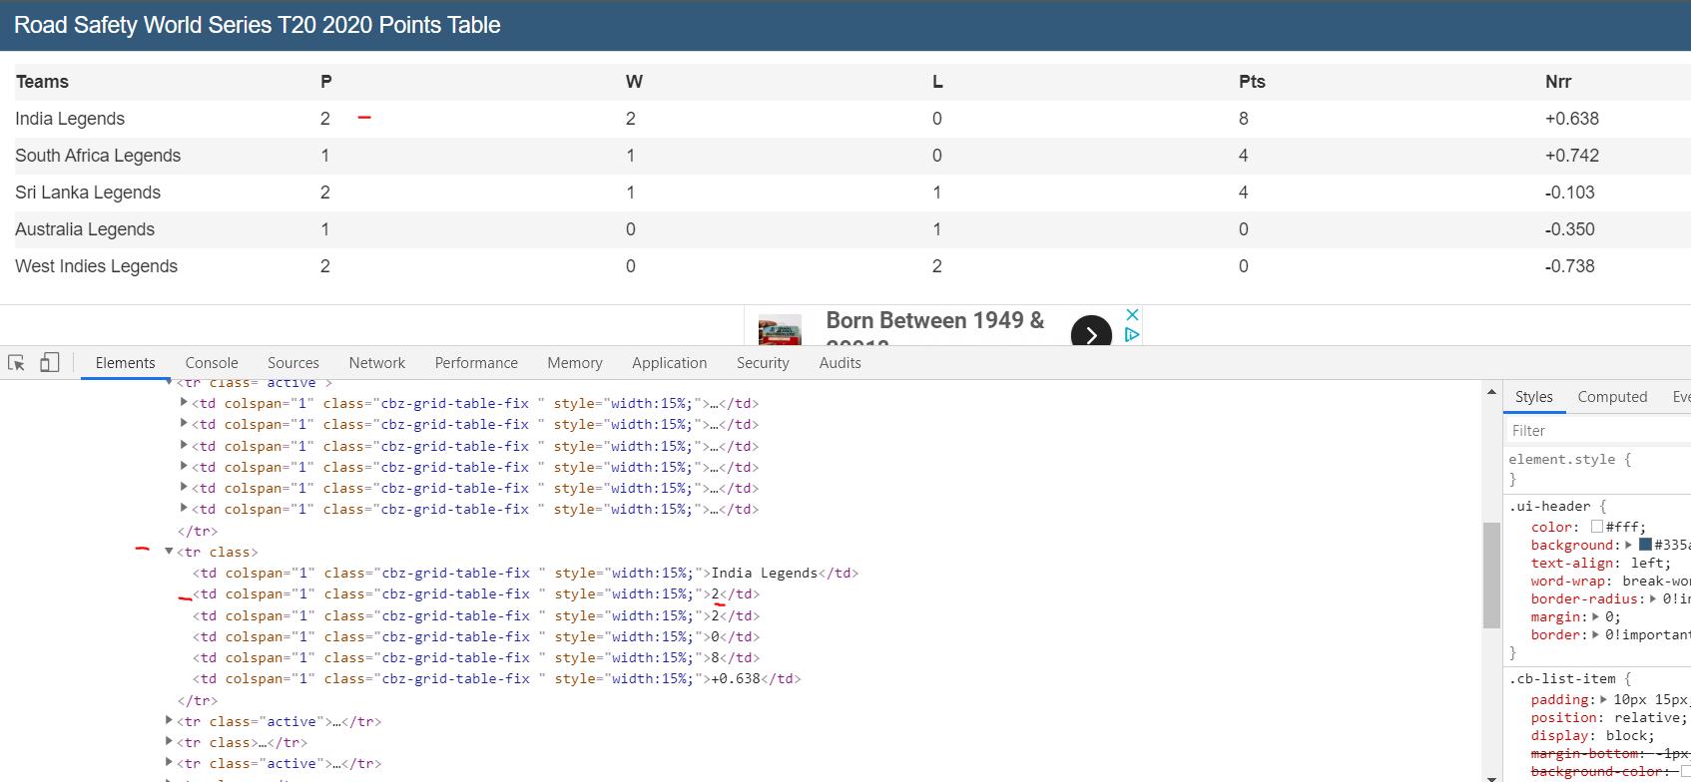

Now take note of what we are doing here.

We want to get all the numbers in the p column.

First we grab the whole table element

Second we try to find out what all 6 columns have in common…I had to hustle it to luckily just fine it

//*[@id="top"]/div/div[5]/div/div/div/div/div/table/tbody/tr[5]

By trial by error I just kept deleting what I thought should help and luckily I found it

//*[@id='top']/div/div[5]/div/div/div/div/div/table/tbody/tr

For cssSelector- tr.active

Then we use ccs to do something…. We dnt want to click it or nothing all we want to say is….for every column…go to the column that has p….take the index and get me the text.

Now if u want to see 6 and u see 7….in the for loop u can use column-1…it will remove the last one and also since P is the 0 index… int i=1 should equal 1 making it 2

We will come back to tables I didn’t get this

<https://www.youtube.com/watch?v=xi7oibukBJE>

finally did it but still need to get back to it

yes back to tabs now first look at the dom

note first you only care about the down arrows. Find the parent like the real root parent and start travelling down form there. Do an expert that lands you there, then use / to fo down the down arrows till you meet your requirement

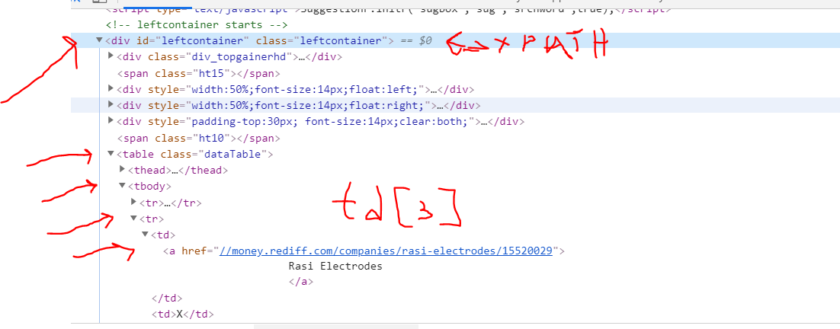

("//*[@id='leftcontainer']/table/tbody/tr/td[3]

Another example using text xpath to find an extra css to add to the list in order to add it

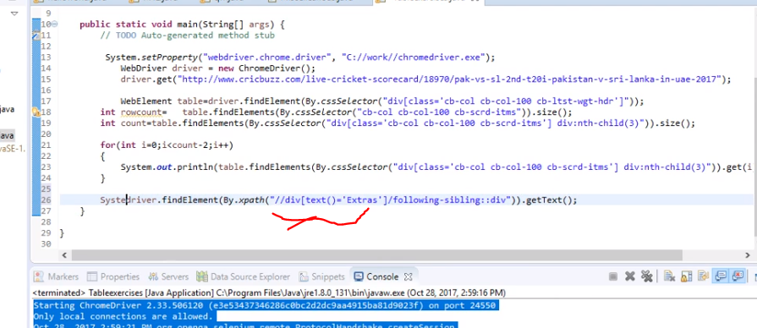

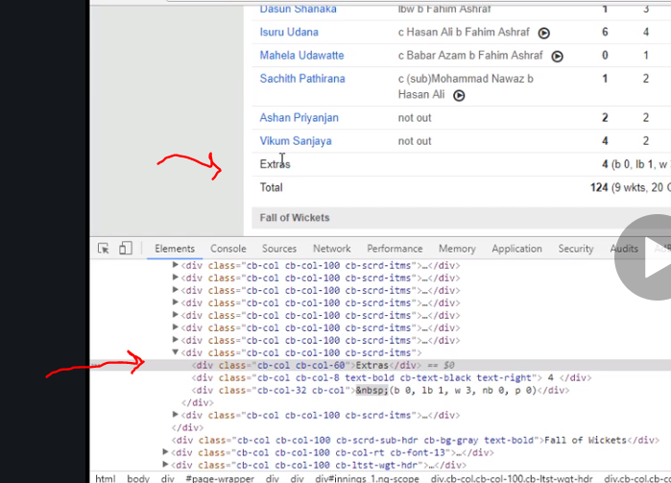

Now look how he added it to the already existing code and list …

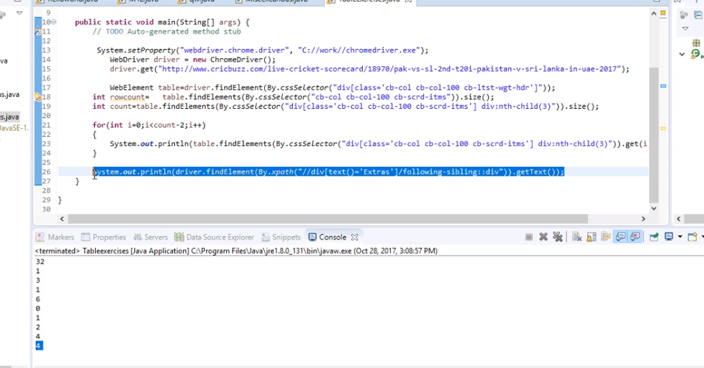

Now we want to grab the total…..same method as extra we use text

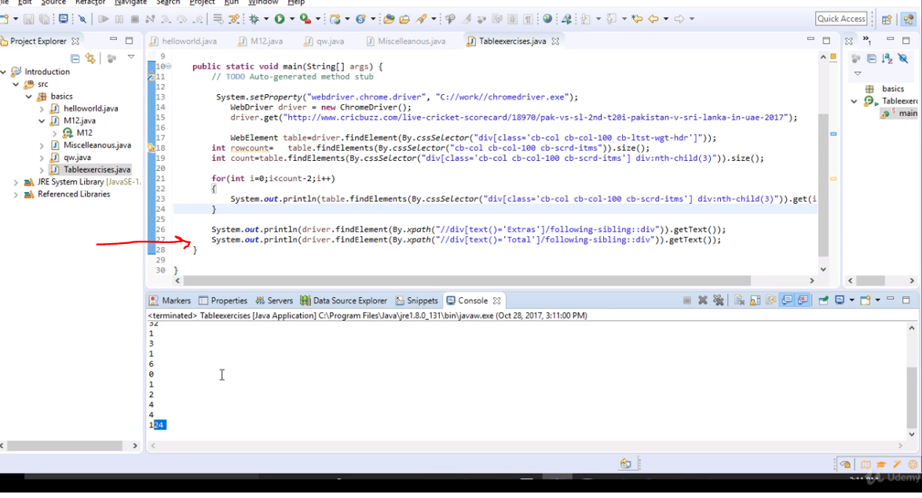

Finally we want to sum it up

Create new variable int…sum

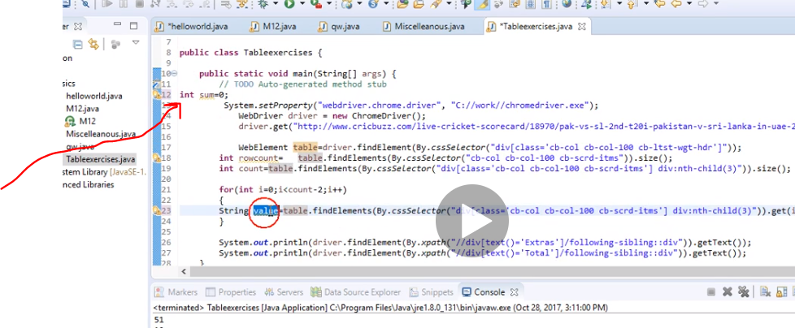

Next convert string to integer

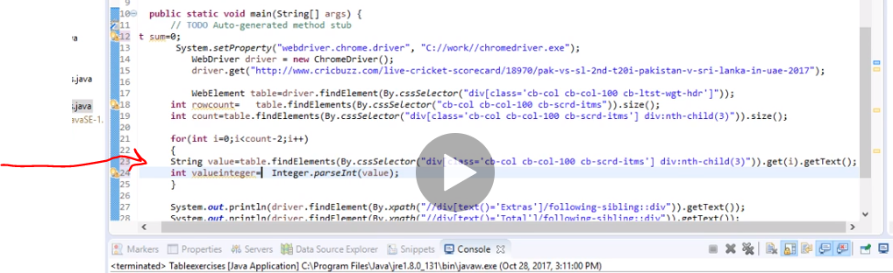

Now we want to use this code in the for loop to add sum after every loop save this value…

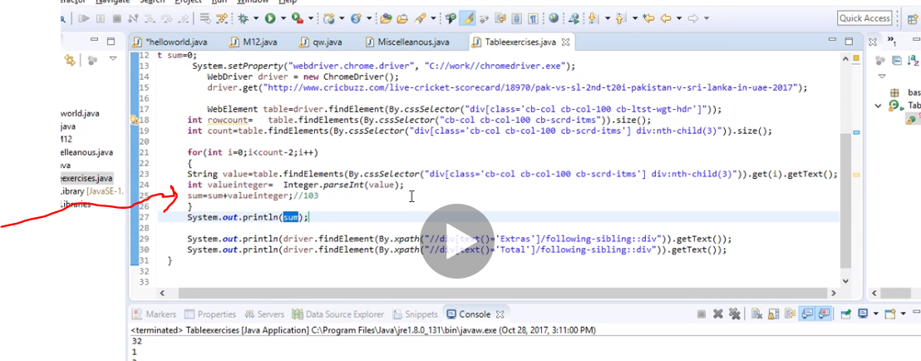

Note the sum is also looping so its holding new values as well amazing. And we add it

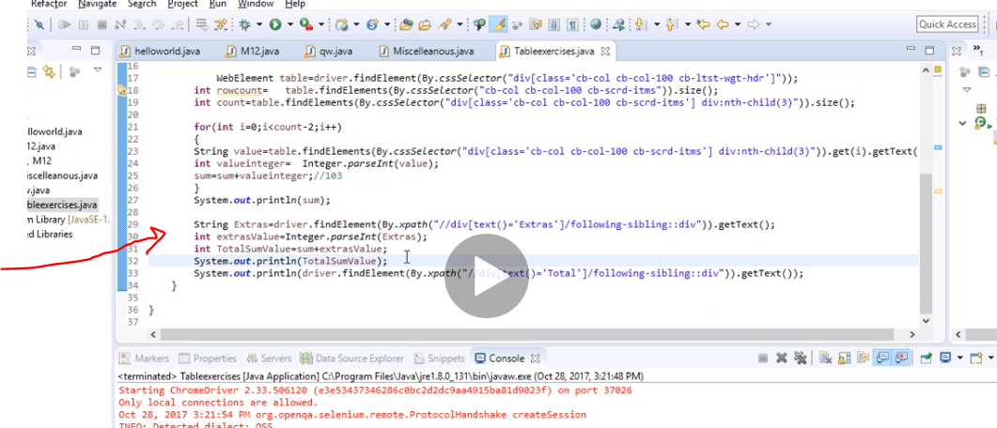

Now compare the both results

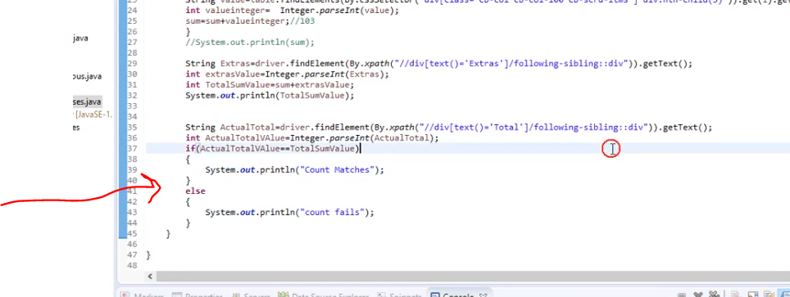

**import** java.util.Iterator;

**import** java.util.Set;

**import** org.openqa.selenium.By;

**import** org.openqa.selenium.Keys;

**import** org.openqa.selenium.WebDriver;

**import** org.openqa.selenium.WebElement;

**import** org.openqa.selenium.chrome.ChromeDriver;

//this involves Tables

**public** **class** Cricbuzztables {

**public** **static** **void** main(String[] args) **throws** InterruptedException {

// **TODO** Auto-generated method stub

System.*setProperty*("webdriver.chrome.driver", "C:\\Chrome\\chromedriver.exe");

WebDriver driver = **new** ChromeDriver();

driver.get("https://money.rediff.com/gainers");

WebElement table=driver.findElement(By.*cssSelector*("tbody"));

**int** rowCount=table.findElements(By.*xpath*("//*[@id='leftcontainer']/table/tbody/tr/td[3]")).size();

System.***out***.println(rowCount);

**for**(**int** i=0;i<rowCount-90;i++)

{

System.***out***.println(table.findElements(By.*xpath*("//*[@id='leftcontainer']/table/tbody/tr/td[3]")).get(i).getText());

}

//https://money.rediff.com/gainers

/*WebElement bottomLinks = driver.findElement(By.xpath("//*[@id='gf-BIG']"));

System.out.println(bottomLinks.findElements(By.tagName("a")).size());

WebElement columnLinks = driver.findElement(By.xpath("//*[@id='gf-BIG']/table/tbody/tr/td[1]/ul"));

System.out.println(columnLinks.findElements(By.tagName("a")).size());

// now we want to click all 5 links and grab their names/title page

for (int i = 1; i < columnLinks.findElements(By.tagName("a")).size(); i++) {

String clicklink = Keys.chord(Keys.CONTROL, Keys.ENTER);

columnLinks.findElements(By.tagName("a")).get(i).sendKeys(clicklink);

}

// get handler for the chrome pages

Set<String> swtch = driver.getWindowHandles();

Iterator<String> cazoo = swtch.iterator();

while (cazoo.hasNext()) {

driver.switchTo().window(cazoo.next());

System.out.println(driver.getTitle());

}*/

}

}

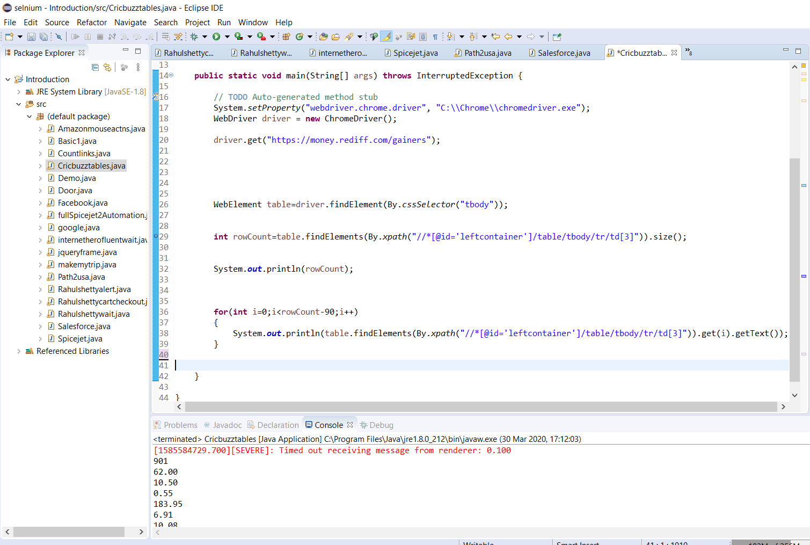

Now created new class ksrtc

Now get text wouldn’t get hidden text that’s the downside to selenium.

This is where we use javascript. Javascript can extract hidden elements

Javascript Dom

Selenium can not identify element with ajax style of implementation

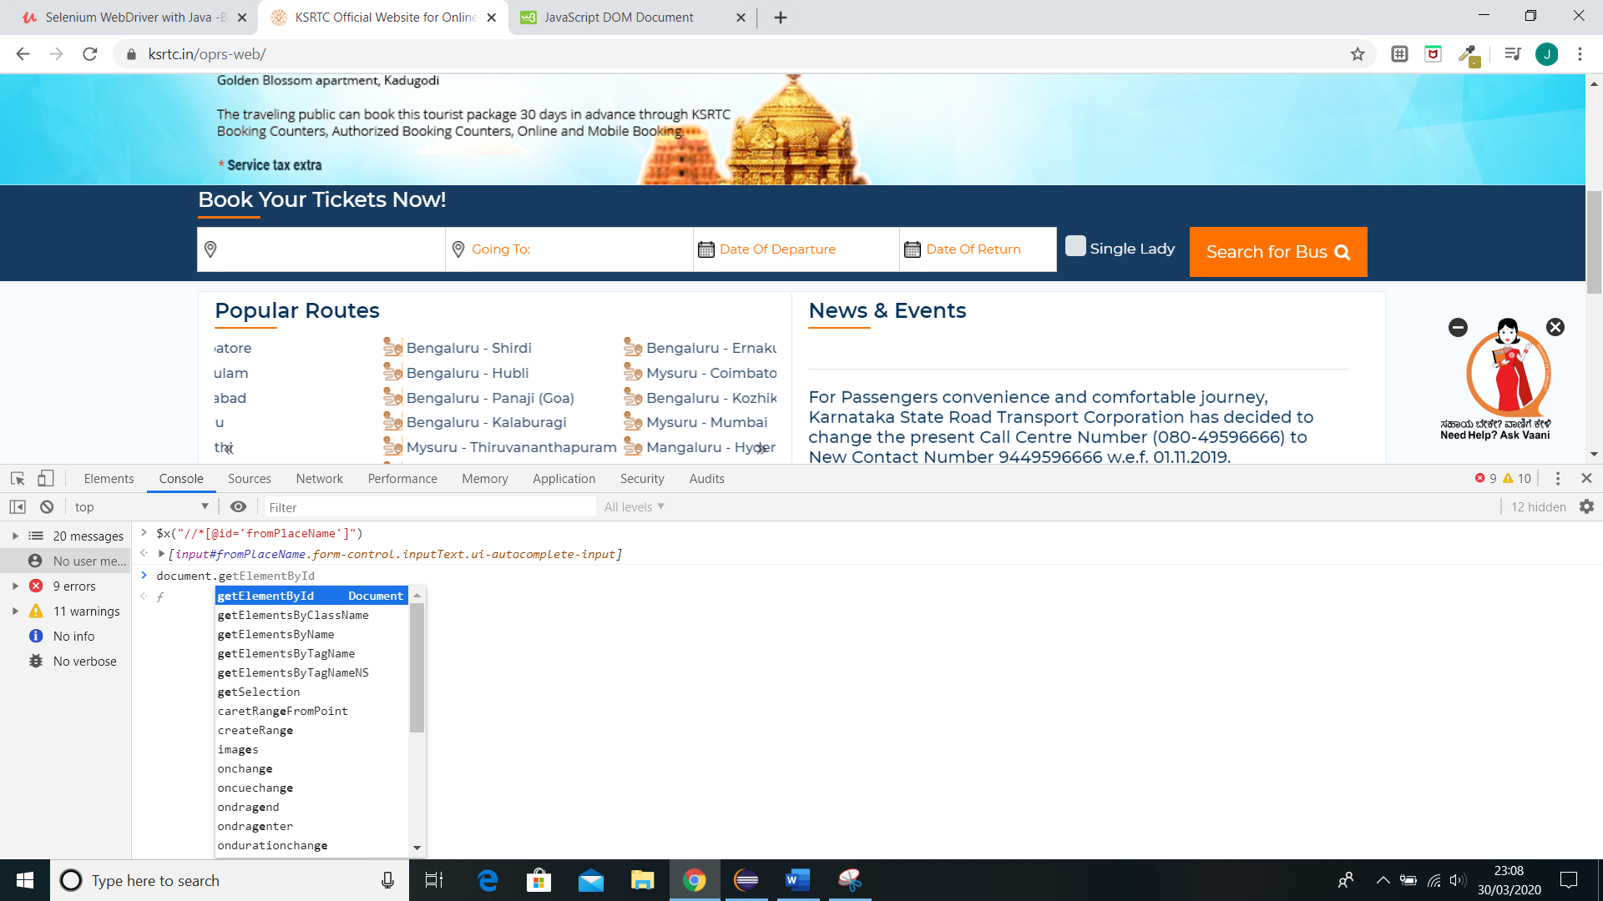

It uses document.get instead of element.find . it uses id

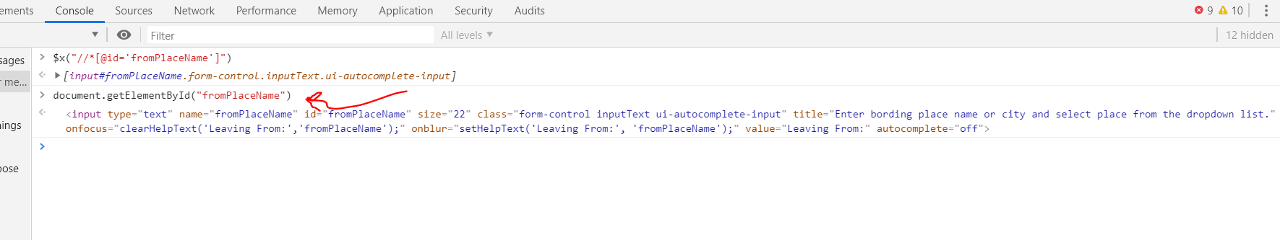

Now to get the value besides just showing the page you do .value so

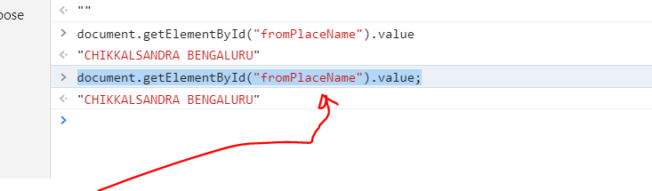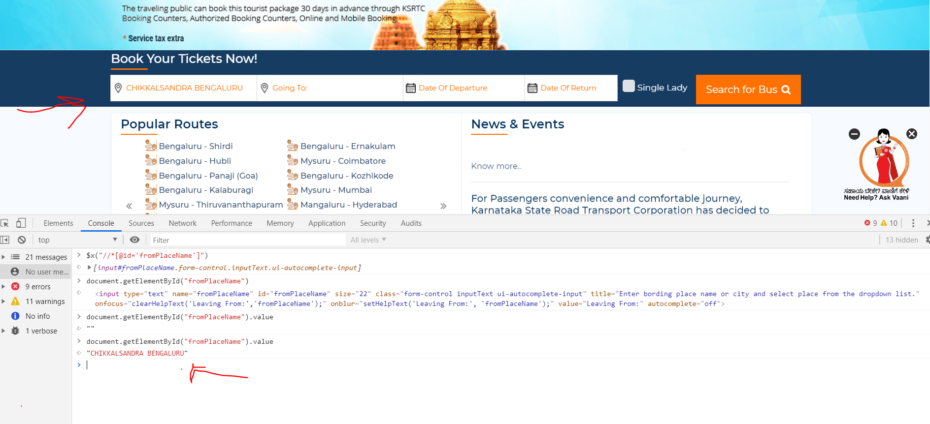

Also use forward slash next to double quotes

\ when using javascript executor in java

Instead of syso they use return

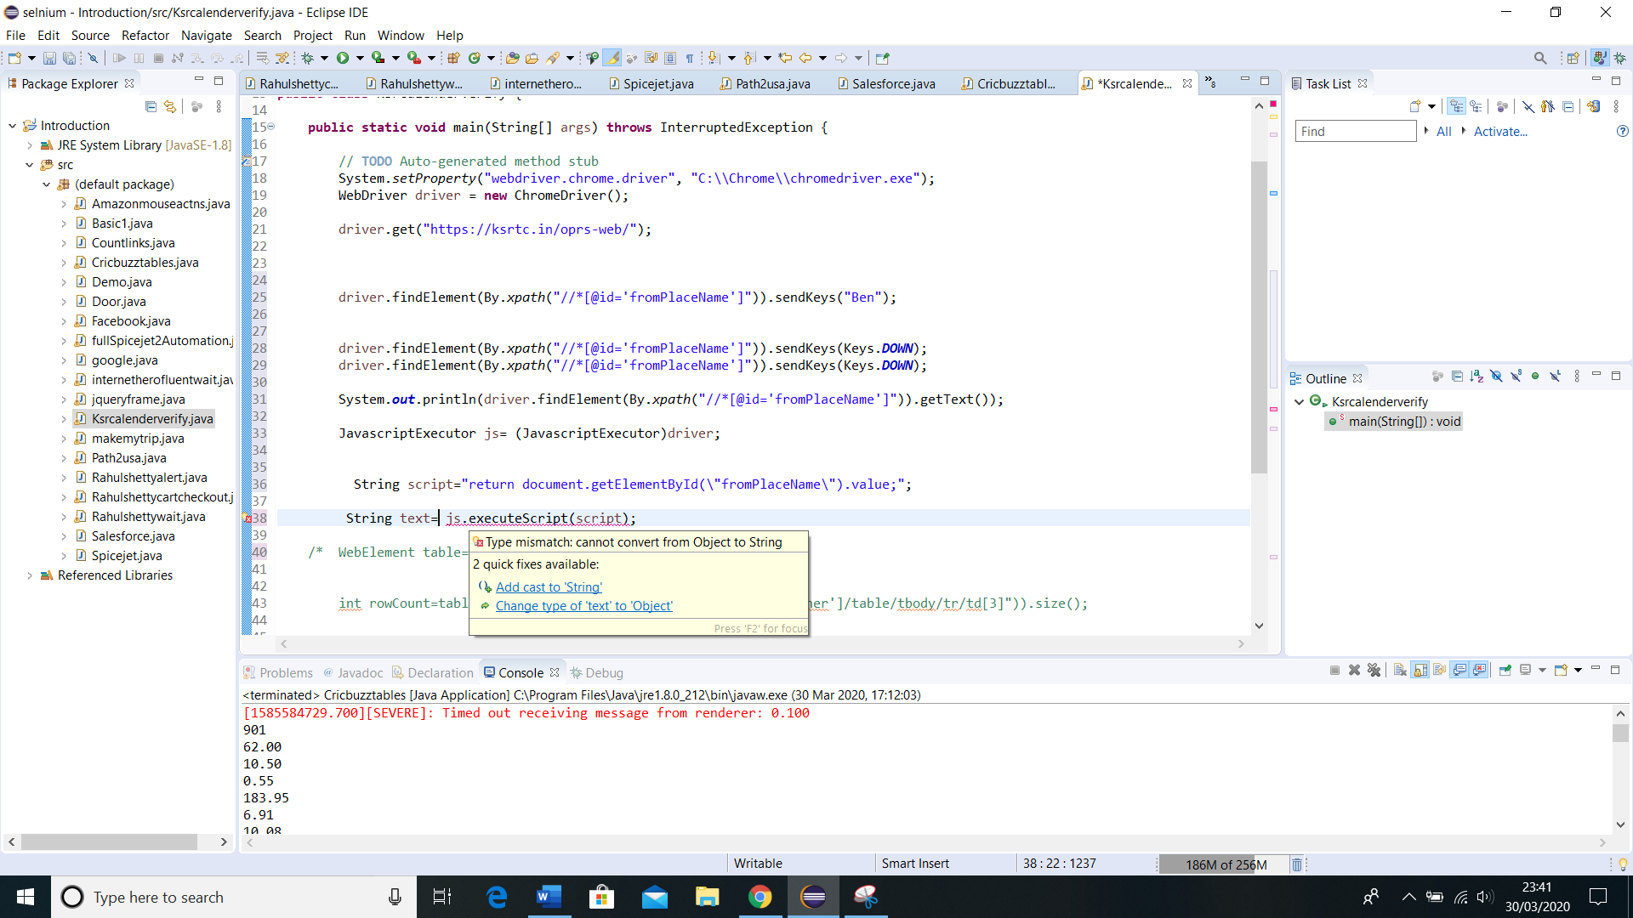

Add cast

<https://www.w3schools.com/js/js_htmldom.asp>

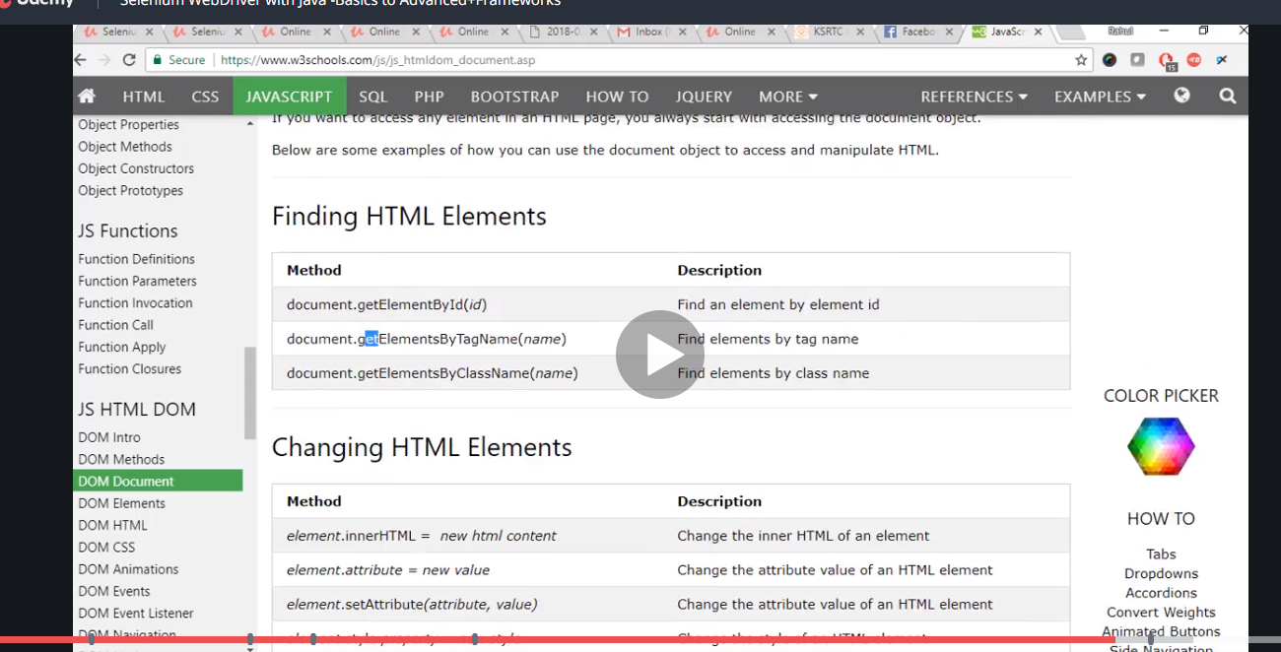

So here we are running it with selenium checking the result with javascript and printing it and then continue the loop.

**import** java.util.Iterator;

**import** java.util.Set;

**import** org.openqa.selenium.By;

**import** org.openqa.selenium.JavascriptExecutor;

**import** org.openqa.selenium.Keys;

**import** org.openqa.selenium.WebDriver;

**import** org.openqa.selenium.WebElement;

**import** org.openqa.selenium.chrome.ChromeDriver;

//this involves calenders with hidden element ajax style on found with javascrip executor

**public** **class** Ksrcalenderverify {

**public** **static** **void** main(String[] args) **throws** InterruptedException {

// **TODO** Auto-generated method stub

System.*setProperty*("webdriver.chrome.driver", "C:\\Chrome\\chromedriver.exe");

WebDriver driver = **new** ChromeDriver();

driver.get("https://ksrtc.in/oprs-web/");

driver.findElement(By.*xpath*("//*[@id='fromPlaceName']")).sendKeys("Ben");

Thread.*sleep*(2000);

driver.findElement(By.*xpath*("//*[@id='fromPlaceName']")).sendKeys(Keys.***DOWN***);

System.***out***.println(driver.findElement(By.*xpath*("//*[@id='fromPlaceName']")).getText());

JavascriptExecutor js= (JavascriptExecutor)driver;

String script="return document.getElementById(\"fromPlaceName\").value;";

String text= (String) js.executeScript(script);

System.***out***.println(text);

**int** i=0;

**while**(!text.equalsIgnoreCase("BENGALURU TERNATIONAL AIPORT"))

{

i++;

driver.findElement(By.*xpath*("//*[@id='fromPlaceName']")).sendKeys(Keys.***DOWN***);

text= (String) js.executeScript(script);

System.***out***.println(text);

**if**(i>10)

{

**break**;

}

}

**if**(i>10)

{

System.***out***.println("Element not found");

}

**else**

{

System.***out***.println("Element found");

}

/* WebElement table=driver.findElement(By.cssSelector("tbody"));

int rowCount=table.findElements(By.xpath("//*[@id='leftcontainer']/table/tbody/tr/td[3]")).size();

System.out.println(rowCount);

for(int i=0;i<rowCount-90;i++)

{

System.out.println(table.findElements(By.xpath("//*[@id='leftcontainer']/table/tbody/tr/td[3]")).get(i).getText());

}*/

}

}

Notice the name is not correct hence it looped in that manner otherwise it will just print the expected name to “ INTERNATIONAL”

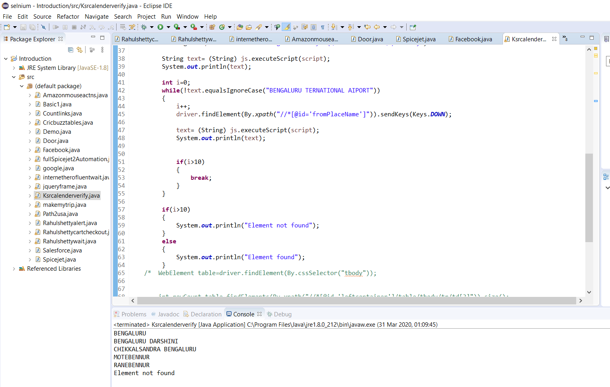

So when you use the correct name the result becomes

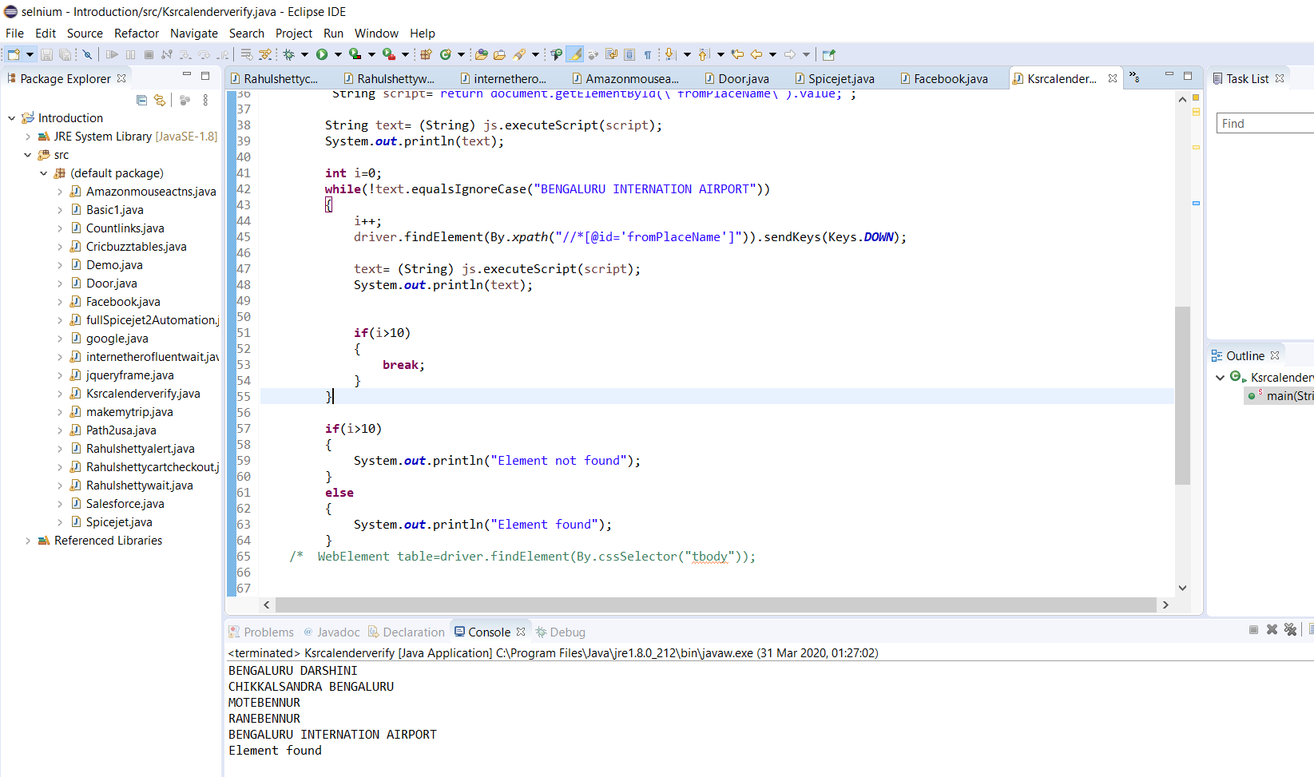

Now next handling https certification….

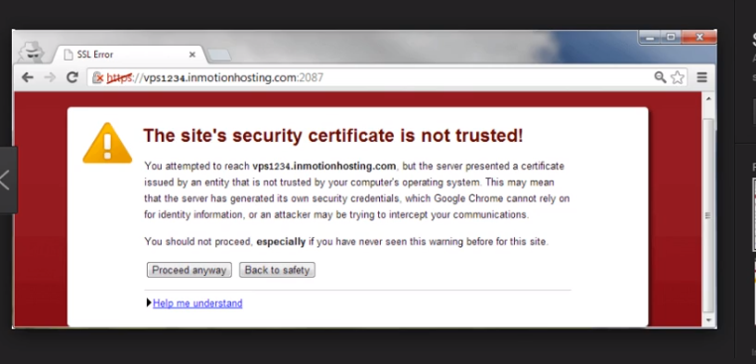

For this there is a class in selenium called chrome options

You just need to hook your chrome with this code so you give your chrome options to use the certifications

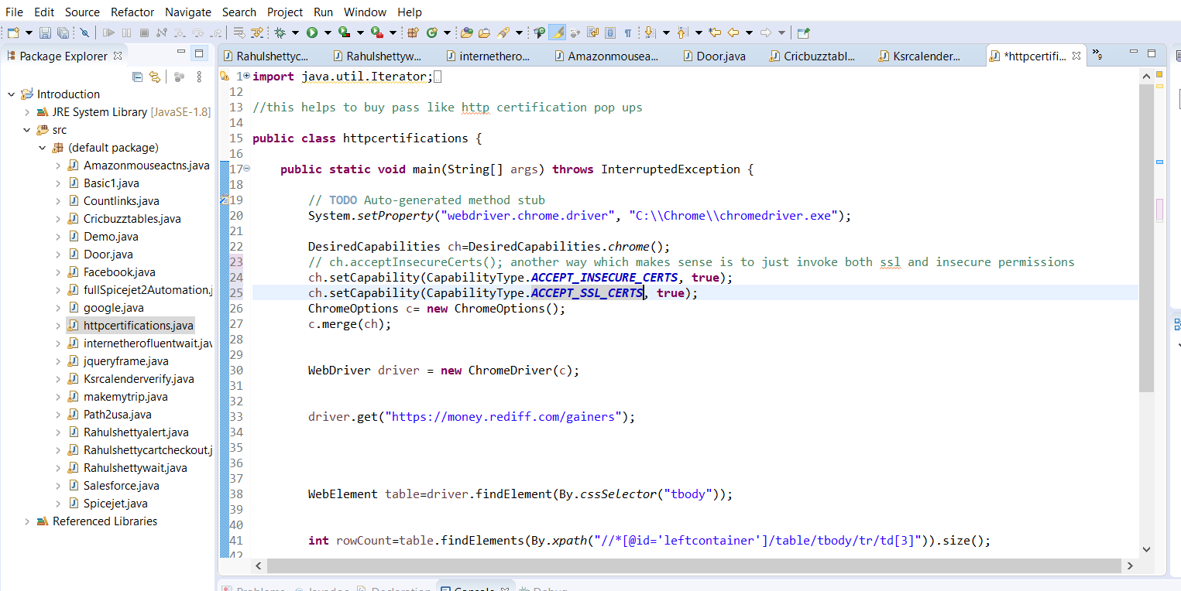

Created a class called httccertification

**import** java.util.Iterator;

**import** java.util.Set;

**import** org.openqa.selenium.By;

**import** org.openqa.selenium.Keys;

**import** org.openqa.selenium.WebDriver;

**import** org.openqa.selenium.WebElement;

**import** org.openqa.selenium.chrome.ChromeDriver;

**import** org.openqa.selenium.chrome.ChromeOptions;

**import** org.openqa.selenium.remote.CapabilityType;

**import** org.openqa.selenium.remote.DesiredCapabilities;

//this helps to buy pass like http certification pop ups

**public** **class** httpcertifications {

**public** **static** **void** main(String[] args) **throws** InterruptedException {

// **TODO** Auto-generated method stub

System.*setProperty*("webdriver.chrome.driver", "C:\\Chrome\\chromedriver.exe");

DesiredCapabilities ch=DesiredCapabilities.*chrome*();

// ch.acceptInsecureCerts(); another way which makes sense is to just invoke both ssl and insecure permissions

ch.setCapability(CapabilityType.***ACCEPT_INSECURE_CERTS***, **true**);

ch.setCapability(CapabilityType.***ACCEPT_SSL_CERTS***, **true**);

ChromeOptions c= **new** ChromeOptions();

c.merge(ch);

WebDriver driver = **new** ChromeDriver(c);

driver.get("https://money.rediff.com/gainers");

}

}

Next we just add capability to maximise it.

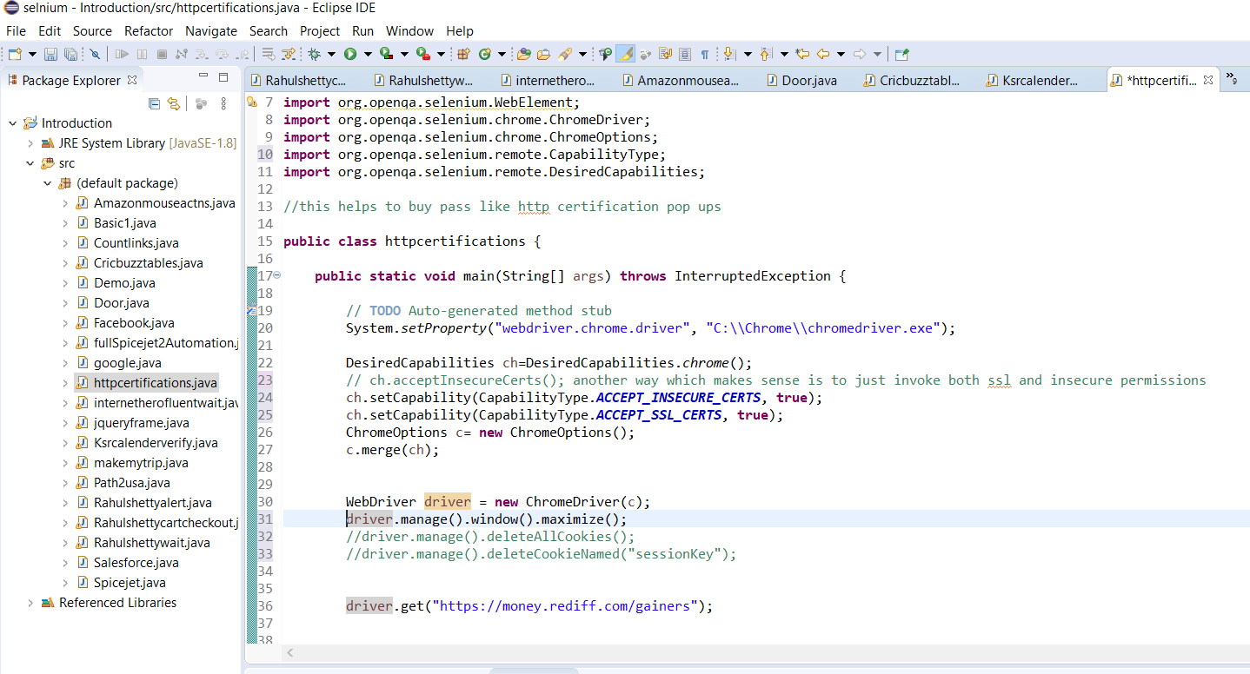

This is a complete starter package to get rid of any bullshit and just start working.

**import** java.util.Iterator;

**import** java.util.Set;

**import** org.openqa.selenium.By;

**import** org.openqa.selenium.Keys;

**import** org.openqa.selenium.WebDriver;

**import** org.openqa.selenium.WebElement;

**import** org.openqa.selenium.chrome.ChromeDriver;

**import** org.openqa.selenium.chrome.ChromeOptions;

**import** org.openqa.selenium.remote.CapabilityType;

**import** org.openqa.selenium.remote.DesiredCapabilities;

//this helps to buy pass like http certification pop ups

**public** **class** httpcertifications {

**public** **static** **void** main(String[] args) **throws** InterruptedException {

// **TODO** Auto-generated method stub

System.*setProperty*("webdriver.chrome.driver", "C:\\Chrome\\chromedriver.exe");

DesiredCapabilities ch=DesiredCapabilities.*chrome*();

// ch.acceptInsecureCerts(); another way which makes sense is to just invoke both ssl and insecure permissions

ch.setCapability(CapabilityType.***ACCEPT_INSECURE_CERTS***, **true**);

ch.setCapability(CapabilityType.***ACCEPT_SSL_CERTS***, **true**);

ChromeOptions c= **new** ChromeOptions();

c.merge(ch);

WebDriver driver = **new** ChromeDriver(c);

driver.manage().window().maximize();

//driver.manage().deleteAllCookies();

//driver.manage().deleteCookieNamed("sessionKey");

driver.get("https://money.rediff.com/gainers");

}

}

Now to take screenshot, you need to convert driver object to sceenshot object.

Now we may need to ad a jar to our bill part in order to achieve this.

Download from common apache

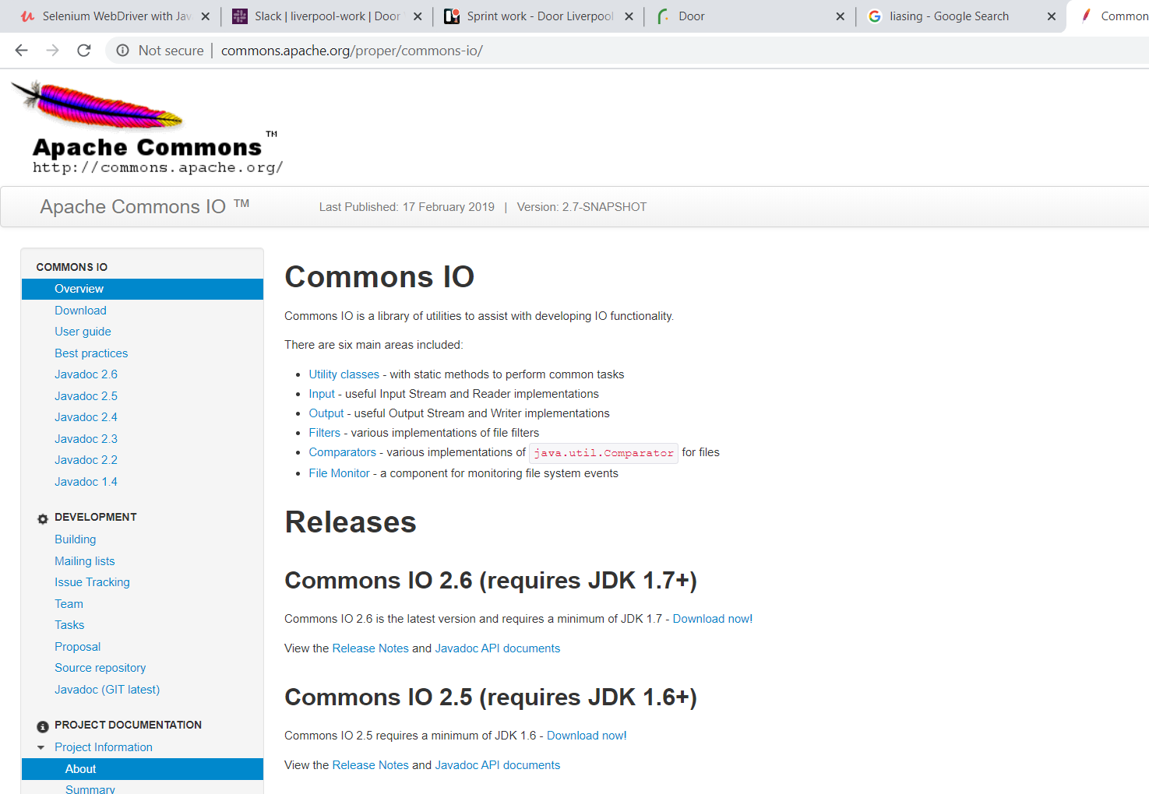

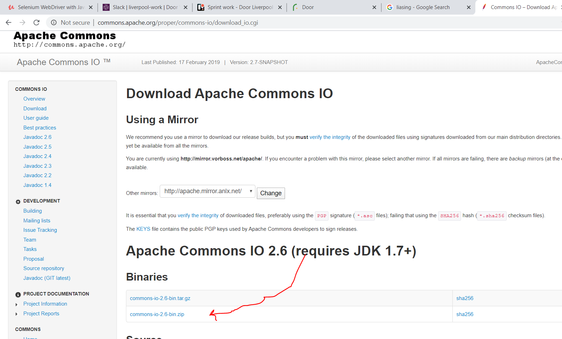

Remember to click the throw exception.

**import** java.io.File;

**import** java.io.IOException;

**import** java.util.Iterator;

**import** java.util.Set;

**import** org.openqa.selenium.By;

**import** org.openqa.selenium.Keys;

**import** org.openqa.selenium.OutputType;

**import** org.openqa.selenium.TakesScreenshot;

**import** org.openqa.selenium.WebDriver;

**import** org.openqa.selenium.WebElement;

**import** org.openqa.selenium.chrome.ChromeDriver;

**import** org.openqa.selenium.chrome.ChromeOptions;

**import** org.openqa.selenium.remote.CapabilityType;

**import** org.openqa.selenium.remote.DesiredCapabilities;

**import** org.apache.commons.io.FileUtils;

//screenshot

**public** **class** screenshot {

**public** **static** **void** main(String[] args) **throws** InterruptedException, IOException {

// **TODO** Auto-generated method stub

System.*setProperty*("webdriver.chrome.driver", "C:\\Chrome\\chromedriver.exe");

DesiredCapabilities ch=DesiredCapabilities.*chrome*();

// ch.acceptInsecureCerts(); another way which makes sense is to just invoke both ssl and insecure permissions

ch.setCapability(CapabilityType.***ACCEPT_INSECURE_CERTS***, **true**);

ch.setCapability(CapabilityType.***ACCEPT_SSL_CERTS***, **true**);

ChromeOptions c= **new** ChromeOptions();

c.merge(ch);

WebDriver driver = **new** ChromeDriver(c);

driver.manage().window().maximize();

//driver.manage().deleteAllCookies();

//driver.manage().deleteCookieNamed("sessionKey");

driver.get("https://money.rediff.com/gainers");

File src= ((TakesScreenshot)driver).getScreenshotAs(OutputType.***FILE***);

FileUtils.*copyFile*(src,**new** File("C:\\Users\\JoshuaIdemudia\\screenshot.png"));

}

}

Next we want to check if a table is sorted by table

We created a class shettysort

First lets get array list of the table

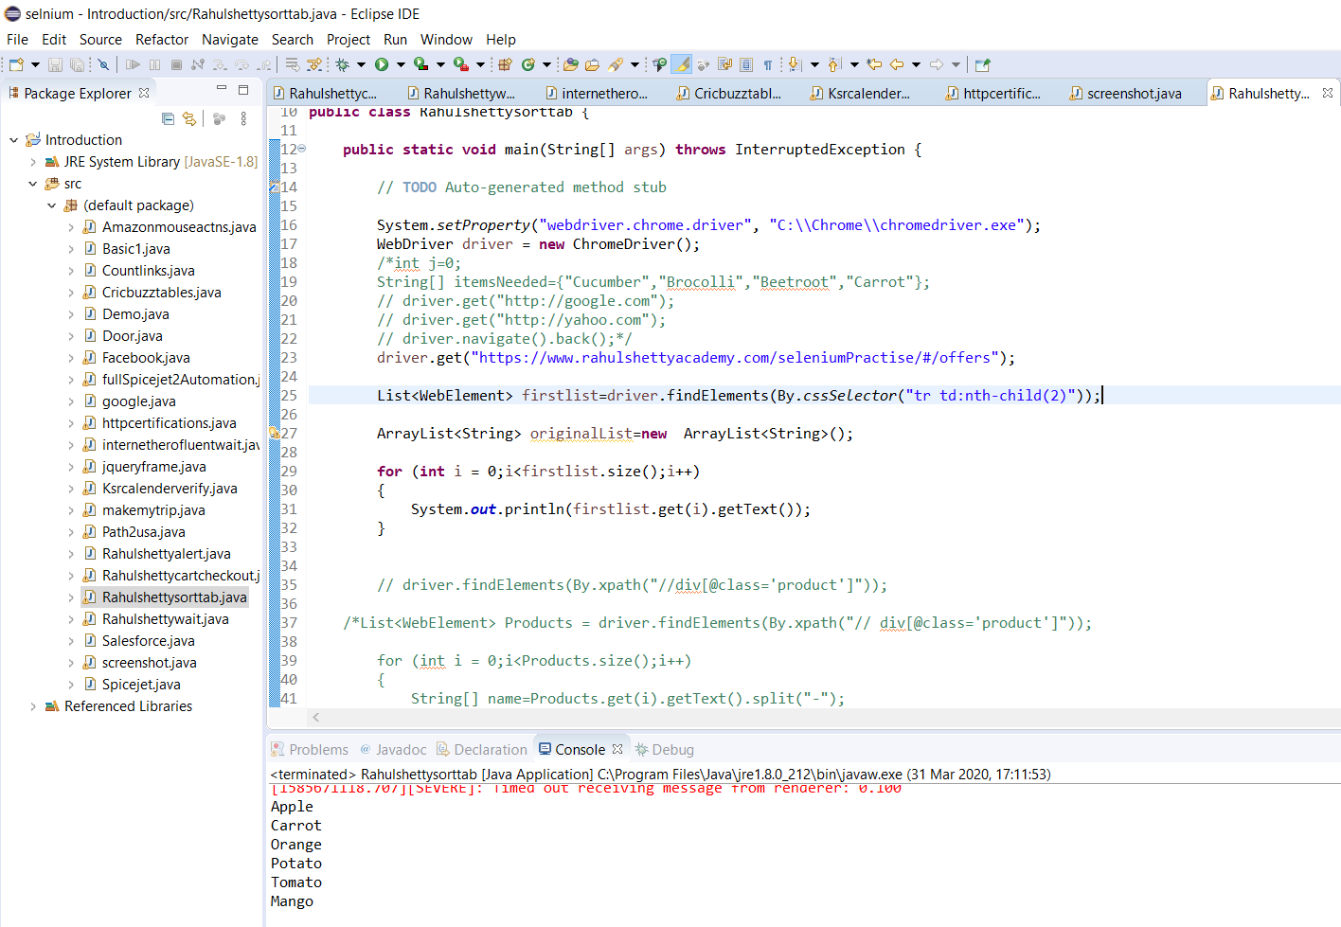

Basically we coped it sort it and then compare.

import java.util.ArrayList;

import java.util.Arrays;

import java.util.Collections;

import java.util.List;

import org.openqa.selenium.By;

import org.openqa.selenium.WebDriver;

import org.openqa.selenium.WebElement;

import org.openqa.selenium.chrome.ChromeDriver;

import org.testng.Assert;

public class Rahulshettysorttab {

public static void main(String[] args) throws InterruptedException {

// TODO Auto-generated method stub

System.setProperty("webdriver.chrome.driver", "C:\\Chrome\\chromedriver.exe");

WebDriver driver = new ChromeDriver();

/*int j=0;

String[] itemsNeeded={"Cucumber","Brocolli","Beetroot","Carrot"};

// driver.get("http://google.com");

// driver.get("http://yahoo.com");

// driver.navigate().back();*/

driver.get("https://www.rahulshettyacademy.com/seleniumPractise/#/offers");

List<WebElement> firstlist=driver.findElements(By.cssSelector("tr td:nth-child(2)"));

ArrayList<String> originalList=new ArrayList<String>();

for (int i = 0;i<firstlist.size();i++)

{

originalList.add(firstlist.get(i).getText());

}

ArrayList<String> copiedlList=new ArrayList<String>();

for (int i = 0;i<originalList.size();i++)

{

copiedlList.add(originalList.get(i));

}

System.out.println("************************");

Collections.sort(copiedlList);

for(String s:copiedlList) // just another way to do same thing

{

System.out.println(s);

}

System.out.println("*****************");

for(String s:originalList)

{

System.out.println(s);

}

System.out.println(copiedlList);

Assert.assertTrue(originalList.equals(copiedlList));

// driver.findElements(By.xpath("//div[@class='product']"));

/*List<WebElement> Products = driver.findElements(By.xpath("// div[@class='product']"));

for (int i = 0;i<Products.size();i++)

{

String[] name=Products.get(i).getText().split("-");

String formattedName=name[0].trim();

List itemsNeededList = Arrays.asList(itemsNeeded);

if (itemsNeededList.contains(formattedName)) {

j++;

driver.findElements(By.xpath("//div[@class='product-action']/button")).get(i).click();

if (j == itemsNeeded.length)

{

break;

}

}

}*/

//*[@id='root']/div/div[1]/div/div[1]/div[3]/button

//button[text()='ADD TO CART']

//div[@class='product-action']/button

// div[@class='product']

}

}

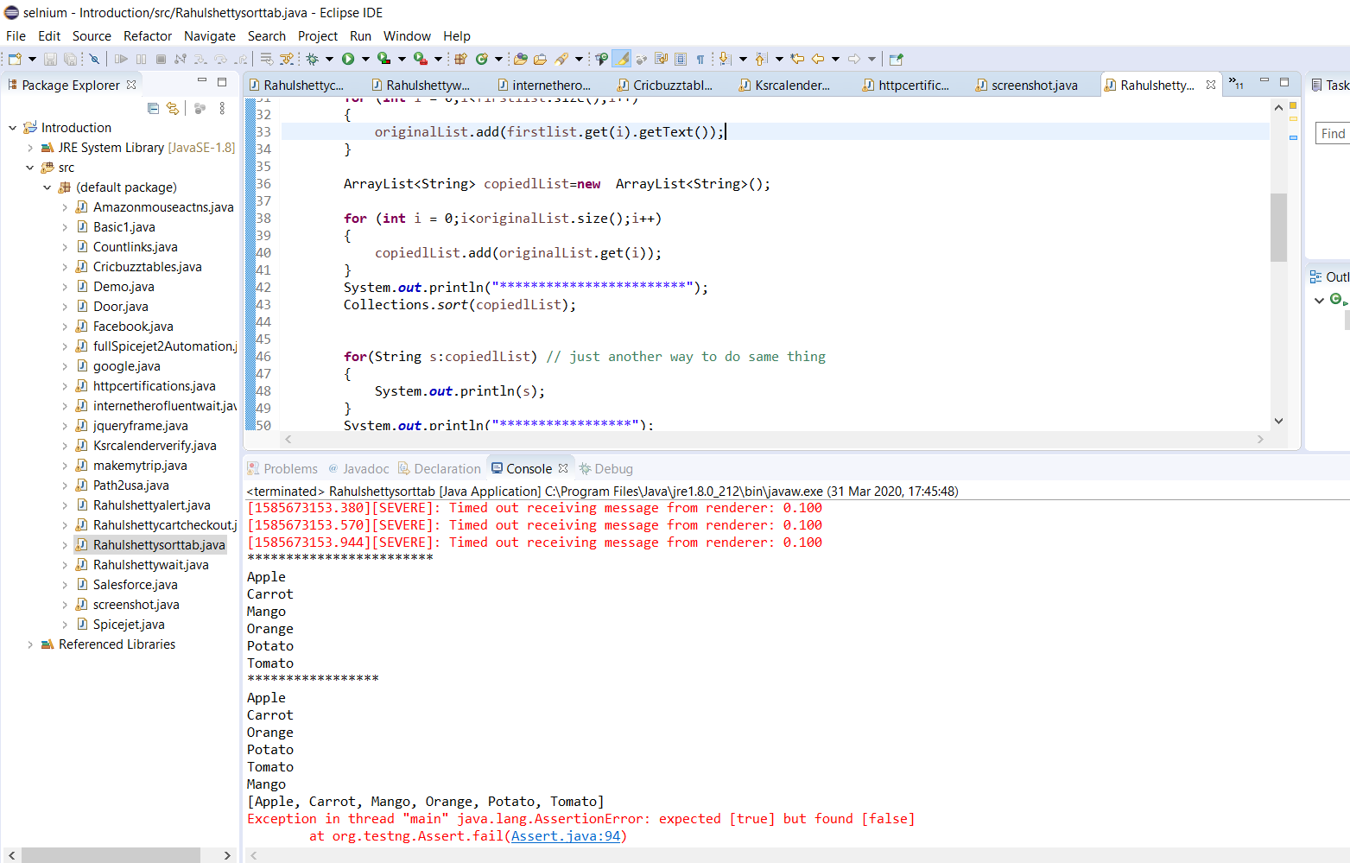

It failed the assertion which means it worked.

Now if we want the assertion to pass which mean copied and original are the same…we created another class where all we do is click the table twice and it should be the same. And if we click once its can also validate descending.

Take note parents travelling just a note.

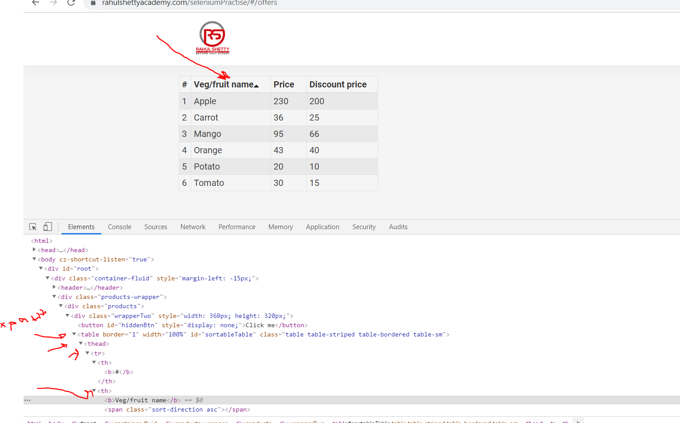

//*[@id='sortableTable']/thead/tr/th[2]/b

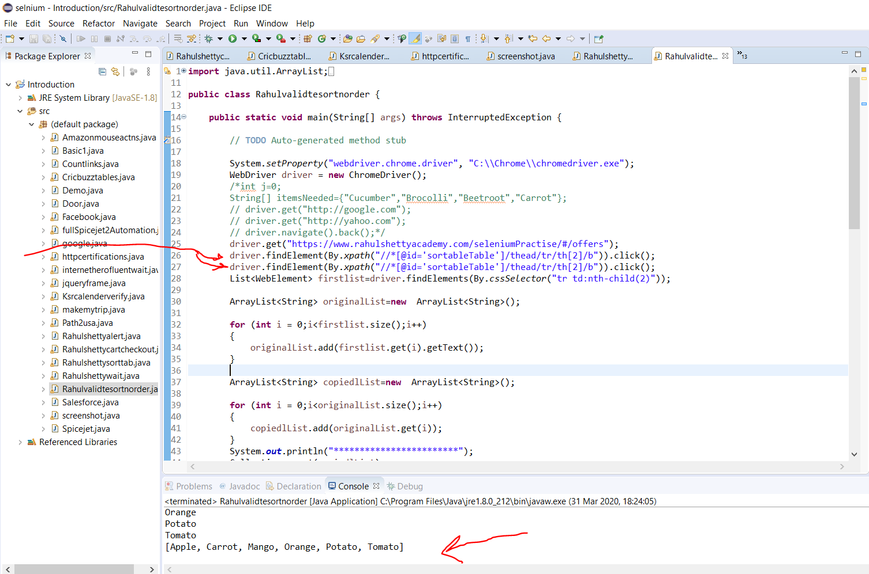

So comment them to simulate one click also notice no error with two clicks.

However note by default the sort method sorts in ascending order …….

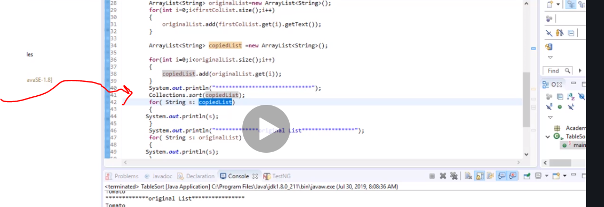

It becomes descending by adding the reverse method

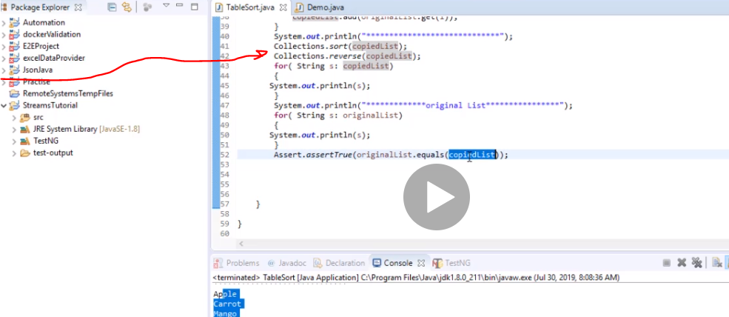

Selenium grid

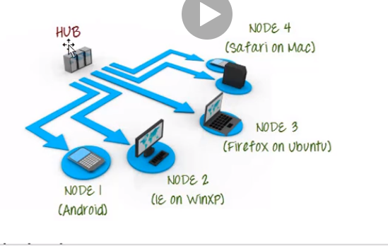

Hub is your local machine. Node is where u are sending it to run in another machine. Must be only one hub where test execution is fired up but runs on the nodes.

Parallel execution

So If you have 50 test cases and distribute them to 5 nodes, it will take only 10mins compare to only one point

Now to do this we need to use selenium server.

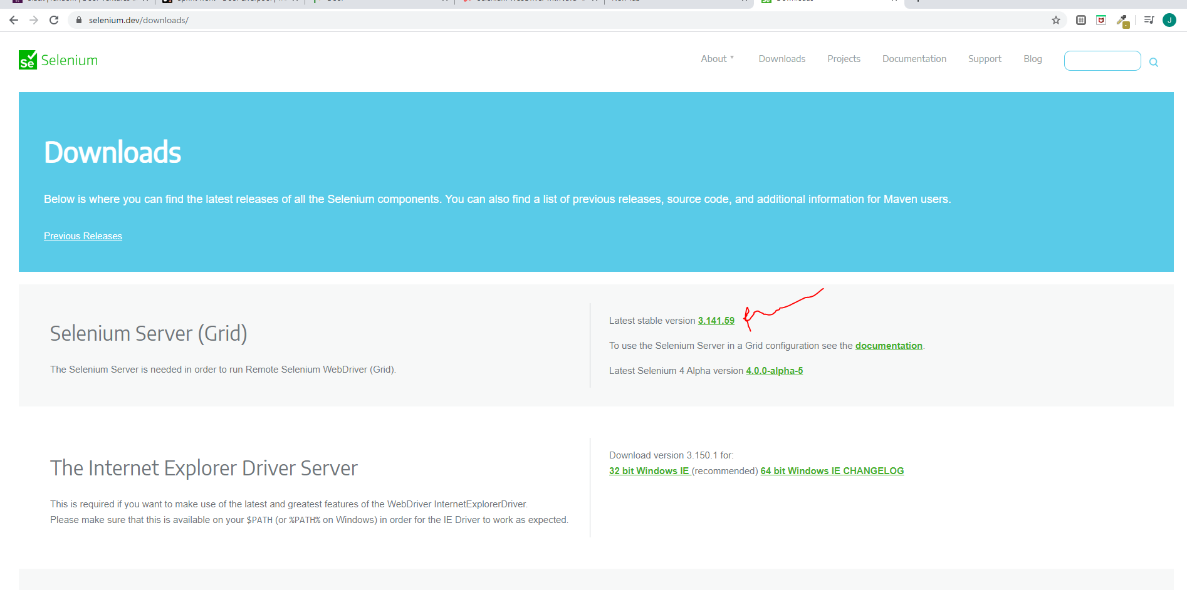

Download the jar

First register the hub…selenium needs to know which is the main machine.

Second save it in your cdrive you have administrative right so just click continue

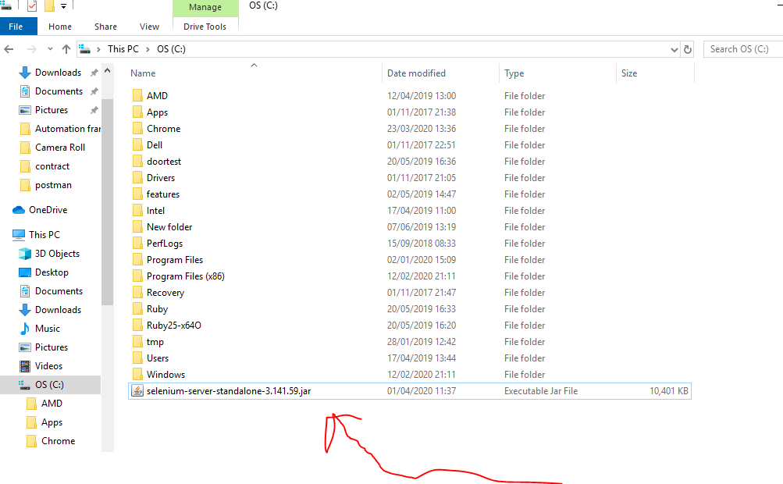

Now to register the hub u need a command so go to dos environment

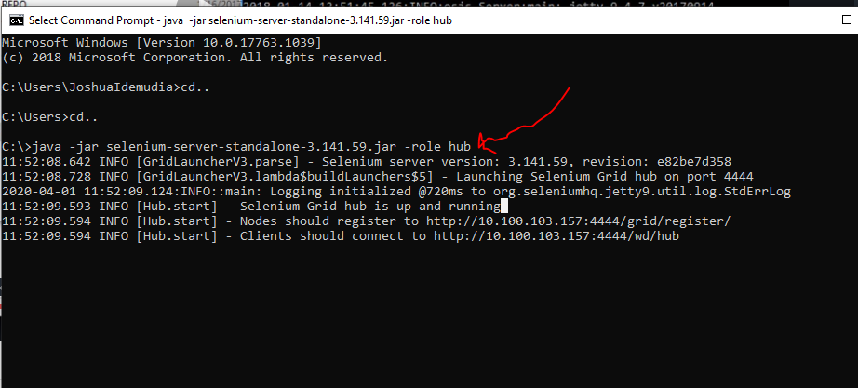

Type that and press enter to start the hub : java -jar selenium-server-standalone-3.141.59.jar -role hub

Obviously always save in C drive and copy the name based on the selenium server u downloaded

So hub is actually a server.

Node should be registered…is now the IP address for your mission. Hub is nothing but server.

The server is now sitting in your machine at port 4444 ……Nodes should register to <http://10.100.103.157:4444/grid/register/>................

So copy it and paste on browser: http://10.100.103.157:4444/grid/console

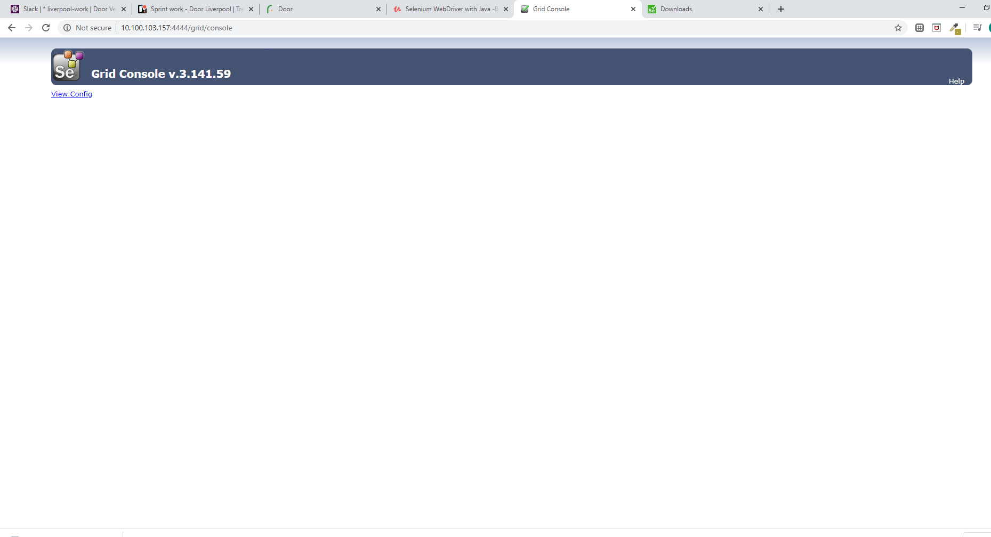

This is now our hub. What we need next is to create nodes.

To set up node log in to the machine where node is being registered(second) machine

So download the server selenium jar as we did in the hub do same in the second machine to be used as node.

Use this actually because I contains chrome webdriver. I explained why but this is the main one for the nodes

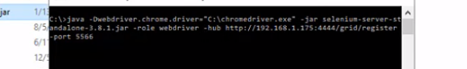

Note your driver and the jar must be in the same path. C

Just paste both there like u did before

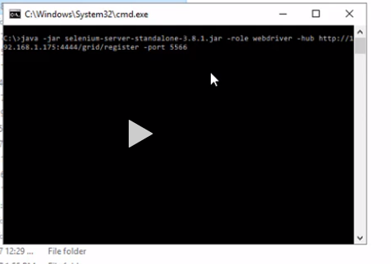

Do as you did before but change name to role webdriver and past

<http://10.100.103.157:4444/grid/register> and give it a port 5566

press enter

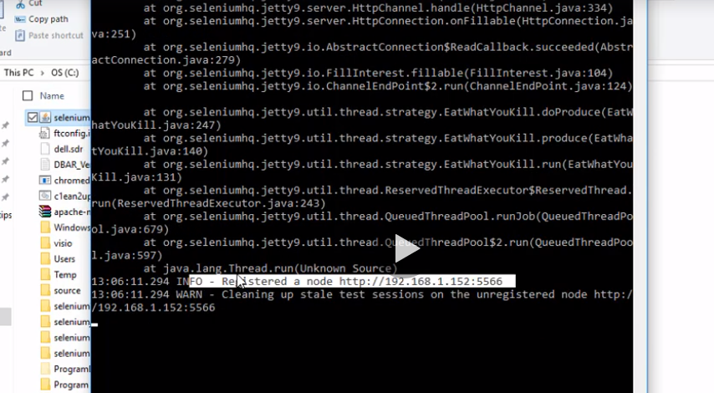

But one more thing you must have chrome driver set up in the node (second compuer) so use the same code as before but add this



Now if you go back to your grid/console and refresh it…it now has the node

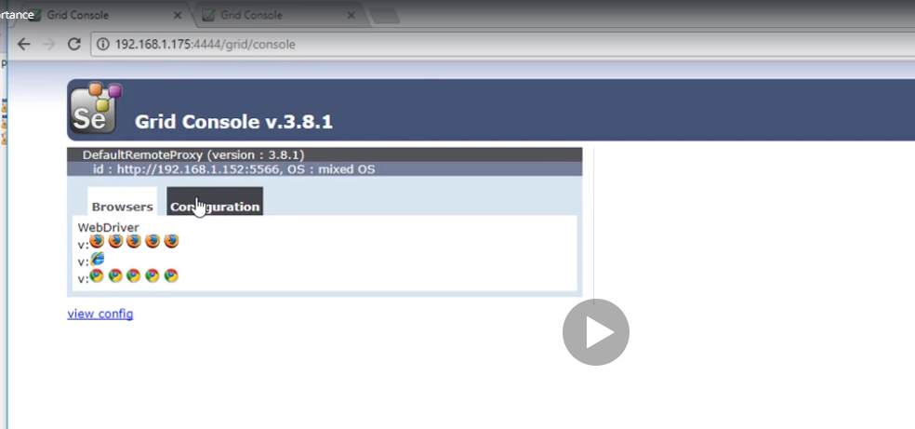

This means you can send 11 testcases to this node.

Now remember to store the selenium server jar into the java project javabuild and shit

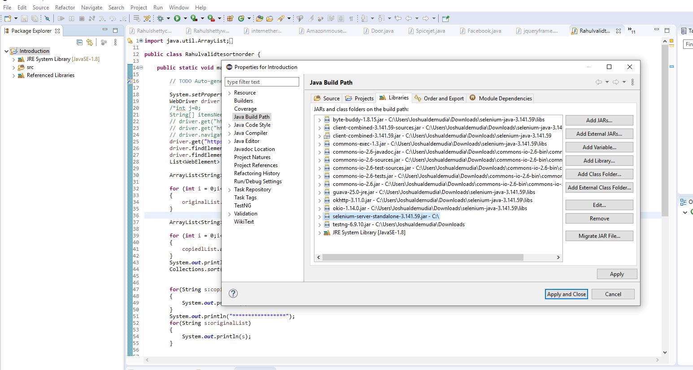

Do this first before writing your code

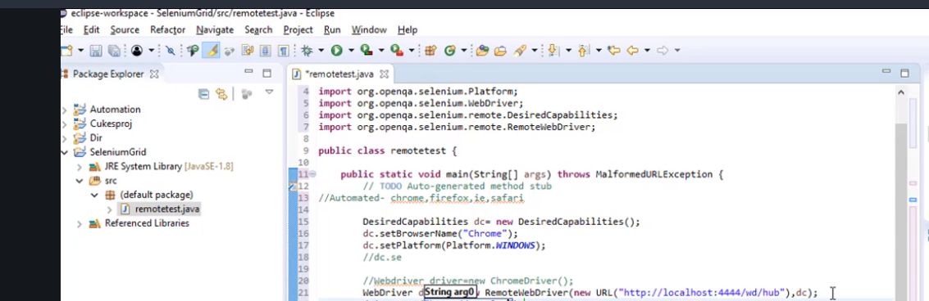

So when you run it…in the hub your laptop nothing is happening but in the node, second laptop it is happening

So basically your capabilities should suit your configuration for your node in order for it to work.

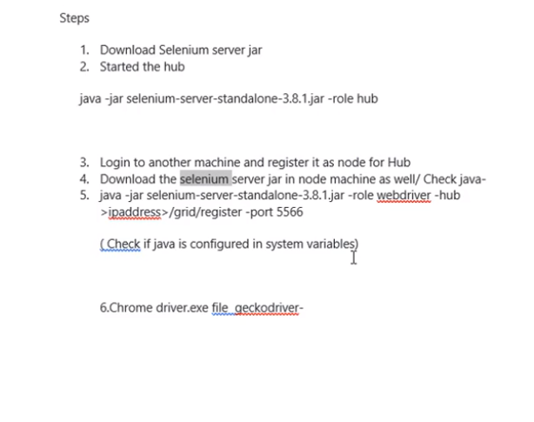

So if it is int explorer change it it on the node command and also on the compatibility and change platform obviously.

Now we start with mobile testing yesssssss

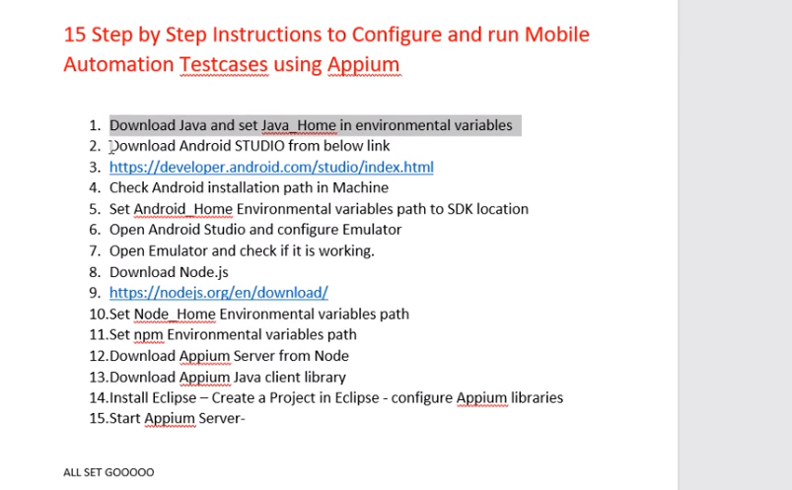

We have java next we need android studio

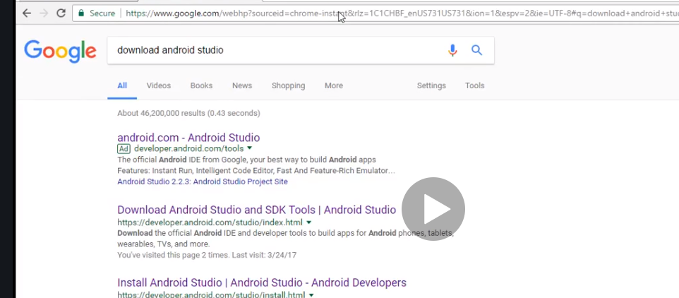

After downloading it, you need to find out where it is located.

Note this comes in two parts as android sdk and android studio so we need to identify. We need to identify both those two locations

Now android sdk is stored in c drive…it may be invisippe just do appdata and select what follows

So we need to configure the environment variables

Just type environment variables on the window search bar

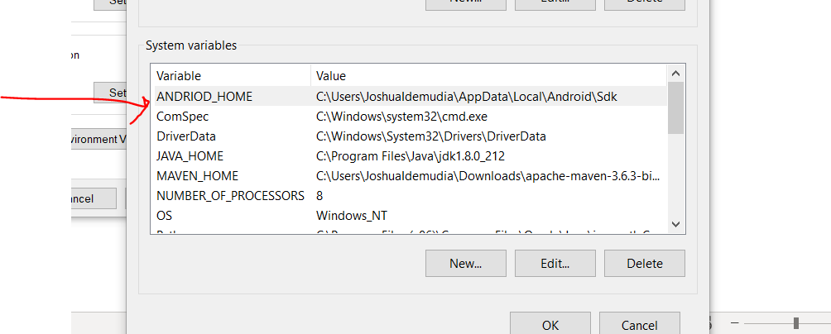

C:\Users\JoshuaIdemudia\AppData\Local\Android\Sdk

And also addd the one with tool by the way finding it was a problem we had to download and add it to the path

So click new and add name android

Then the rest

Double click path or Click edit

And just paste them

C:\Users\JoshuaIdemudia\AppData\Local\Android\Sdk\tools\bin

C:\Users\JoshuaIdemudia\AppData\Local\Android\Sdk\tools

C:\Users\JoshuaIdemudia\AppData\Local\Android\Sdk\platform-tools

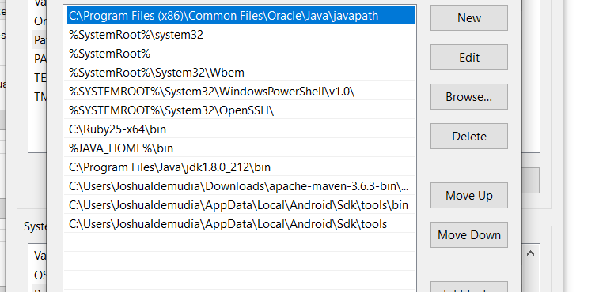

Now we start

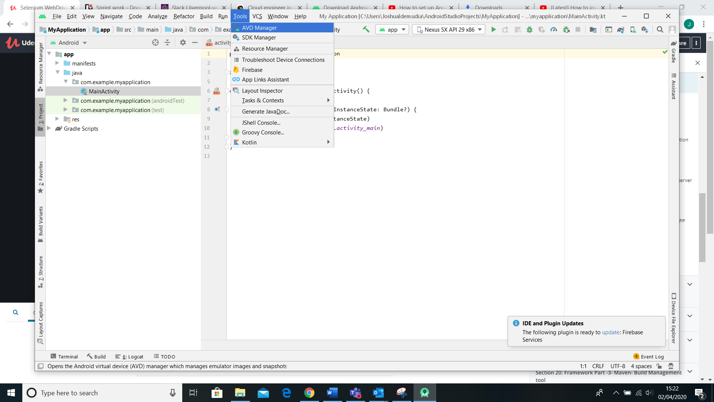

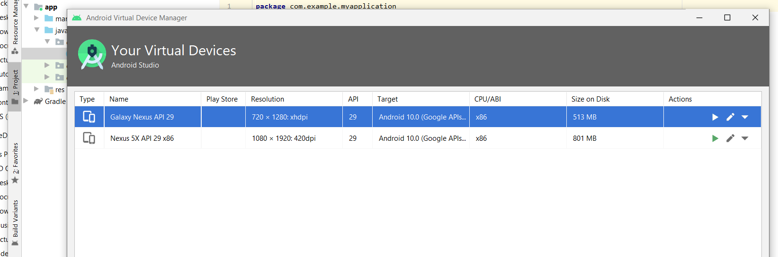

Select the mobile if you can see it it is set up if not go below and create one and press next till u add all configuaratioons . if it is greyed out just download it.

Now click the launch will gve you a new phone yaye. Emulator. But if you just want the phone…u only need avd to set up the kingd of phone u want after that go to cmd

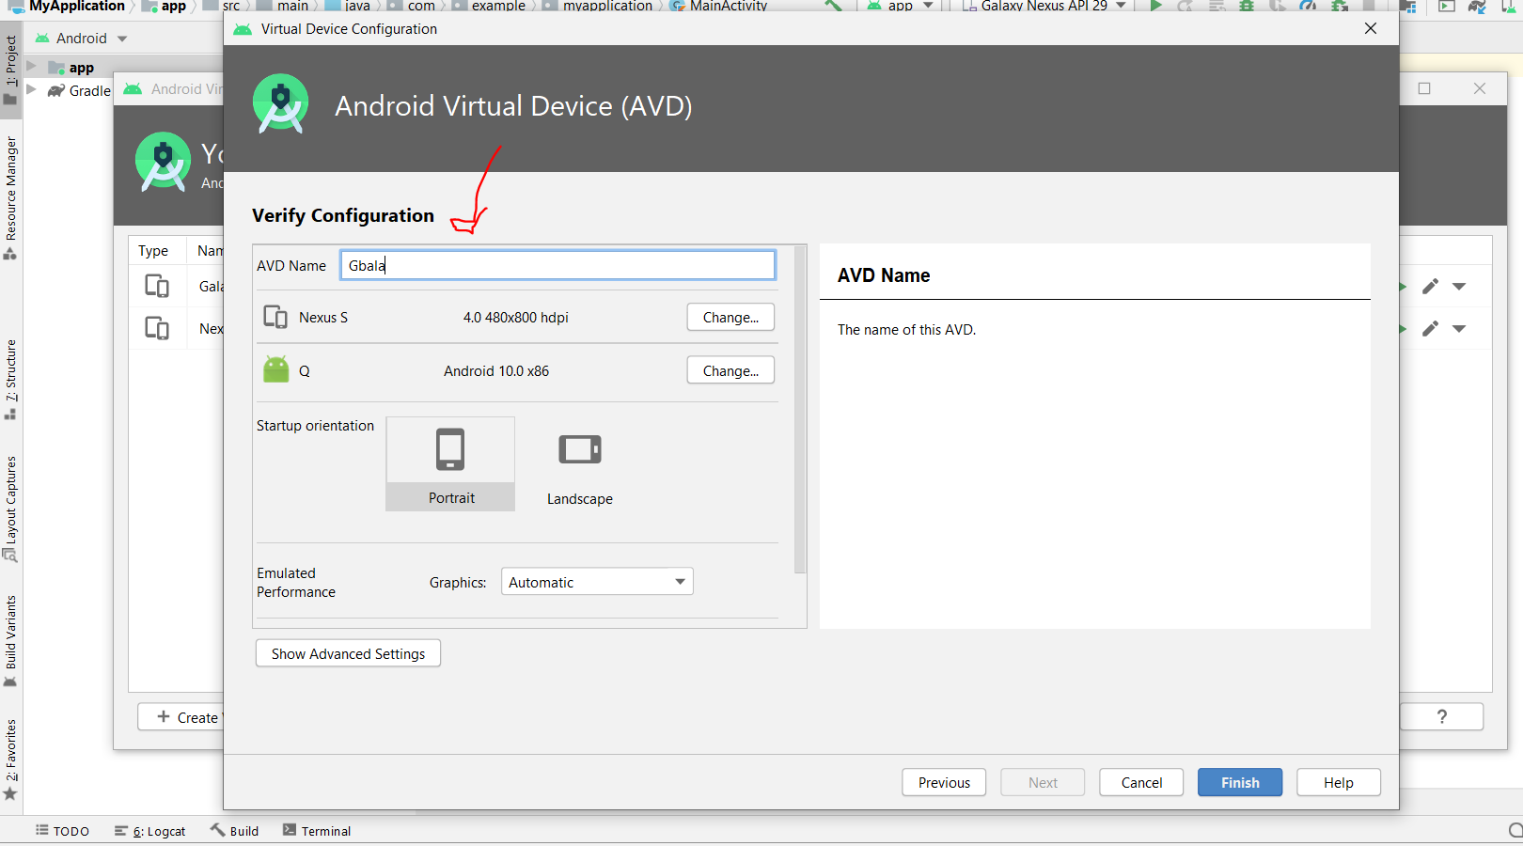

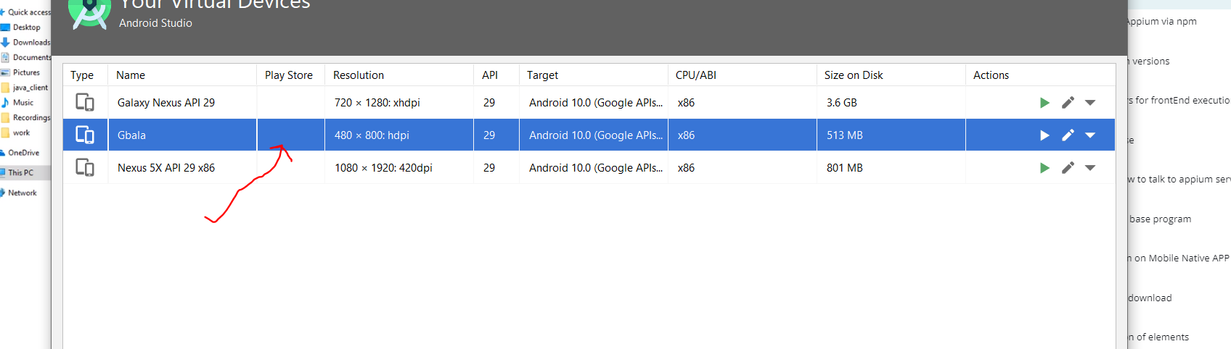

C:\Android\Sdk\tools

Now you have to do all this for the first time after which then you will and can just open it with cmd

I had to add emulator command to my path all seemed to fail finally did it.

C:\Users\JoshuaIdemudia\AppData\Local\Android\Sdk\emulator

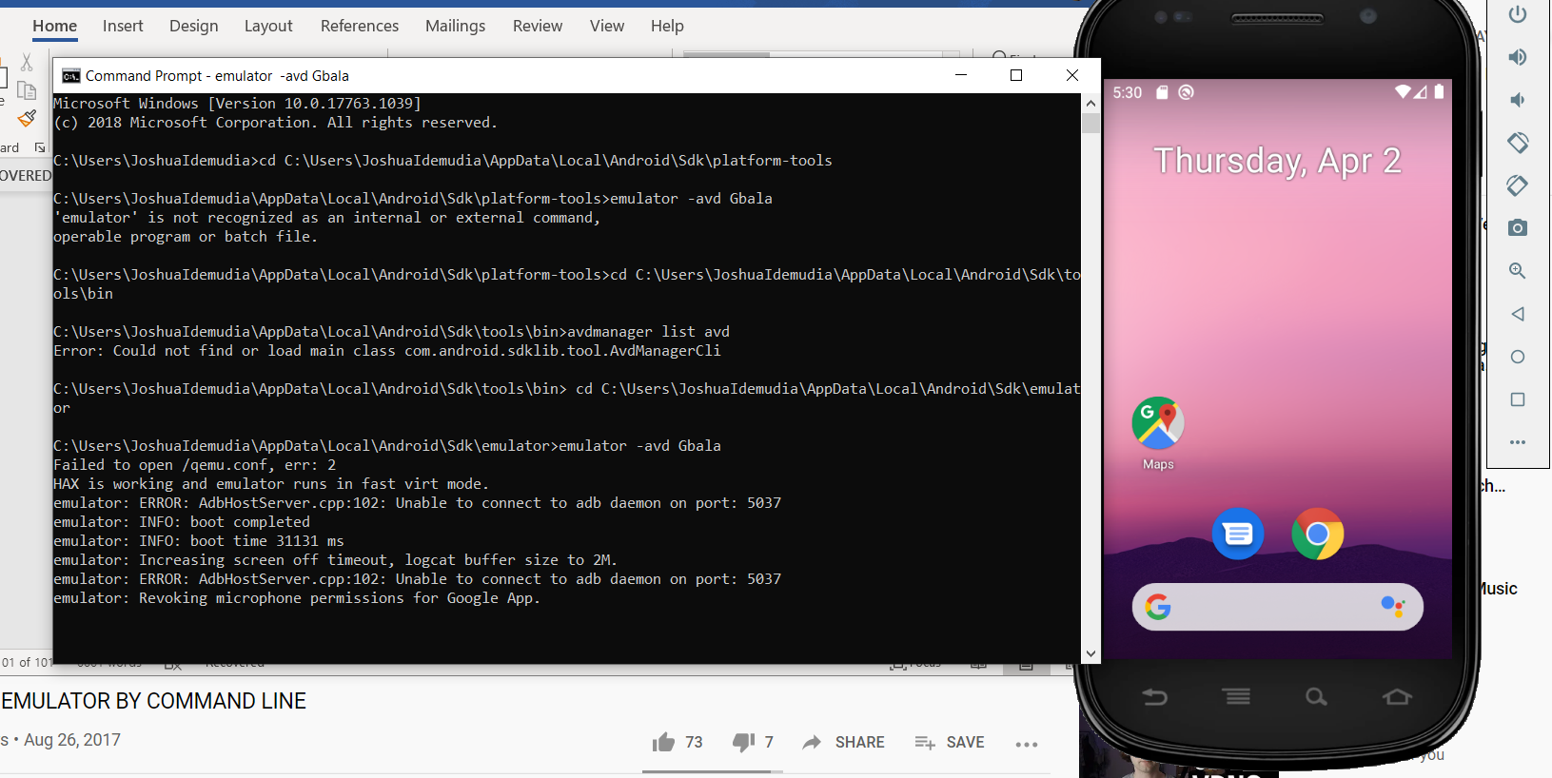

NOW DOWNLOAD NODE JS AND SAVE THE PATH

C:\Program Files\nodejs – NODEJS_HOME

C:\Program Files\nodejs\node_modules\npm\bin

NOW LETS DOWNLOAD APPIUM

Appium has two parts client and server.

Client in this case is JAVA cleient jars……

Client communicates with the server. Run your code sends to server and server listens

Since we downloaded and saved npm…. We can use the command promp to download Appium server

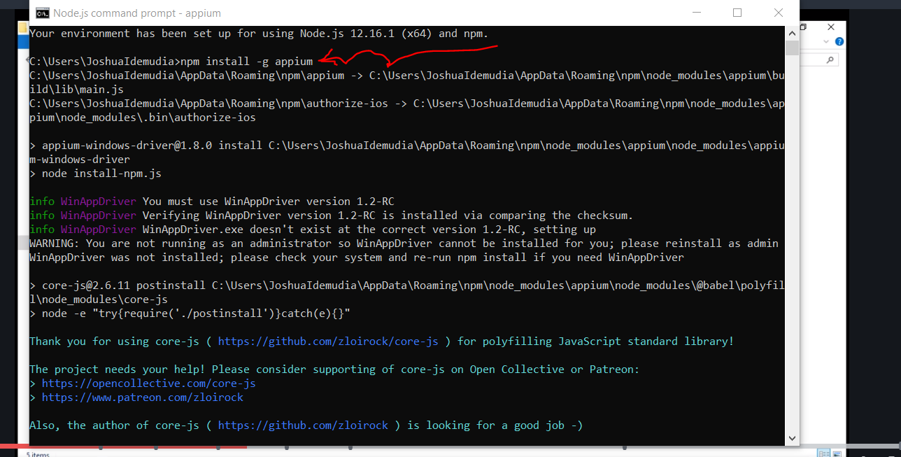

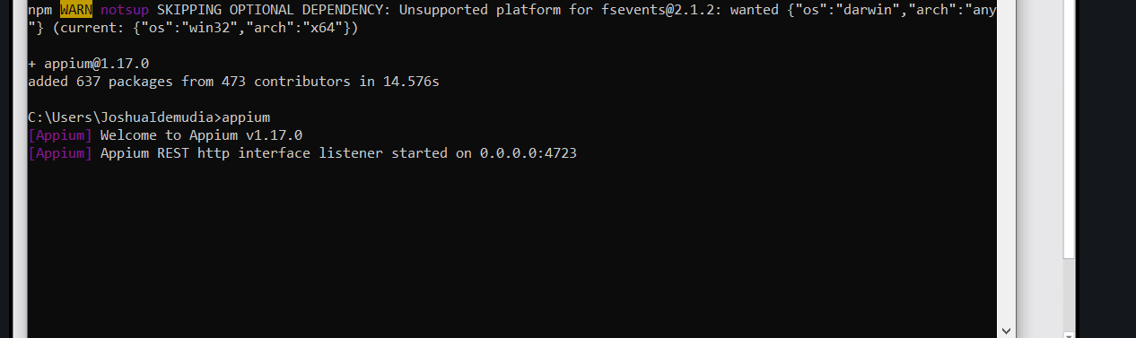

Appium client next

Just extra note

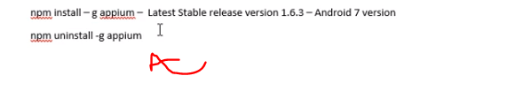

Alternatively

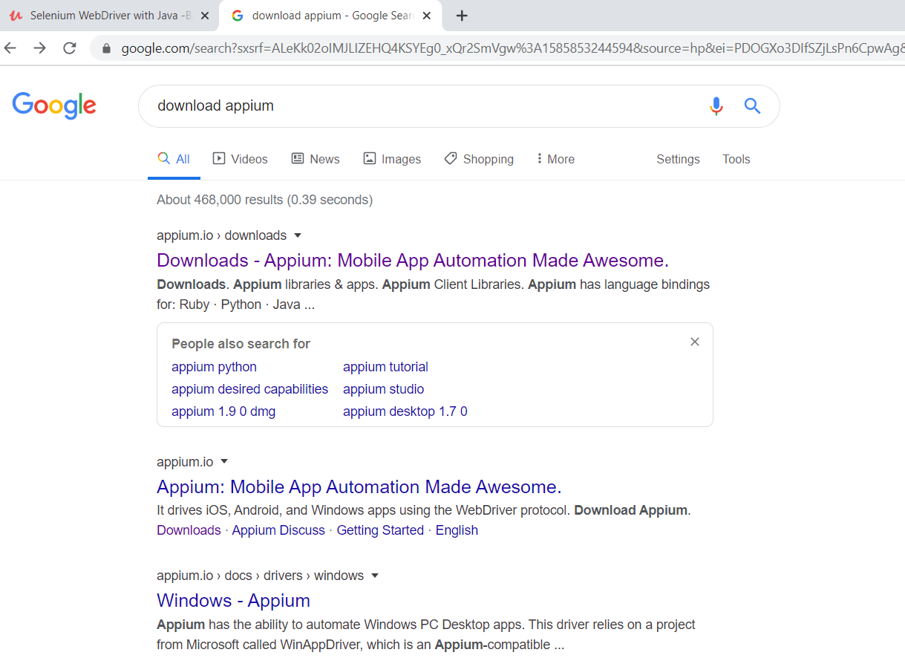

But we want the client now we already got the server

Click Appium client for java download jar and add to java build part for the project.

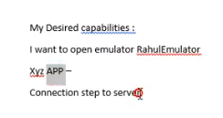

Now we create class but he done something funny while writing the code he added strange stuff..i just downloaded it… 

He pasted it to his source folder.

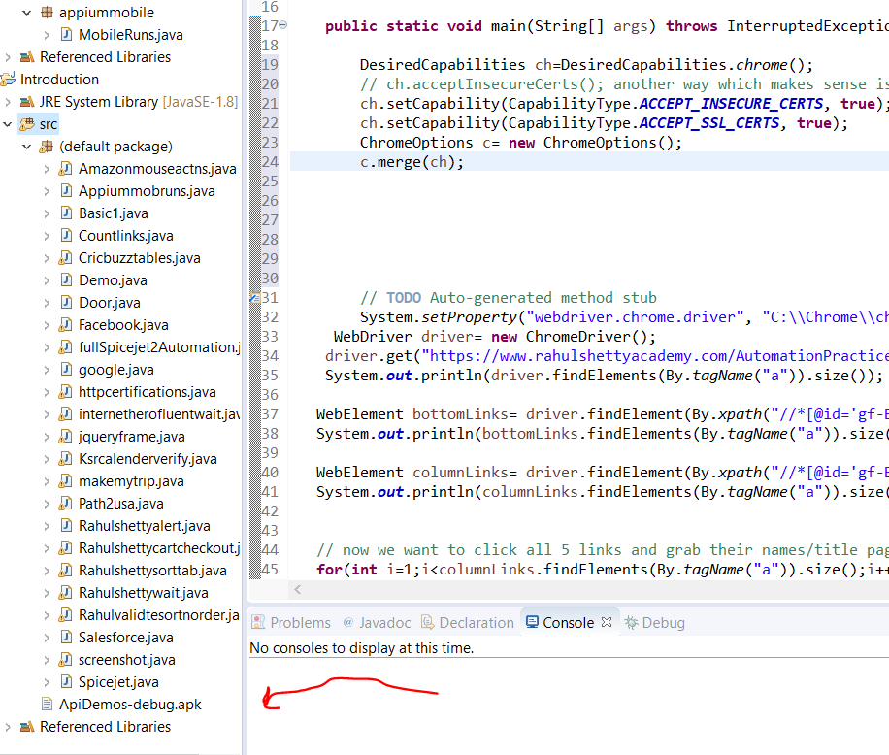

Right click on it and select properties and pass it into the code also remember I name my device gbala.

This is so cool instead of writing the link and copying it we just wrote this code

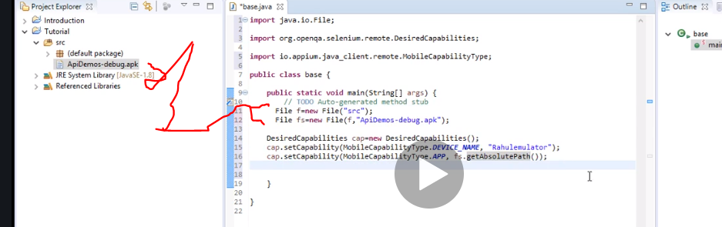

Now from my Appium I could see my url

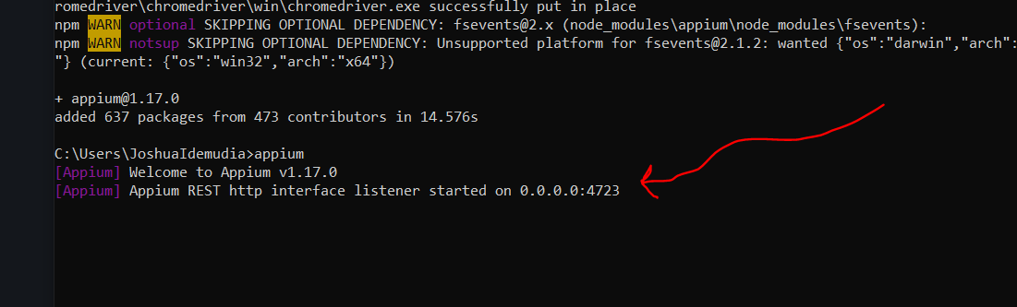

Which means http//127 ……its always 127 it’s the local host for every mission

So it http://127.0.0.1:4723

Code is wrong

**import** java.io.File;

**import** java.net.MalformedURLException;

**import** java.net.URL;

**import** java.util.Iterator;

**import** java.util.Set;

**import** org.openqa.selenium.By;

**import** org.openqa.selenium.Keys;

**import** org.openqa.selenium.WebDriver;

**import** org.openqa.selenium.WebElement;

**import** org.openqa.selenium.chrome.ChromeDriver;

**import** org.openqa.selenium.chrome.ChromeOptions;

**import** org.openqa.selenium.remote.CapabilityType;

**import** org.openqa.selenium.remote.DesiredCapabilities;

**import** io.appium.java_client.andriod.AndriodDriver;

**import** io.appium.java_client.andriod.AndriodElement;

**import** org.openqa.selenium.android.AndroidDriver;

**import** io.appium.java_client.remote.MobileCapabilityType;

//this involves counting a specific area on the webpage.limiting webdriver scope by selecting an area

**public** **class** Appiummobruns {

**public** **static** **void** main(String[] args) **throws** MalformedURLException{

File f = **new** File("src");

File fs= **new** File(f,"ApiDemos-debug.apk");

DesiredCapabilities cap=**new** DesiredCapabilities();

// ch.acceptInsecureCerts(); another way which makes sense is to just invoke both ssl and insecure permissions

cap.setCapability(MobileCapabilityType.***DEVICE_NAME***, "Gbala");

cap.setCapability(MobileCapabilityType.***APP***,fs.getAbsolutePath());

AndriodDriver<AndriodElement> drive=**new** AndriodDriver<>(**new** URL("http://127.0.0.1:4723/wd/hub"),cap);

}

}

Whyyyyyyyyyyyyyyyyyyyyyyyyyyyyyyyyyyyyyyyyyyyy

Ui automator I dnt even have …….. this didn’t go well…. Need to redo mobile automation.

Testng…this is a testing frame work

Now we created new java project and in src we made package.

Public main when you remove it doesn’t run and when u use it it say run as java applicatiin but if u use annotation @test then it automatically runs it as testng.

Next using xml…. Note you can trigger multiplr test from a single class

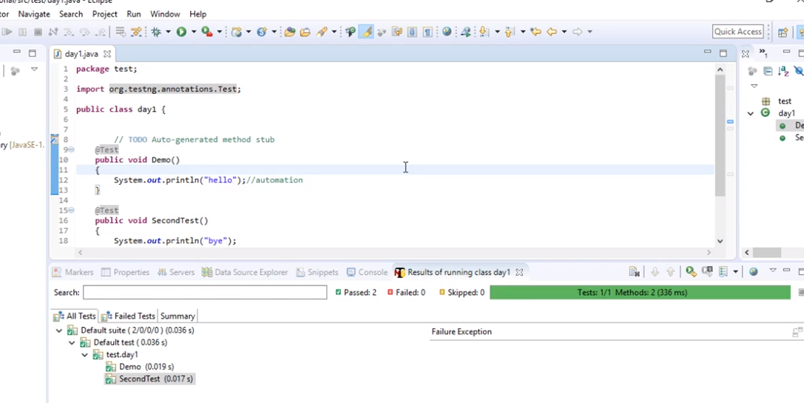

U can also run all from xml file

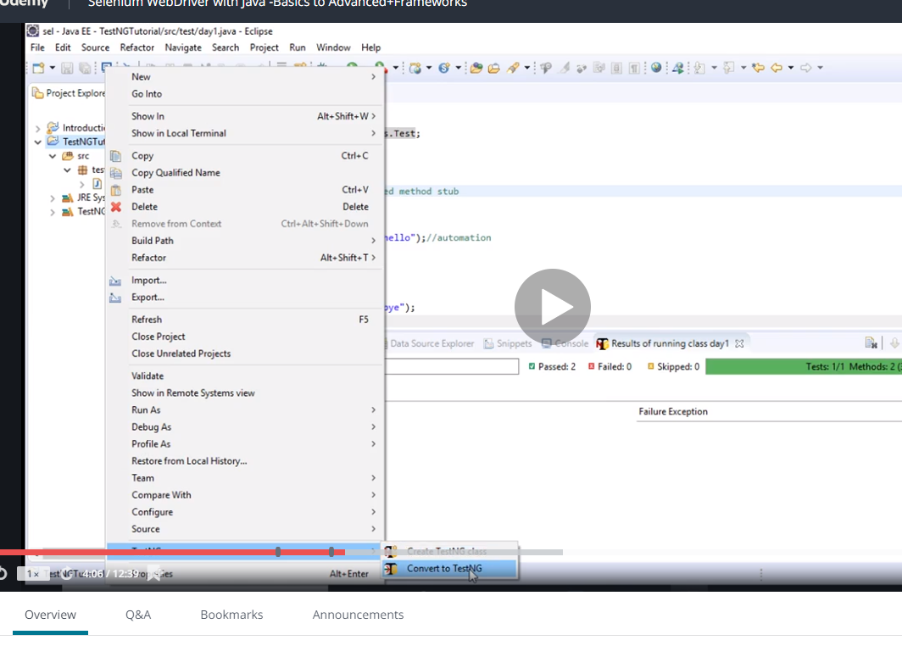

Right click your project---test ng----convert to testng

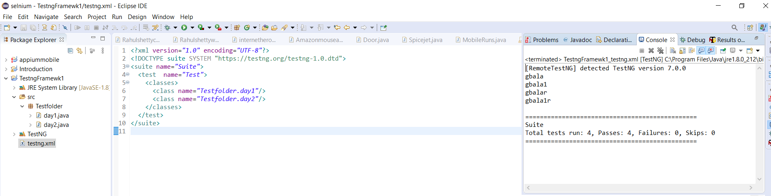

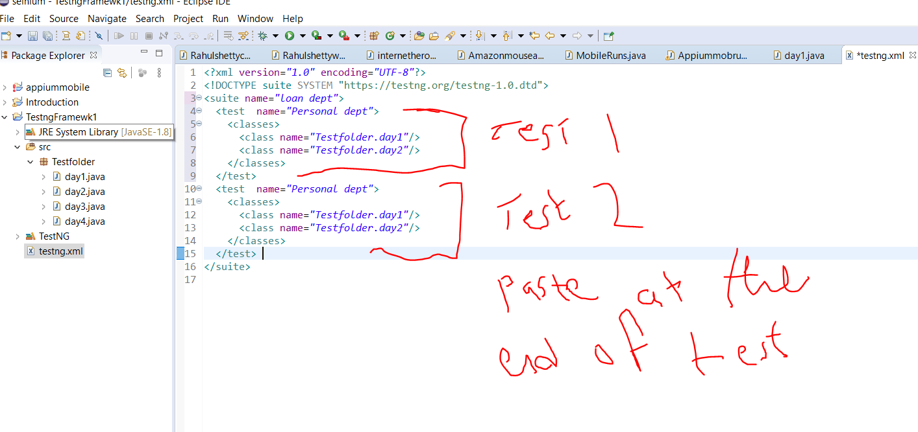

That’s how to separate test cases

If you want to run just one testcase in a very folder u want to skip one and run the rest

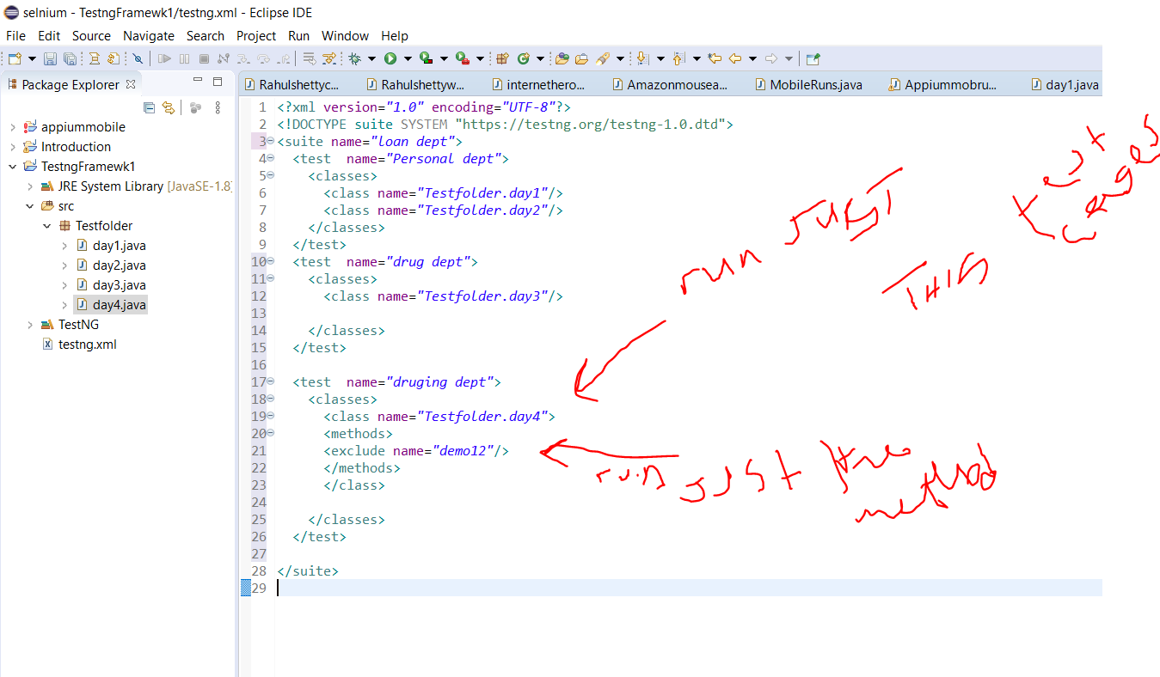

You can exclude test cases and methods and you can also include. Above is exclude

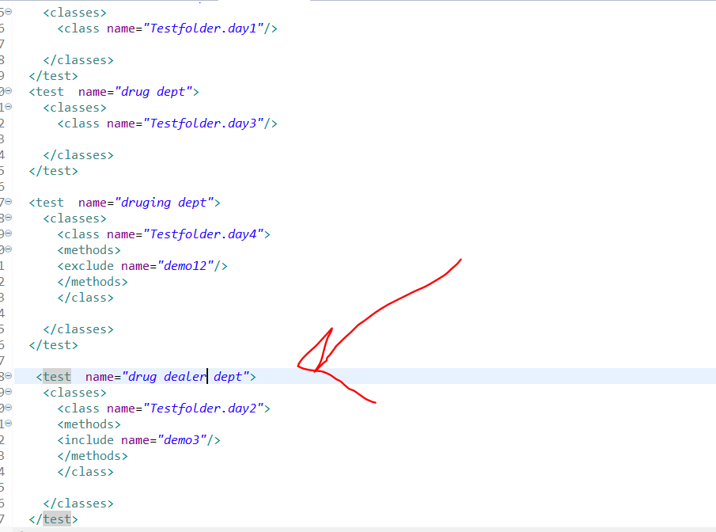

Now payattention…when you write your framework it is important to find a word that is similar to all other cases and methods….so if you are told to delete 40 test cases from 100…that’s crazy but because you have a testing convention ll you do is call the name and do. *

Exclude Mobile.*

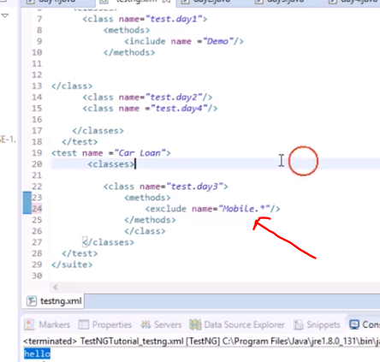

Now if you want to run all the test cases u run the package

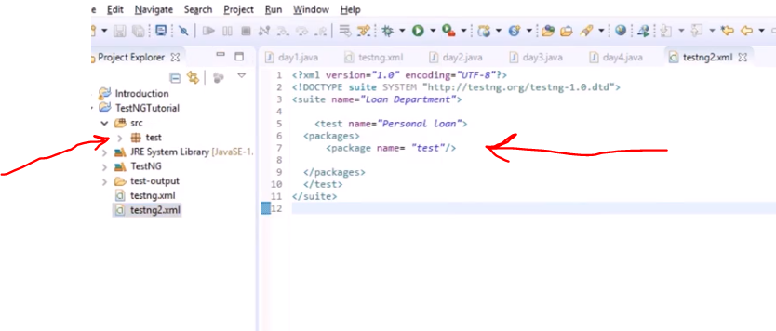

Now lets discuss before annotation

So what tesng does if you have two test suite a and B…. it will run a as normal but when it get to B, it will run the method with@beforetest first before any other method.

@Aftertest is also used at the end of the test maybe to print or get report or close browser.

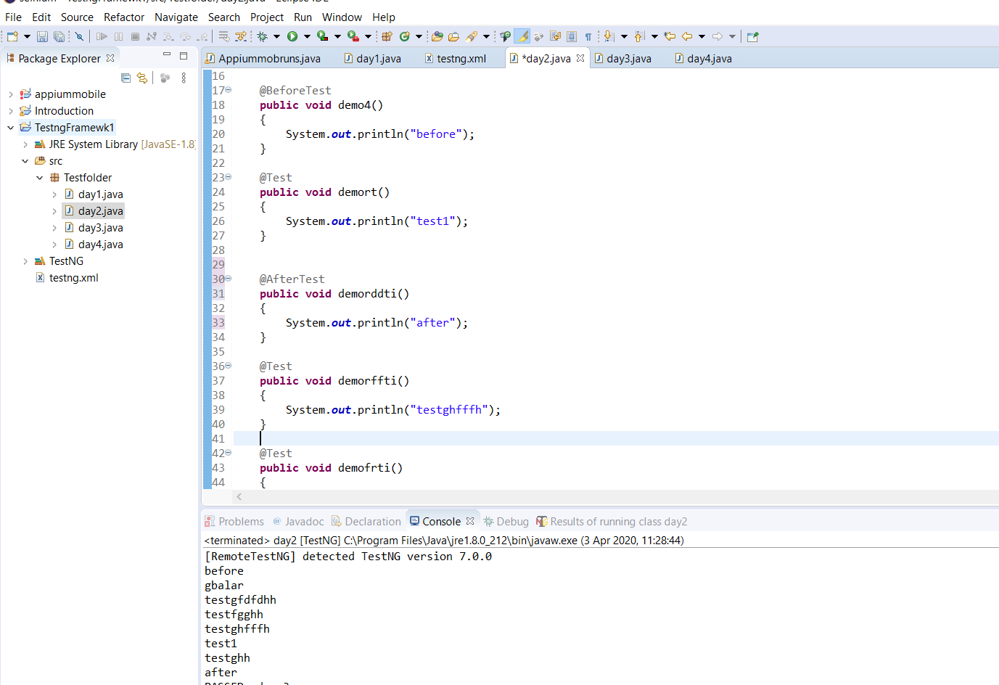

So if suite has testcase 1 2 3 4 5…. It will read the one with before first and read the method with after last so if 1.1 has before and 4.3 has after..the order will be

* 1. , 1 ,2 ,3 ,4 ,5 ,4.3

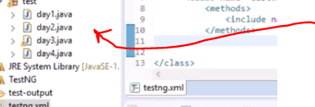

If day 2 has before suit….it will run that method and that suite first then continue and run the day 4 last with the aftersuit.

Now we also have before and after suite which means….. it runs the suite first …irrespective of how many test cases are in it after running all then it carries on running other suits…

So suite b4/after first and then before /after test then normal test that’s the order of annotation.

So what it does it runs the method with suit first, then it goes and start executing the classes like normal but while doing this when it gets to aclass with a before test it handles it first in that very class or if it is an after but once it finishes it comes out of that class and moves to the next and then i. it runs the after suit method last. Test suite b4/after is useful for arranging methods in a package packages while normal before/after is good for arranging methods in a class

Note there is another called before method

@Beforemethod….this just says execeute this method first before running the other methods so for test 1 2 3 it will first run beforemethod for 1 2 3 this is important if you want to clean or for fresh data before the actual method starts.

@aftermethod same idea but after the method then do something ….to all the methods….its like before method….before put on shirt belt trouser…. Clean it at every three point after method is after wearing every item look at the mirror….

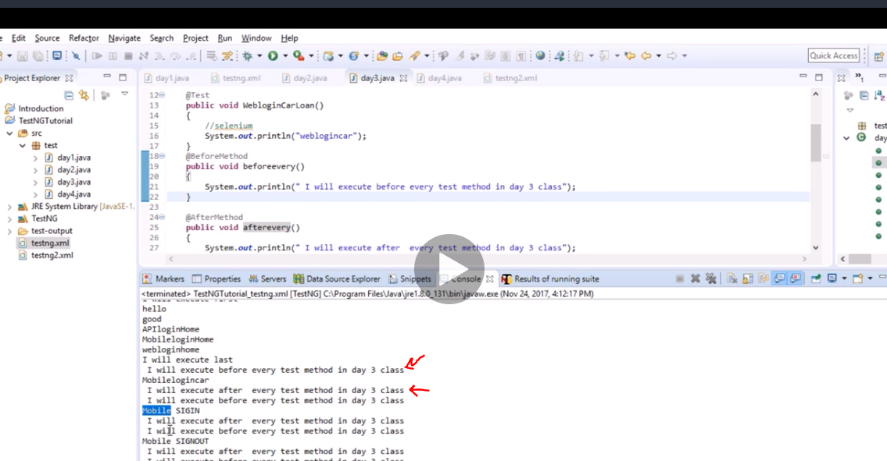

Ater and berore class is just between the class.

Also note something…testng simulates in alphabetical order from up to down.

Say you just want to run some specific test and you just dnt know how to do it……we use groups

Now

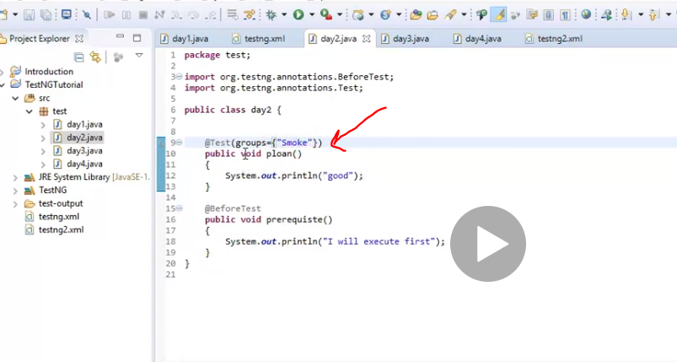

Here the tag is smoke to that test case

So we will tell xml to execute only cases with this tags called groups

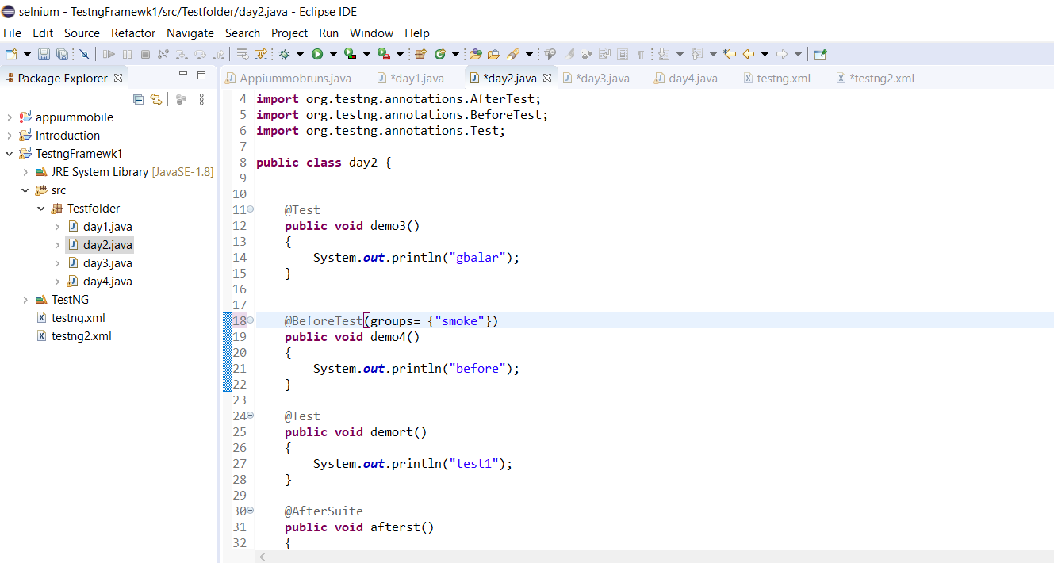

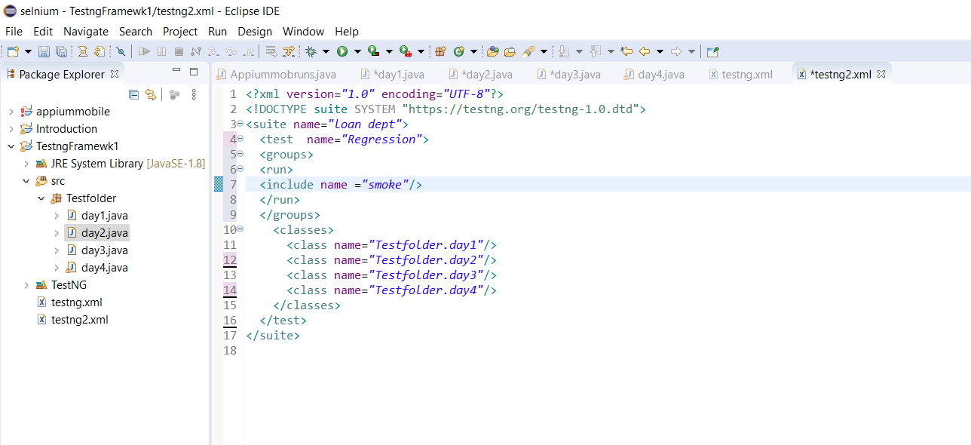

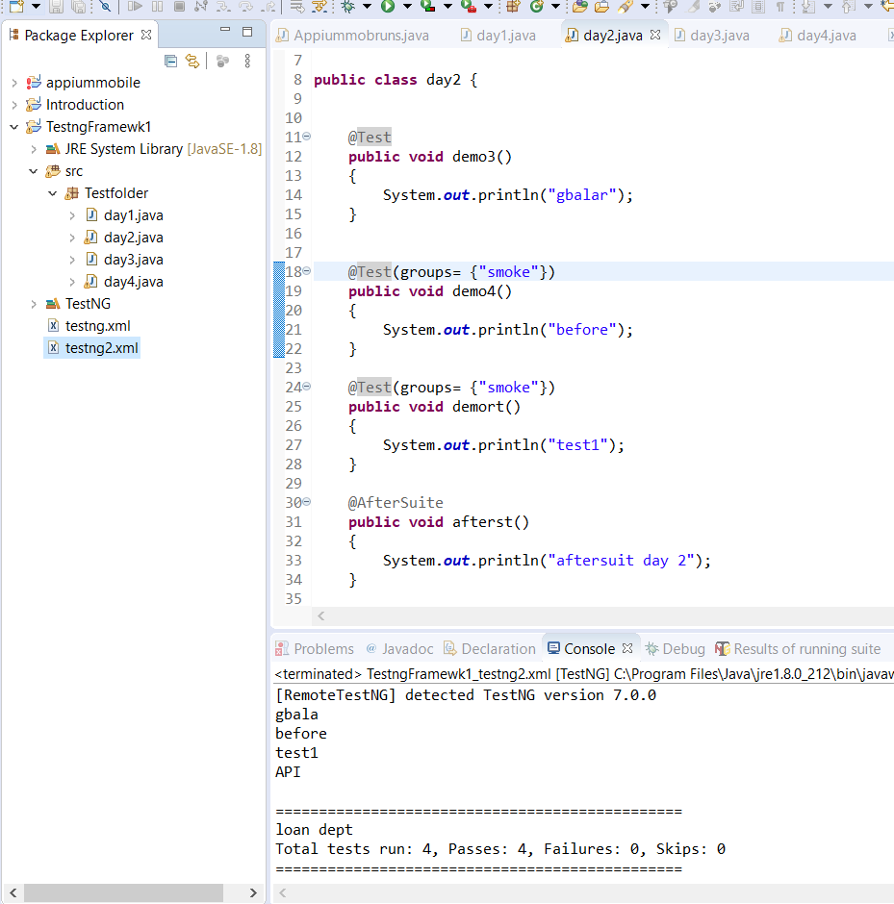note they all have to be @test….. if not it will run but will say its 3 test instead of 4

You can exclude group aswell

Now there is a depency to run one after the other

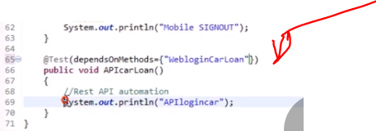

So run carloan first then run the api next

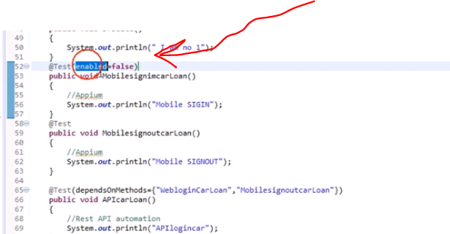

This will be skipped during execution

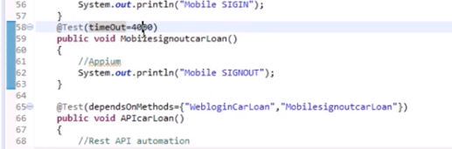

Run for 40 sec before fail.

Now we will have properties class soon….but now how to drive parameters now from xml.

No hard coding all main details comes from a file.

If all values are specific then just define them.

To add parameter

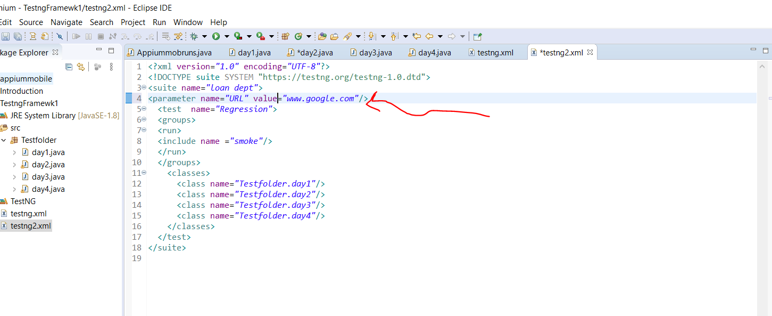

Followed by the annotation for parameter to run it on this method

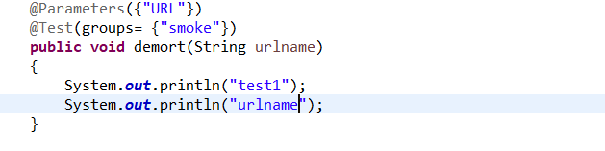

Above is suit level parametesation and below is test level

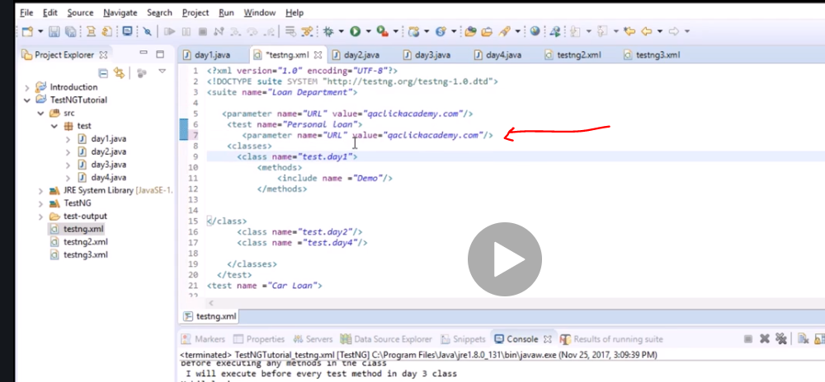

If you have multiple parameters do

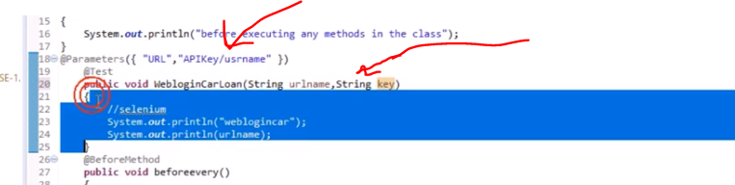

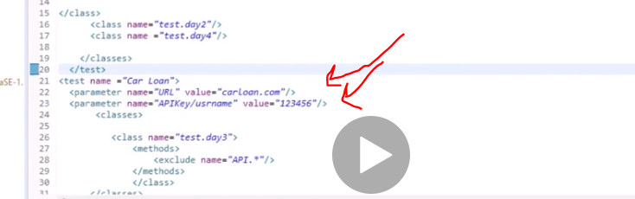

Now using data provider

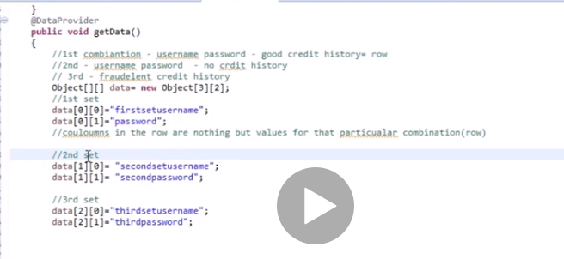

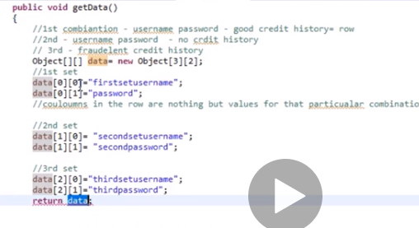

Forgot to add the return data and change thevoid to object by clicking option from return.

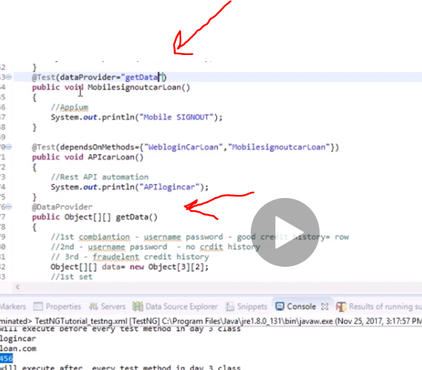

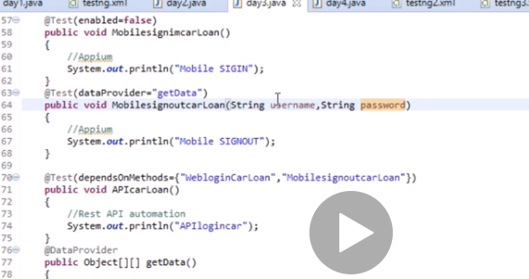

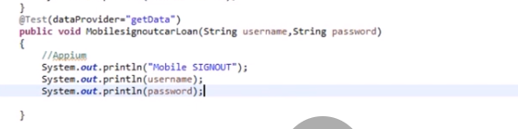

Listeners….

So when u do screenshot…its intelligence when it fails to take pic. It listens and invokes methods

Next make class called listener

We use keyword implement now we start

I dnt know what he did but the listener gave him some 6 methods. I had to write them manually 6 methods context to result.

So if it pass or fail then it will execute wht u put in it, if not it just close.

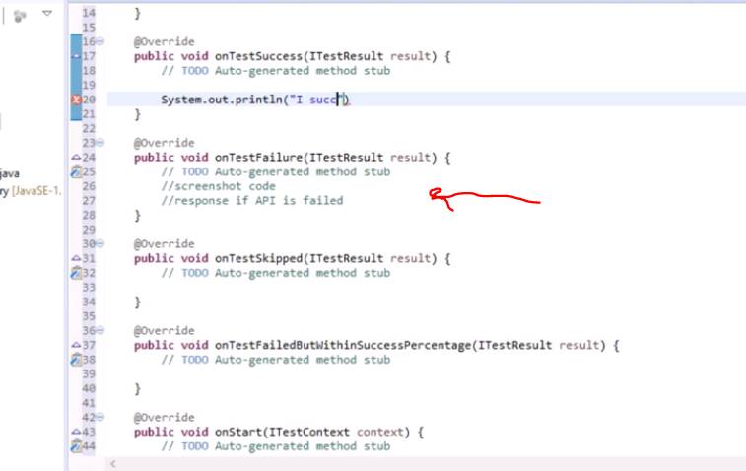

U need to tell where listener class is located

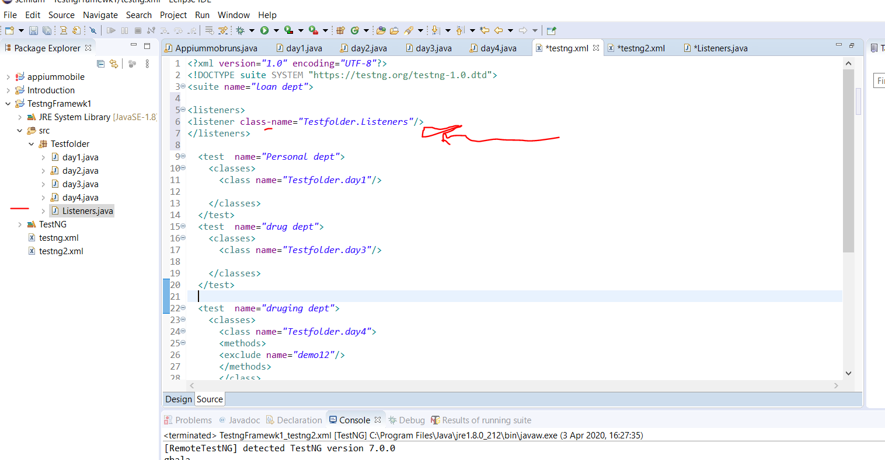

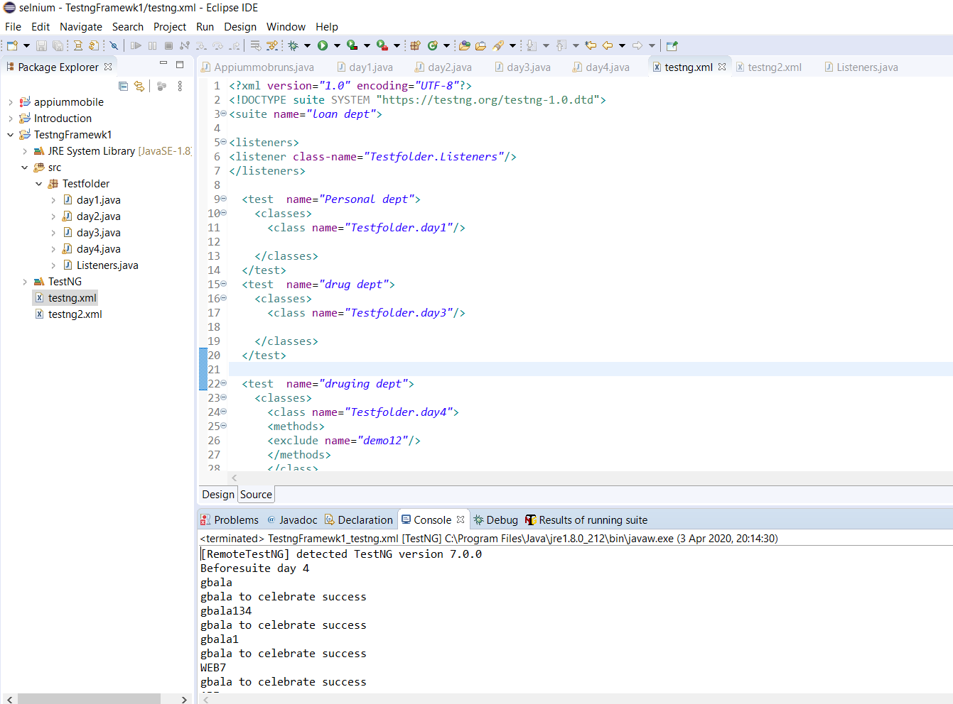

Running test parallel with testng….

You cant hit 100 testcases at the same time. This will lead to performance issue…but to run though

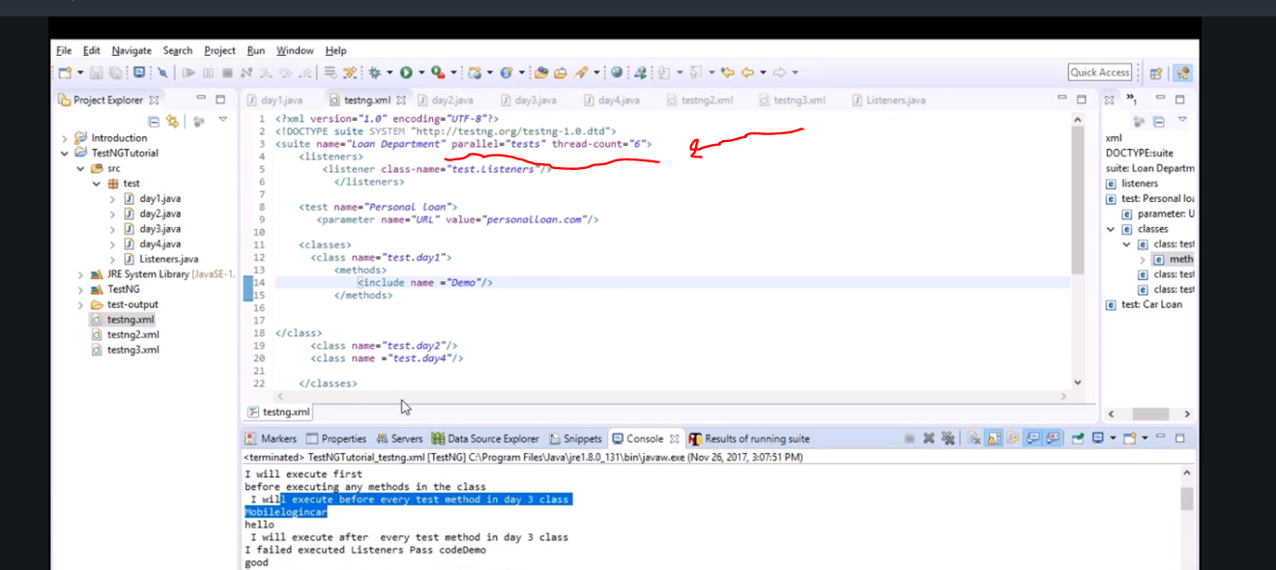

Selenium grid is better be careful with this one.

To see a report after running it, go to the java project and refresh it. Notice a test output appears

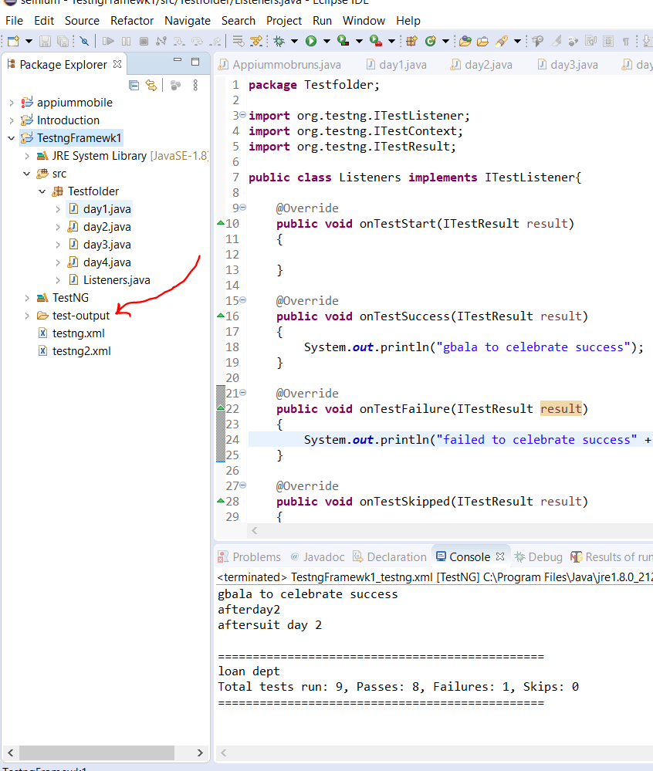

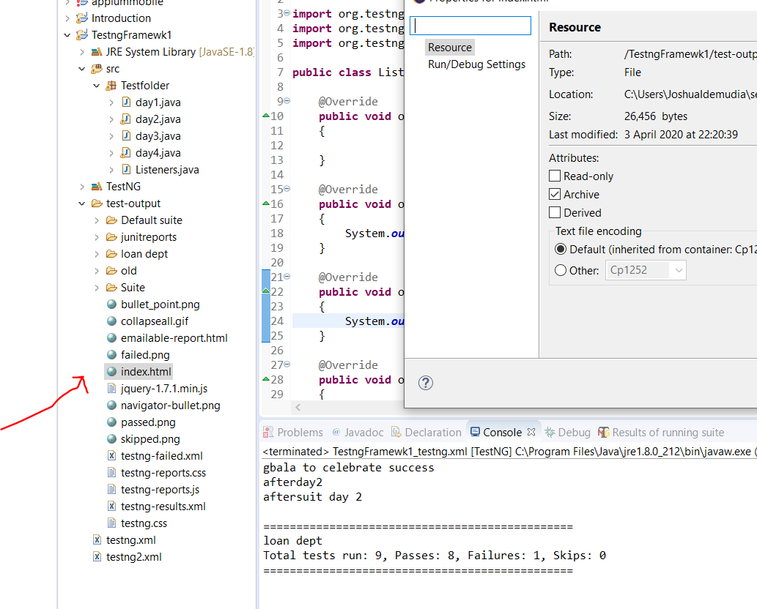

Global environmrnt

Now we dnt want to hardcode shit so we must use properties file.

At the end of the name always save it as shit.properties.

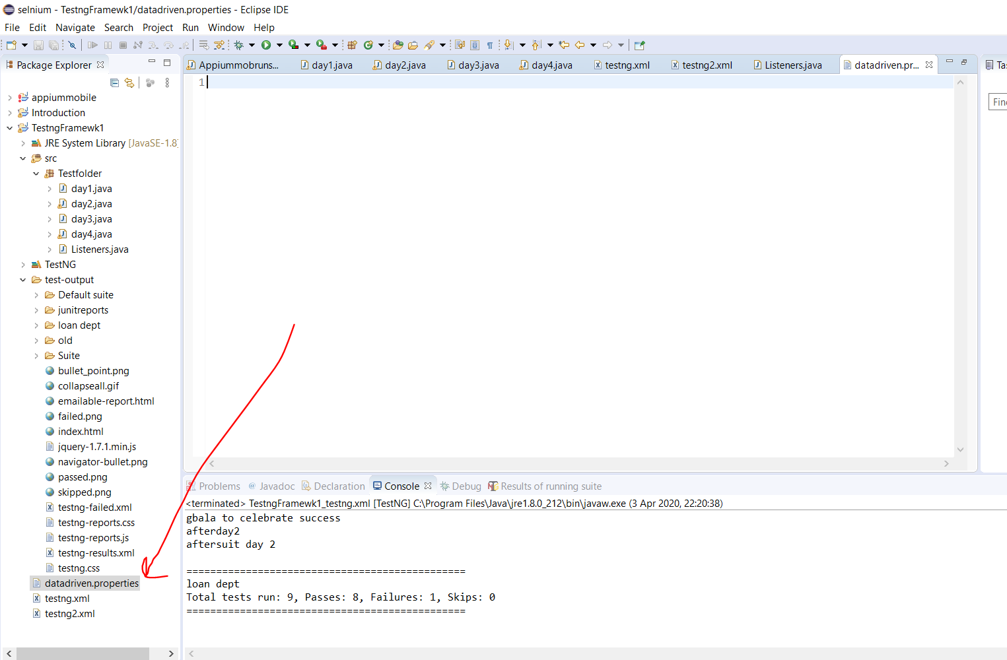

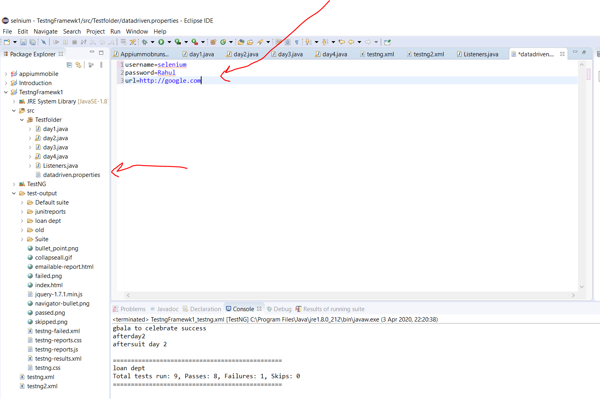

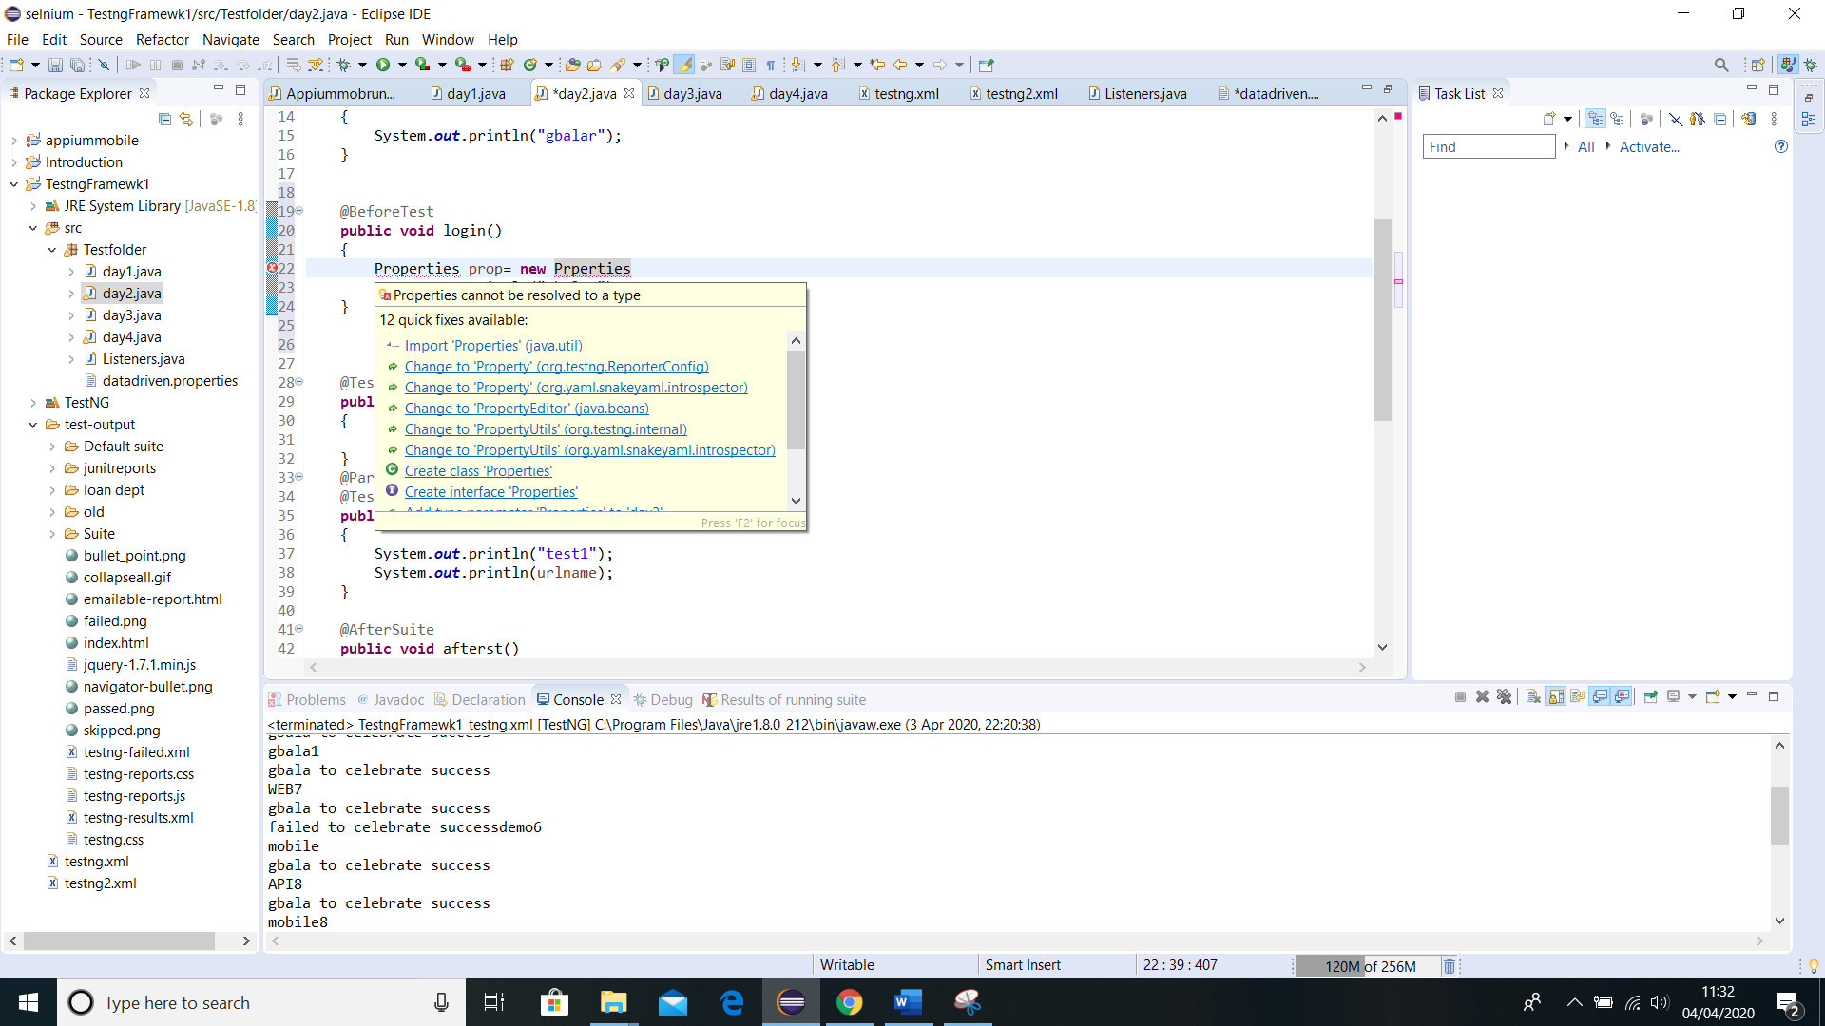

FileInputStream show the file lies by showing a path.

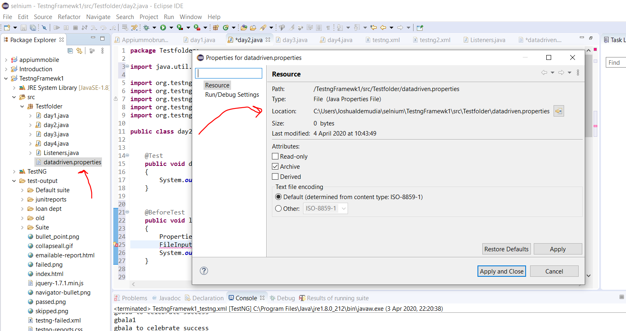

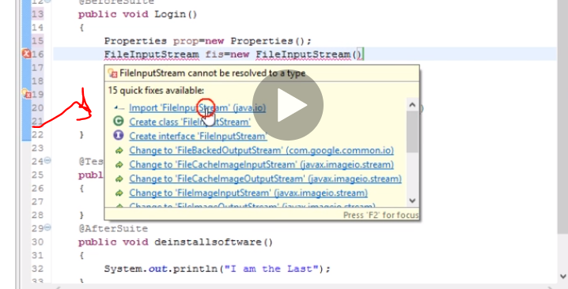

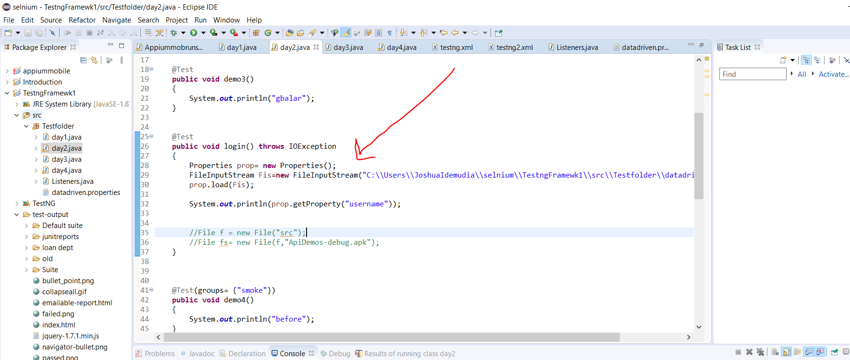

Now if your client wants to run firefox will you go and start changing everything…no so

The properties is not working …what the hell…

Lets move to maven

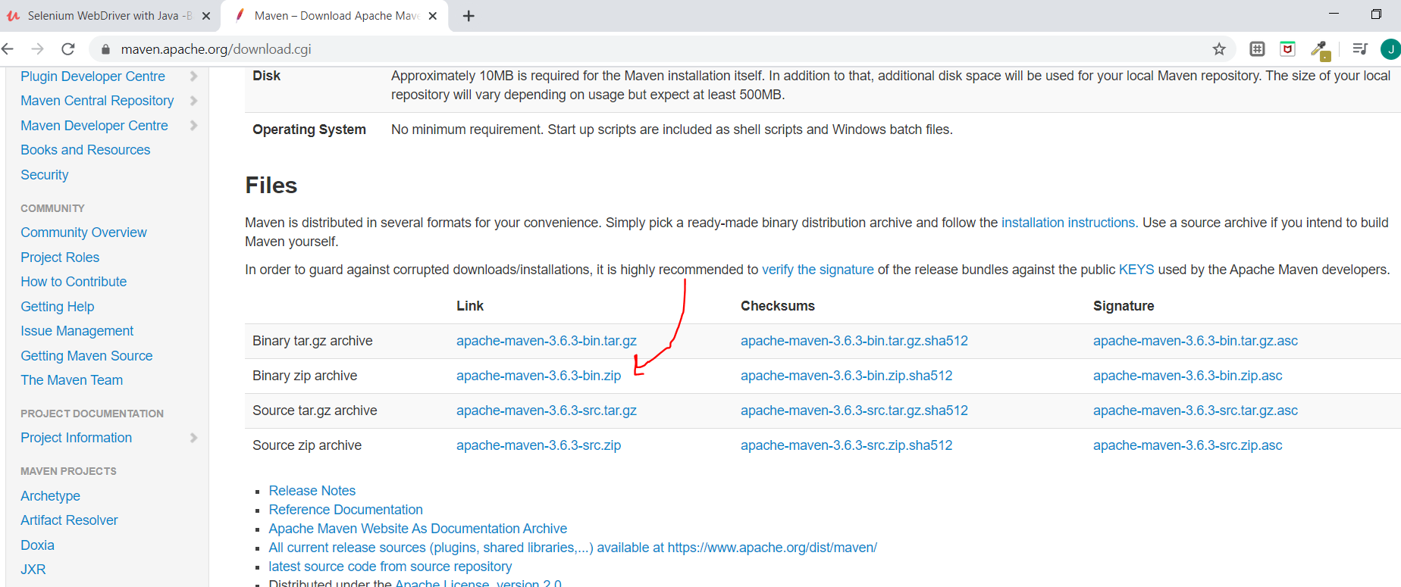

C:\Users\JoshuaIdemudia\Downloads\apache-maven-3.6.3-bin (1)\apache-maven-3.6.3 do the same for the bin. I already have them.

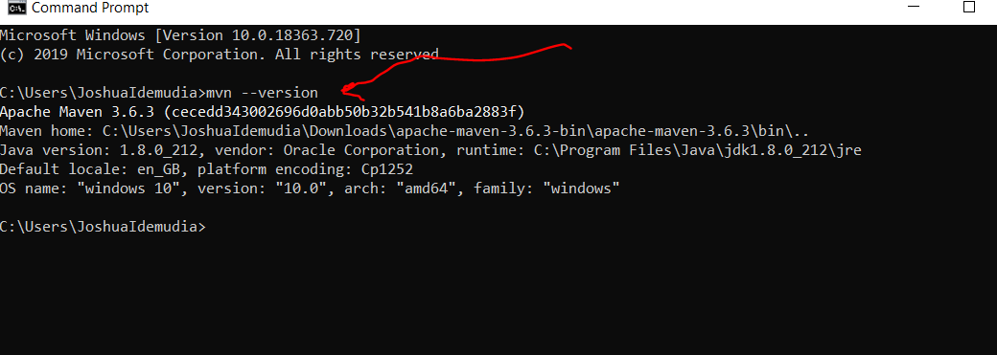

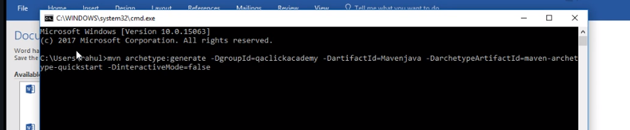

To build remember we done this already

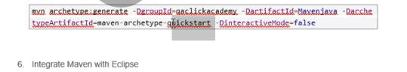

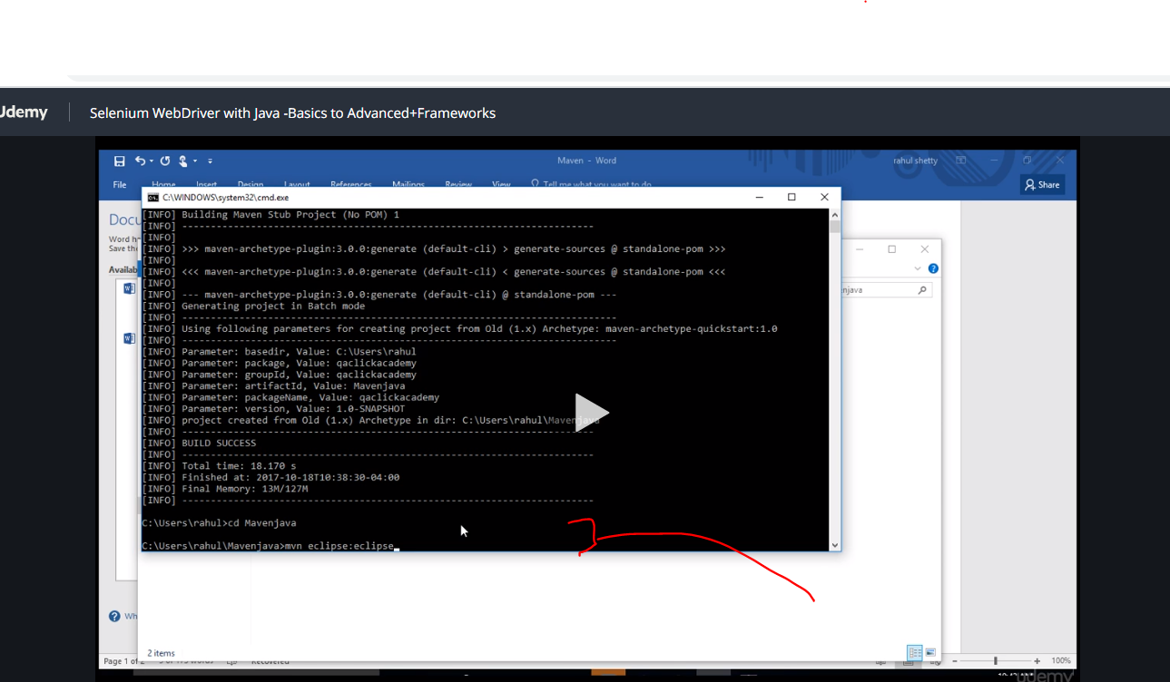

Get it to eclipse

To open file-import-maven-existing maven project

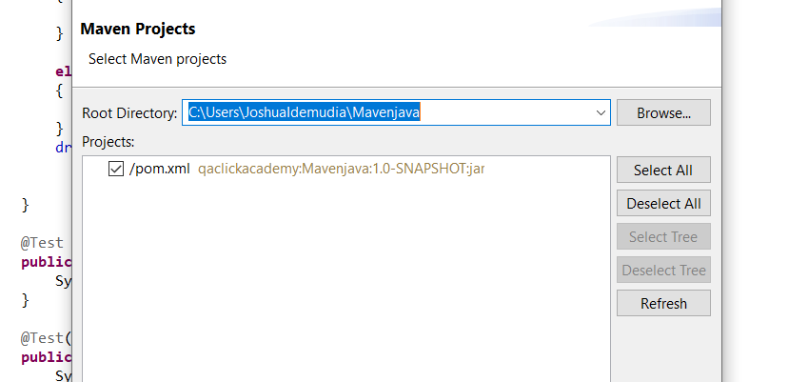

Now

To create new maven project

Go-file- new-project-maven project-search for quick start maven archeology and openg acheaology click and set up artefact names.

Click your pom and add this dependencies

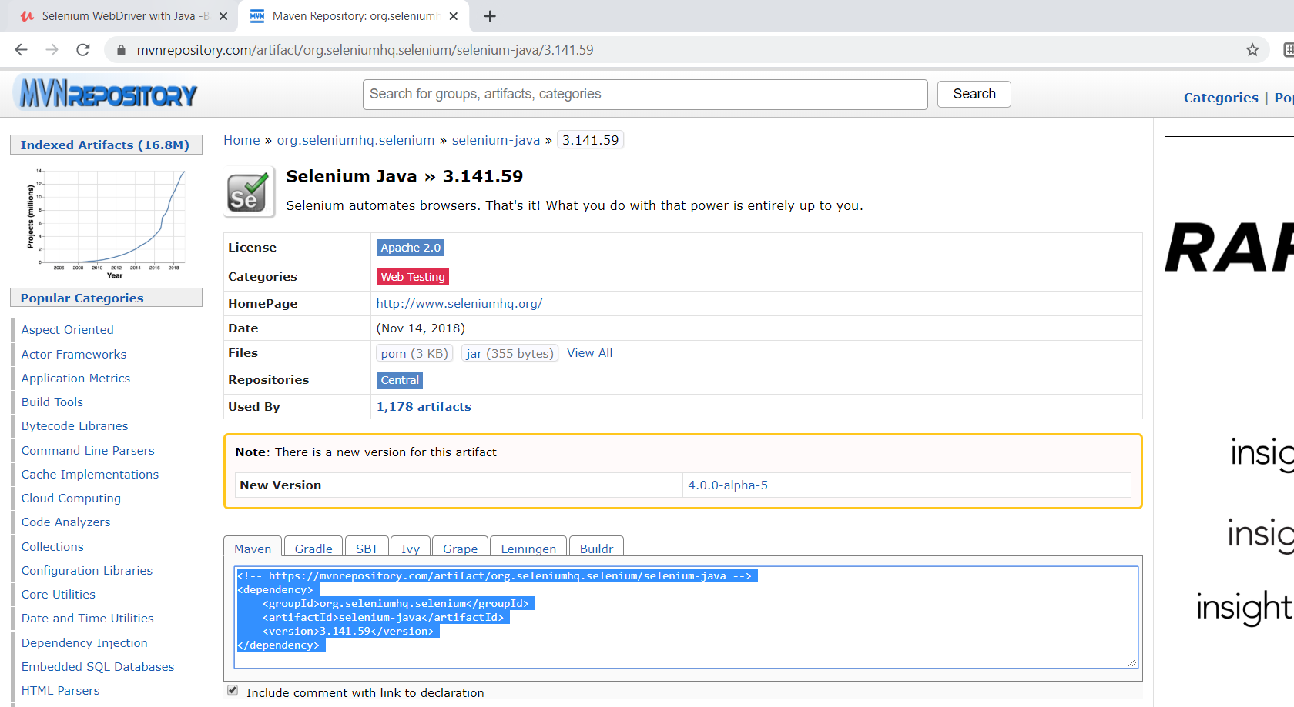

We download testng as well

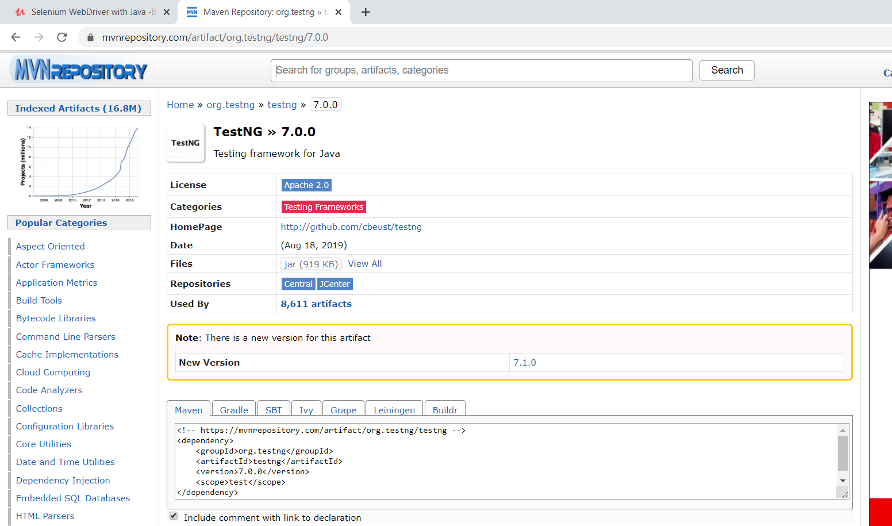

Now we need maven surefireplugin to run it

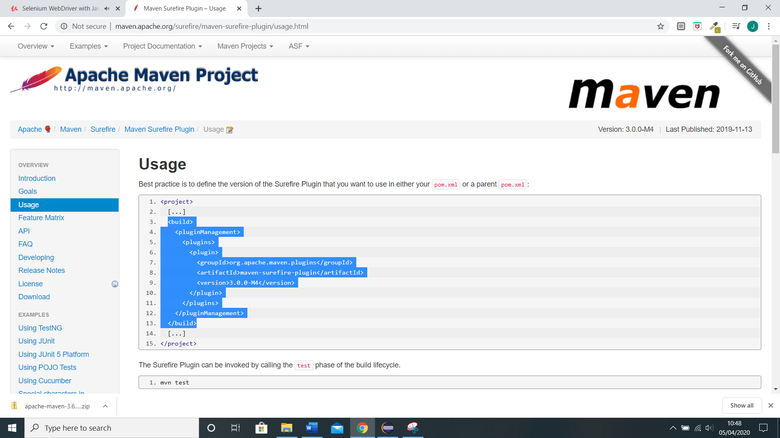

Copy from build into pom….just before dependencies..

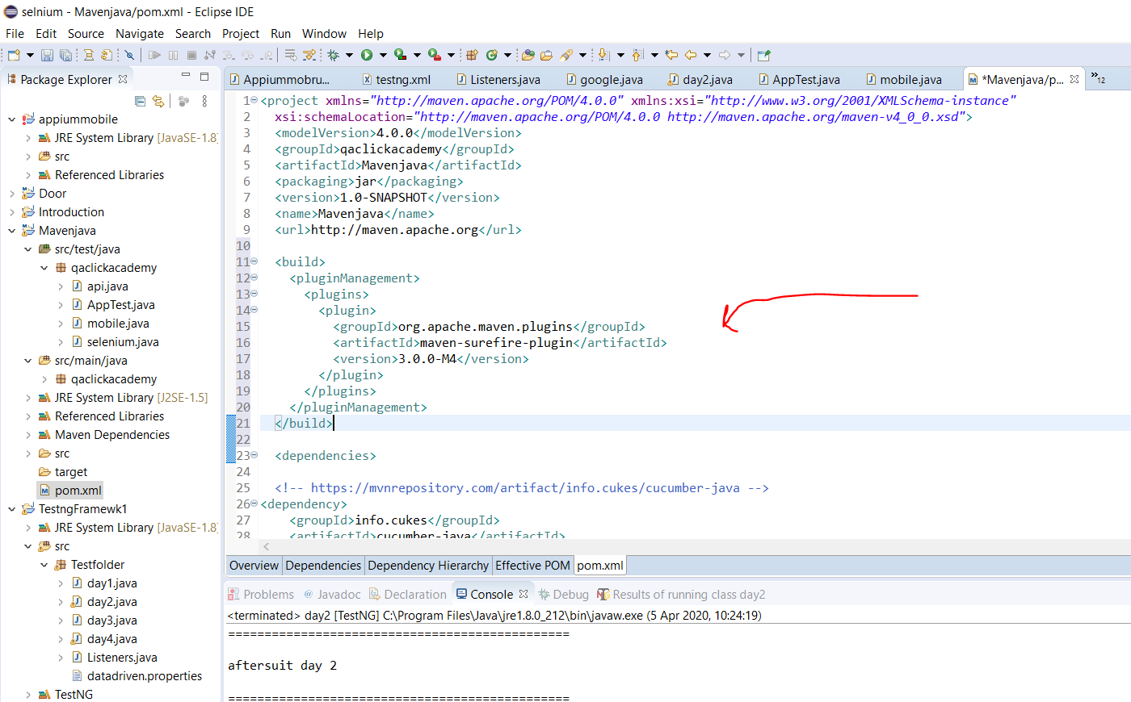

Now three things

So go to command

Mvn clean…… try to hit pom

Make sure you get the right address of the project you are working on and the use mvn clean on it.

You can right click it and go properties and copy the path

C:\Users\JoshuaIdemudia\Mavenjava

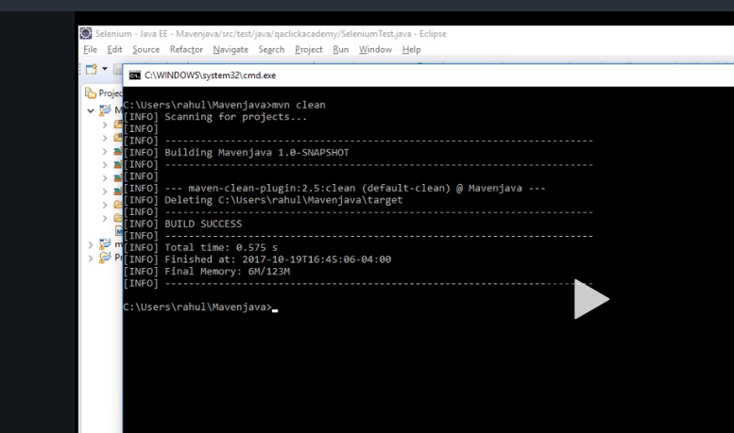

Using compile will show there is no error in your Jenkins

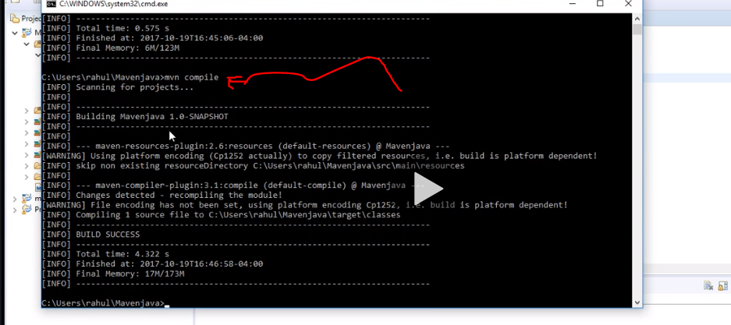

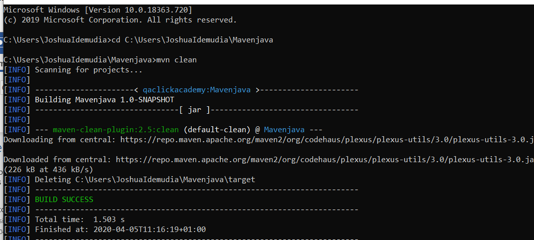

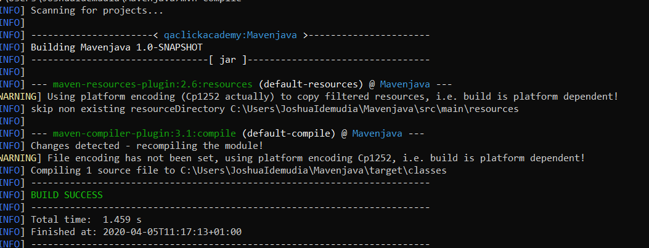

Now when u write your test….mvn test ……..always save all your test case with Test……..

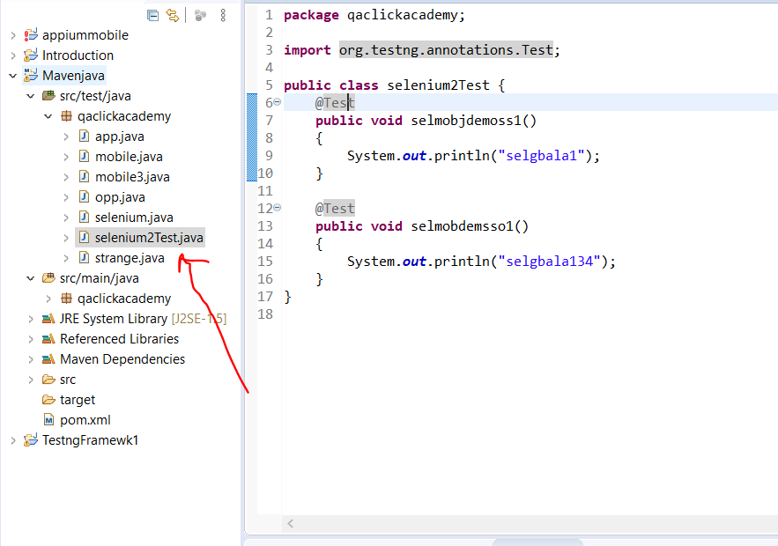

Now we executed test folder with maven now we want to trigger xml file.

To do this it is the same step just convert the maven project to xml right click and go to convert to testng like we do

Go back to the website maven sure fire

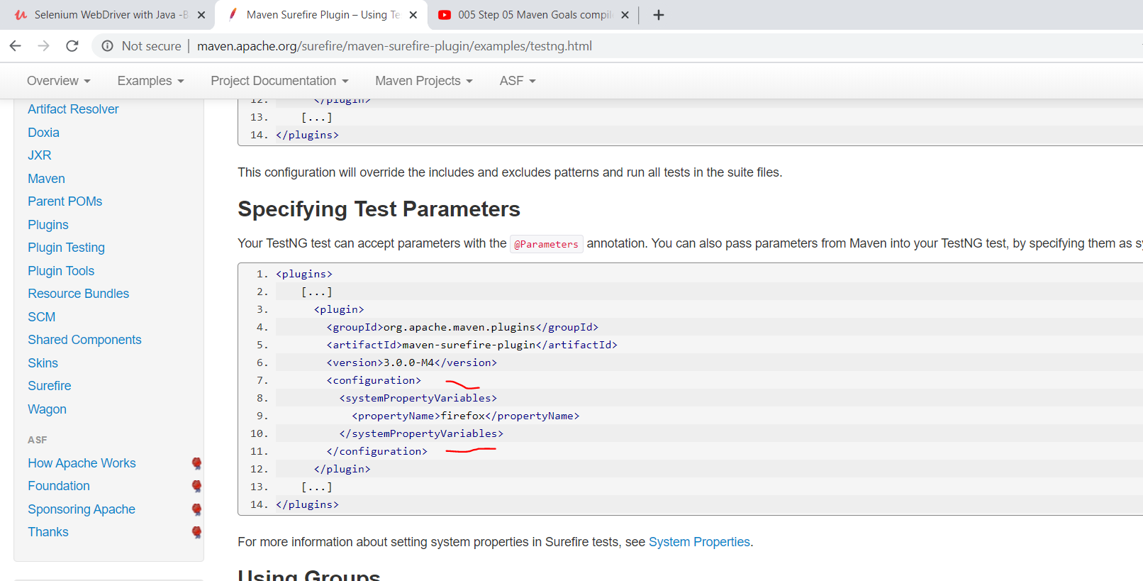

Click using testng and scroll down

Now copy the configuration and go paste it in your maven pom under version

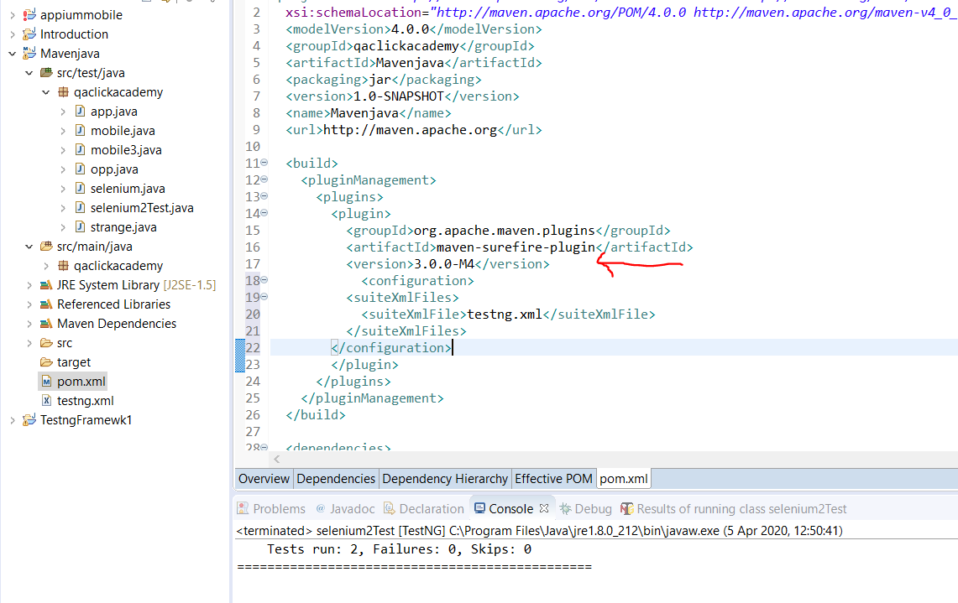

Now do mvn test will run both

If you just want to run one line from your test case not xml do this

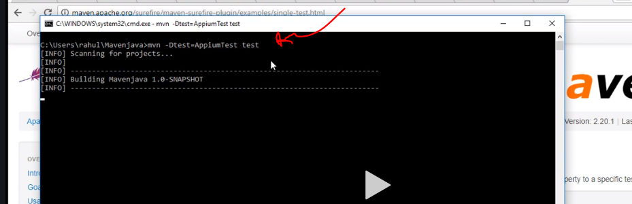

Also u can read it up single text from the surefire site.

So say you have more than one xml file and u want to run one without going to change it all the time from the pom how do we do this

We use profiling…just above dependcies create

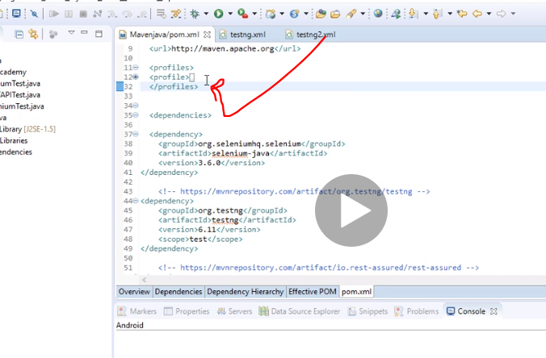

Name it regression or whatever, copy the current build into it and change the name to the second xml file

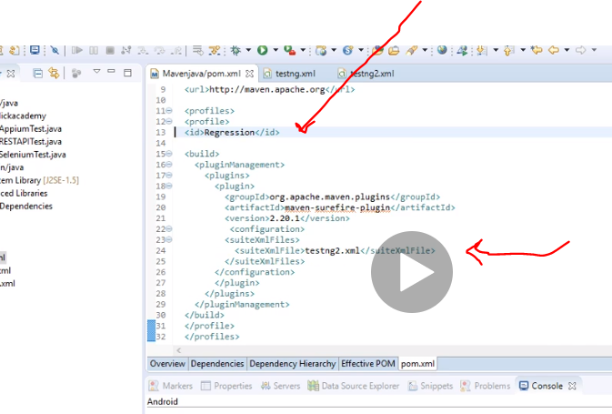

In the same way create another one and as many as you like just as a frofie child

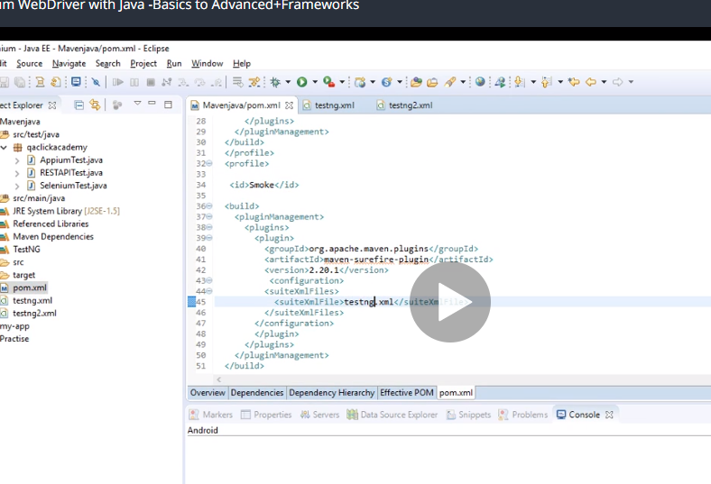

So two profiles one for regression and the other for smoke.

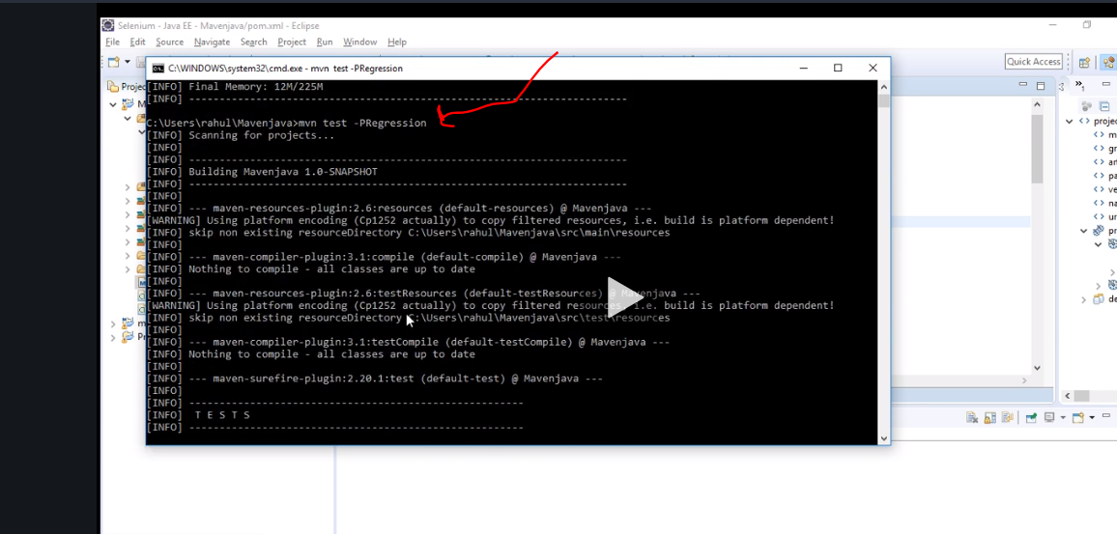

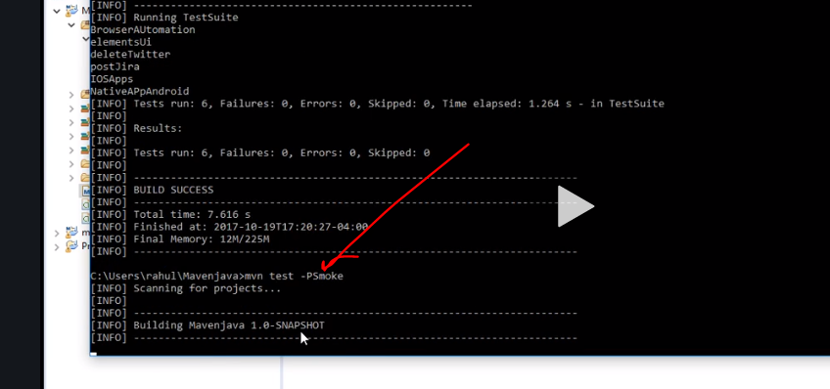

# Jenkins- Start

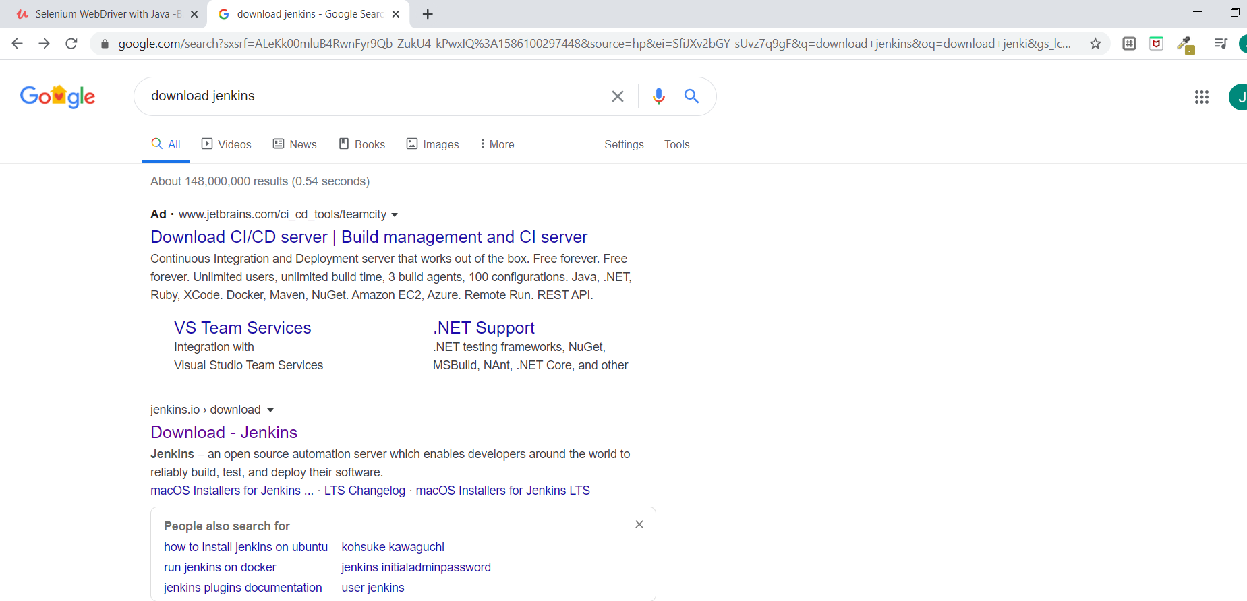

Download the war at the bottom because we are using it as windows service so we are not hosting it on any servers

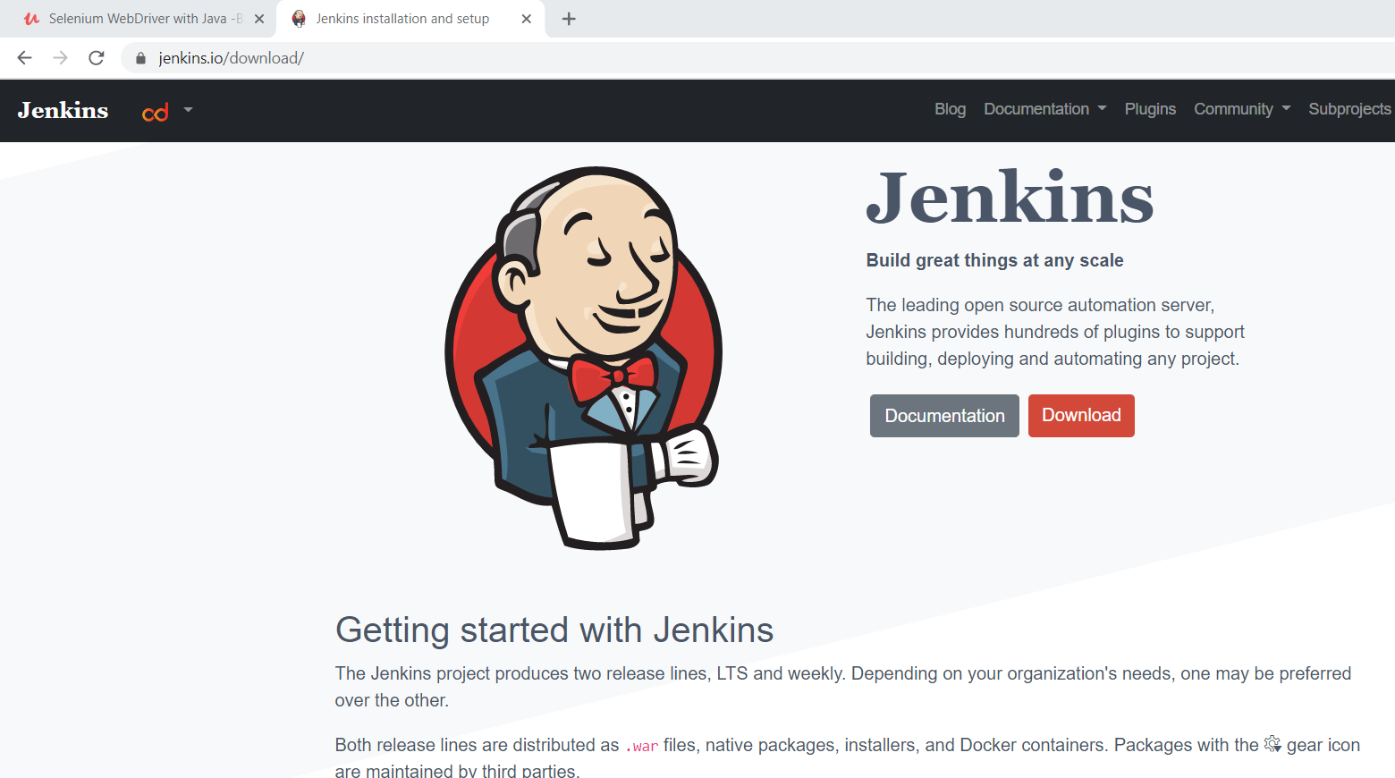

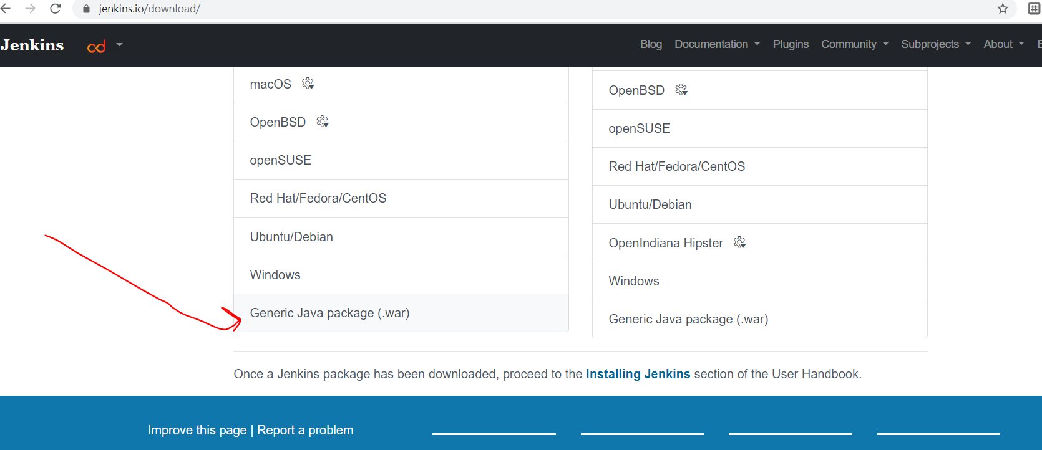

The command to give your server is

First go where your jenkin war file is located

C:\Users\JoshuaIdemudia\Downloads

C:\Users\JoshuaIdemudia\Downloads>java -jar jenkins.war -httpPort=8080 but he said 9090 which must be wrong.

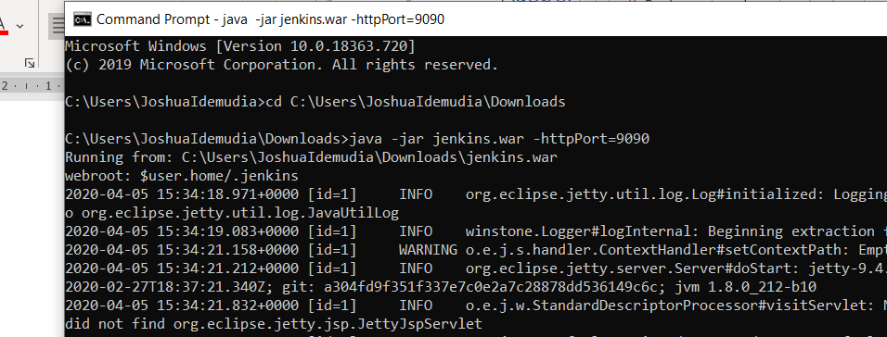

“

*************************************************************

*************************************************************

*************************************************************

Jenkins initial setup is required. An admin user has been created and a password generated.

Please use the following password to proceed to installation:

65d01d7e8877402eafafa11da8fe578a

This may also be found at: C:\Users\JoshuaIdemudia\.jenkins\secrets\initialAdminPassword

*************************************************************

*************************************************************

*************************************************************”

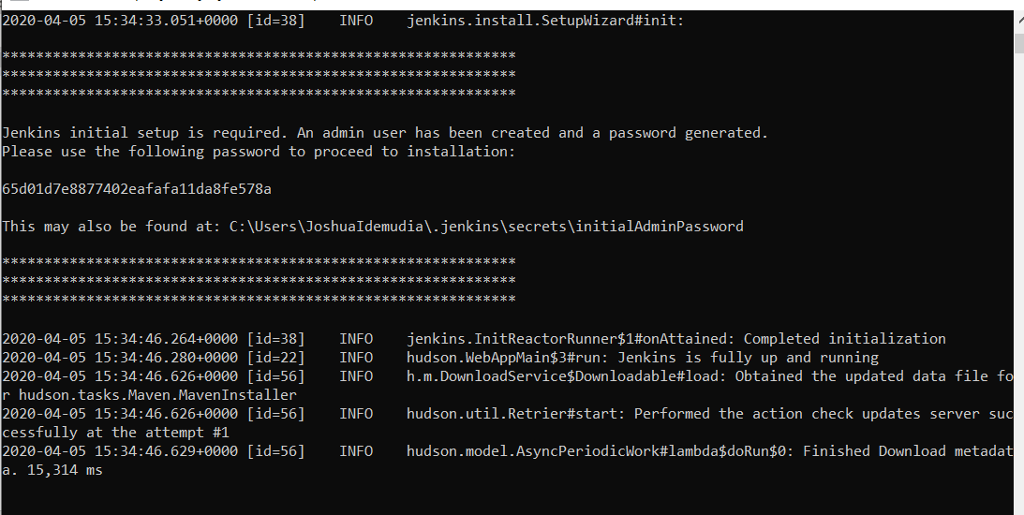

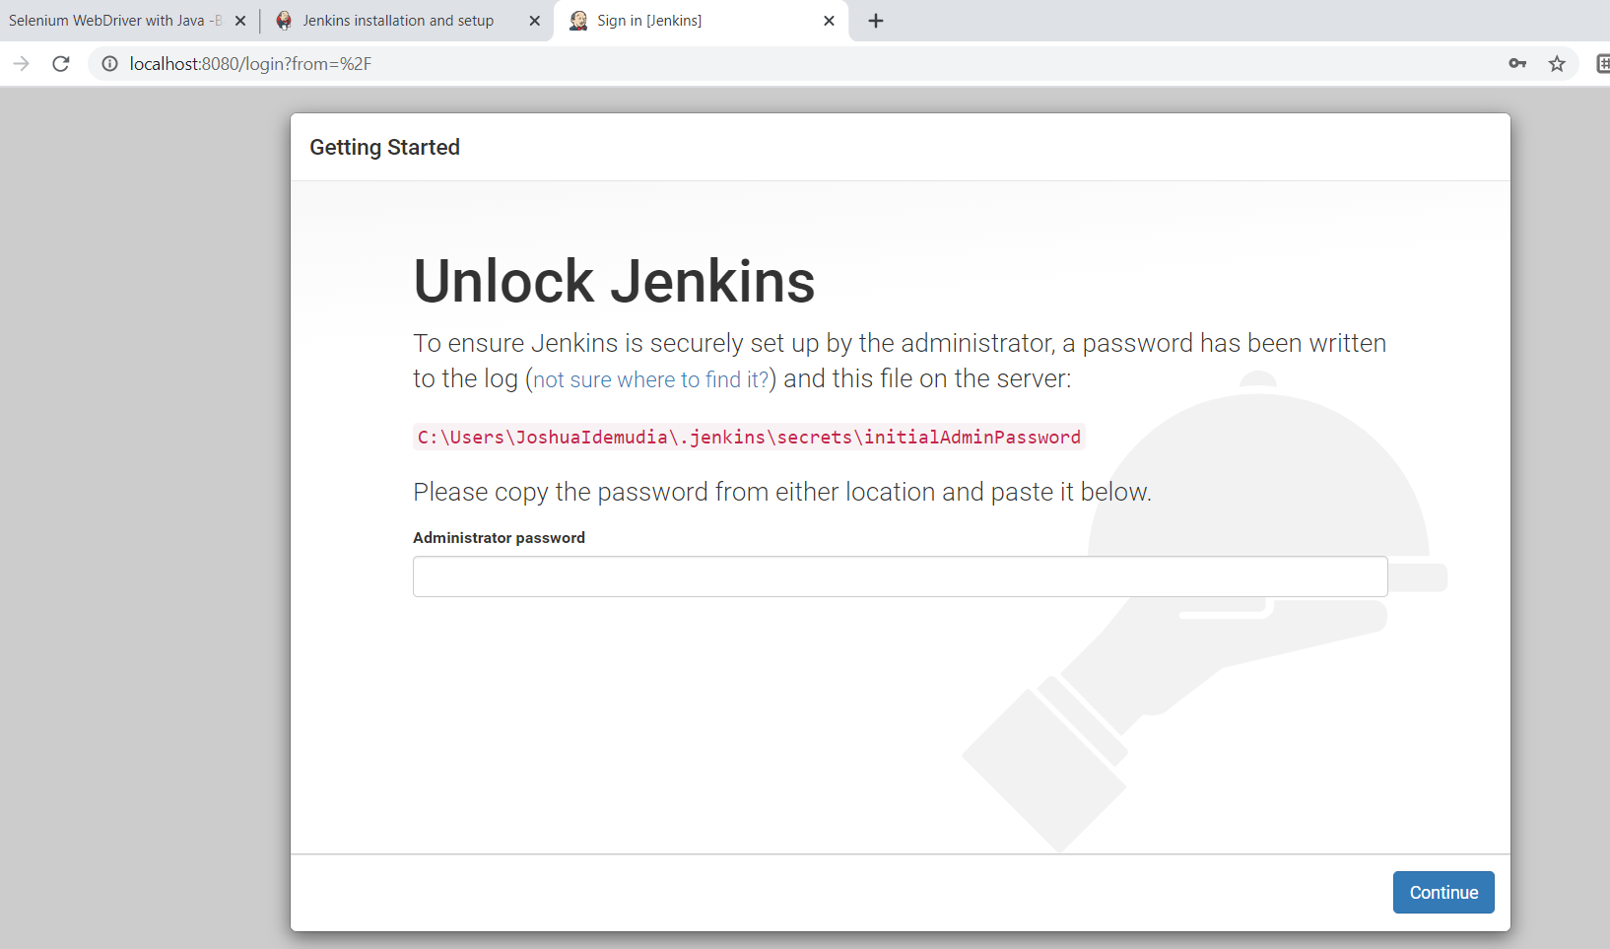

So use that password and then next just agree to download normal stuff….username Enreidem and password Enreidem1….full name steelblast and used same email

Now click on manage Jenkins- click on global tools configuration-click jdk installations

Copy the part of java jdk from your mission and paste there

Make sure you untick that

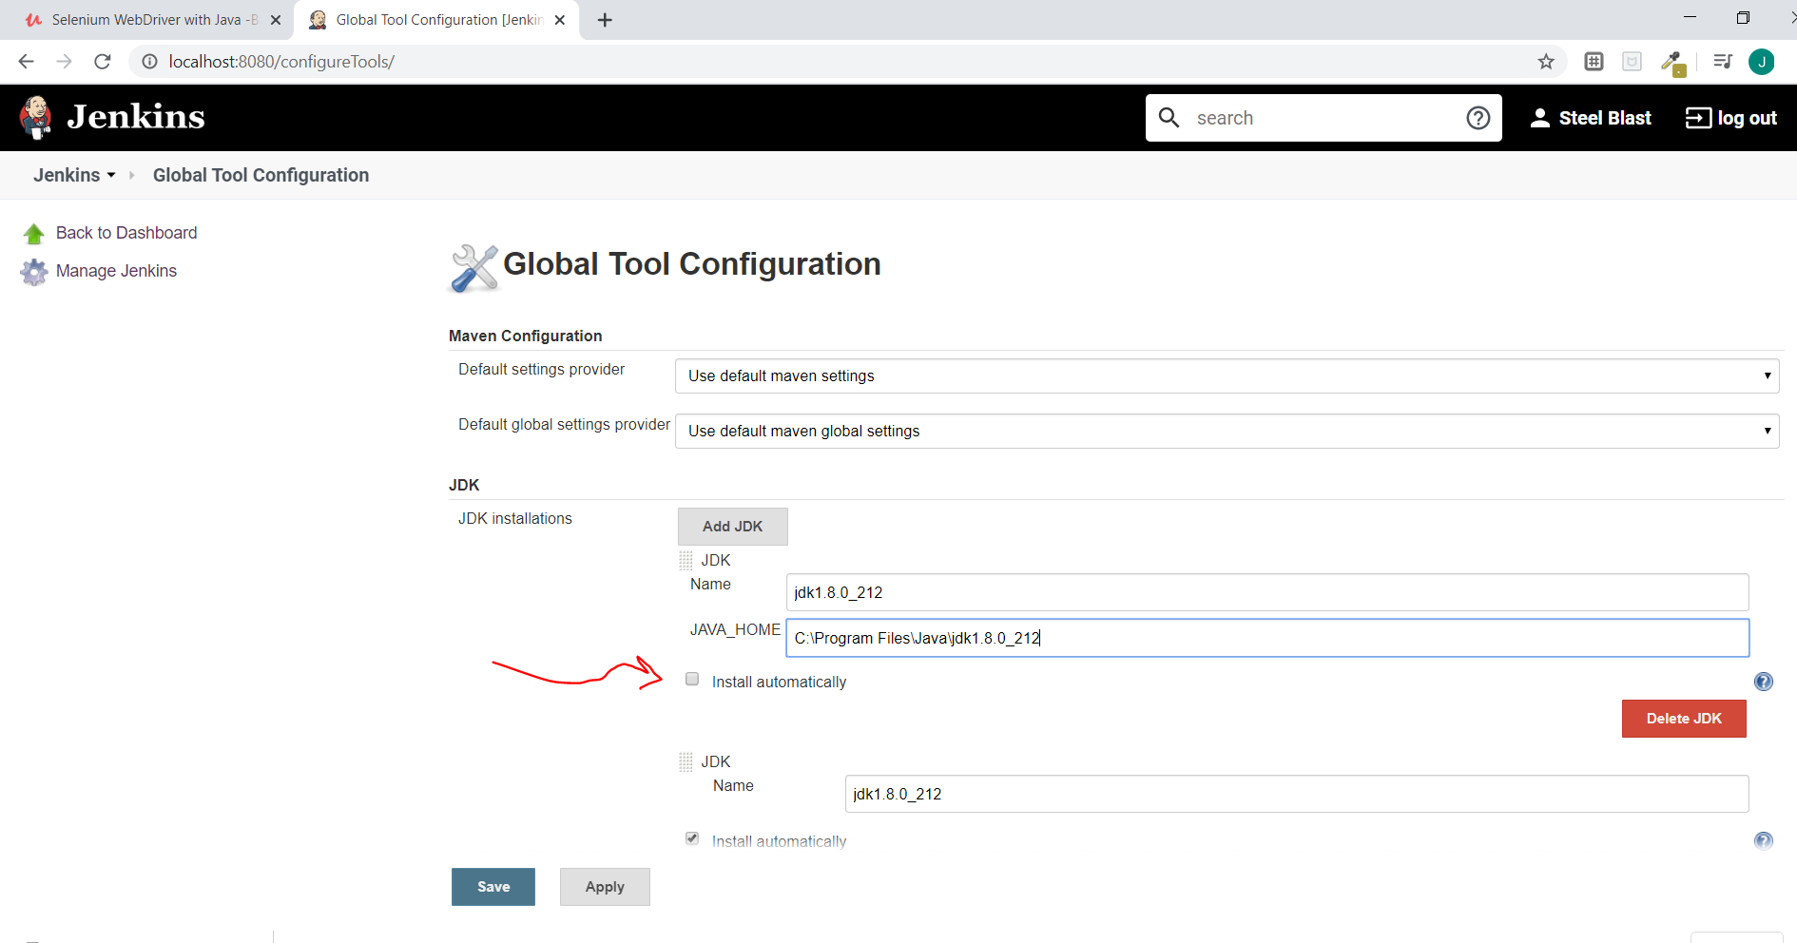

Next is maven

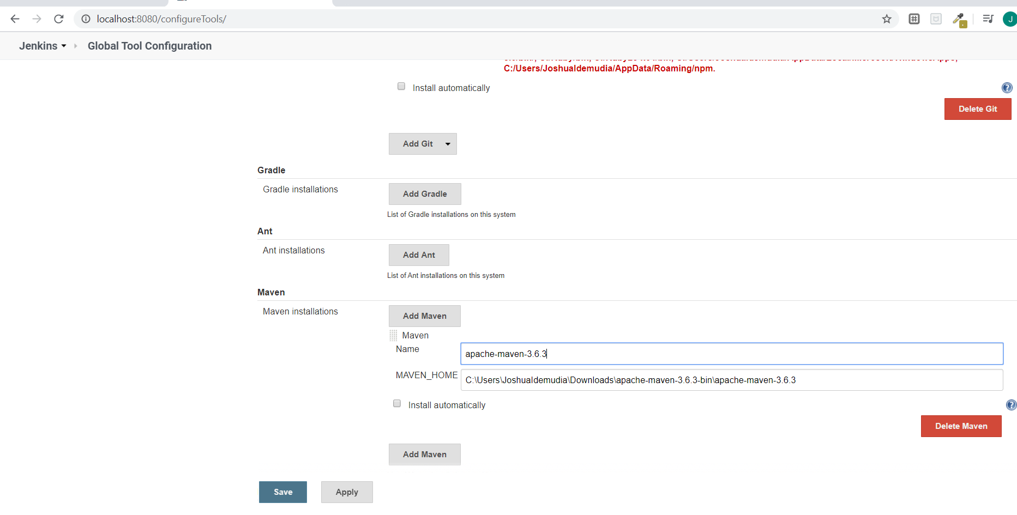

Next step you are back on the jenkin page….

Click new item….enter job name…click freestyle project—advance by the jdk and choose use custom workspace

In real world they will pass the link where the code is present

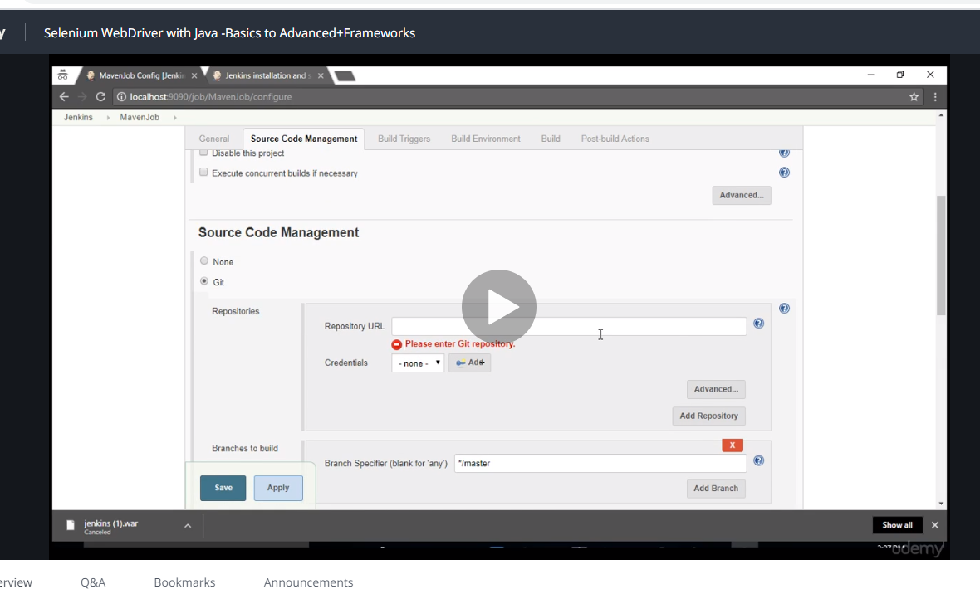

But since we dnt have that we go and click…..use custom workspace

Then go and find your maven java copy the folder and go and paste it in the .jenkins folder.

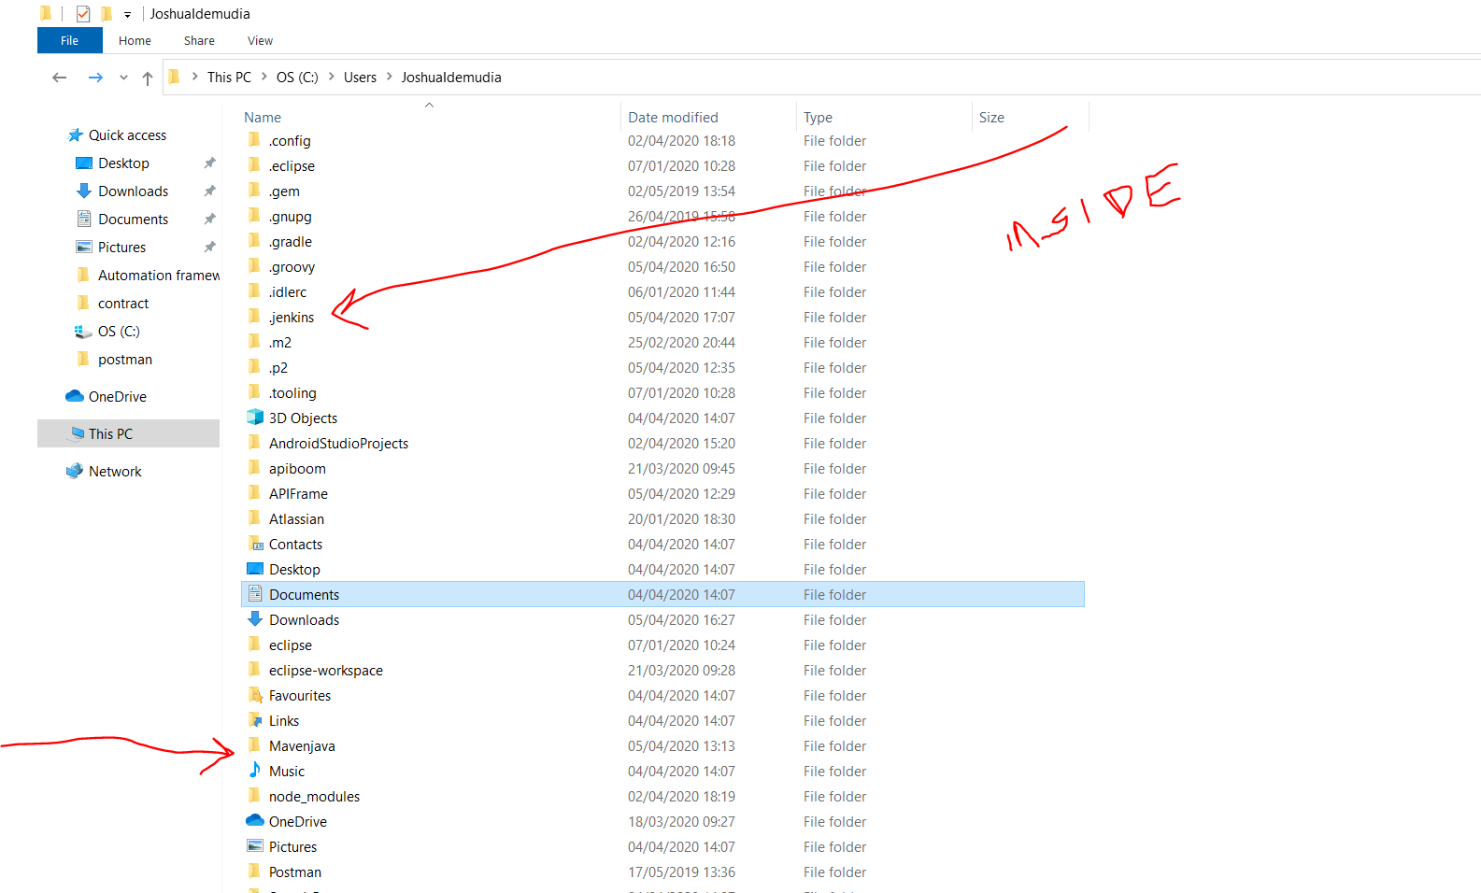

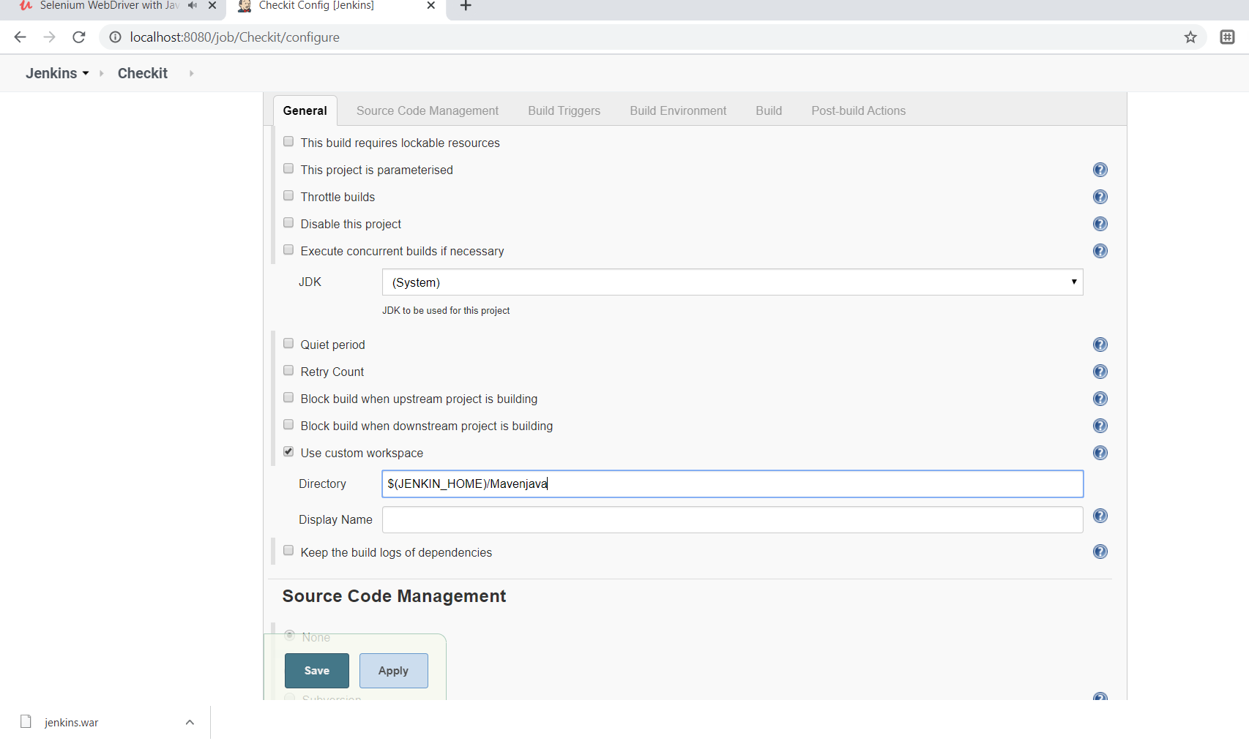

Keep scrolling down to build and click invoke top maven project…. Give it the name and the name of the xml file u saved as regression

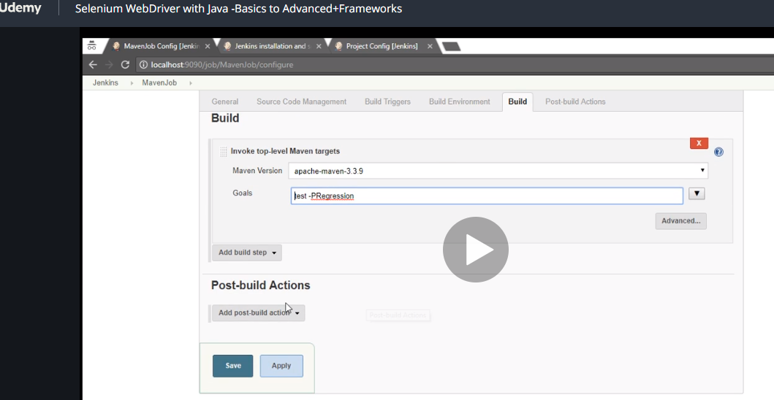

And save.

Then on the jenkin page click build now

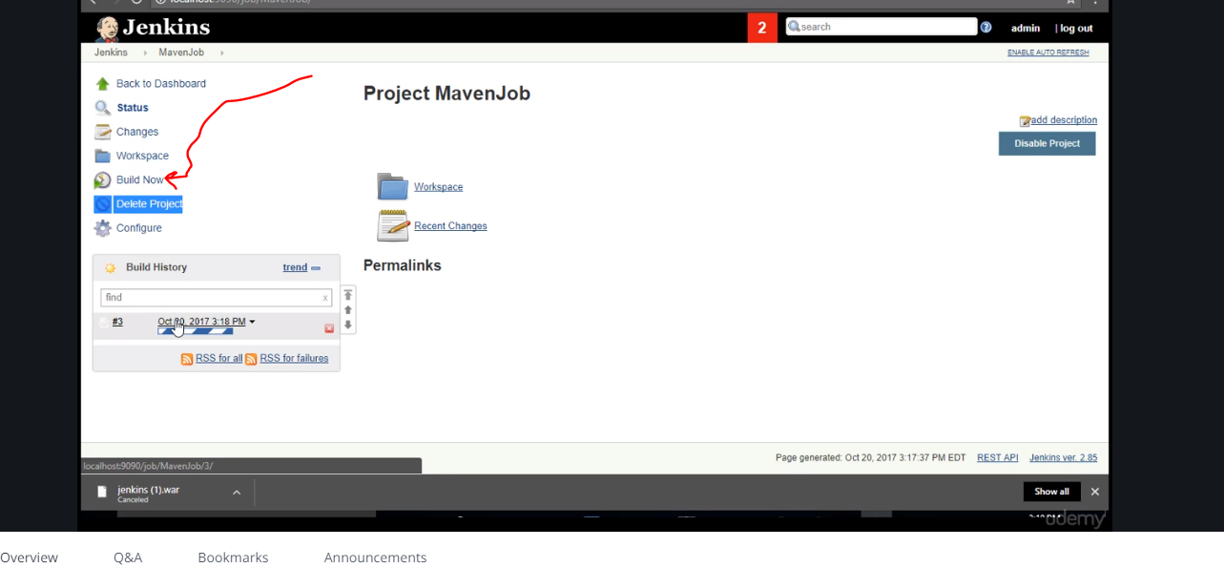

Click the date at the bottom there and go to console output.

Once you run your project with maven…go and refresh your project and you will see target …click it and you will see surefire report….. expand and go to index,html. Copy it and paste in on a browser.

Now if you look down pass index html you notice testng result xml. This is what jenkin needs to create report.

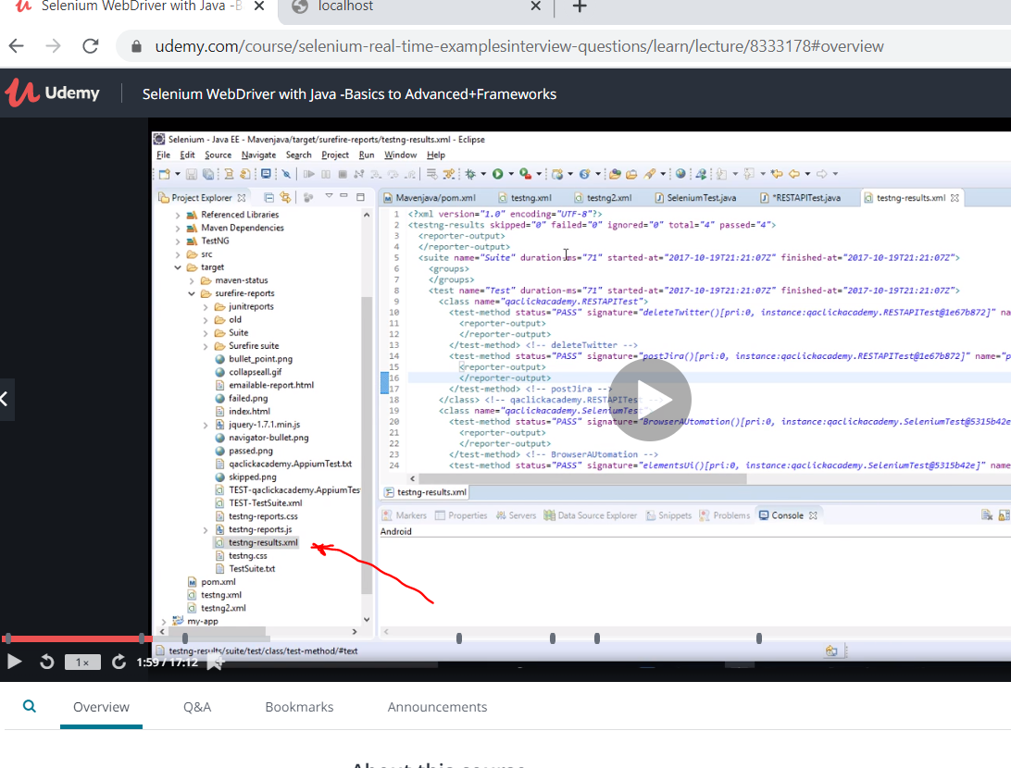

So go back to manage Jenkins ….scroll down and click manage plugins

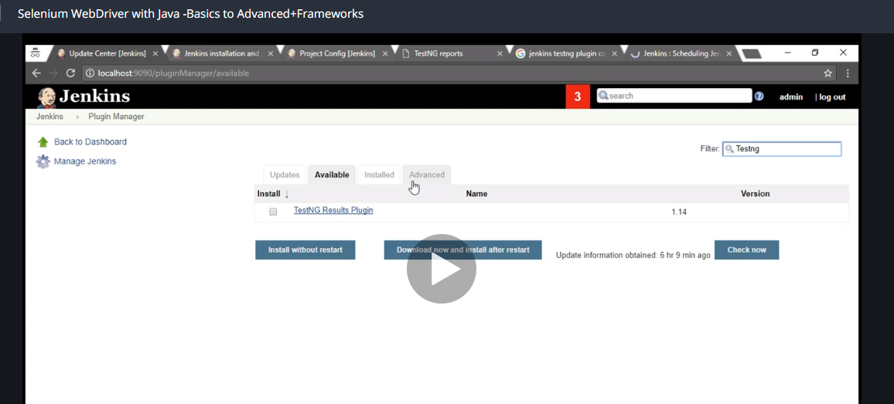

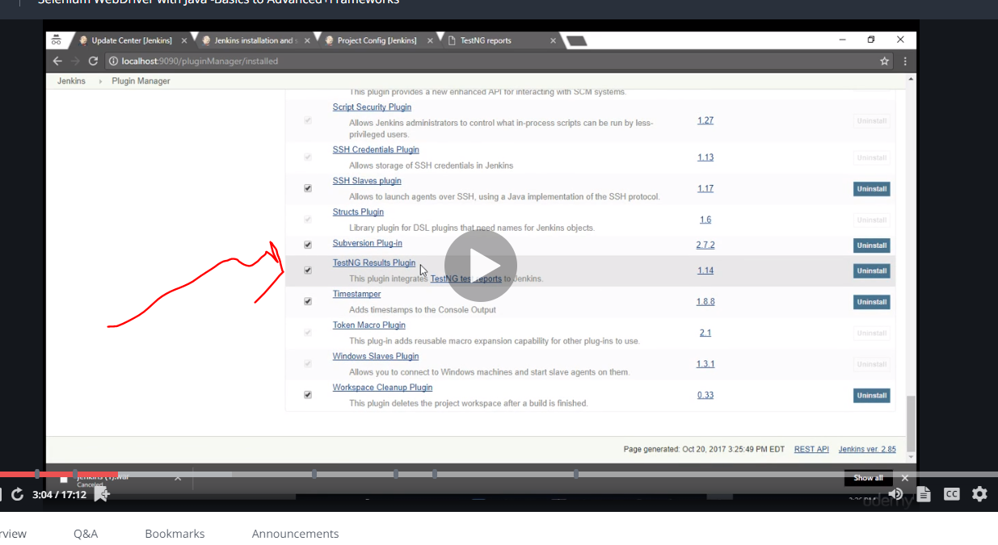

Search for it and download it

Click install without restart once you select it.

If you want to change the configuration, select the job and

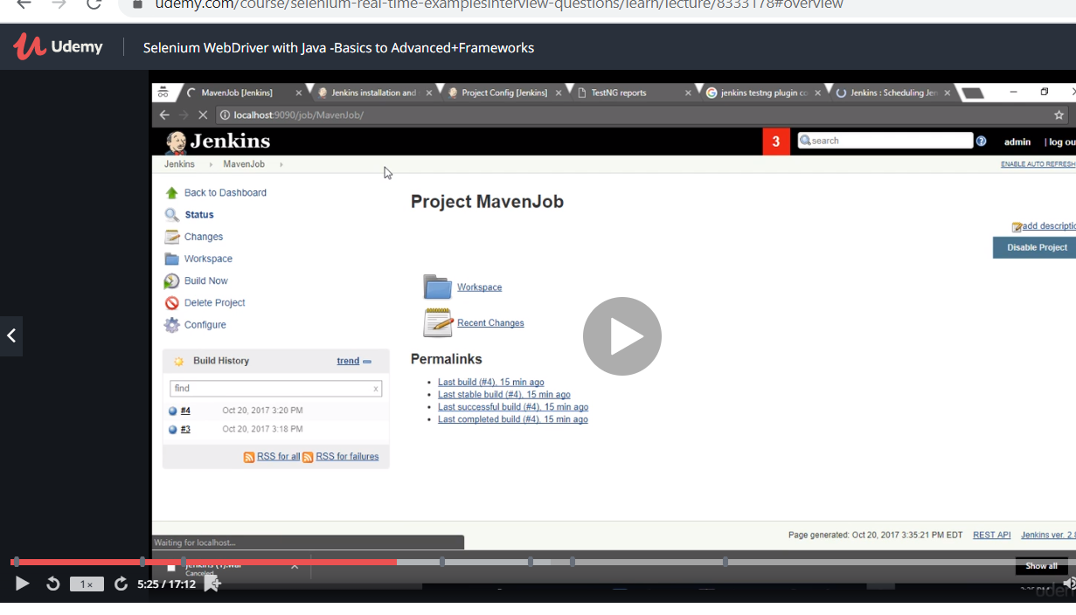

And click configure.

Now go and select the dropdown option for post build

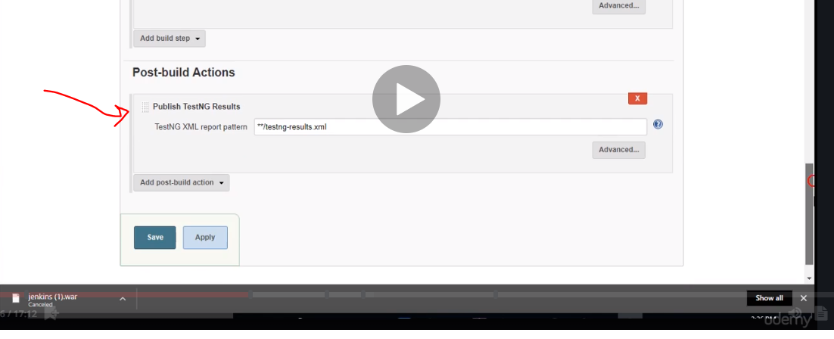

Now scheduling your Jenkins….

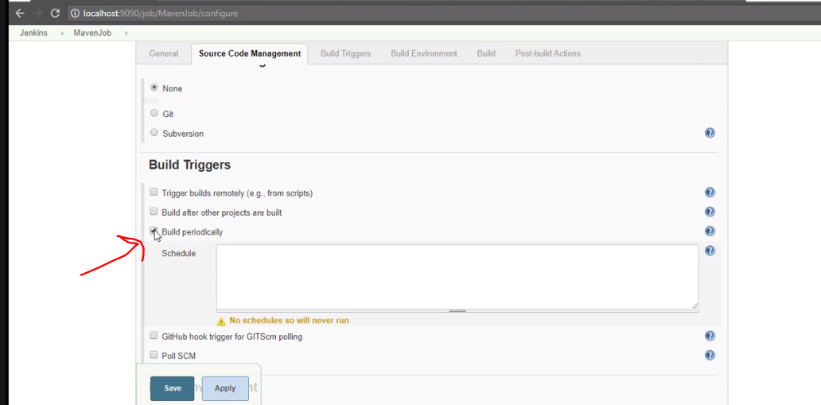

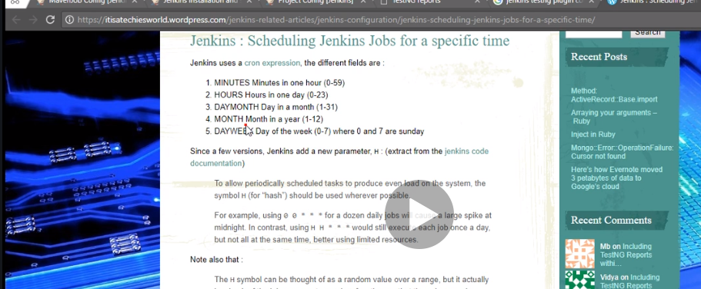

Star means run anytime so if you want to run 7am everyday and month

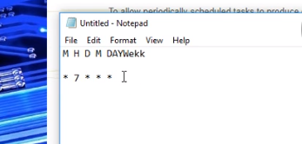

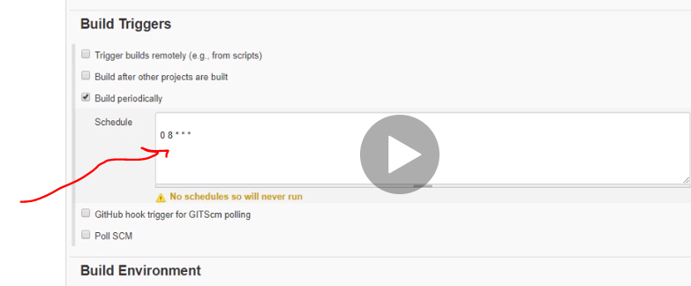

Save the project.

So when u click build ..after it builds…go back to dashboard and you will notice the report

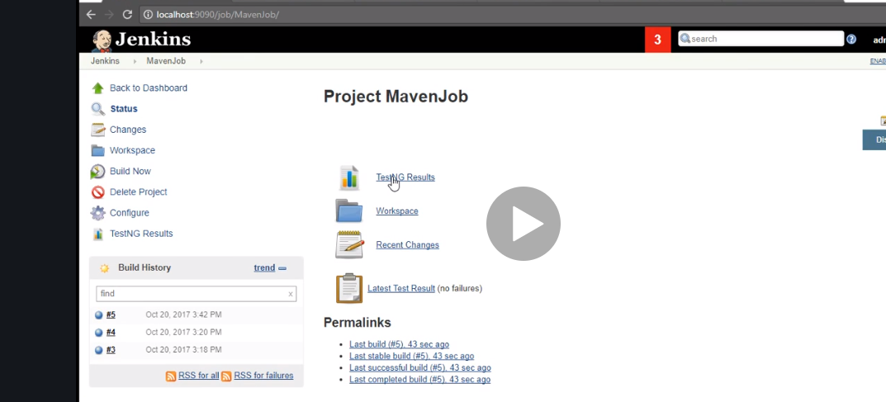

As you keep building on you will notice a graph if nlue all good if bugs abit of red

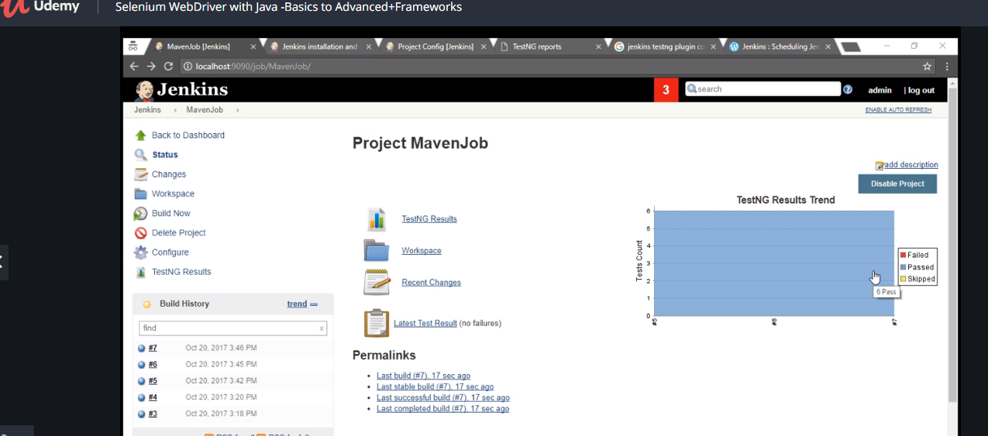

# Data driven with excel

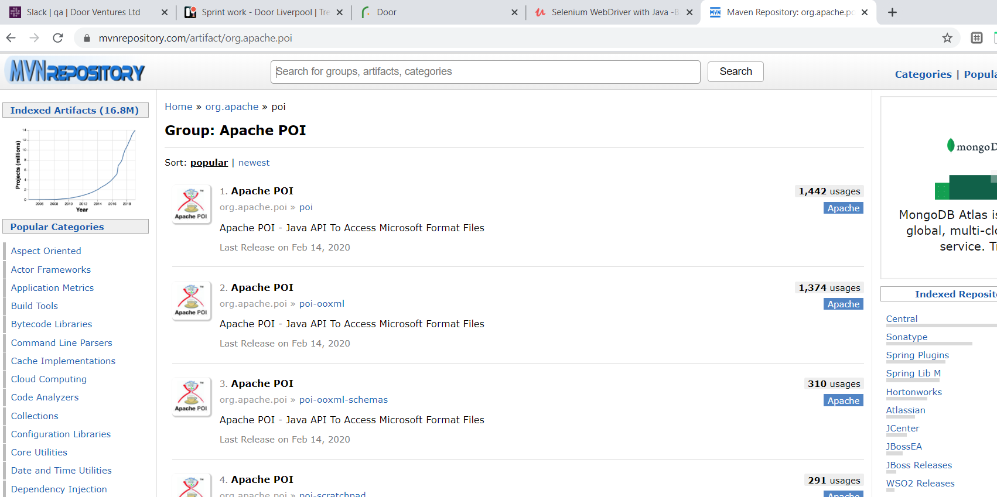

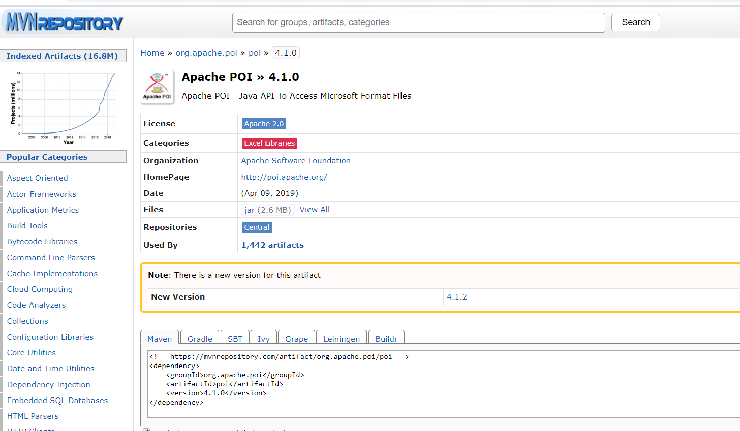

Download dependencies

Also u can do create maven project and skip acheology click the tick box give names and set up. There u have to costomise the pom yourself which is even better.

So just type dependencies and paste the dependency inside

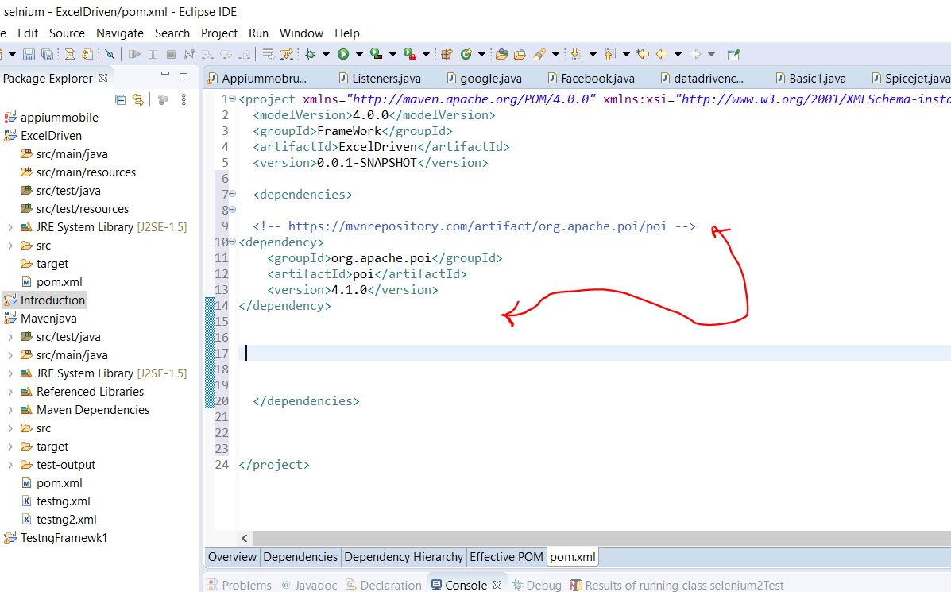

And we need the second one

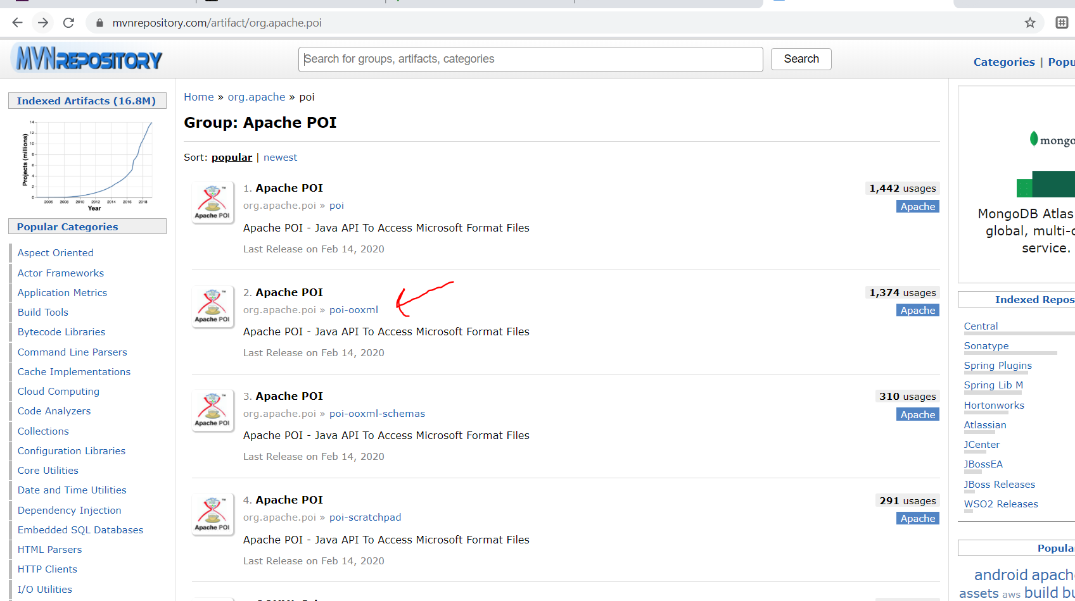

Now create a class datadrvn

Now we want to create an object

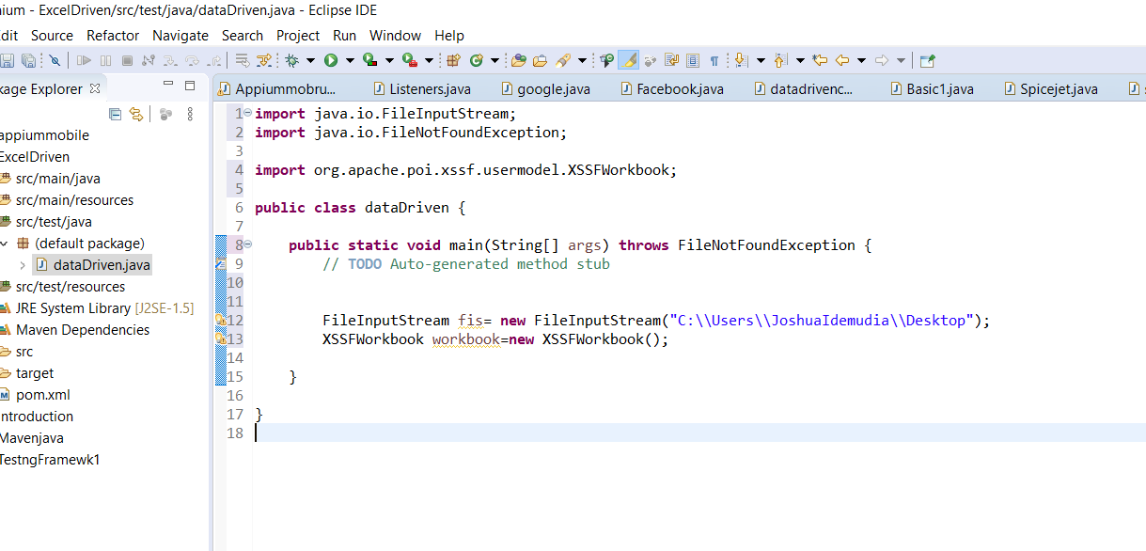

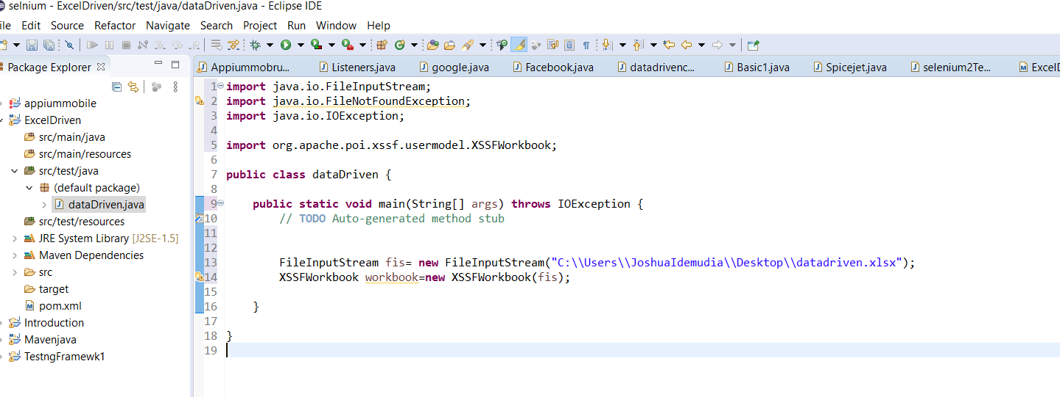

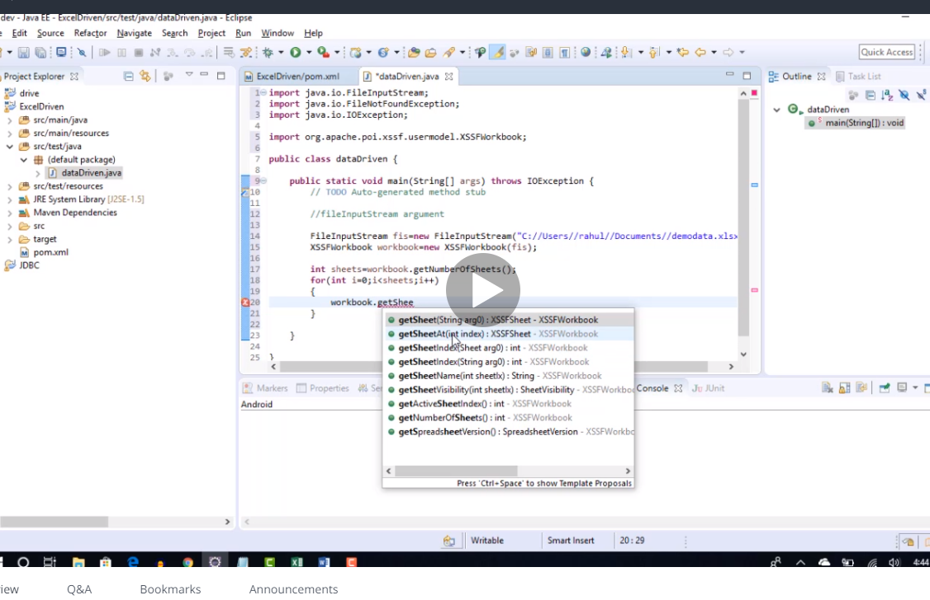

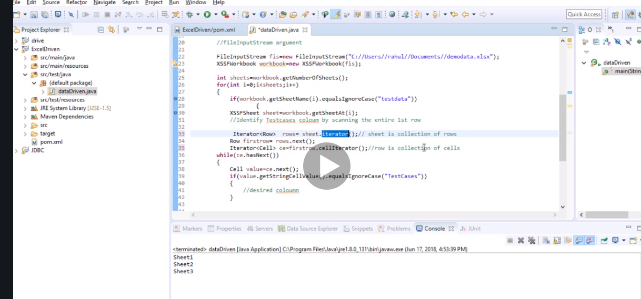

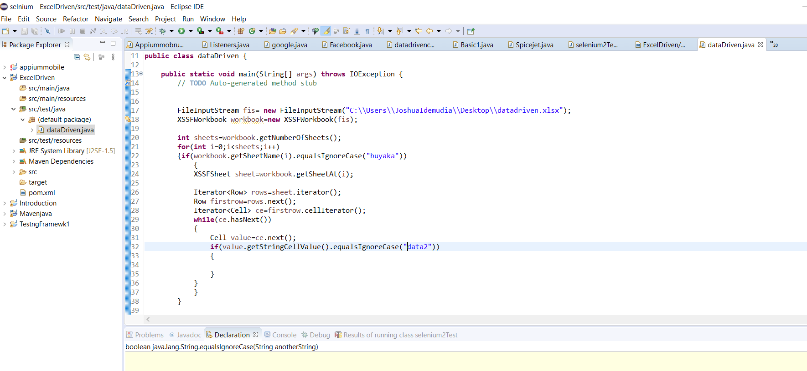

**import** java.io.FileInputStream;

**import** java.io.FileNotFoundException;

**import** java.io.IOException;

**import** java.util.Iterator;

**import** org.apache.poi.ss.usermodel.Cell;

**import** org.apache.poi.ss.usermodel.Row;

**import** org.apache.poi.xssf.usermodel.XSSFSheet;

**import** org.apache.poi.xssf.usermodel.XSSFWorkbook;

**public** **class** dataDriven {

**public** **static** **void** main(String[] args) **throws** IOException {

// **TODO** Auto-generated method stub

FileInputStream fis= **new** FileInputStream("C:\\Users\\JoshuaIdemudia\\Desktop\\datadriven.xlsx");

XSSFWorkbook workbook=**new** XSSFWorkbook(fis);

**int** sheets=workbook.getNumberOfSheets();

**for**(**int** i=0;i<sheets;i++)

{**if**(workbook.getSheetName(i).equalsIgnoreCase("buyaka"))

{

XSSFSheet sheet=workbook.getSheetAt(i);

Iterator<Row> rows=sheet.iterator();

Row firstrow=rows.next();

Iterator<Cell> ce=firstrow.cellIterator();

**int** k=0; ///this is just for the while condition skip till when value is equal to data 2 at that point k=column

**int** column=0; // note k is 3 and column is 2 think about it

**while**(ce.hasNext())

{

Cell value=ce.next();

**if**(value.getStringCellValue().equalsIgnoreCase("data2"))

{

column=k;

}

k++;

}

System.***out***.println(k);

}

}

}

}

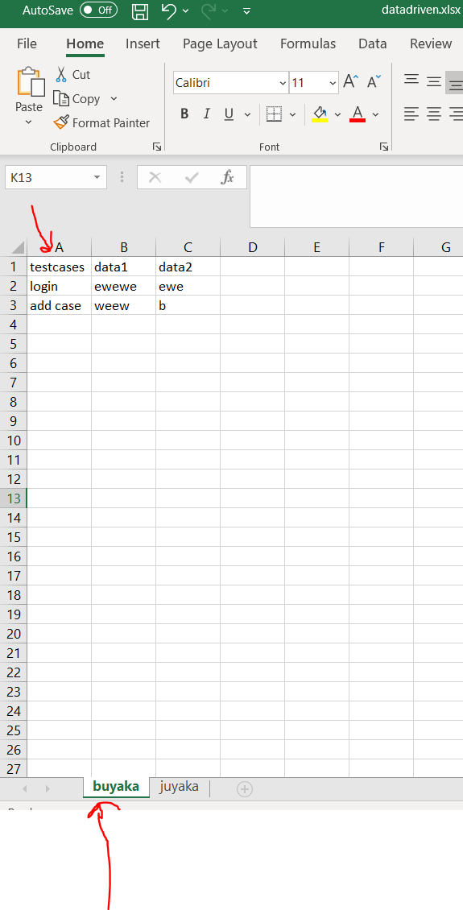

Now we can move to any column from testcase to data 3 from above and also select the sheet…what we need now is to be able to move downward from the top column

**import** java.io.FileInputStream;

**import** java.io.FileNotFoundException;

**import** java.io.IOException;

**import** java.util.Iterator;

**import** org.apache.poi.ss.usermodel.Cell;

**import** org.apache.poi.ss.usermodel.Row;

**import** org.apache.poi.xssf.usermodel.XSSFSheet;

**import** org.apache.poi.xssf.usermodel.XSSFWorkbook;

**public** **class** dataDriven {

**public** **static** **void** main(String[] args) **throws** IOException {

// **TODO** Auto-generated method stub

FileInputStream fis= **new** FileInputStream("C:\\Users\\JoshuaIdemudia\\Desktop\\datadriven.xlsx");

XSSFWorkbook workbook=**new** XSSFWorkbook(fis);

**int** sheets=workbook.getNumberOfSheets();

**for**(**int** i=0;i<sheets;i++)

{**if**(workbook.getSheetName(i).equalsIgnoreCase("buyaka")) // sheet name

{

XSSFSheet sheet=workbook.getSheetAt(i);

Iterator<Row> rows=sheet.iterator();

Row firstrow=rows.next();

Iterator<Cell> ce=firstrow.cellIterator();

**int** k=0; ///this is just for the while condition skip till when value is equal to data 2 at that point k=column

**int** column=0; // note k is 3 and column is 2 think about it

**while**(ce.hasNext())

{

Cell value=ce.next();

**if**(value.getStringCellValue().equalsIgnoreCase("testcases"))//

{

column=k;

}

k++;

}

System.***out***.println(column);

**while**(rows.hasNext())

{

Row r=rows.next();

**if**(r.getCell(column).getStringCellValue().equalsIgnoreCase("login"))

{

Iterator<Cell> cv=r.cellIterator();

**while**(cv.hasNext())

{

System.***out***.println(cv.next().getStringCellValue());

}

}

}

}

}

}

}

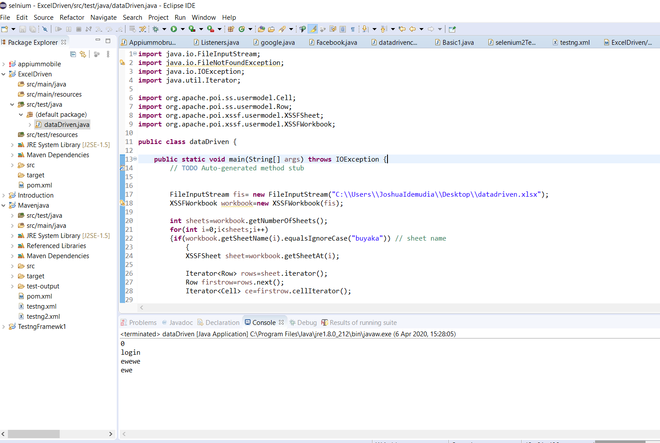

Now by adding an array a…..we then copied the values to save as a. so it will print properly.

**import** java.io.FileInputStream;

**import** java.io.FileNotFoundException;

**import** java.io.IOException;

**import** java.util.ArrayList;

**import** java.util.Iterator;

**import** org.apache.poi.ss.usermodel.Cell;

**import** org.apache.poi.ss.usermodel.Row;

**import** org.apache.poi.xssf.usermodel.XSSFSheet;

**import** org.apache.poi.xssf.usermodel.XSSFWorkbook;

**public** **class** dataDriven {

**public** **static** **void** main(String[] args) **throws** IOException {

ArrayList<String> a =**new** ArrayList<String>();

FileInputStream fis= **new** FileInputStream("C:\\Users\\JoshuaIdemudia\\Desktop\\datadriven.xlsx");

XSSFWorkbook workbook=**new** XSSFWorkbook(fis);

**int** sheets=workbook.getNumberOfSheets();

**for**(**int** i=0;i<sheets;i++)

{**if**(workbook.getSheetName(i).equalsIgnoreCase("buyaka")) // sheet name

{

XSSFSheet sheet=workbook.getSheetAt(i);

Iterator<Row> rows=sheet.iterator();

Row firstrow=rows.next();

Iterator<Cell> ce=firstrow.cellIterator();

**int** k=0; ///this is just for the while condition skip till when value is equal to data 2 at that point k=column

**int** column=0; // note k is 3 and column is 2 think about it

**while**(ce.hasNext())

{

Cell value=ce.next();

**if**(value.getStringCellValue().equalsIgnoreCase("testcases"))//

{

column=k;

}

k++;

}

System.***out***.println(column);

**while**(rows.hasNext())

{

Row r=rows.next();

**if**(r.getCell(column).getStringCellValue().equalsIgnoreCase("login"))

{

Iterator<Cell> cv=r.cellIterator();

**while**(cv.hasNext())

{

a.add(cv.next().getStringCellValue());

}

}

}

}

}

}

}

Now we have created another code to do this and made it a method. We have also created another class sample test.

We want to create an object in sample class to run the method in the dadadriven class

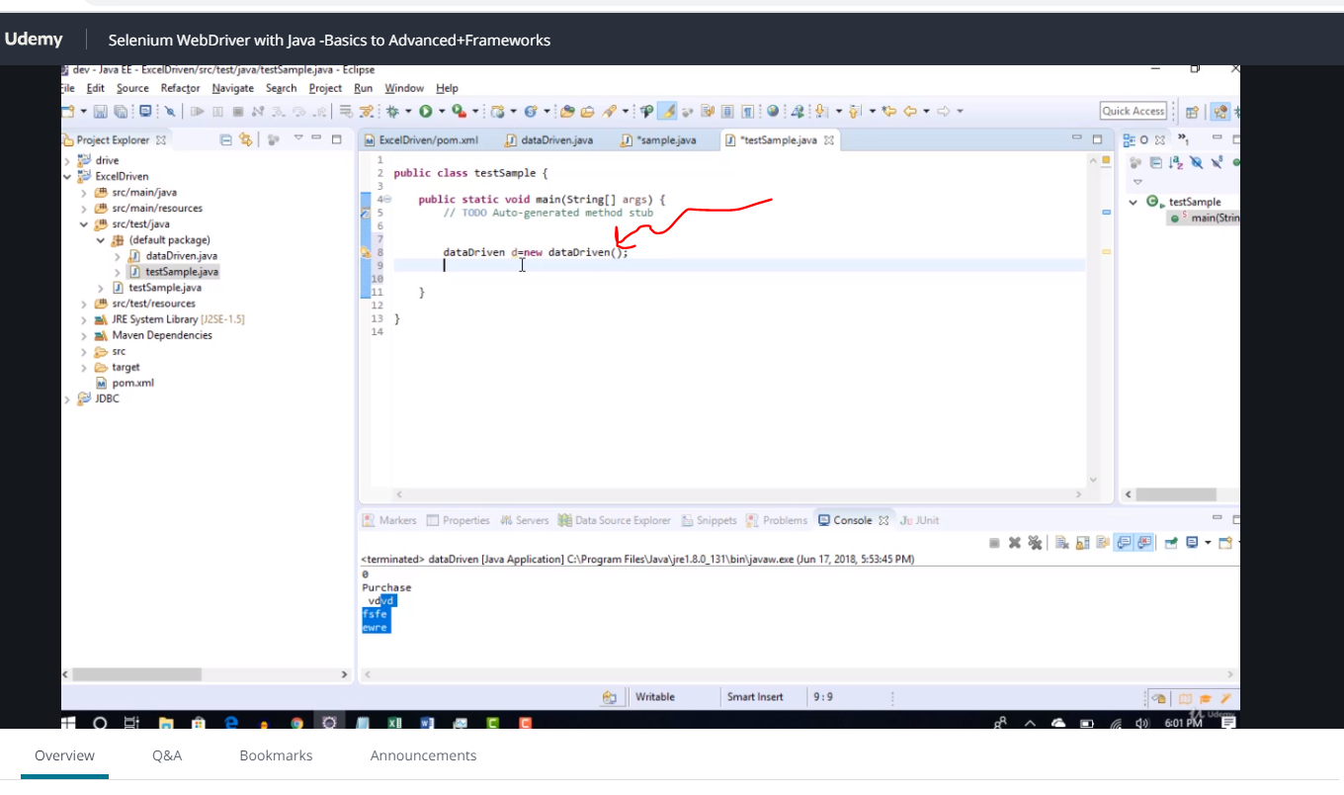

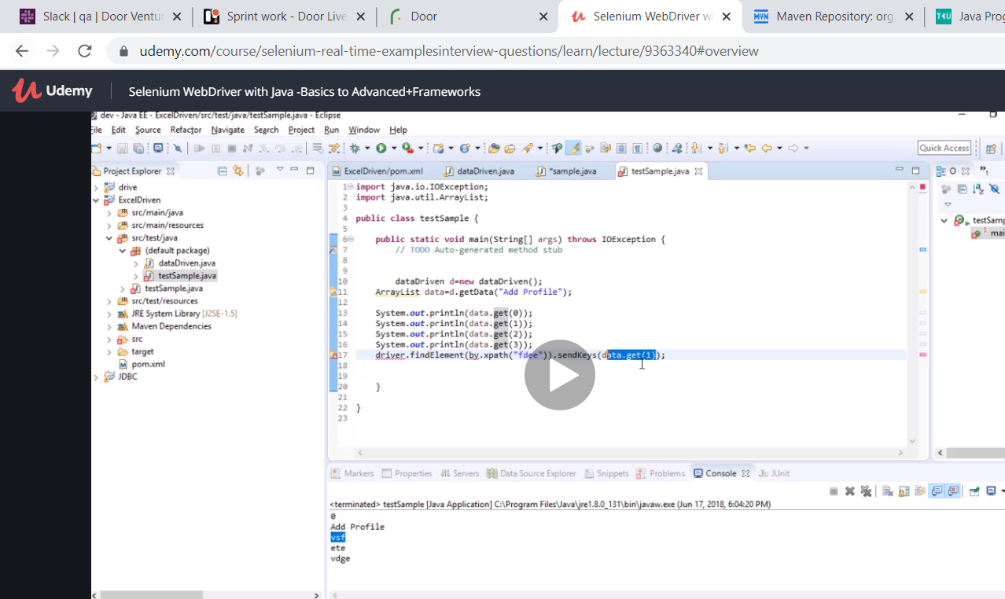

Now we use sample file to get the method in datadriven how cool it is so if you need to use it in selenium just save your data and get it from there.

Here is the code when we now make it a method for sample test

**import** java.io.IOException;

**import** java.util.ArrayList;

**public** **class** Sampletest {

**public** **static** **void** main(String[] args) **throws** IOException {

dataDriven d=**new** dataDriven();

ArrayList data=d.getData("login");

// **TODO** Auto-generated method stub

System.***out***.println(data.get(0));

System.***out***.println(data.get(1));

//so if i want to dor driver.findelement(by.xpath(dsssddss)).sendkey("data.get(0)")

}

}

And this is for datadriven

**import** java.io.FileInputStream;

**import** java.io.FileNotFoundException;

**import** java.io.IOException;

**import** java.util.ArrayList;

**import** java.util.Iterator;

**import** org.apache.poi.ss.usermodel.Cell;

**import** org.apache.poi.ss.usermodel.Row;

**import** org.apache.poi.xssf.usermodel.XSSFSheet;

**import** org.apache.poi.xssf.usermodel.XSSFWorkbook;

**public** **class** dataDriven {

**public** ArrayList<String> getData(String TestcaseName) **throws** IOException

{

ArrayList<String> a =**new** ArrayList<String>();

FileInputStream fis= **new** FileInputStream("C:\\Users\\JoshuaIdemudia\\Desktop\\datadriven.xlsx");

XSSFWorkbook workbook=**new** XSSFWorkbook(fis);

**int** sheets=workbook.getNumberOfSheets();

**for**(**int** i=0;i<sheets;i++)

{**if**(workbook.getSheetName(i).equalsIgnoreCase("buyaka")) // sheet name

{

XSSFSheet sheet=workbook.getSheetAt(i);

Iterator<Row> rows=sheet.iterator();

Row firstrow=rows.next();

Iterator<Cell> ce=firstrow.cellIterator();

**int** k=0; ///this is just for the while condition skip till when value is equal to data 2 at that point k=column

**int** column=0; // note k is 3 and column is 2 think about it

**while**(ce.hasNext())

{

Cell value=ce.next();

**if**(value.getStringCellValue().equalsIgnoreCase("testcases"))//

{

column=k;

}

k++;

}

System.***out***.println(column);

**while**(rows.hasNext())

{

Row r=rows.next();

**if**(r.getCell(column).getStringCellValue().equalsIgnoreCase(TestcaseName))

{

Iterator<Cell> cv=r.cellIterator();

**while**(cv.hasNext())

{

a.add(cv.next().getStringCellValue());

}

}

}

}

}

**return** a;

}

**public** **static** **void** main(String[] args) **throws** IOException {

}

}

Now finally this is all sweet but what happens if it is not a string but integer it fails how do we fix it?

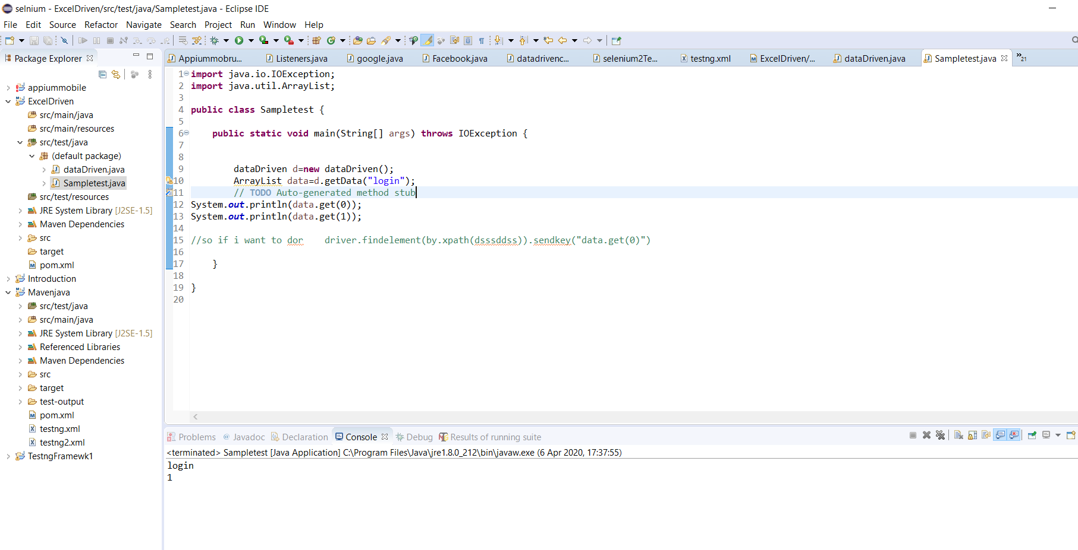

My code now has a trick to make the numeric look like string instead of integer

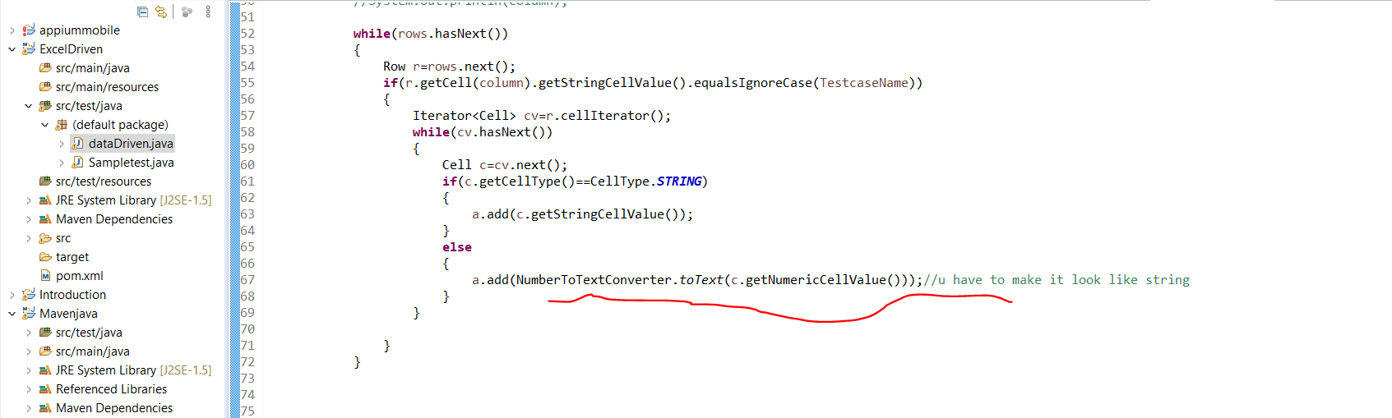

**import** java.io.FileInputStream;

**import** java.io.FileNotFoundException;

**import** java.io.IOException;

**import** java.util.ArrayList;

**import** java.util.Iterator;

**import** org.apache.poi.ss.usermodel.Cell;

**import** org.apache.poi.ss.usermodel.CellType;

**import** org.apache.poi.ss.usermodel.Row;

**import** org.apache.poi.ss.util.NumberToTextConverter;

**import** org.apache.poi.xssf.usermodel.XSSFSheet;

**import** org.apache.poi.xssf.usermodel.XSSFWorkbook;

**public** **class** dataDriven {

**public** ArrayList<String> getData(String TestcaseName) **throws** IOException

{

ArrayList<String> a =**new** ArrayList<String>();

FileInputStream fis= **new** FileInputStream("C:\\Users\\JoshuaIdemudia\\Desktop\\datadriven.xlsx");

XSSFWorkbook workbook=**new** XSSFWorkbook(fis);

**int** sheets=workbook.getNumberOfSheets();

**for**(**int** i=0;i<sheets;i++)

{**if**(workbook.getSheetName(i).equalsIgnoreCase("buyaka")) // sheet name

{

XSSFSheet sheet=workbook.getSheetAt(i);

Iterator<Row> rows=sheet.iterator();

Row firstrow=rows.next();

Iterator<Cell> ce=firstrow.cellIterator();

**int** k=0; ///this is just for the while condition skip till when value is equal to data 2 at that point k=column

**int** column=0; // note k is 3 and column is 2 think about it

**while**(ce.hasNext())

{

Cell value=ce.next();

**if**(value.getStringCellValue().equalsIgnoreCase("testcases"))//

{

column=k;

}

k++;

}

//System.out.println(column);

**while**(rows.hasNext())

{

Row r=rows.next();

**if**(r.getCell(column).getStringCellValue().equalsIgnoreCase(TestcaseName))

{

Iterator<Cell> cv=r.cellIterator();

**while**(cv.hasNext())

{

Cell c=cv.next();

**if**(c.getCellType()==CellType.***STRING***)

{

a.add(c.getStringCellValue());

}

**else**

{

a.add(NumberToTextConverter.*toText*(c.getNumericCellValue()));//u have to make it look like string

}

}

}

}

}

}

**return** a;

}

**public** **static** **void** main(String[] args) **throws** IOException {

}

}

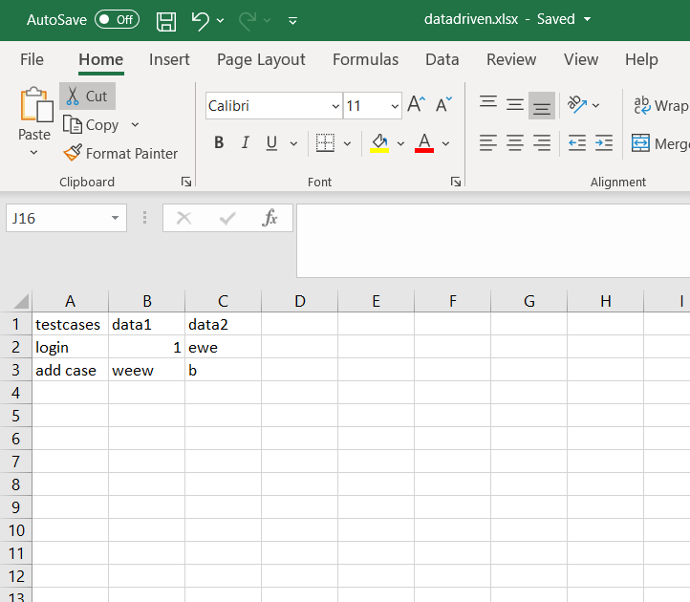

Log 4 G

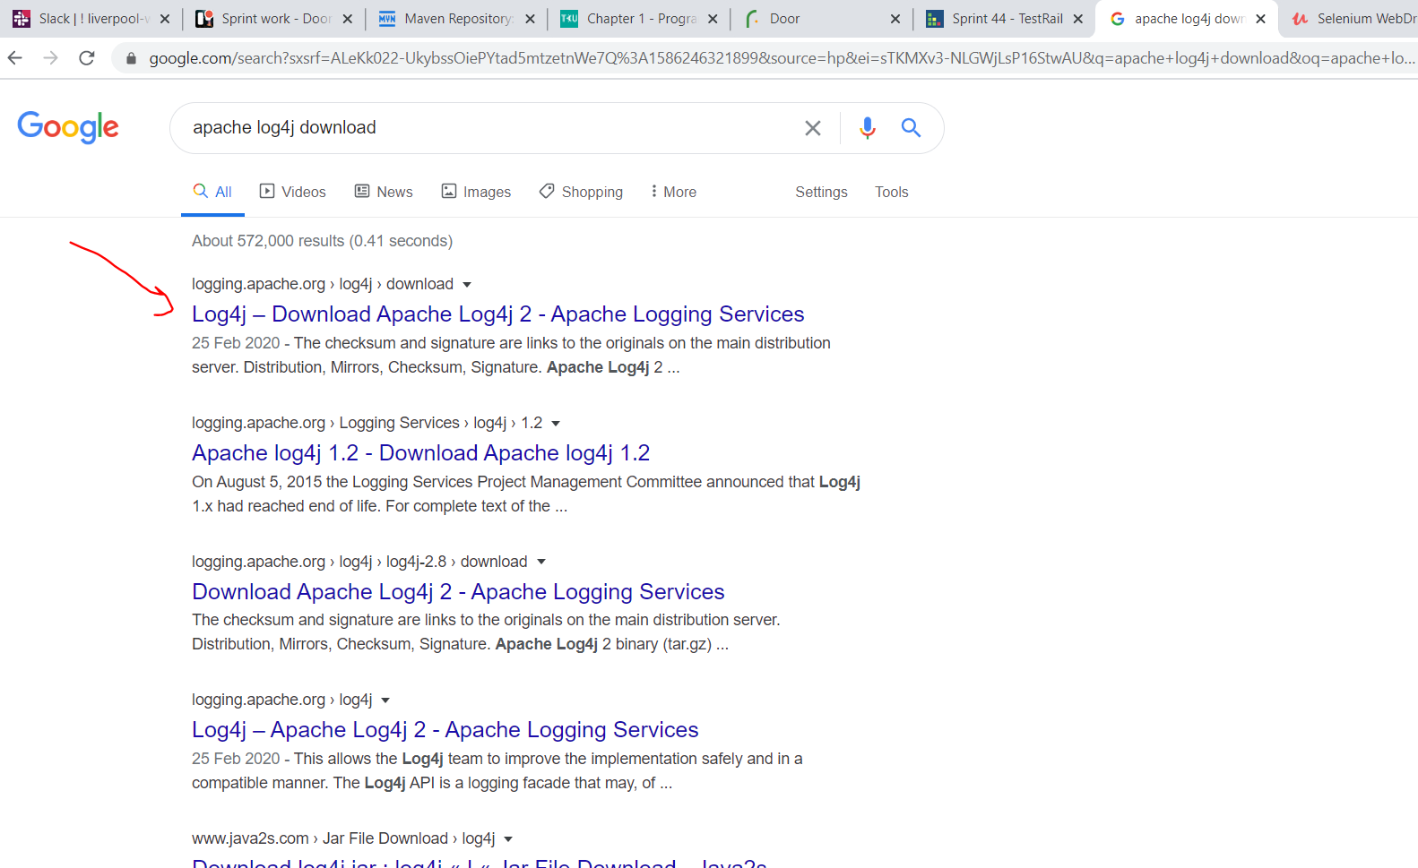

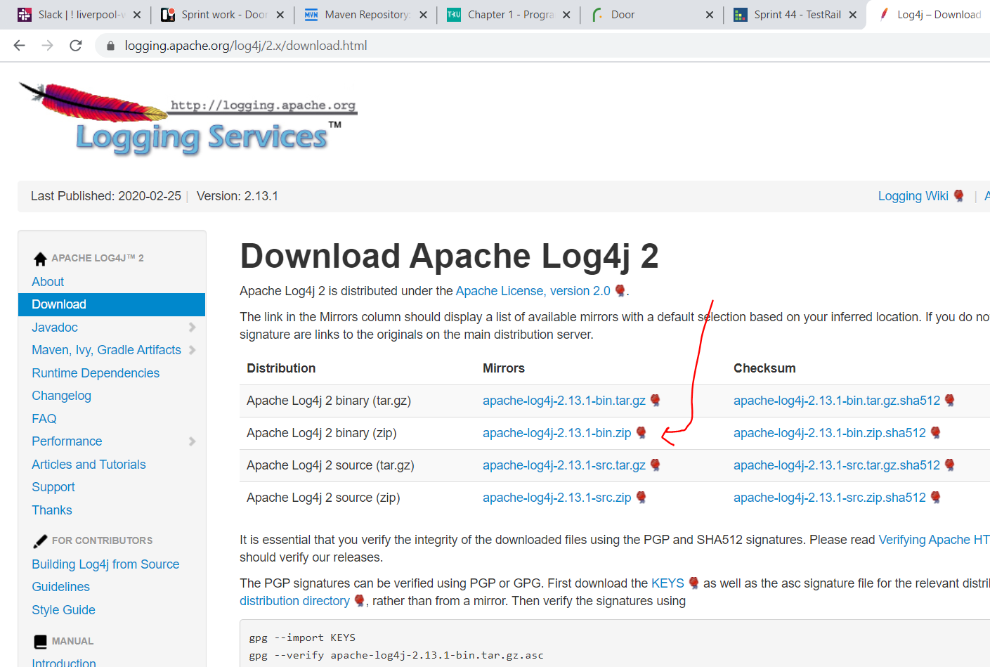

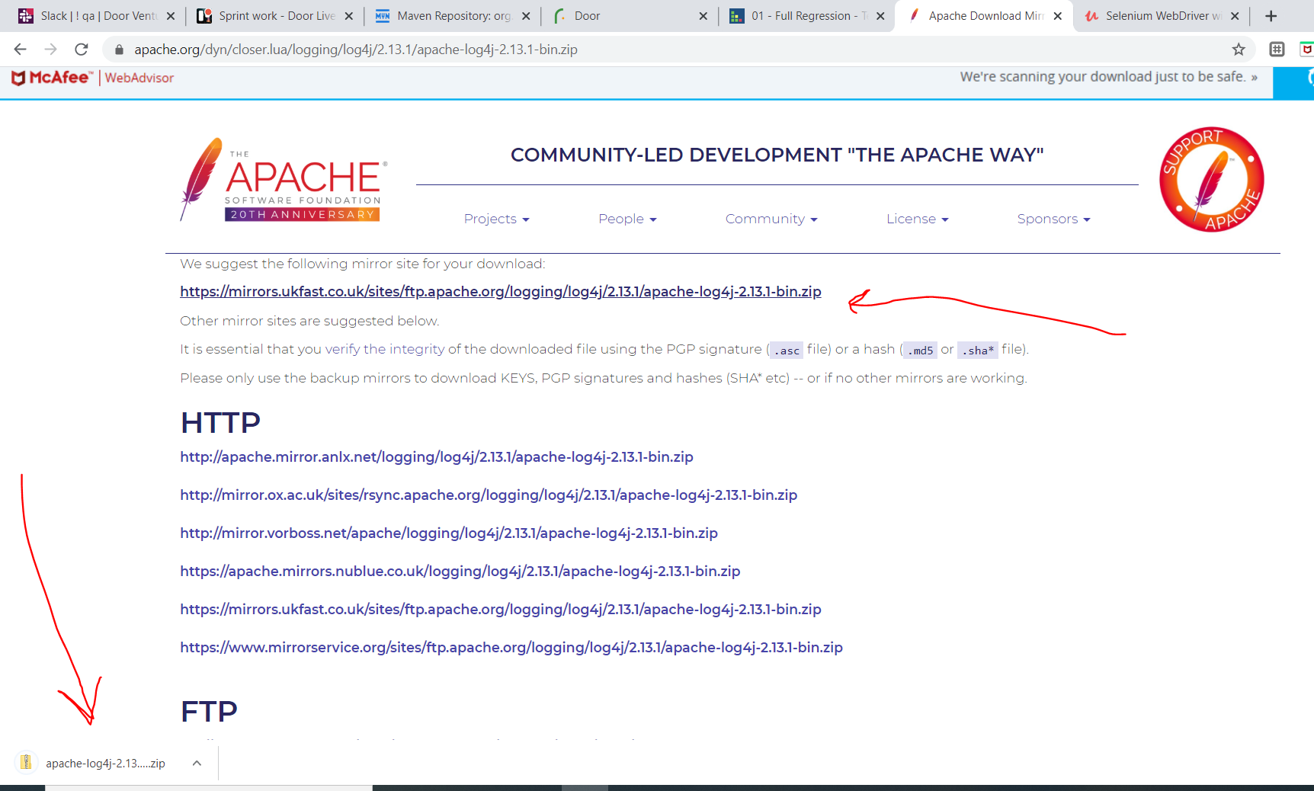

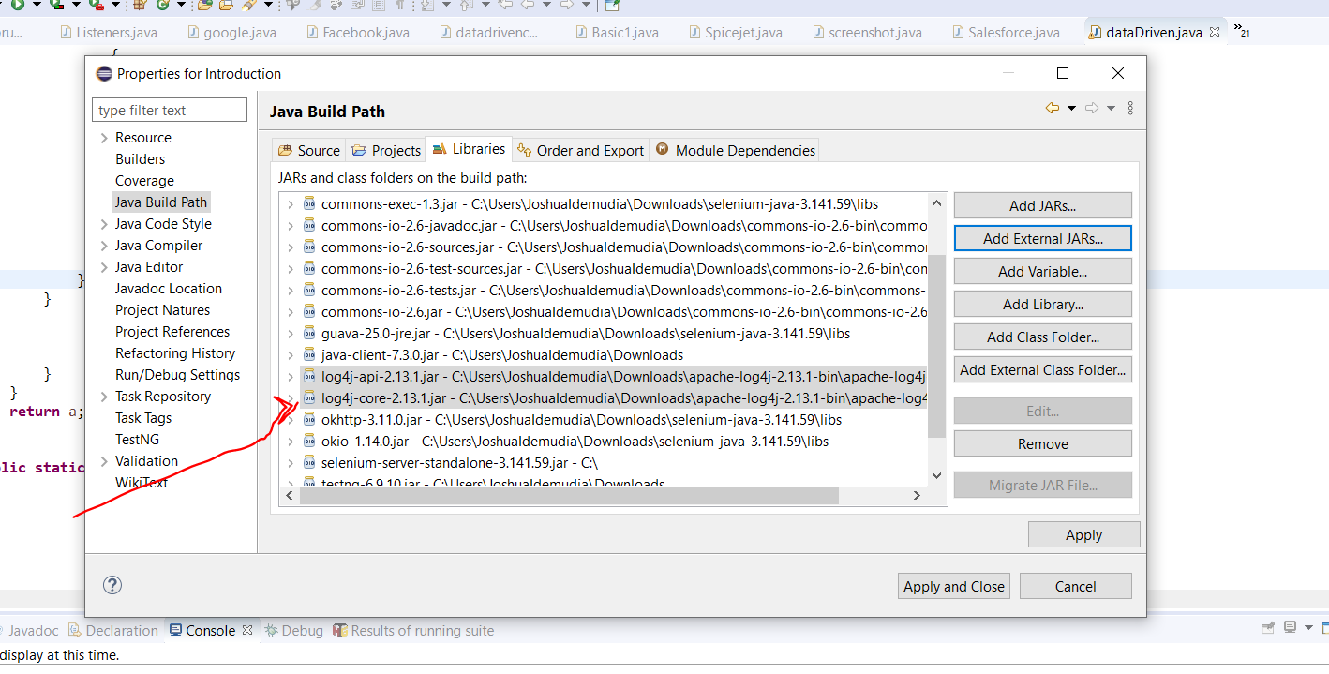

Then we import library and create an object so we can start logging everything

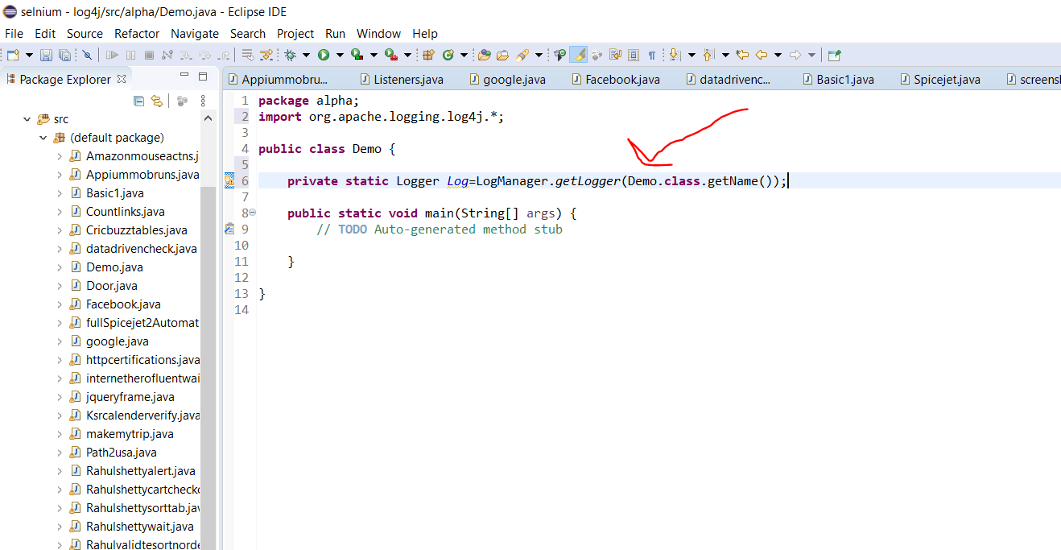

Name of the file.

Next create a package….then new…other…xml…xml file…put name next finish.

Go on the page click configuration on the page and copy this

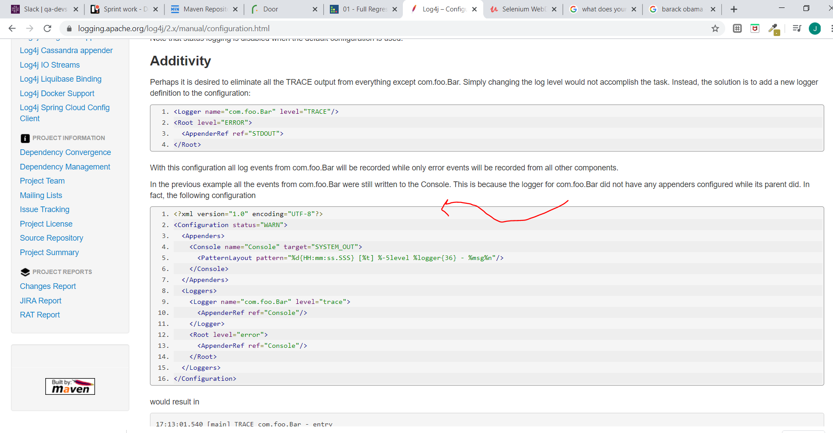

Change error to trace will show all error

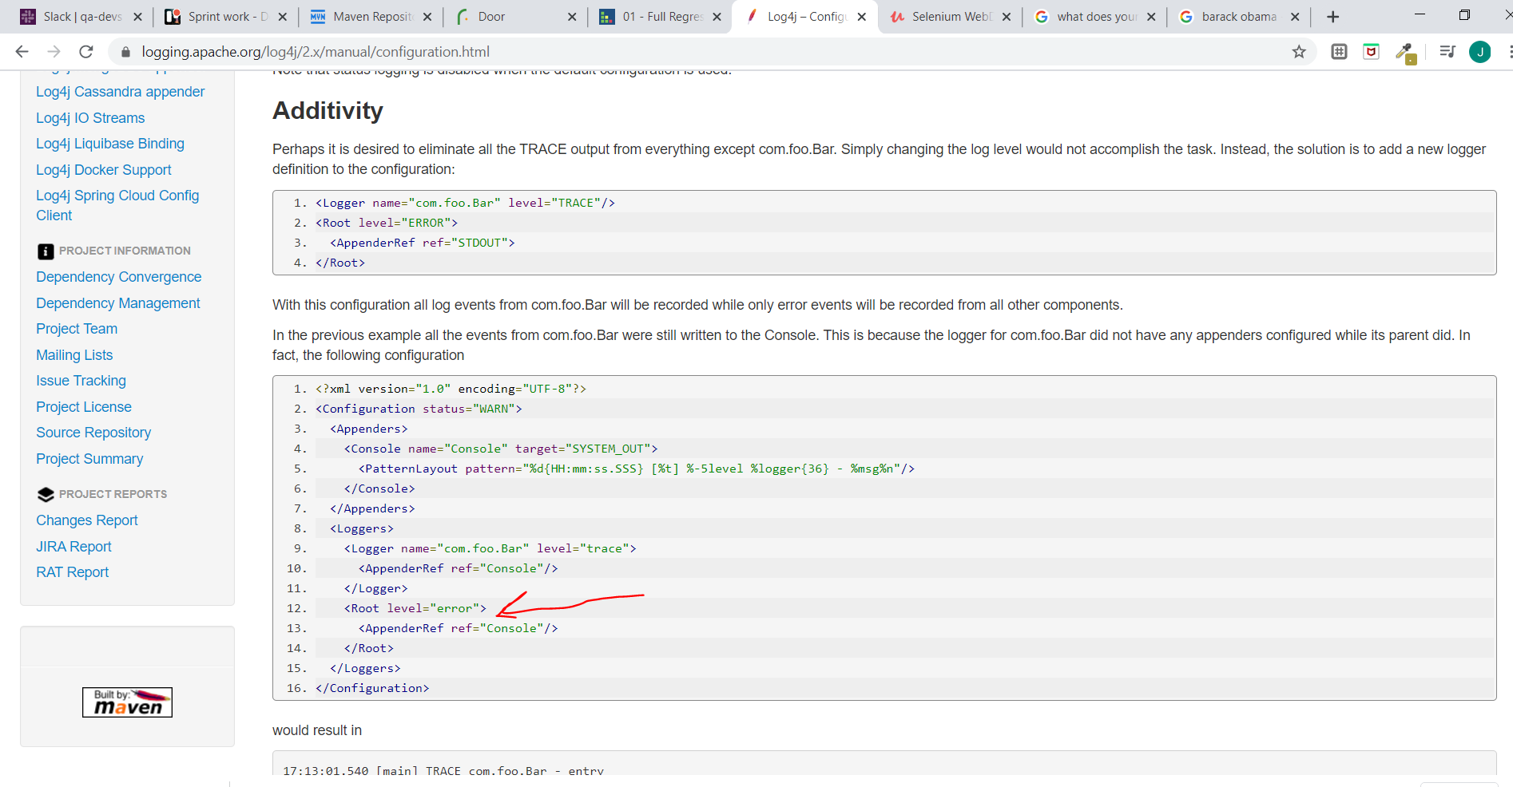

Remove the logger part too.

You also need to add to your build path select the project and go build path change it to sources and then ad folder as you can see

First copy the resource and paste it inside your project. Log4j

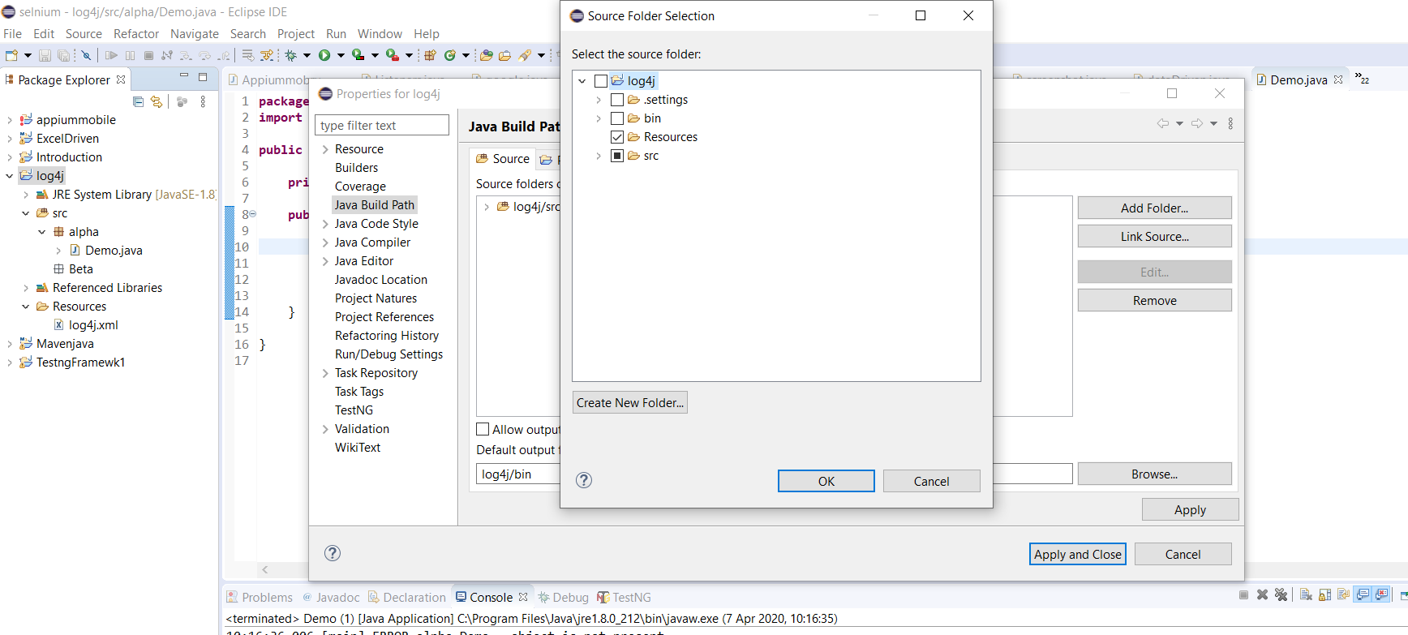

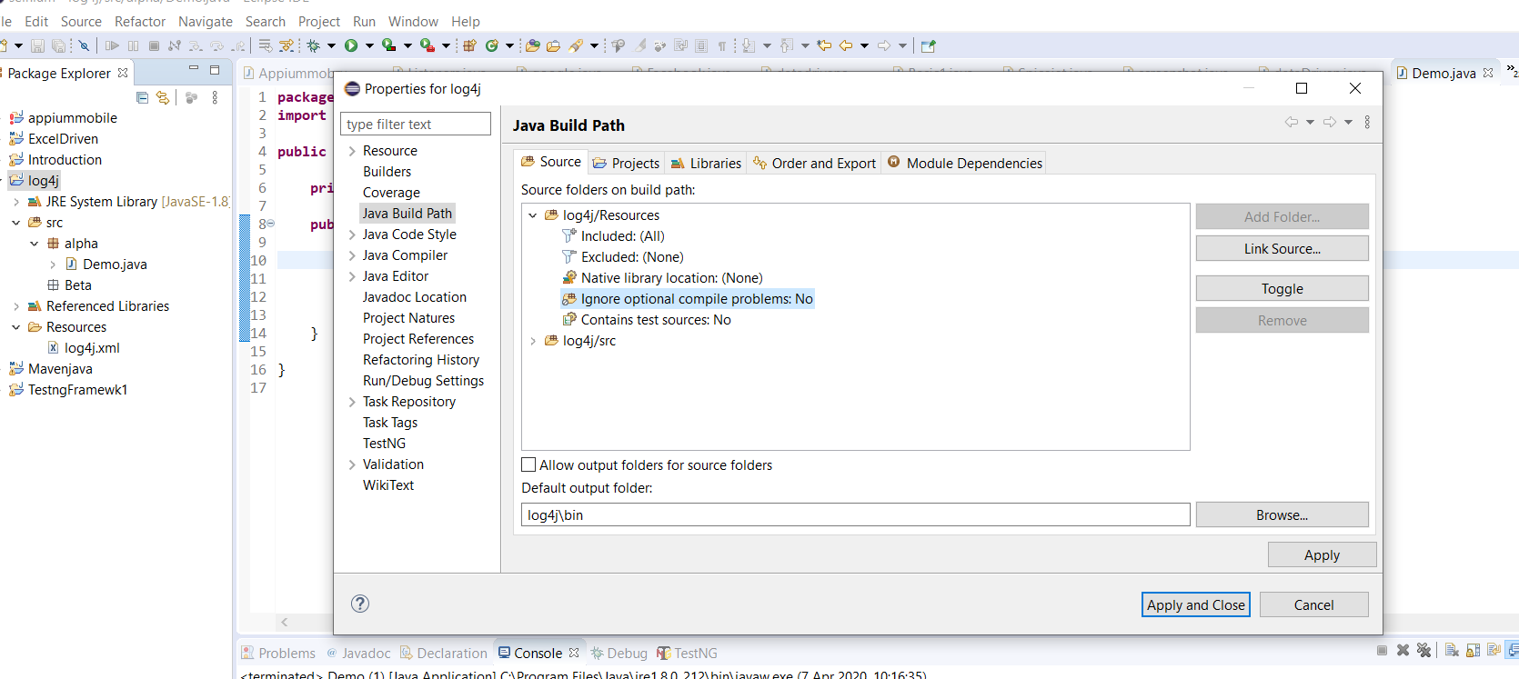

And press ok

To rename…use right click, refactor change name.

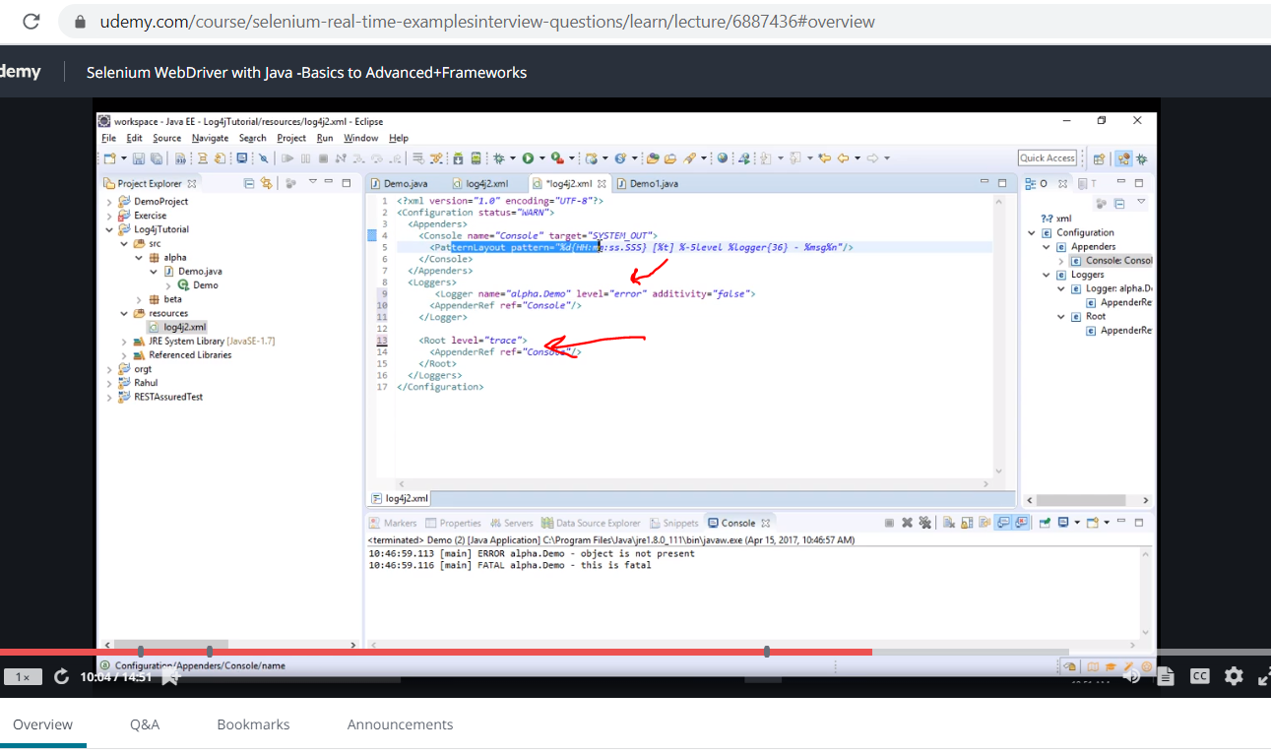

Run only errors for that file and the rest show all …….trace.

<https://www.youtube.com/watch?v=rbuR9Q_55h4>

<https://www.youtube.com/watch?v=Ed1OTpmDfR8>

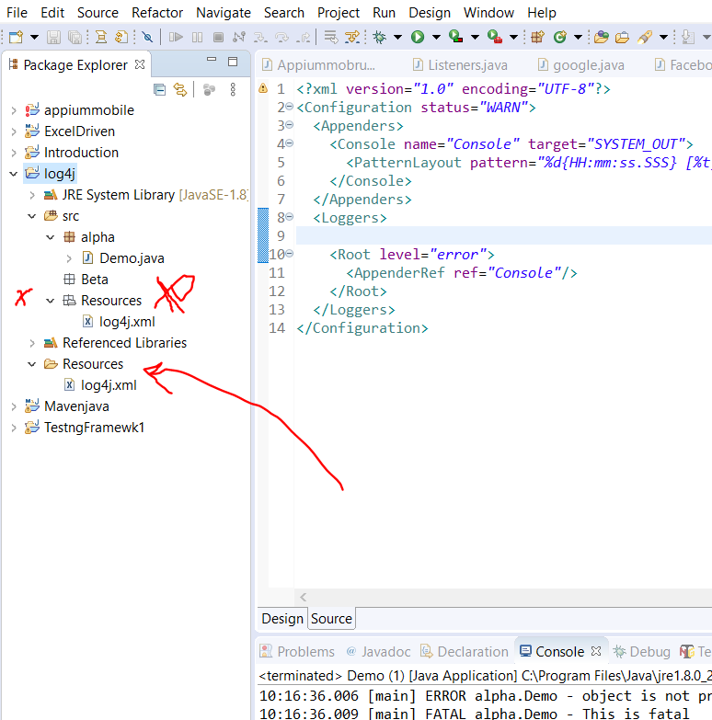

Delete the other resources on top

Page Object Model

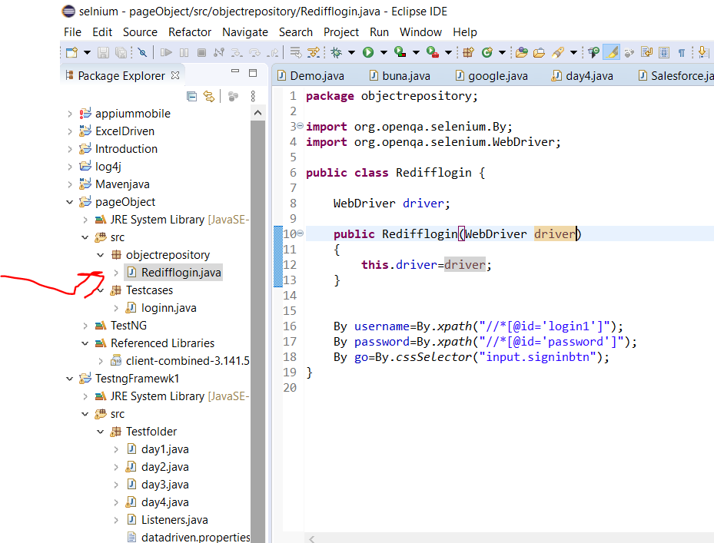

This is saying make object and testcase driver have same value.

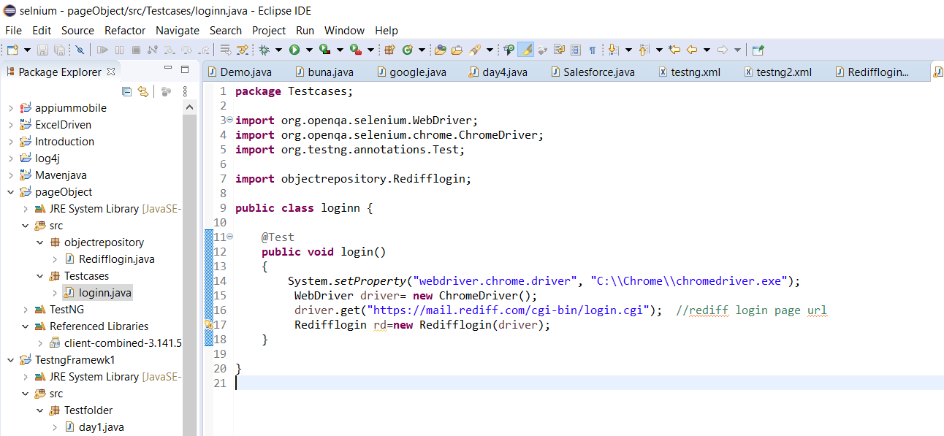

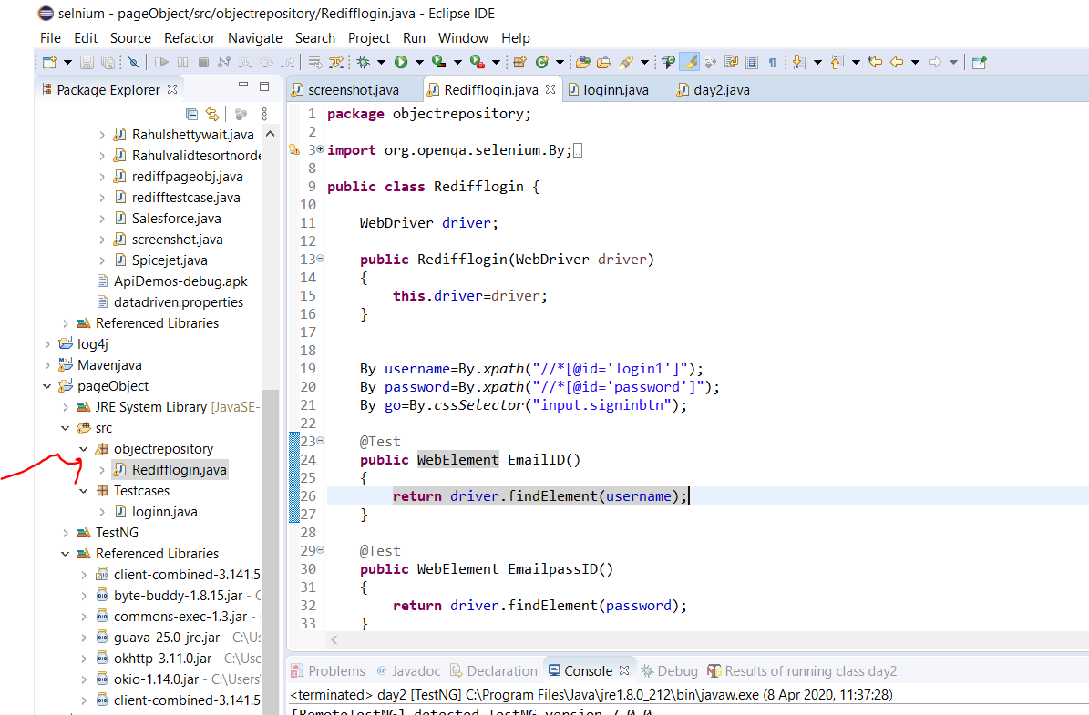

Now we have the object repository where we define or initialise the webelements and use this elements for the testcase

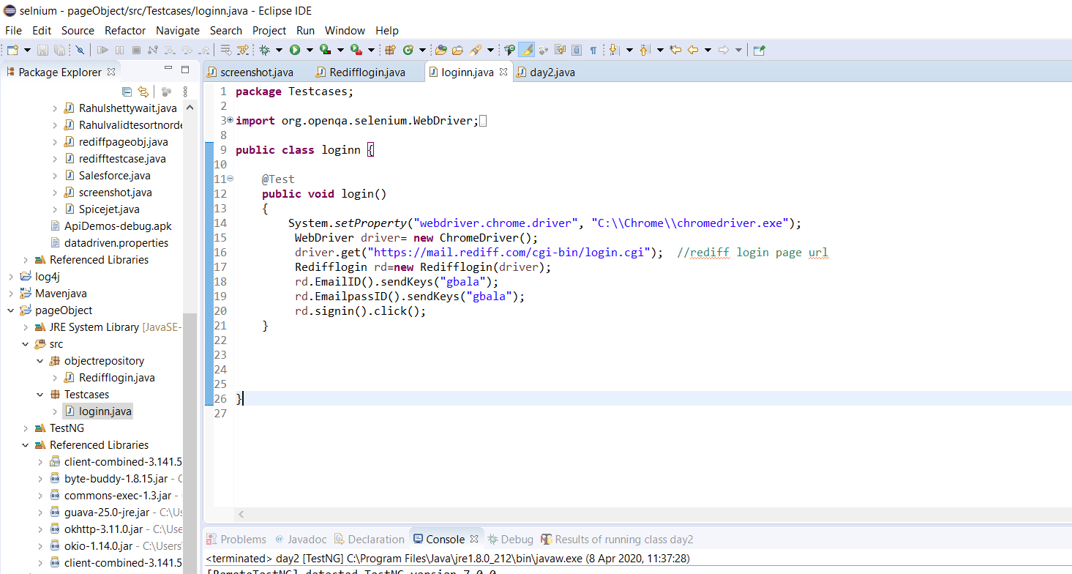

Now take note the first code we wrote is for one page…so if we went into another page we will need a new page object for it

Now this is your testcase looking clean. All your main work is done in the backend

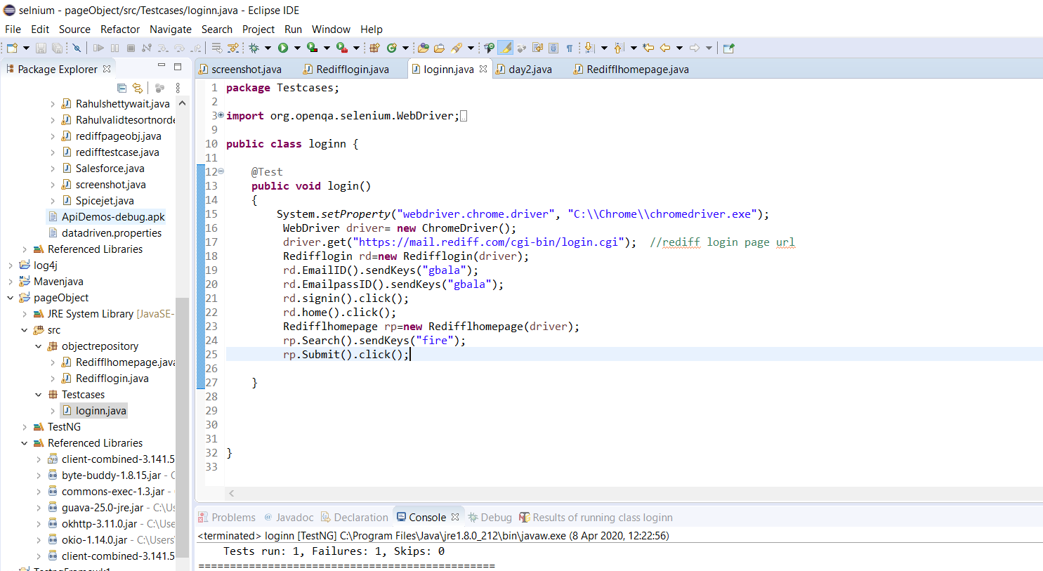

You dnt see any code at all …all you are doing here is creating objects to run the methods with the codes.

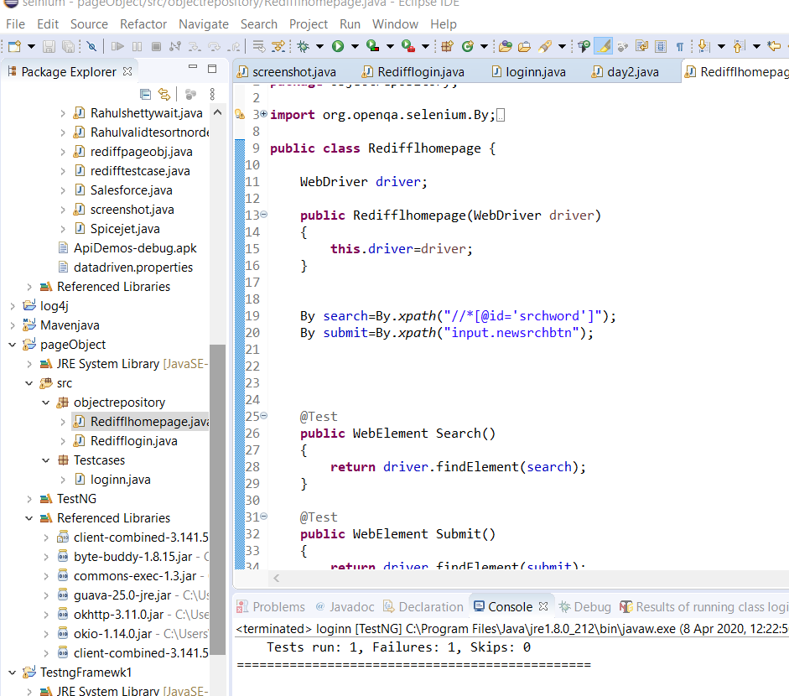

The testcase is one testcase the object models are just for new pages. So obect model has 5 codes for 5 pages and the testcase is just still one testcase. How cool is that ahahahah

Refactory

This is samething but just made easier

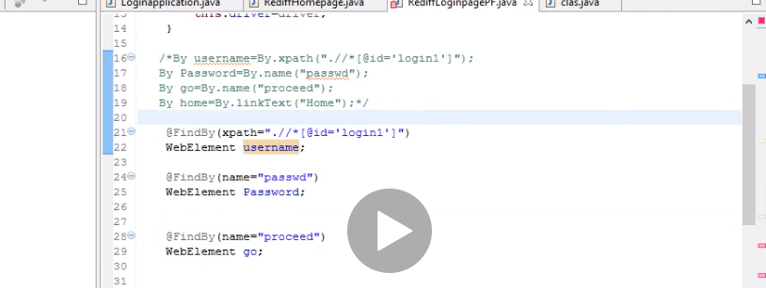

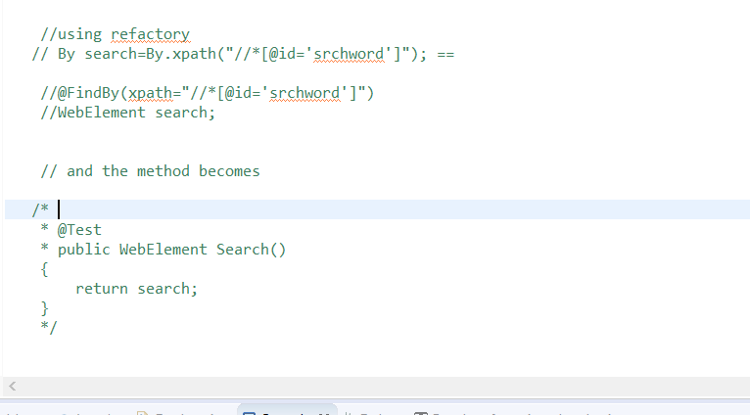

Now the only difference was you need to add this to the constructor

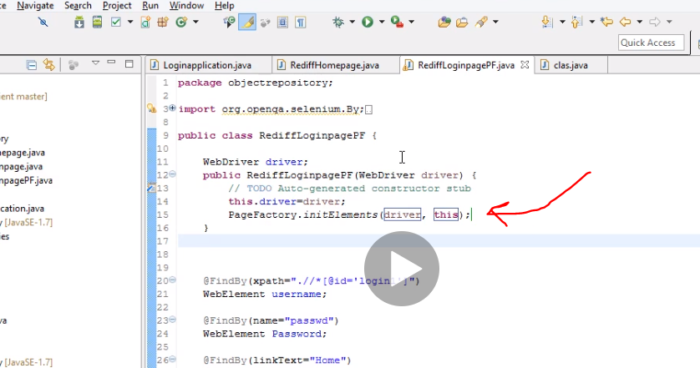

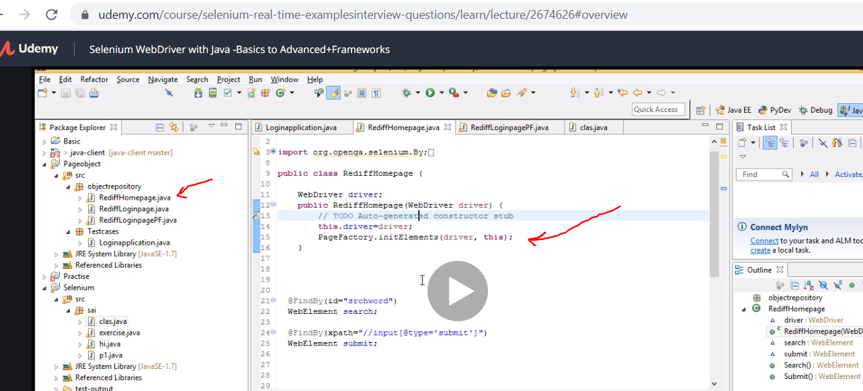

FRAMEWORK BUILD FROM SCRATCH

First set up maven

Second add selenium dependencies

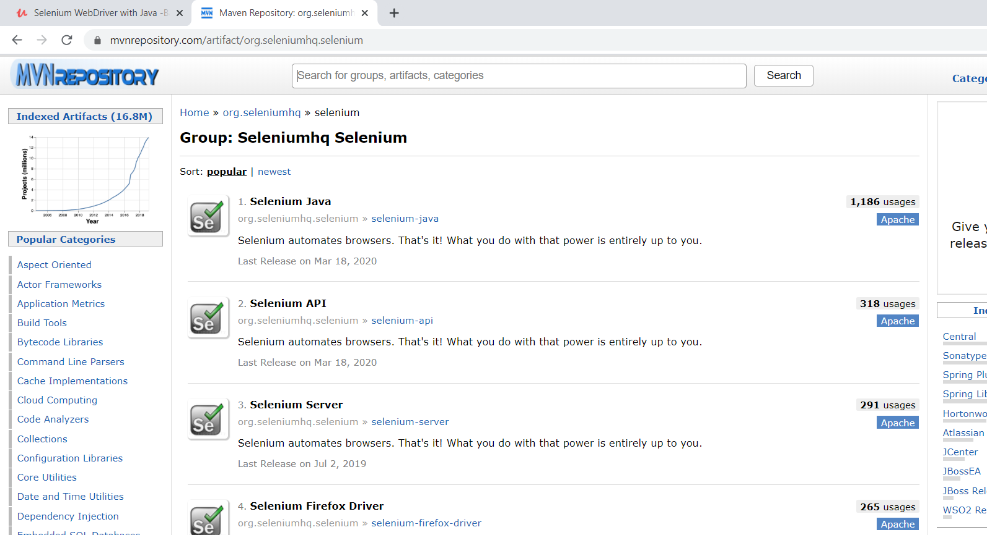

We need testng

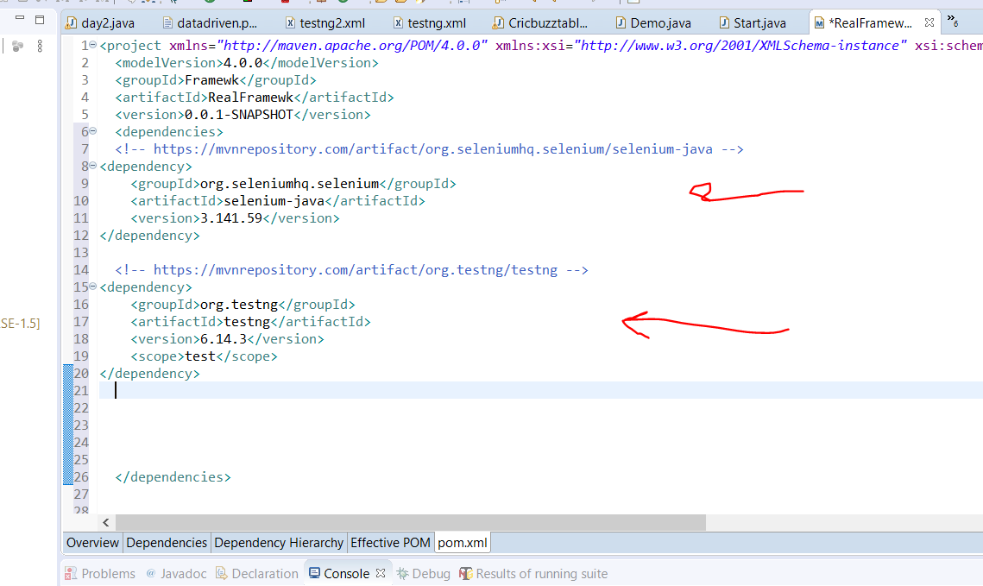

I also added Junit dependency ….dnt think I need it but uncle Shetty has it.

Now in the src/main/java we create new class. We call this class base since it needs to be executed all the time.

Take note for default package just create another folder, the default ones disappear by themselves and all is well haha

Cntrl +click takes you into the method

Base driver has a method called intialise driver which contains the browser.. now we create another class and call it home page. Now instead of using object and all that we just used extend to base with the initialise method and store it as driver. Mean now, driver has the initialise method how cool it is.

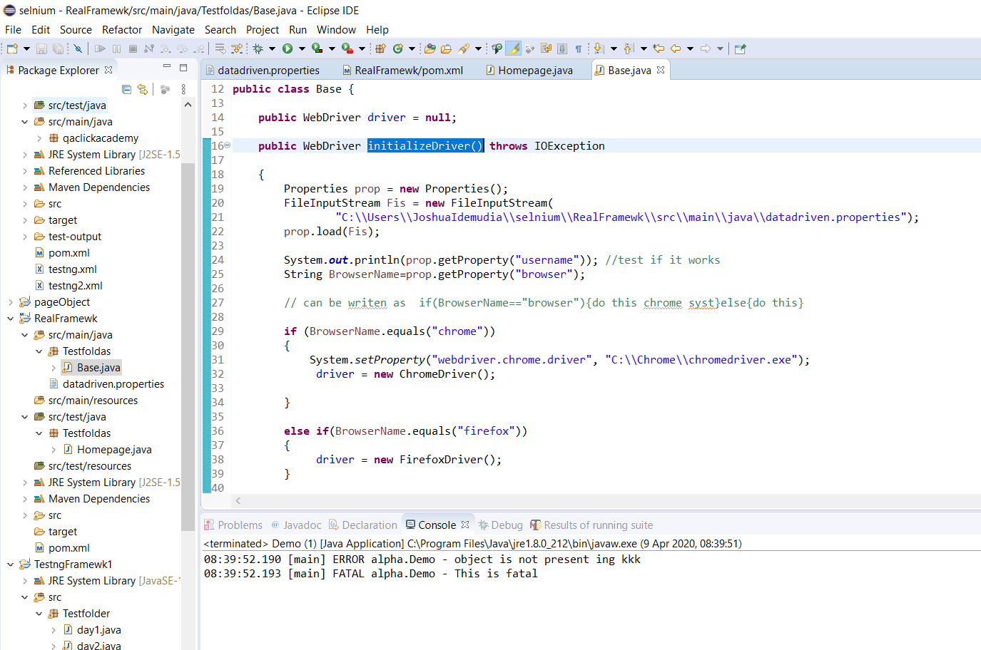

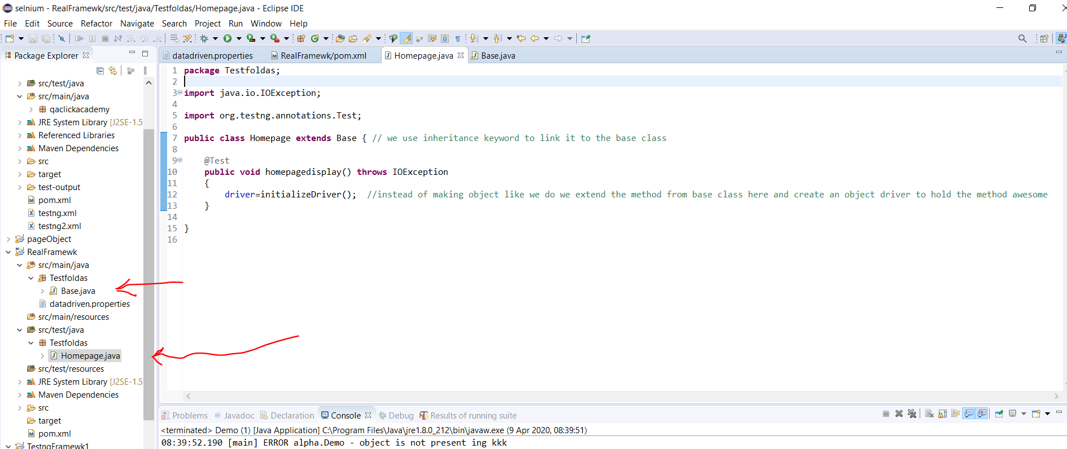

After that we use page object model to log in and shit.

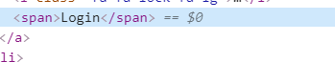

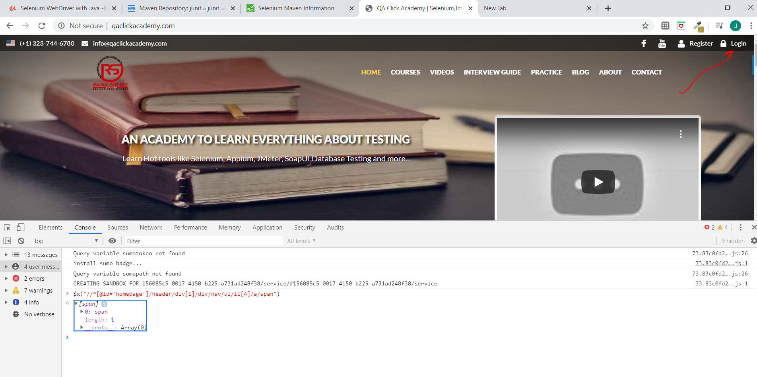

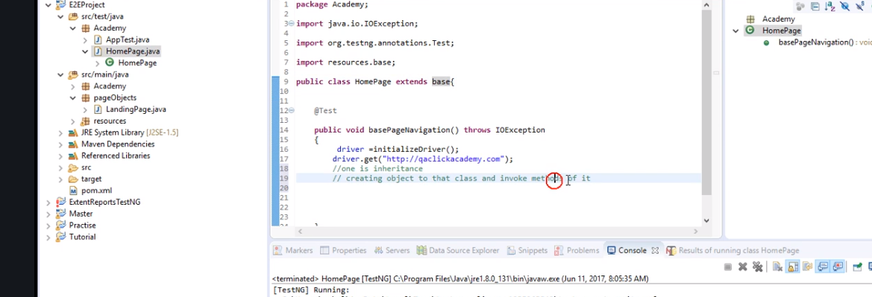

Can use inheritance or create object to class and invoke method

Next just click create constructor to run the driver

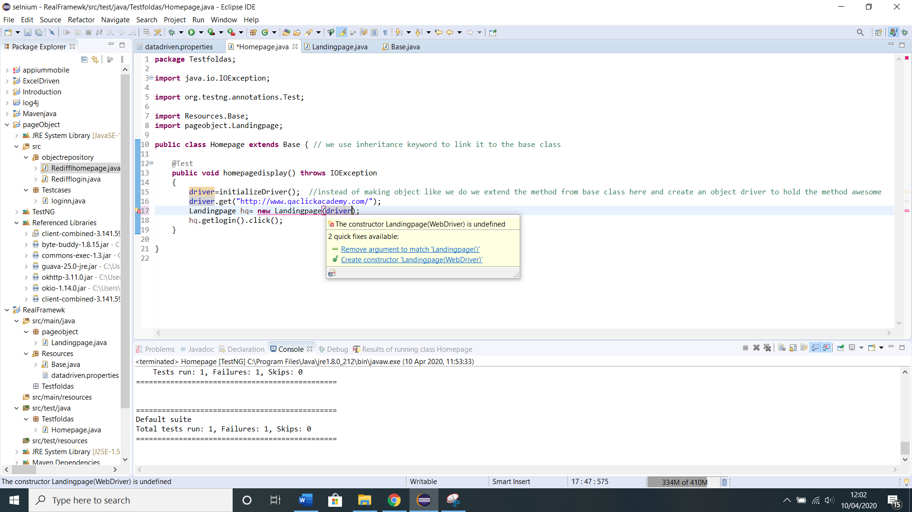

Now we made some changes but we set up pageobject like we did before

Now

Data provider to pass data

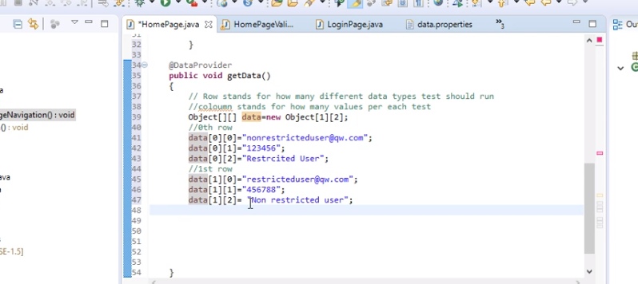

So run the complete set of test cases for two users restricted and nonrestricted with values so just always start from 00 and count up to as many as you want .[2][3] means at the end of whatever you do, u should have 3 users with whatever value u want starting form 00.

Actually

the first row is number of times to run or happen or number of clients or names while second row is the amount of values or parameters or variables

start counting from 0.

Now say we want to compare we have to use

Assertion we used.

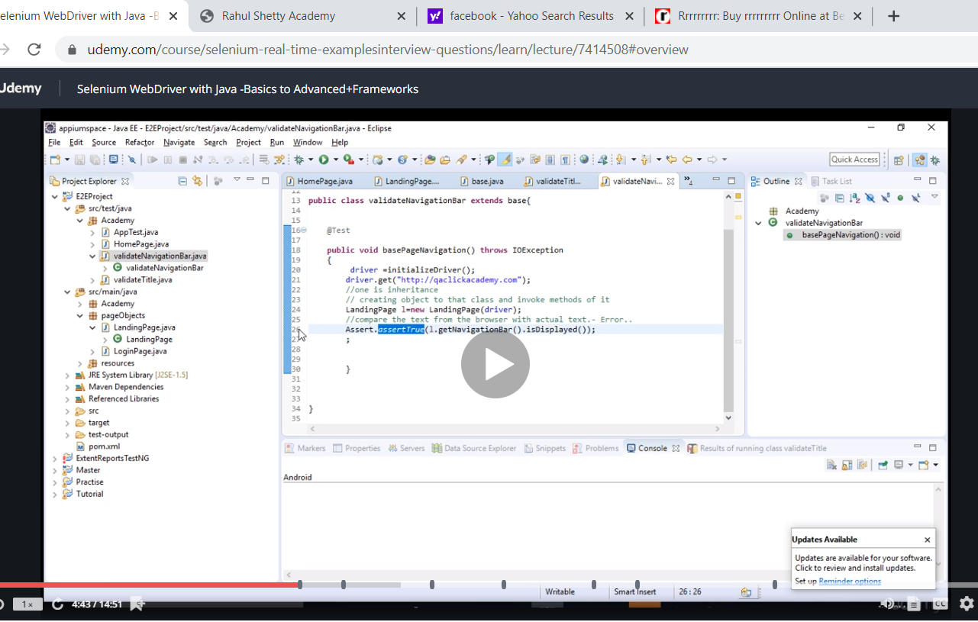

Using assert true is another way to use it. Or assert false

Also prop.getProperty("browser") we had to make it a global variable so when wwe use inheritance we can use it in another class

Homepage code

**package** Testfoldas;

**import** **static** org.testng.Assert.*assertEquals*;

**import** **static** org.testng.Assert.*assertTrue*;

**import** java.io.IOException;

**import** org.openqa.selenium.chrome.ChromeOptions;

**import** org.openqa.selenium.remote.CapabilityType;

**import** org.openqa.selenium.remote.DesiredCapabilities;

**import** org.testng.Assert;

**import** org.testng.annotations.DataProvider;

**import** org.testng.annotations.Test;

**import** Resources.Base;

**import** pageobject.rediffhmepage;

**import** pageobject.redlogn;

**import** pageobject.resultpage;

**public** **class** Homepage **extends** Base { // we use inheritance keyword to link it to the base class

@Test(dataProvider="getdata")

**public** **void** homepagedisplay(String username, String password /*String text*/) **throws** IOException

{

driver=initializeDriver(); //instead of making object like we do we extend the method from base class here and create an object driver to hold the method awesome

driver.get(prop.getProperty("url")); //come back to this later http://www.qaclickacademy.com/

redlogn rd=**new** redlogn(driver);

rd.EmailID().sendKeys(username);

rd.EmailpassID().sendKeys(password);

rd.signin().click();

rd.home().click();

rediffhmepage rp=**new** rediffhmepage(driver);

rp.Search().sendKeys("rrrrrrrrr");

rp.Submit().click();

resultpage bf=**new** resultpage(driver);

System.***out***.println(bf.SearchResult().getText());

Assert.*assertEquals*(bf.SearchResult().getText(), "shakalama");

}

@DataProvider

**public** Object[][] getdata()

{ //0 rows

Object[][] data=**new** Object[1][2]; // the first row is number of times to run or happen or number of clients or names while second row is the amount of values or parameters or variables

data[0][0]="usernamegbala";

data[0][1]="1234";

//data[0][0]="restricted gbala";

//1st row

//data[0][0]="nonrestricted";

//data[0][0]="56456";

//data[0][0]="non restricted";

**return** data;

}

}

Now remember to d the build for pom for the xml

<build>

<pluginManagement>

<plugins>

<plugin>

<groupId>org.apache.maven.plugins</groupId>

<artifactId>maven-surefire-plugin</artifactId>

<version>3.0.0-M4</version>

<configuration>

<suiteXmlFiles>

<suiteXmlFile>testng.xml</suiteXmlFile>

</suiteXmlFiles>

</configuration>

</plugin>

</plugins>

</pluginManagement>

</build>

Also remember if you have more than one xml you create what is called profile and paste this build inside it and chang the name to the name of the xml file. Testxml2

Next we go to the main project…get the directory by doing property copy it and go to cmd change directory and do mvn compile

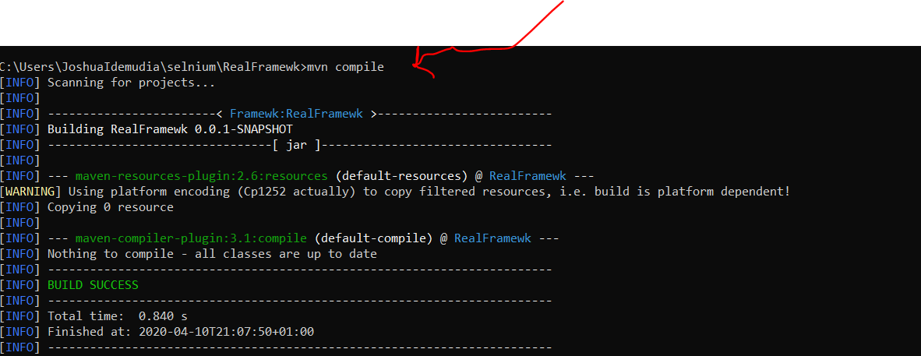

Maven apache ---using testng

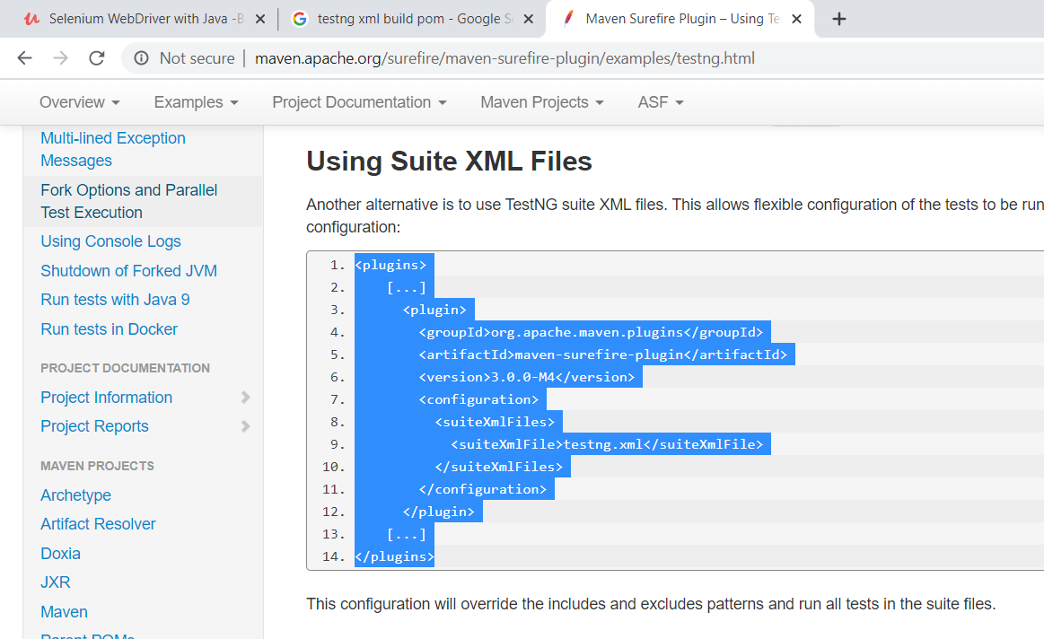

It worked . so lesson the only thing that should show in your xml is just test …anything else remove.

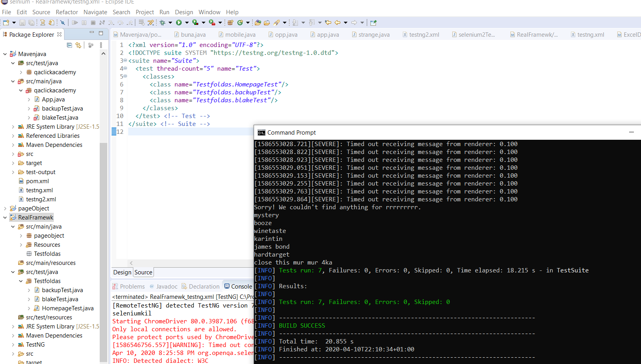

So do mvn compile when you get to the directory and mvn test to finalise the project.

Now we need to get jars for log 4j but good news yaye f that shit so its maven we need the dependencies for it yayeeeee

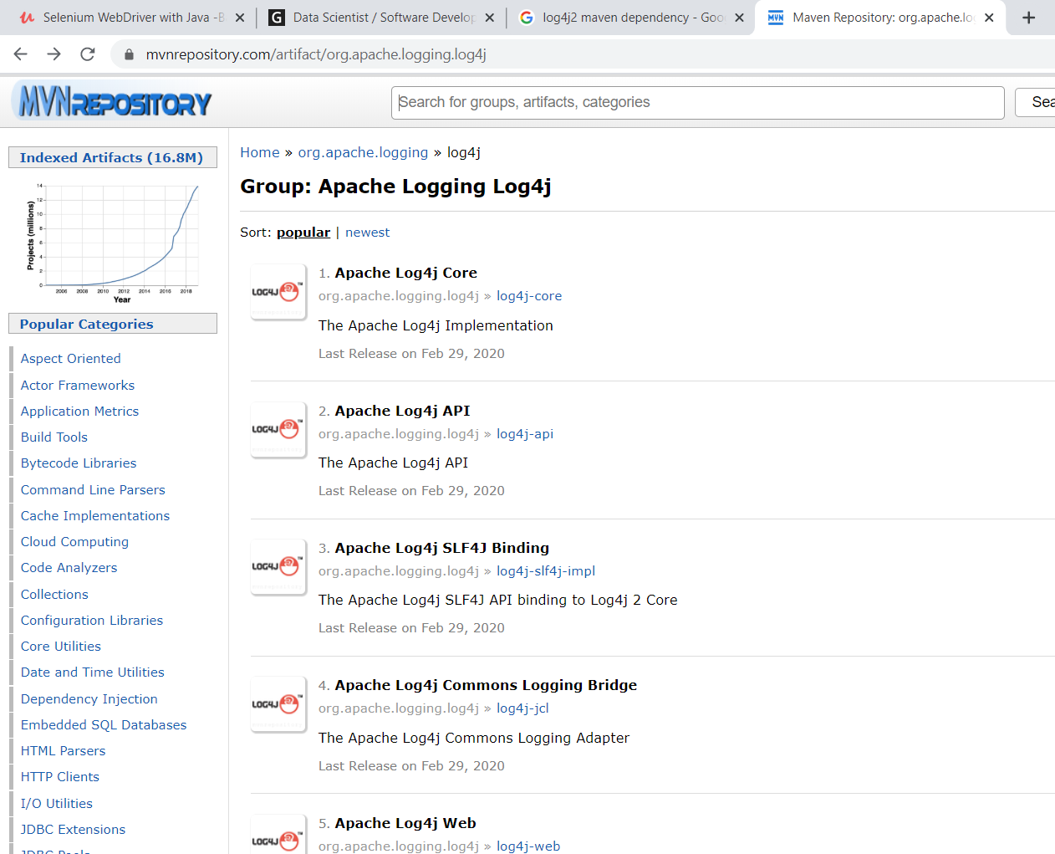

Download apache core and api

<https://www.youtube.com/results?search_query=configure+log4j+in+maven+project+>

come back to this

<?xml version="1.0" encoding="UTF-8"?>  
<Configuration status="WARN">  
       <Properties>  
<Property name="basePath">./logs</Property>  
</Properties>  
   
  <Appenders>  
      <RollingFile name="File" fileName="${basePath}/prints.log" filePattern="${basePath}/prints-%d{yyyy-MM-dd}.log">  
     <PatternLayout pattern="%d{HH:mm:ss.SSS} [%t] %-5level %logger{36} - %msg%n"/>  
      <SizeBasedTriggeringPolicy size="500" />  
          </RollingFile>  
    <Console name="Console" target="SYSTEM_OUT">  
      <PatternLayout pattern="%d{HH:mm:ss.SSS} [%t] %-5level %logger{36} - %msg%n"/>  
    </Console>  
  </Appenders>  
  <Loggers>  
    <Root level="trace">  
      <AppenderRef ref="File"/>  
    </Root>  
  </Loggers>  
</Configuration>

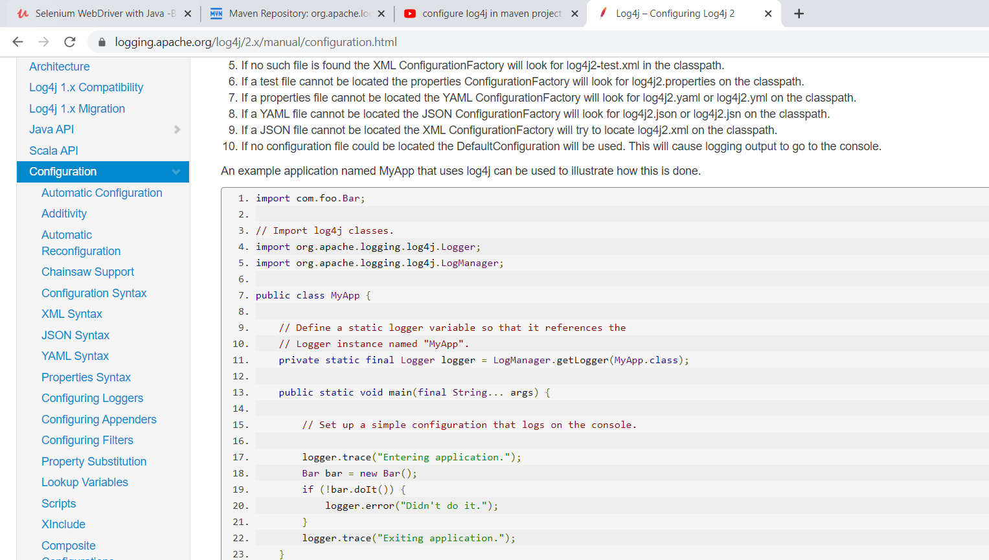

Actually got it to work first makesure u make the folder in src. Then cpy and paste it to the project and delete it. Then change to trace an then attach it on java build simple.

Now using the page object project… I have beta.boom1 and testcases.boom. nw we change to error and trace depending if client just wants to see them differently.

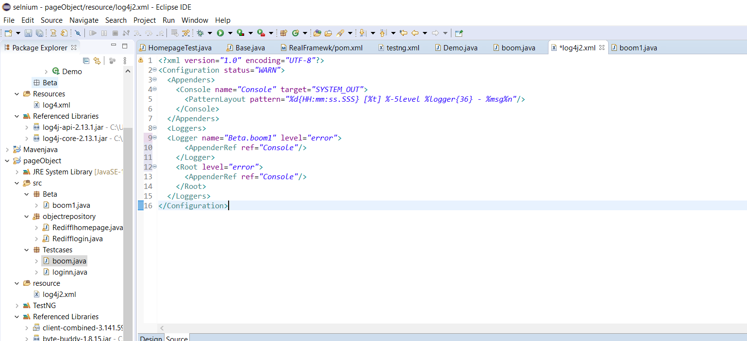

So the additive helpd it not duplicate answer.

The logger is to specify which one to show error so the specific test will show only log and any other test will show trace

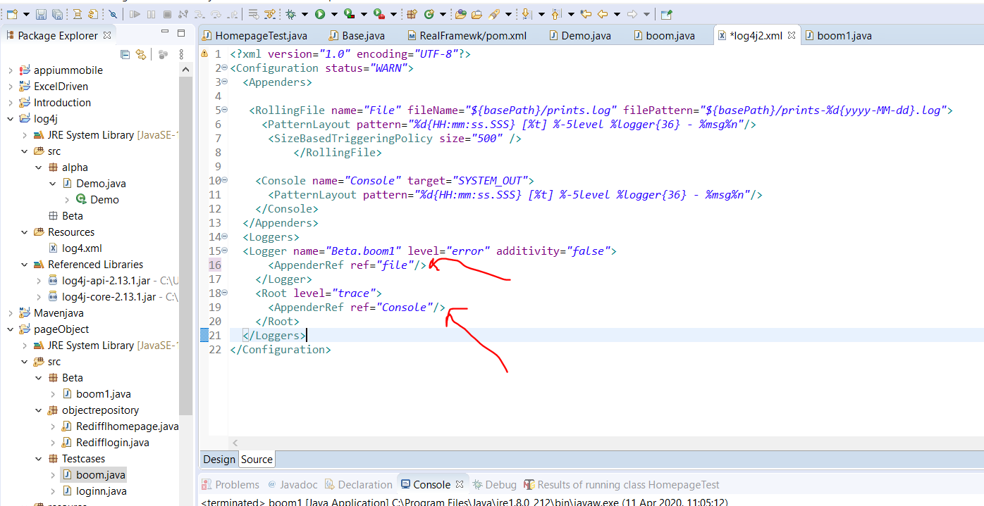

Means that file prints to file and the other prints to console.

Now we create another package to keep all the log files go to right vlivk on src and other and general and untitled text file

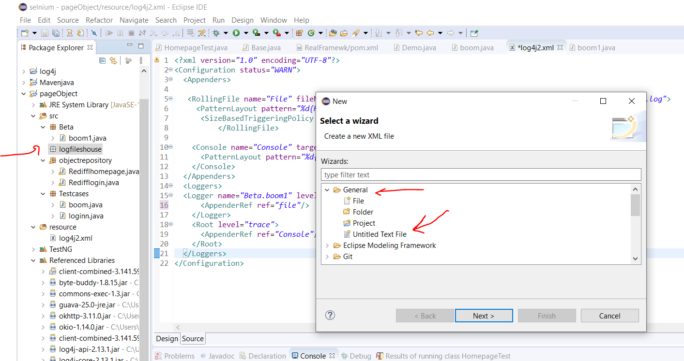

Now type anything into it save it as a .log and also click the location and save.

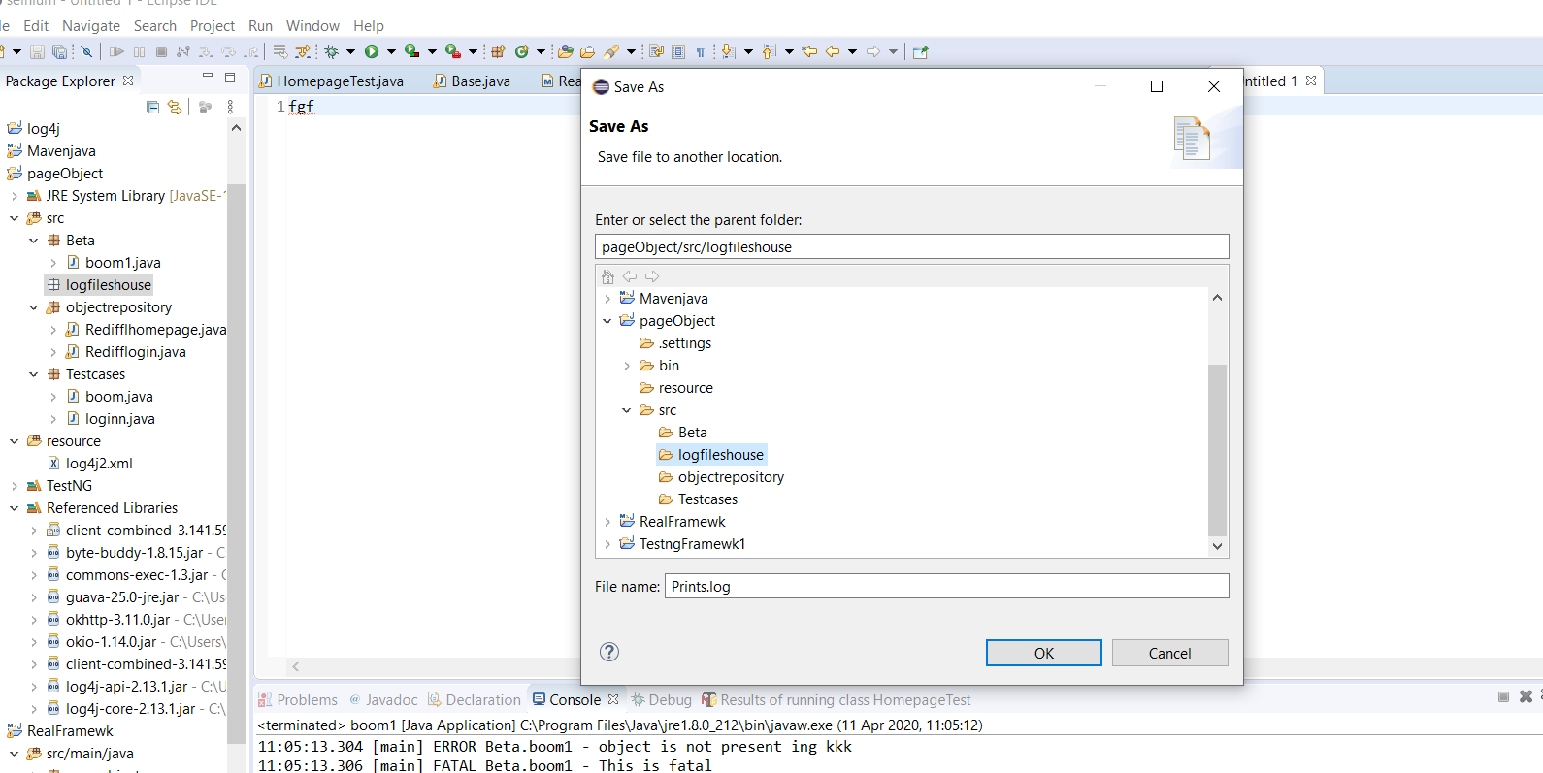

Now pass the location to the xml file section

Now you need to add properties before appender

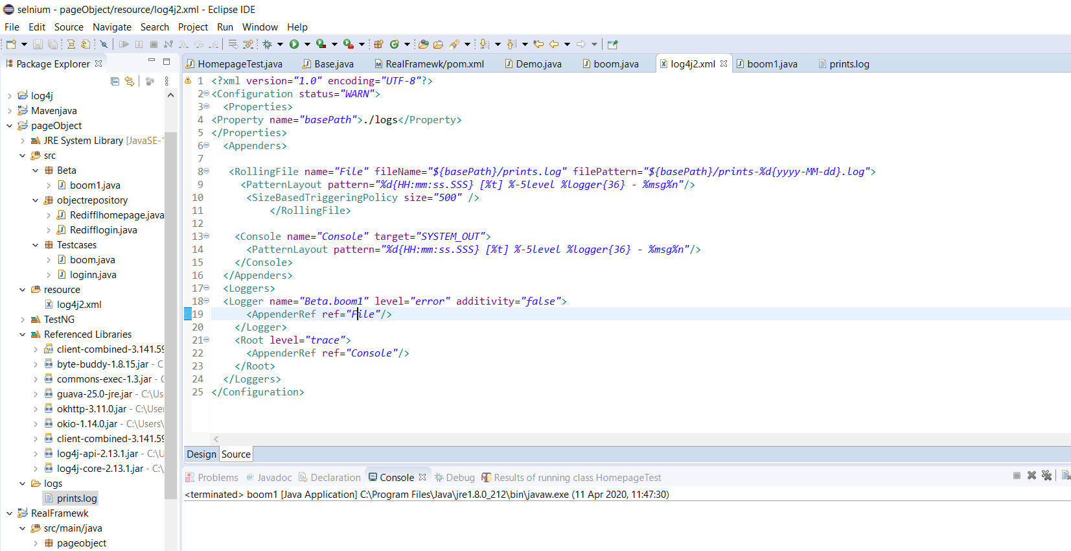

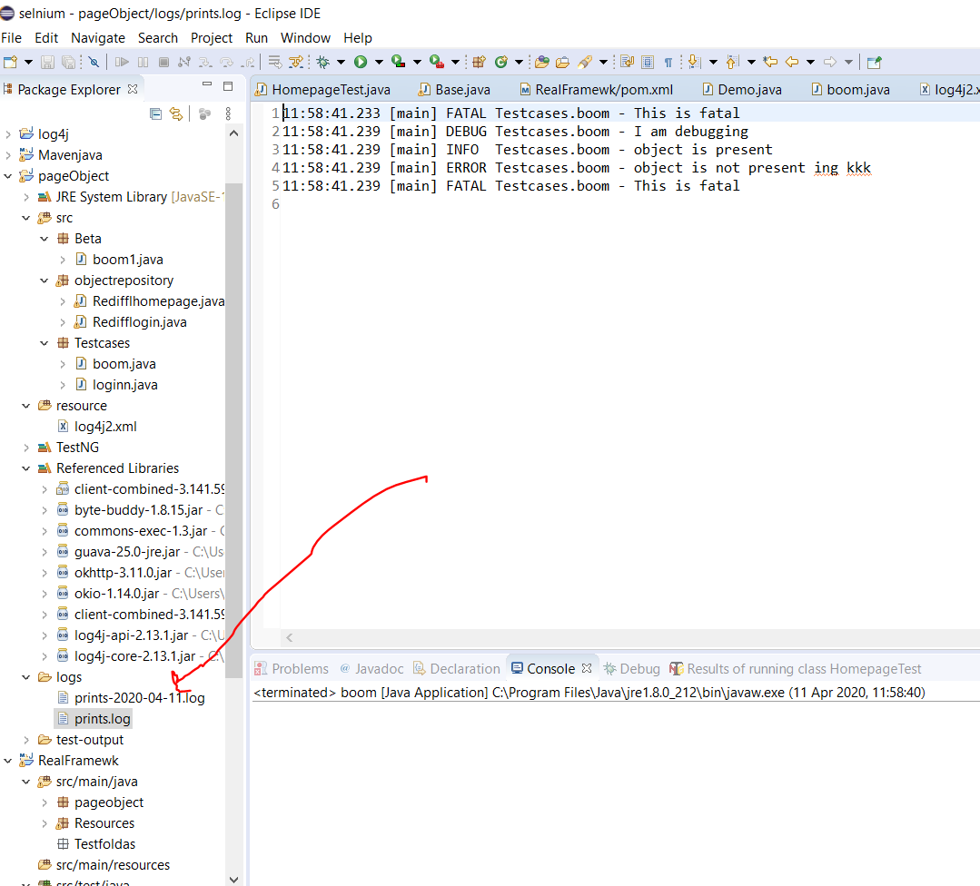ot makes extra logs when u have too much in the log.

Now again copy the log and paste in in project aand delete it from the scr.

Now fast forward to present day, he pasted the log folder in resources.

Now so the pom can connect with the log print xml we need to add resources to build.

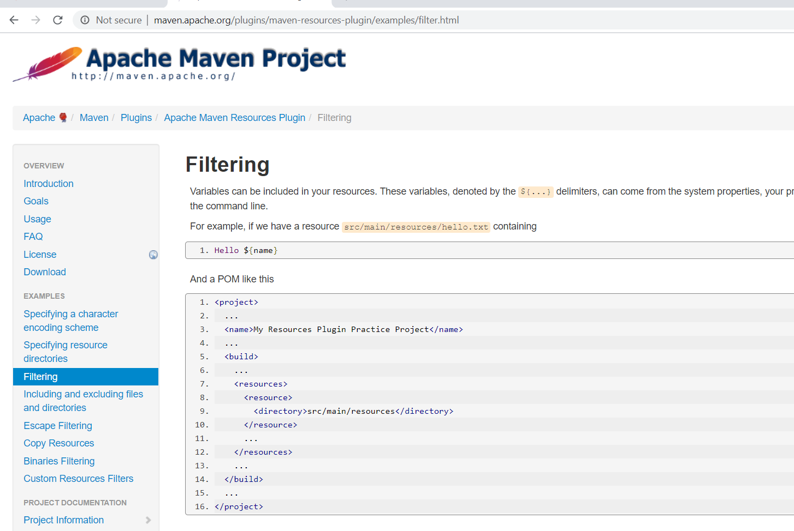

Type maven resource filtering to find it.

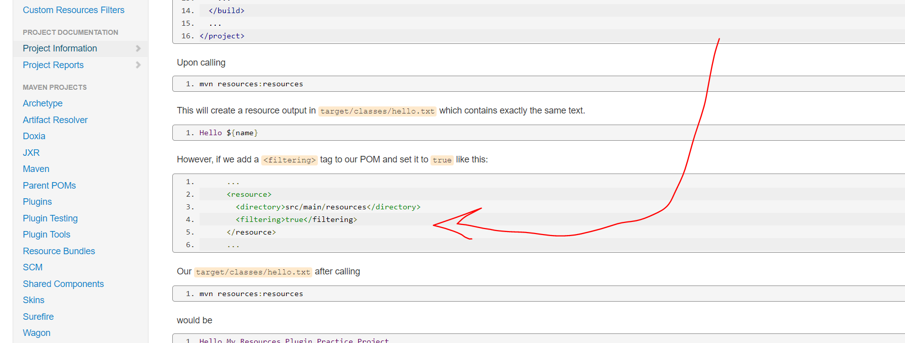

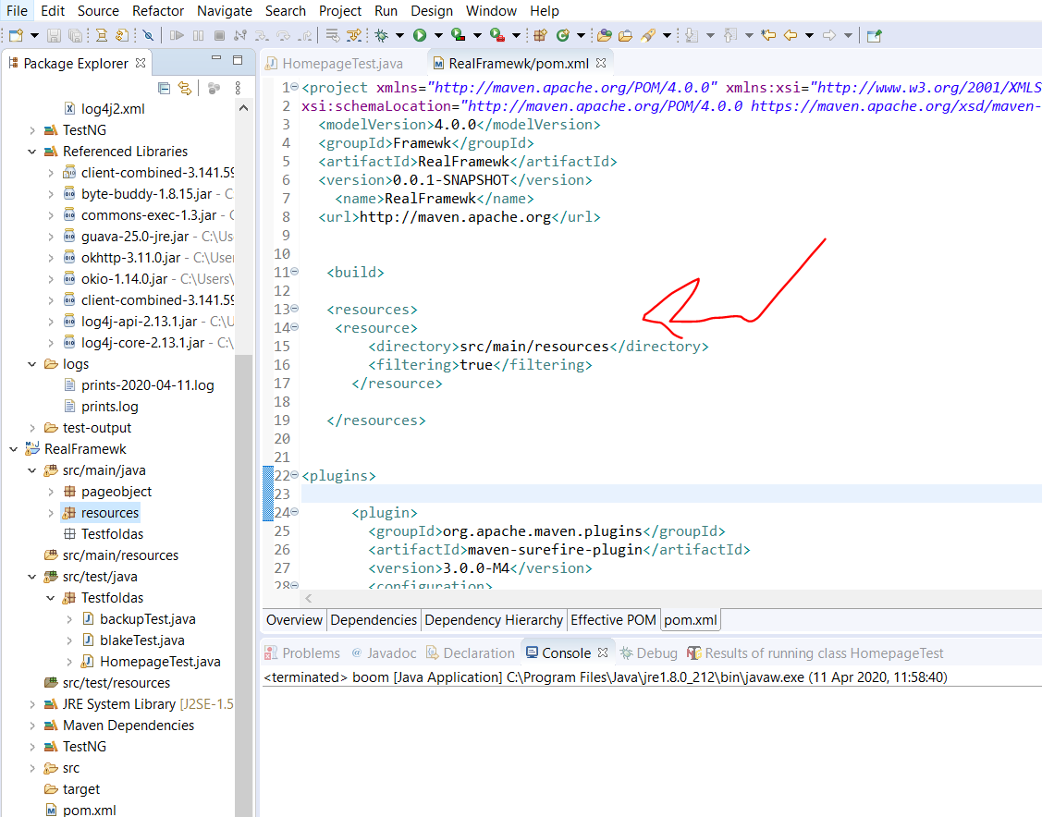

Separate like this so driver .close closes each of them after running

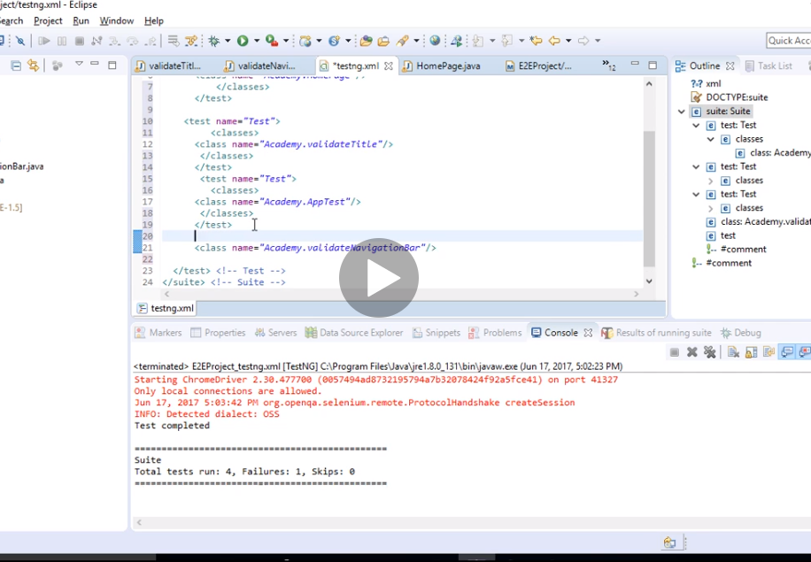

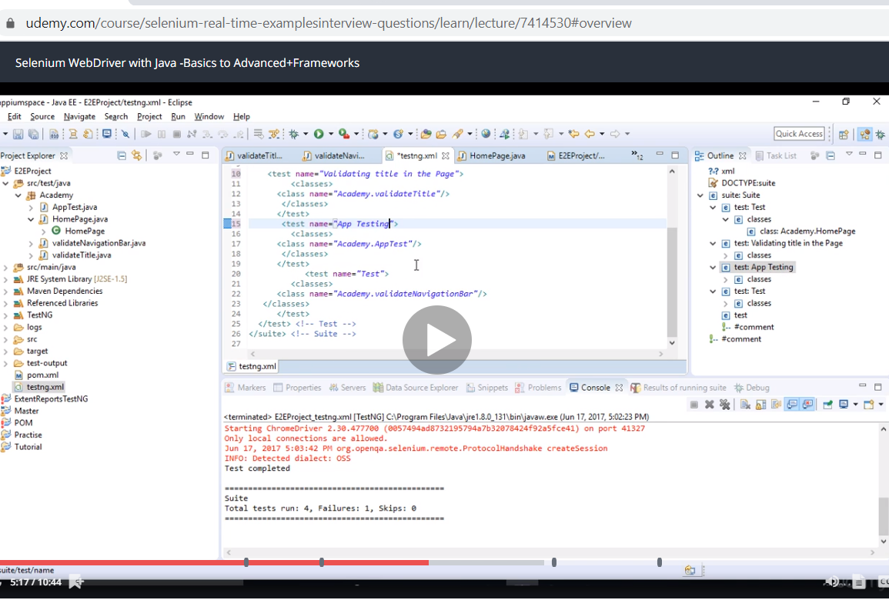

Now screenshots.

He defines this in his base class…..

Now we need to create listeners…. We create a new class in the src/test/java

Guess what yayeeee…..this time the unimplemented method shows before it didn’t yaye

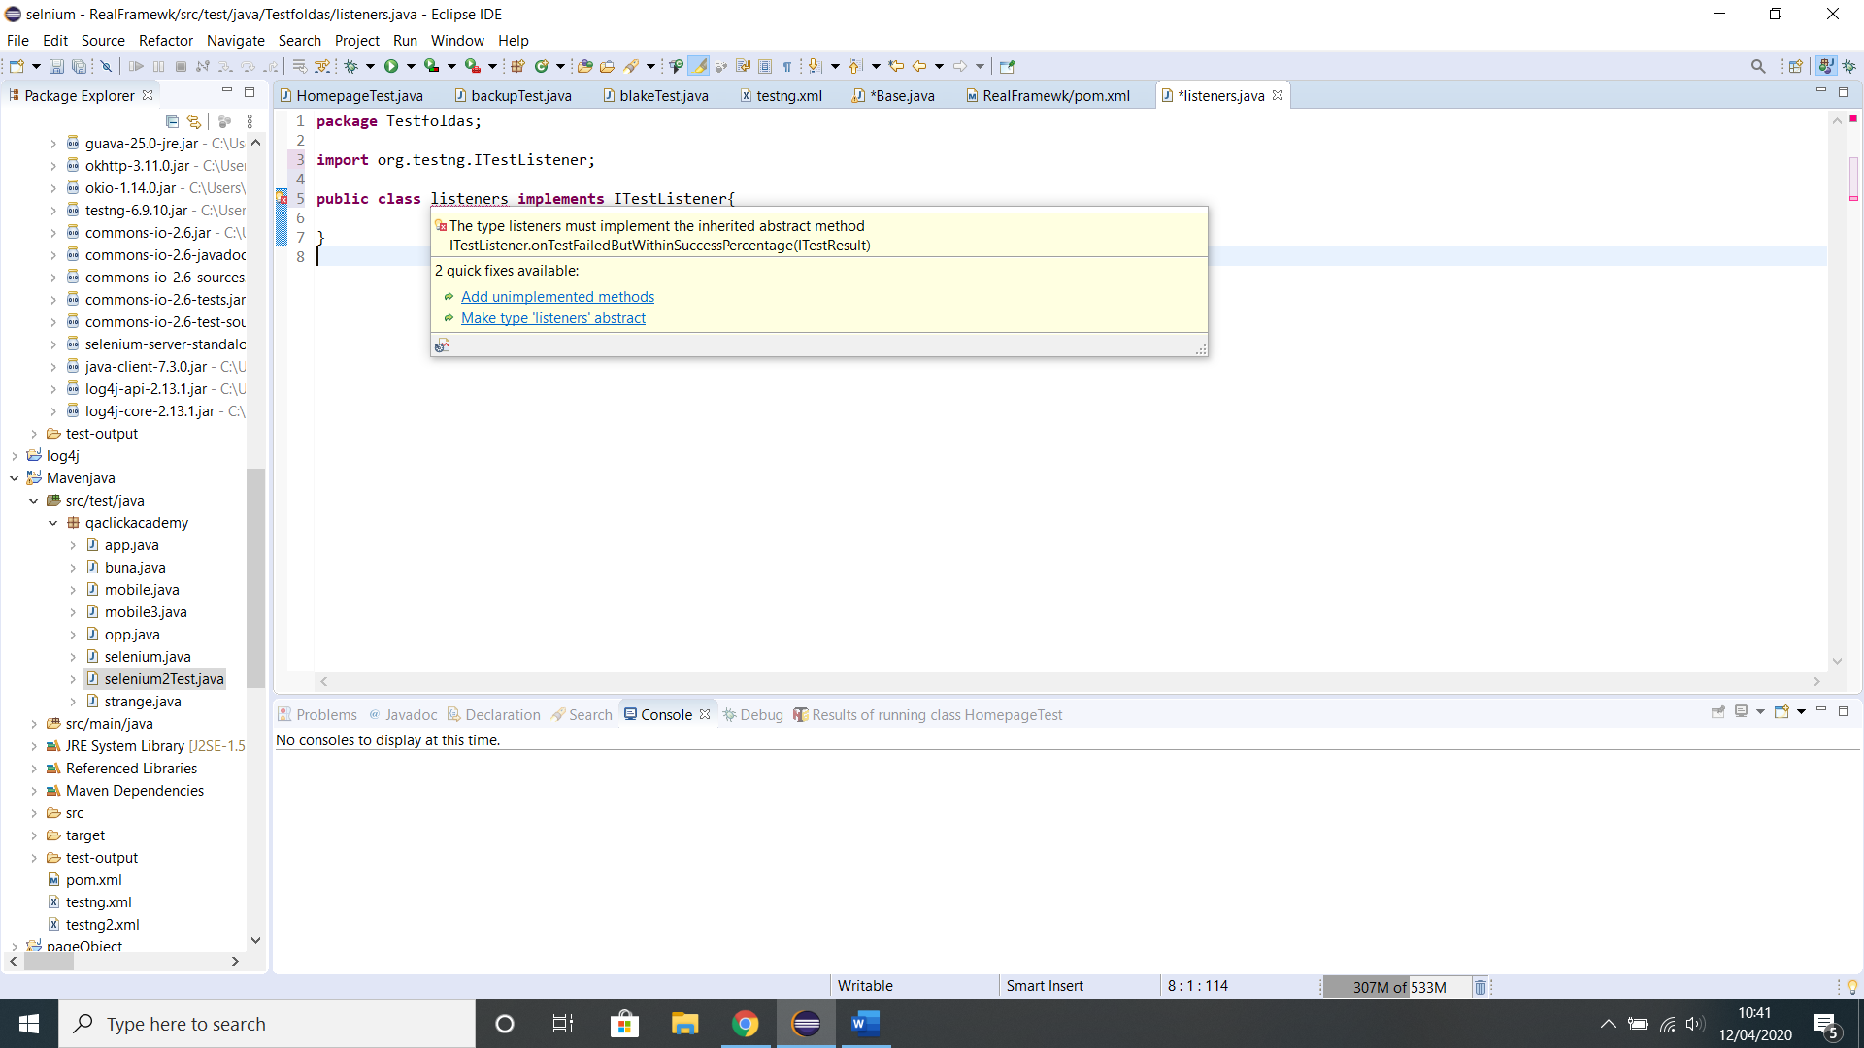

**package** Testfoldas;

**import** org.testng.ITestContext;

**import** org.testng.ITestListener;

**import** org.testng.ITestResult;

**public** **class** listeners **implements** ITestListener{

**public** **void** onTestStart(ITestResult result) {

// **TODO** Auto-generated method stub

}

**public** **void** onTestSuccess(ITestResult result) {

// **TODO** Auto-generated method stub

}

**public** **void** onTestFailure(ITestResult result) {

// **TODO** Auto-generated method stub

}

**public** **void** onTestSkipped(ITestResult result) {

// **TODO** Auto-generated method stub

}

**public** **void** onTestFailedButWithinSuccessPercentage(ITestResult result) {

// **TODO** Auto-generated method stub

}

**public** **void** onStart(ITestContext context) {

// **TODO** Auto-generated method stub

}

**public** **void** onFinish(ITestContext context) {

// **TODO** Auto-generated method stub

}

}

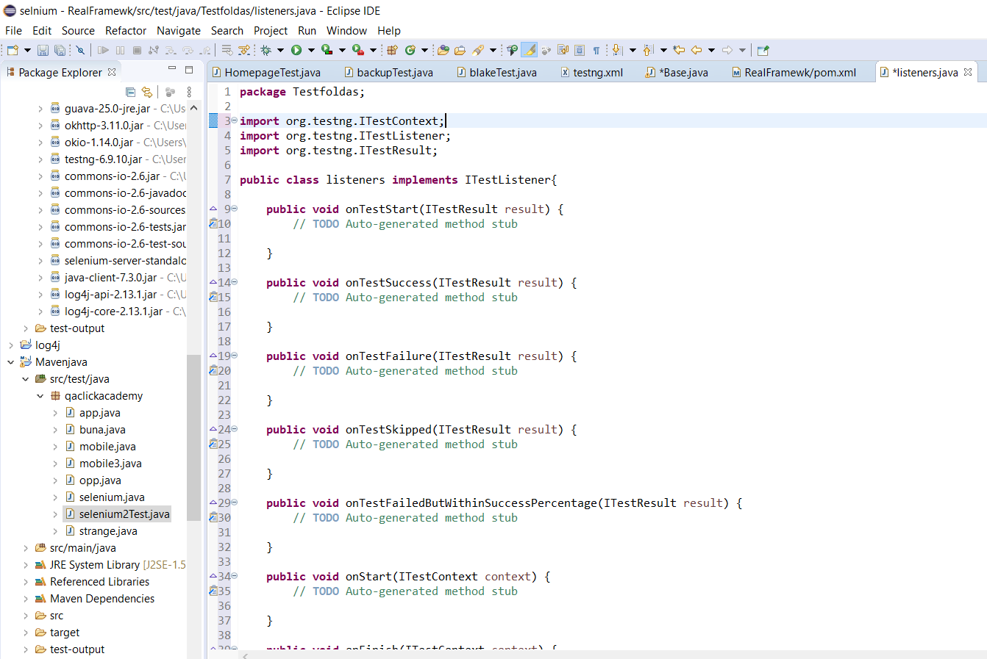

Now we need to create a base class to access it in

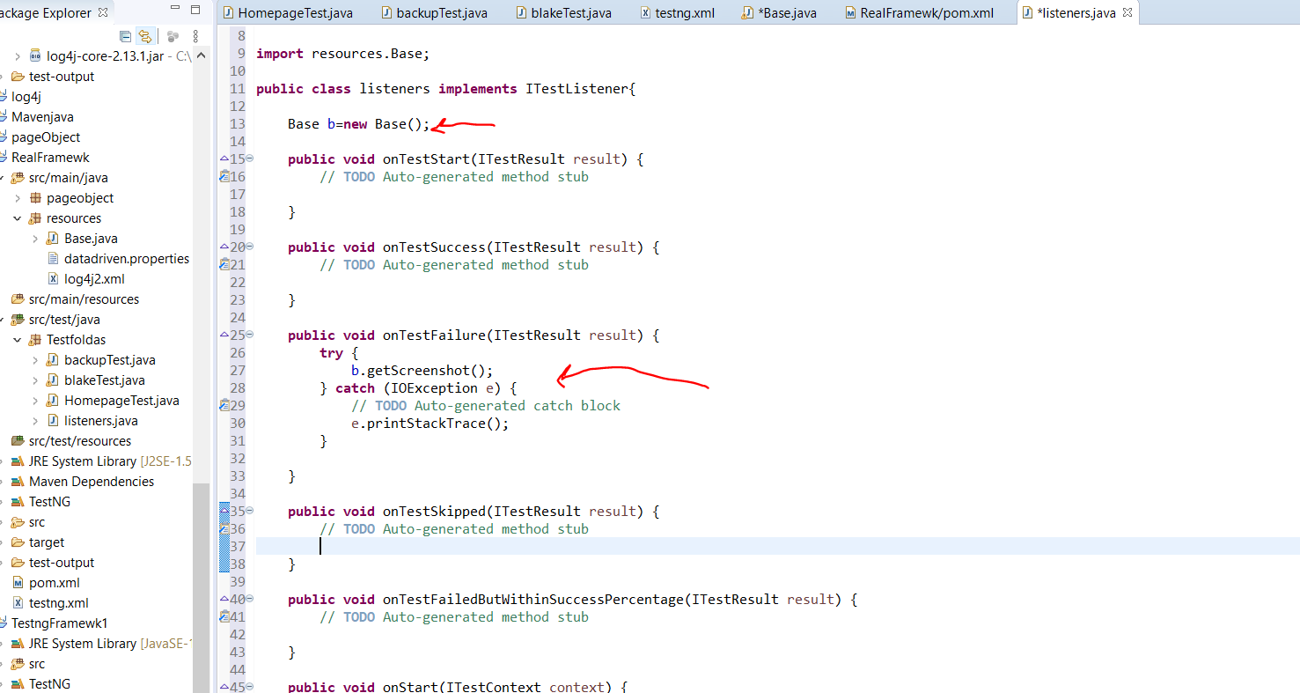

We make it an object and call it into the failed listener method

Now you need to tell your xml that there are listeners and should keep an eye on them testng.xml

Now how do we make our screenshot dynamic so it does not need to overwrite and I dnt have to manually save it?

Change listener class

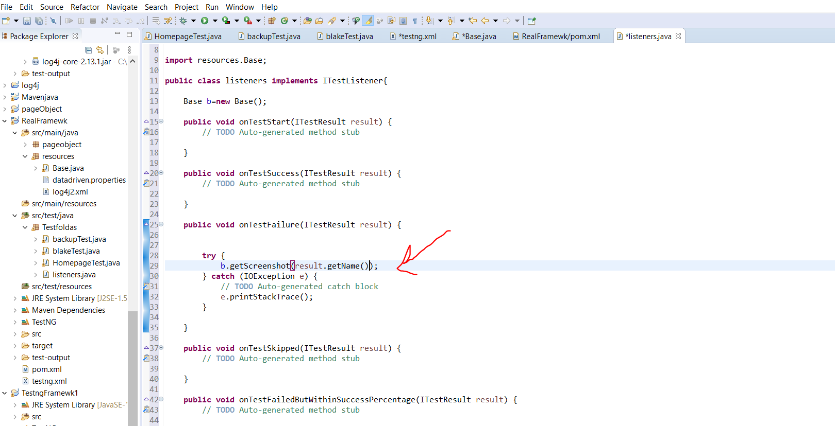

Change base class

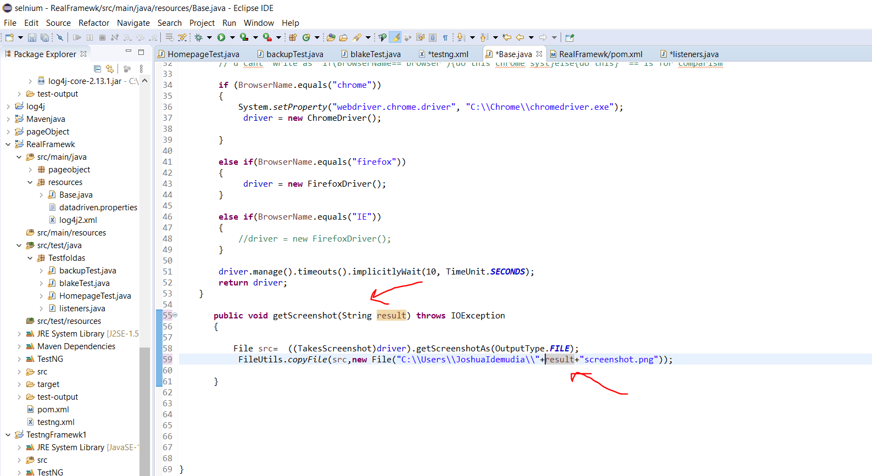

<https://www.youtube.com/watch?v=1V1w8ccRp_M&t=880s>

come back to this screenshot

now extent report

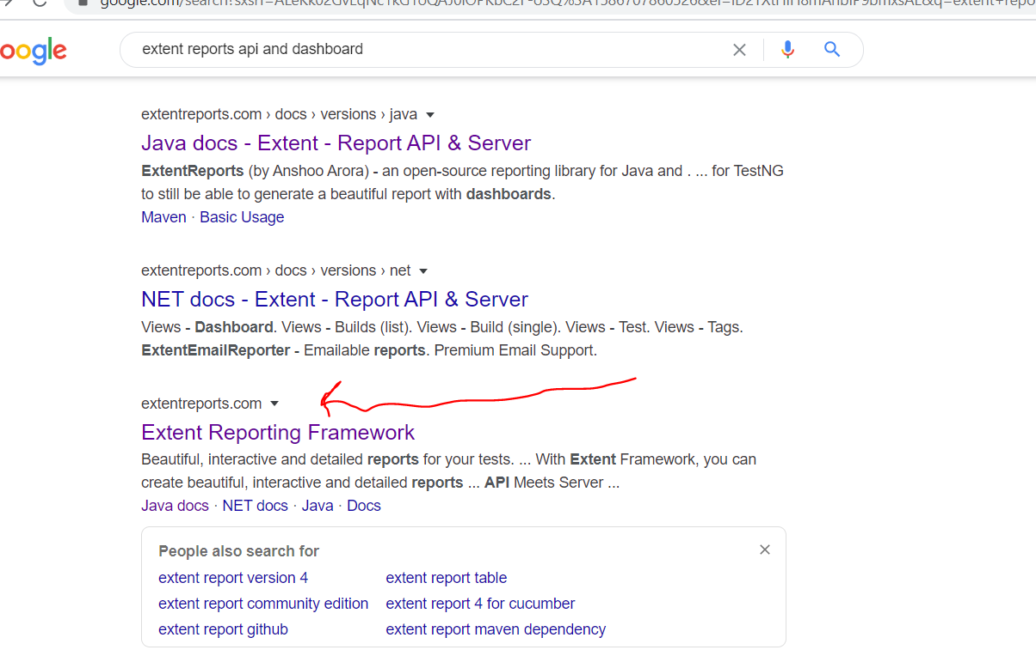

<http://extentreports.com/docs/versions/4/java/>

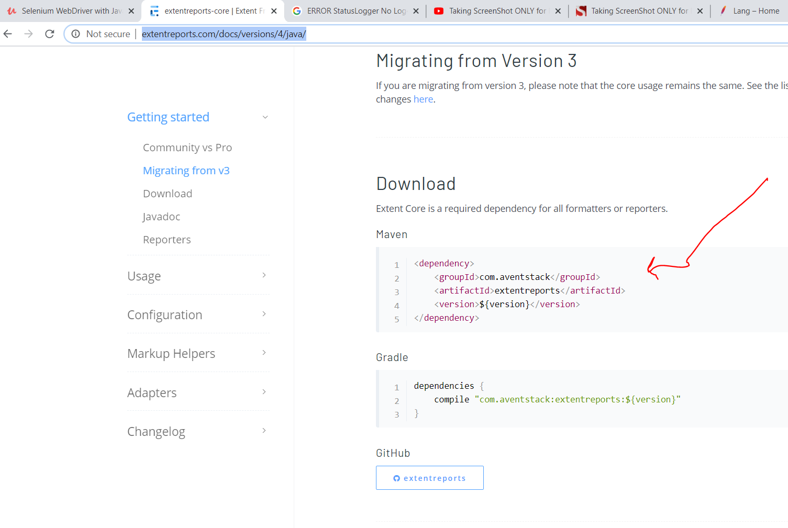

To open a project I click on import and select existing file and shit

Now to create a new workspace….. go to file…switch workspace….. and then other…then change the name and click launch.

Automising parametricing …….to pimp our framework

Click the project in Jenkins

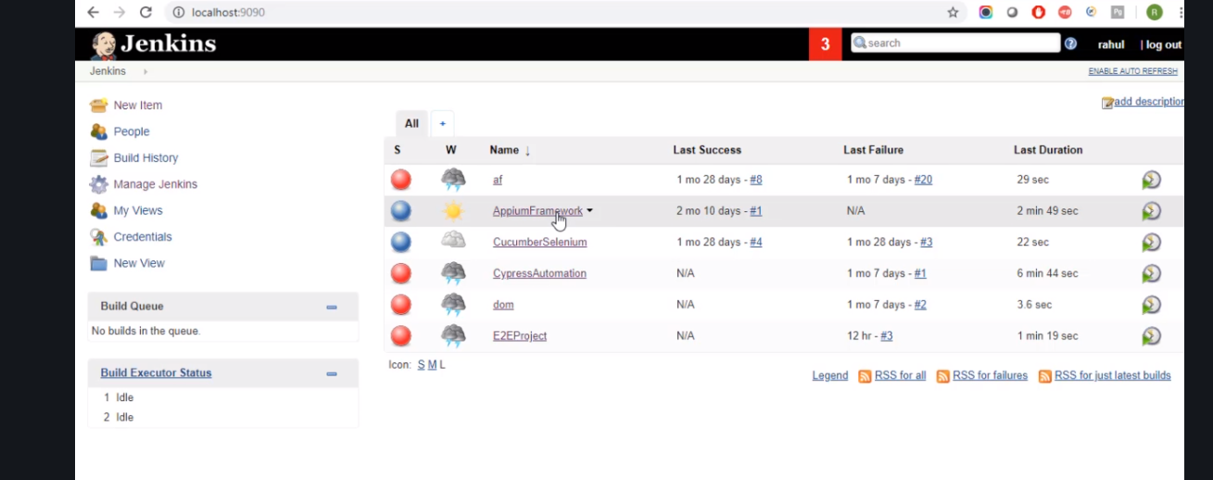

Next go to the side and click build with parameters

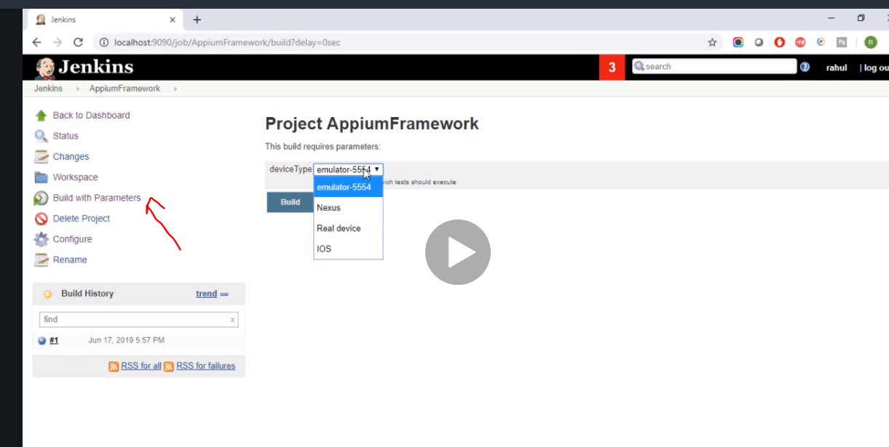

Now we go to our base file

Now can we run the browser from jenkin

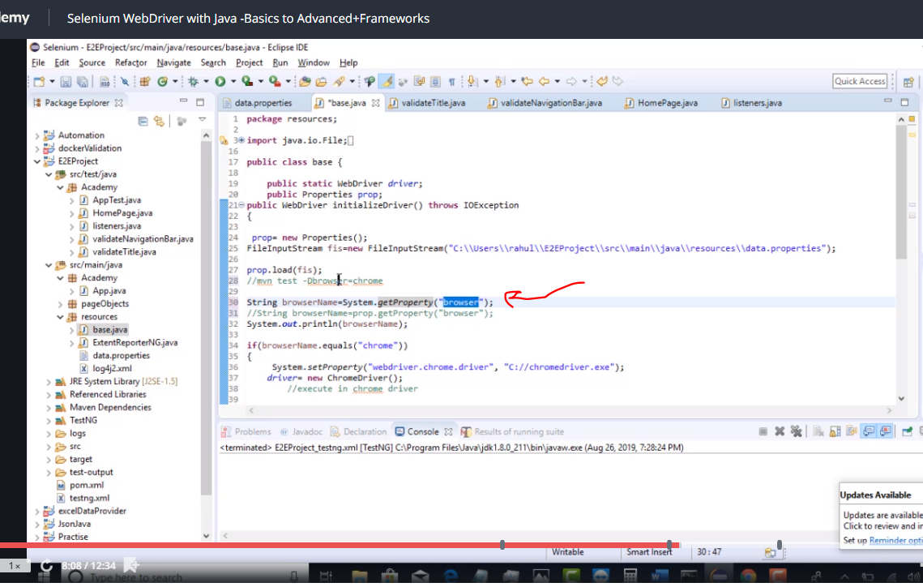

This way parameter is sent to maven so just change that line

Next back to cmd

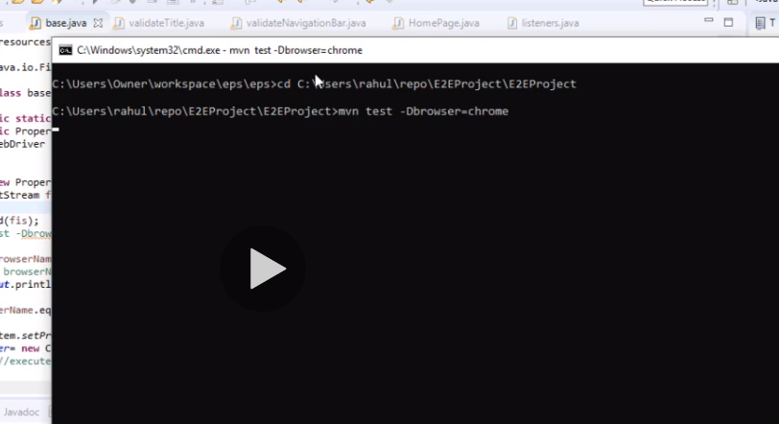

Always use chrome.

Go back to Jenkins

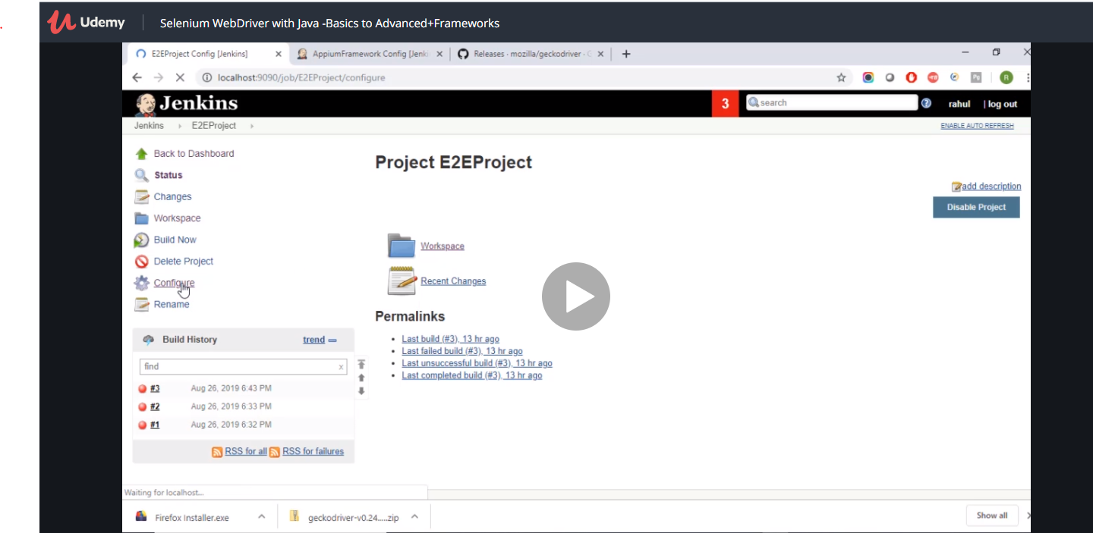

Click configure

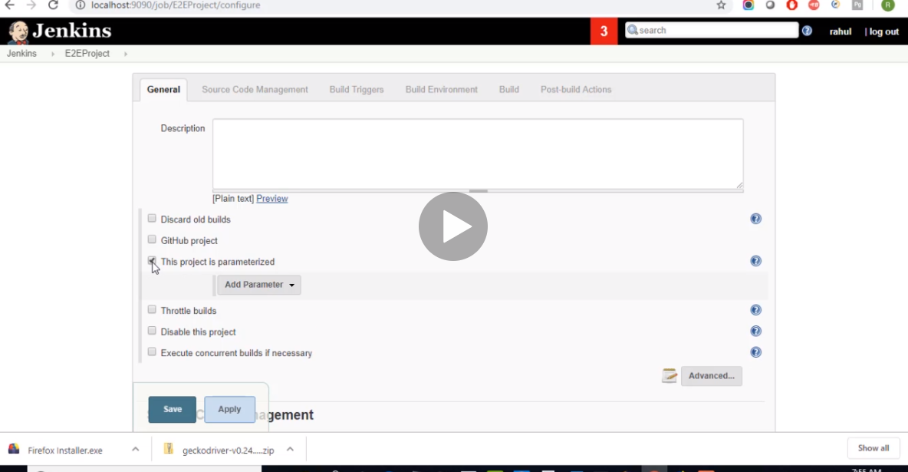

It is now parameterised 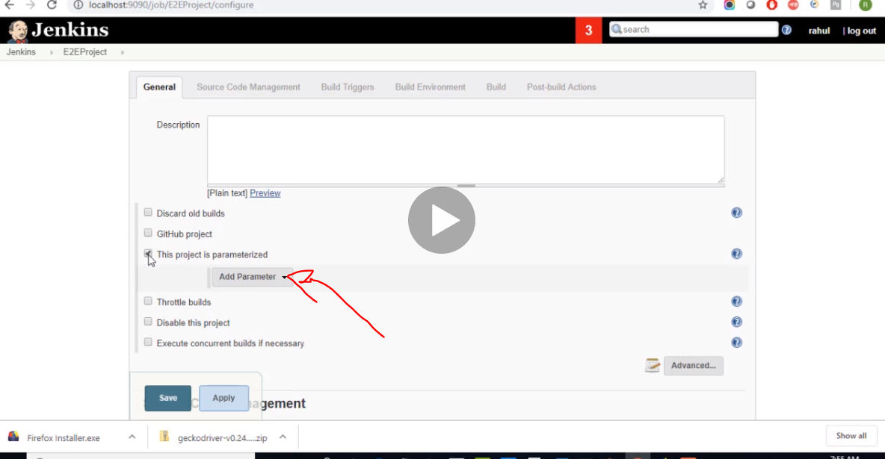

Click on choice parameter to give it a property name

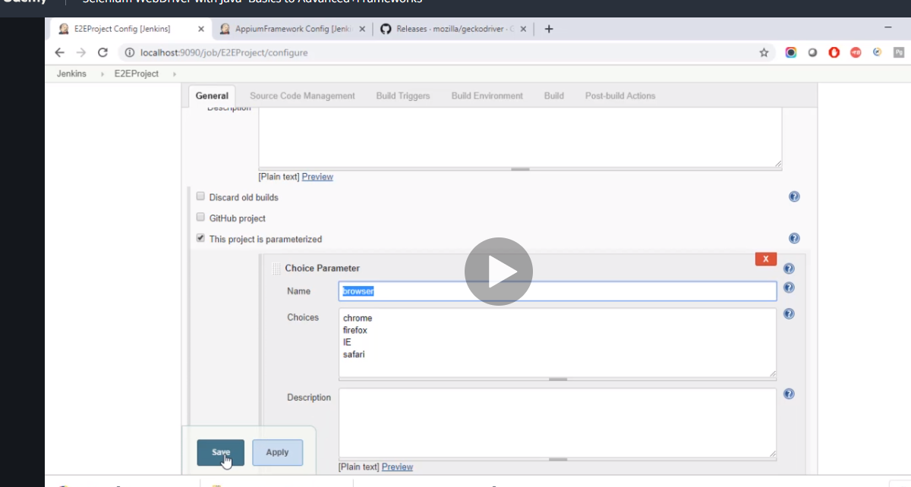

Once you save it then you will have build with parameters

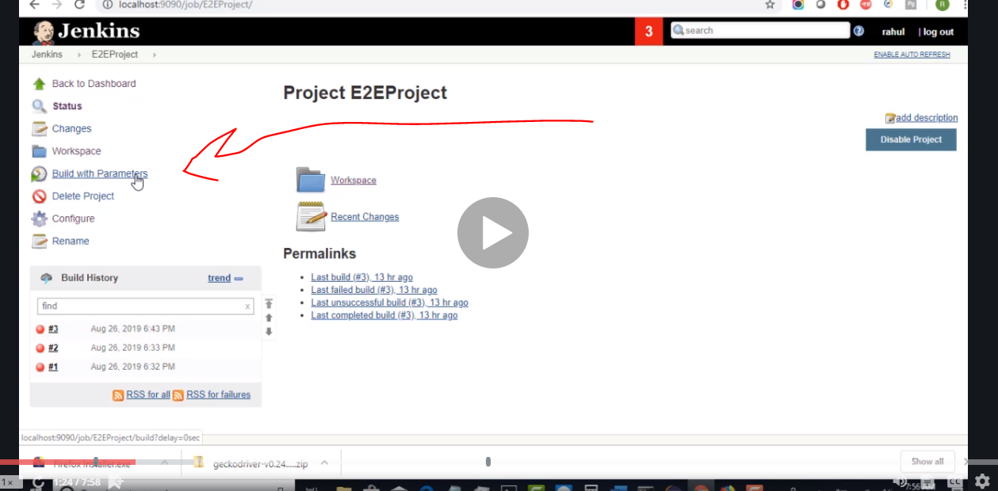

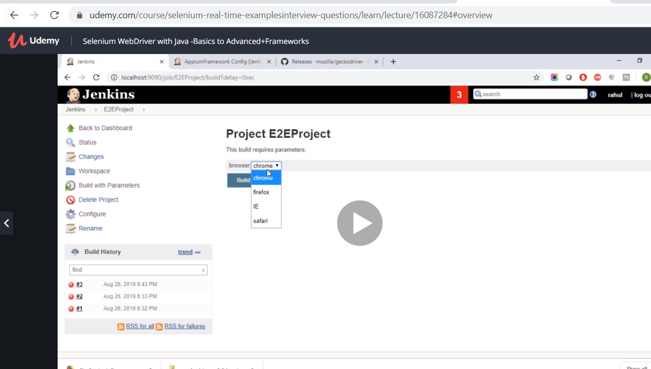

Go back to configuration

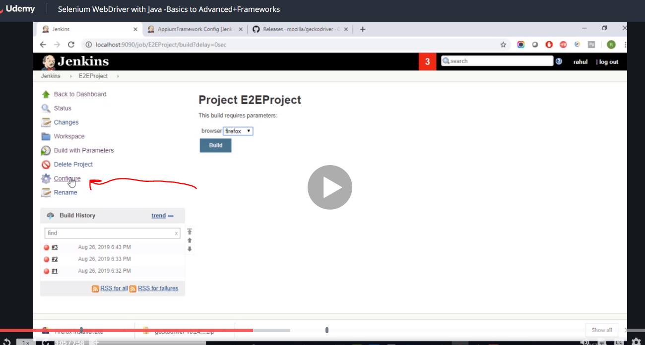

Scroll down and write

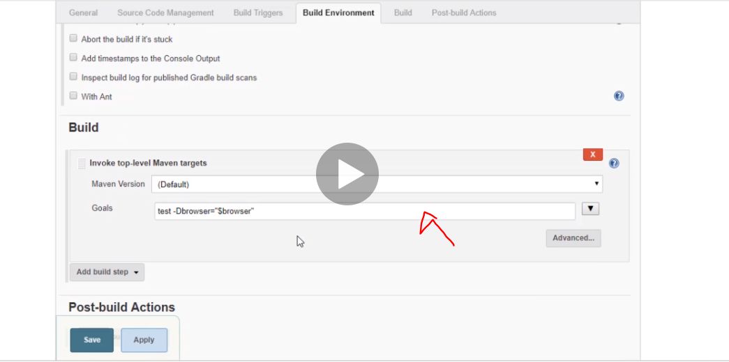

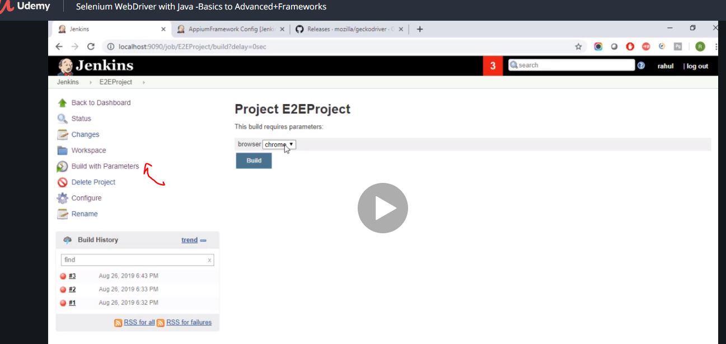

Go back to build parameter click the browser you want and click build

Then back to build parameter and click console output

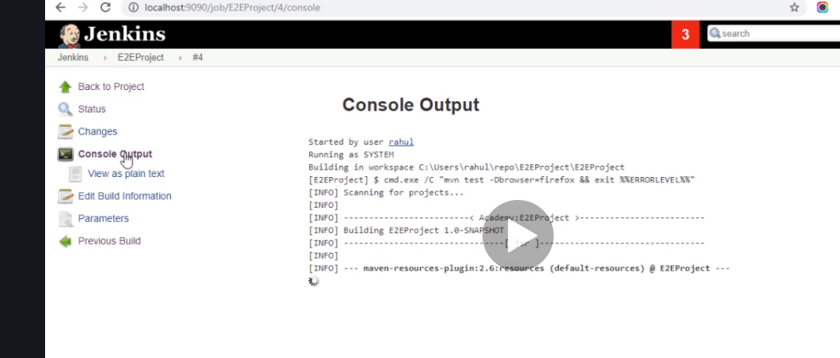

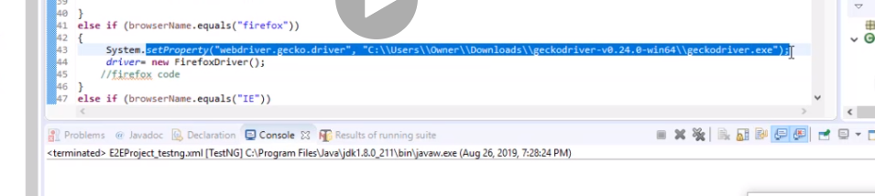

Add this line for firefox. When switching browser.

So to use click on the project, go to build parameter, select the browser and then click build.

Encapsulator …make accessible methods public and make data and variables private.

Next to avoid hardcoding we use

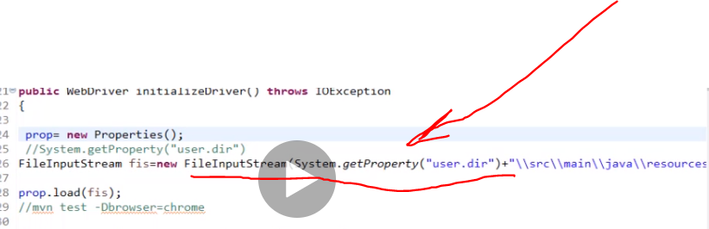

Instead of having

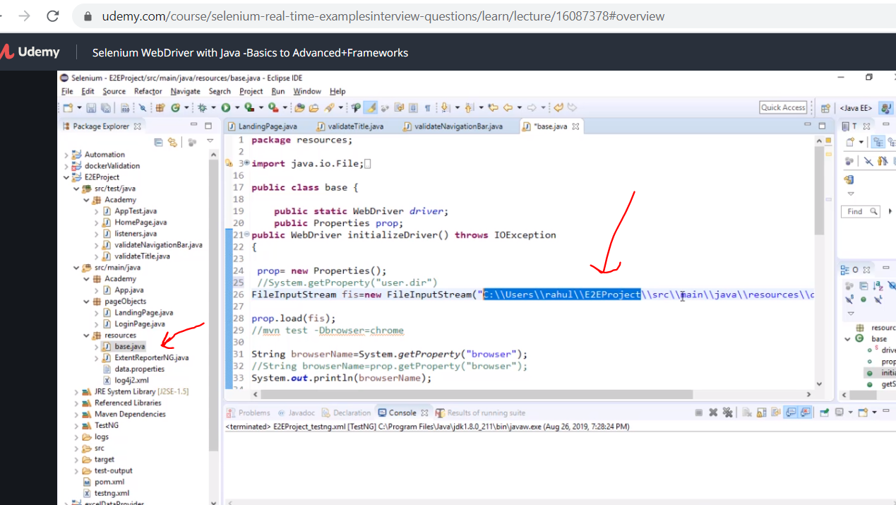

Now to run chrome in headless mode

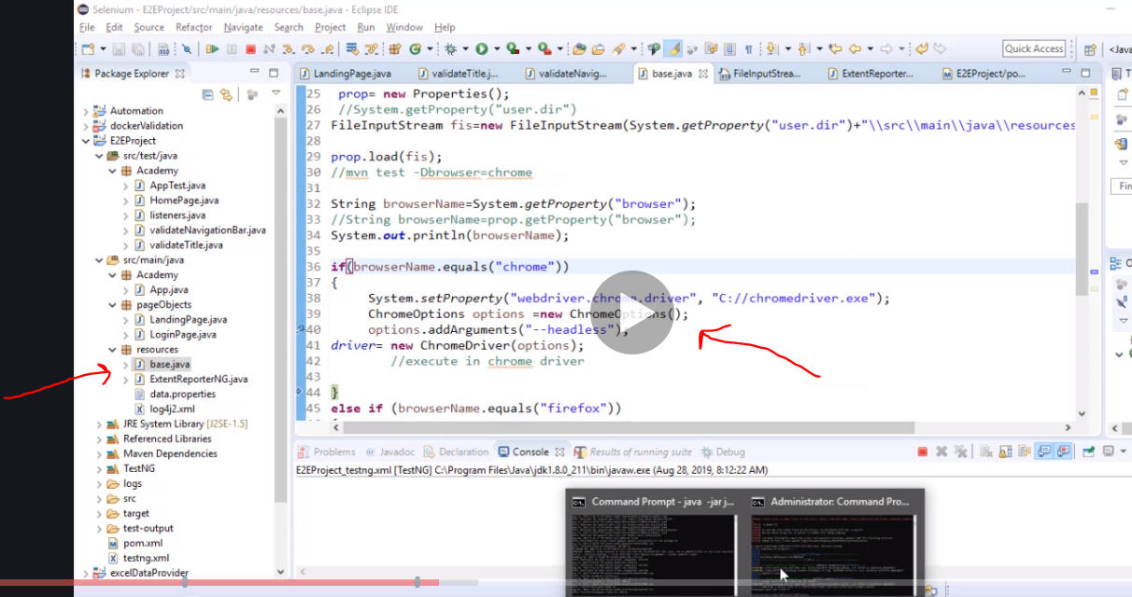

Now everything is headless does not show the browser.

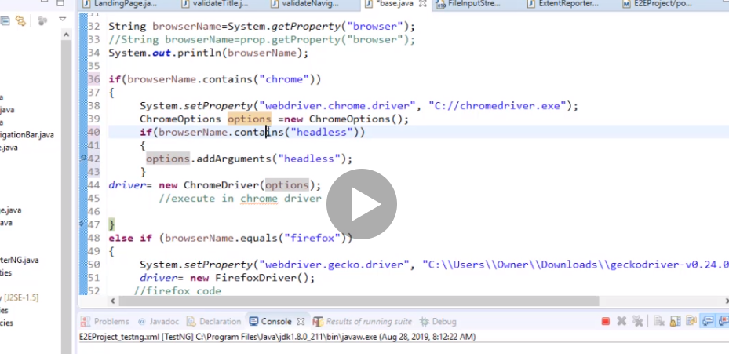

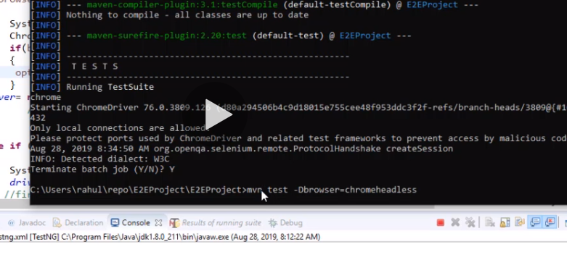

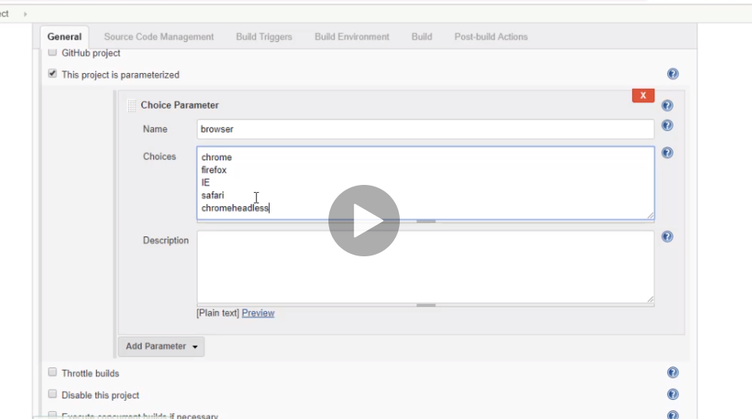

Using selenium to sort database validation

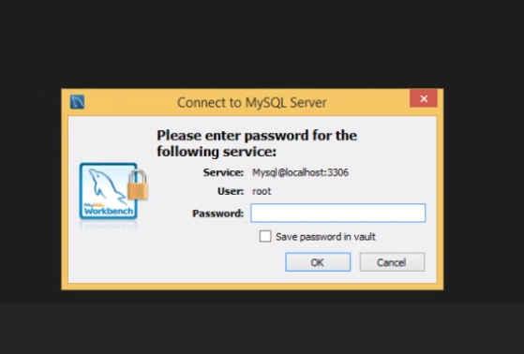

User have to produce this 3 point inorder to log in.

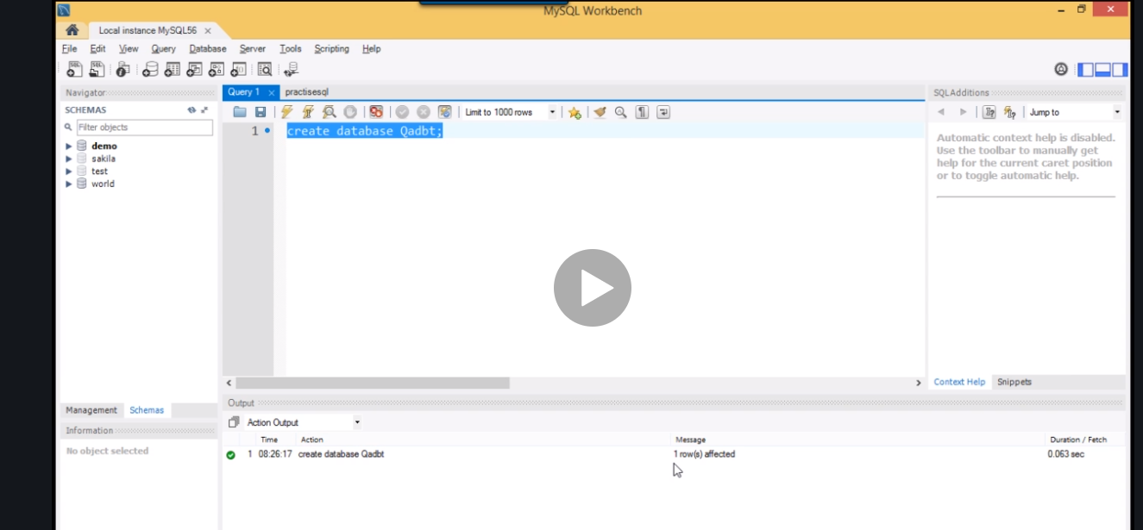

This is used to create a database. Click refresh …

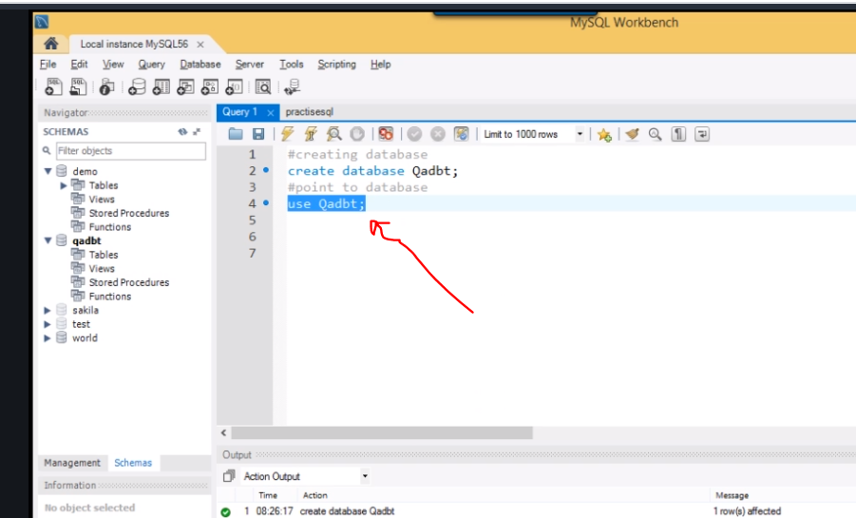

Now this means you want to create a table

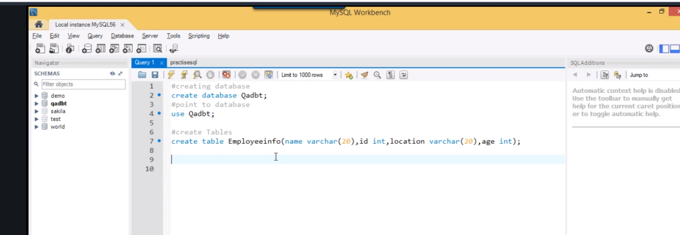

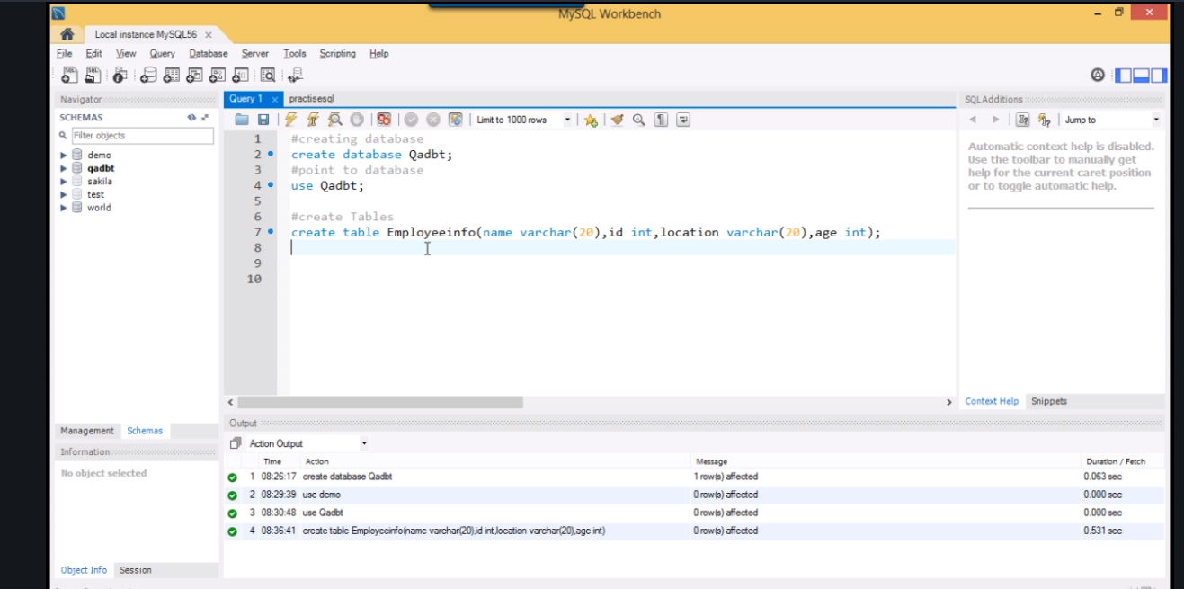

Make the table

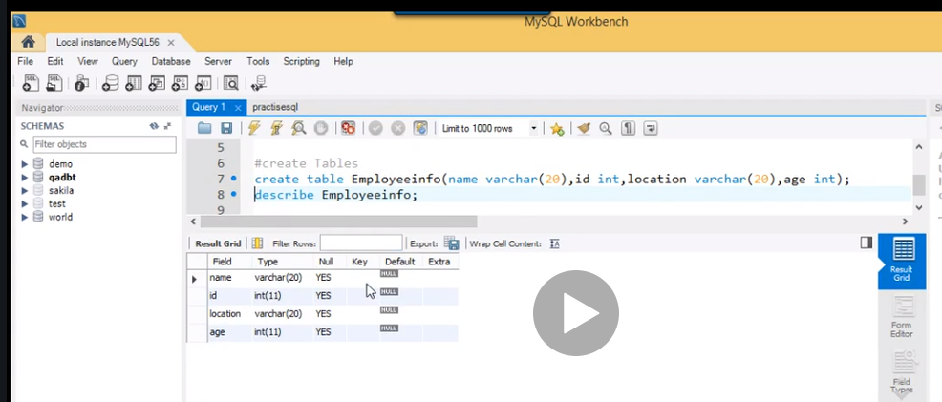

Check the table and view the structure

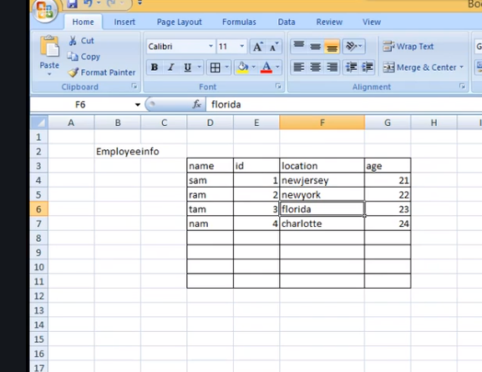

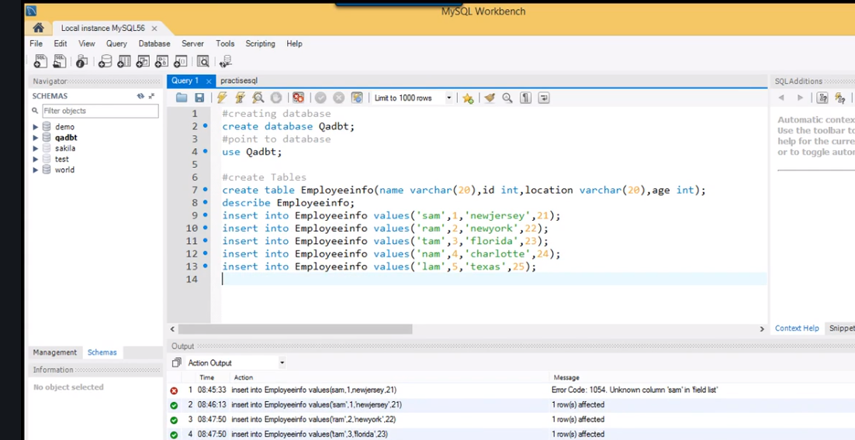

This puts values in the table.

Next we create a java project and connect

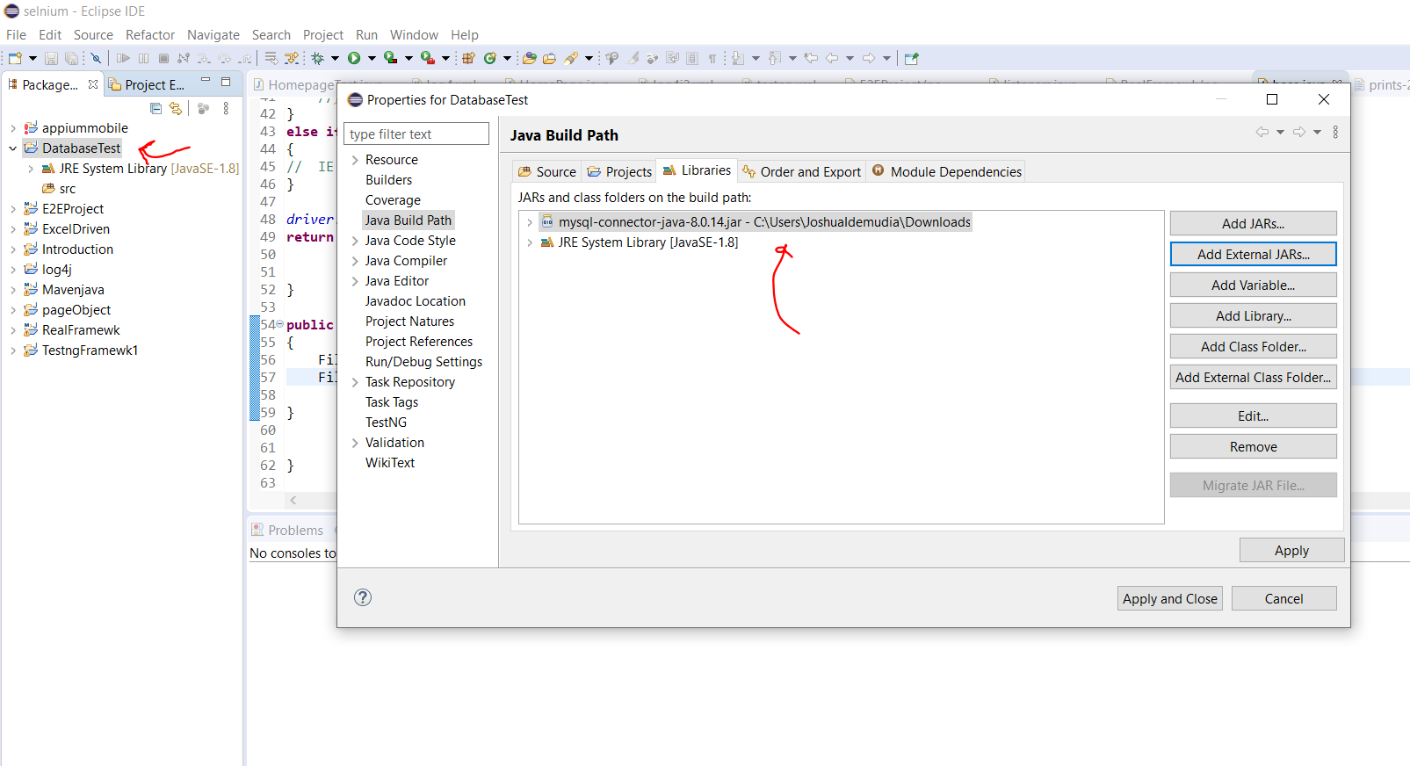

Now create a class

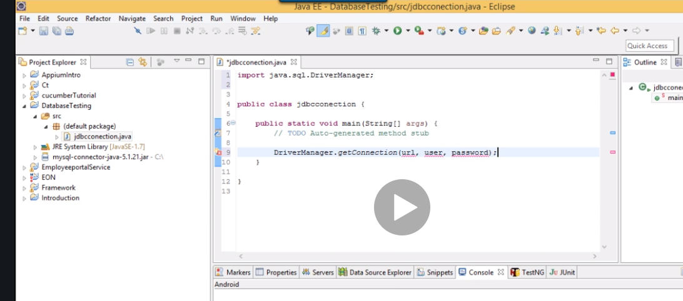

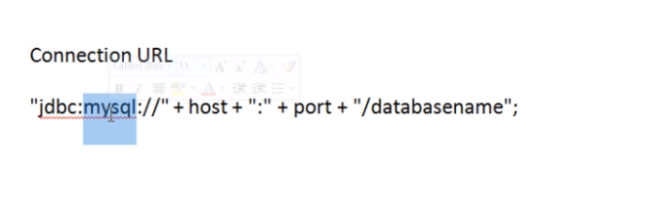

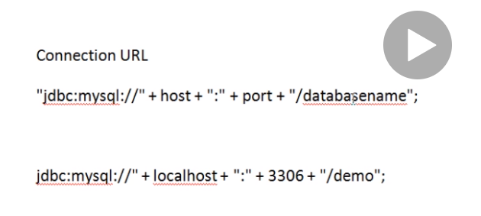

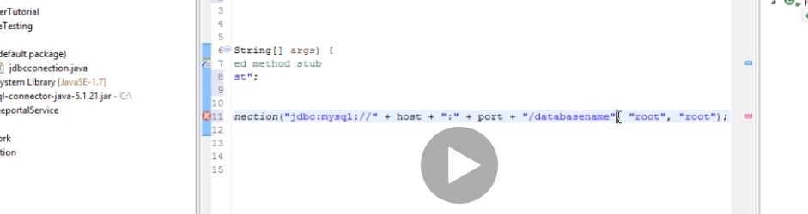

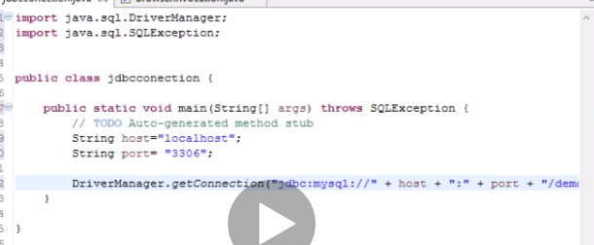

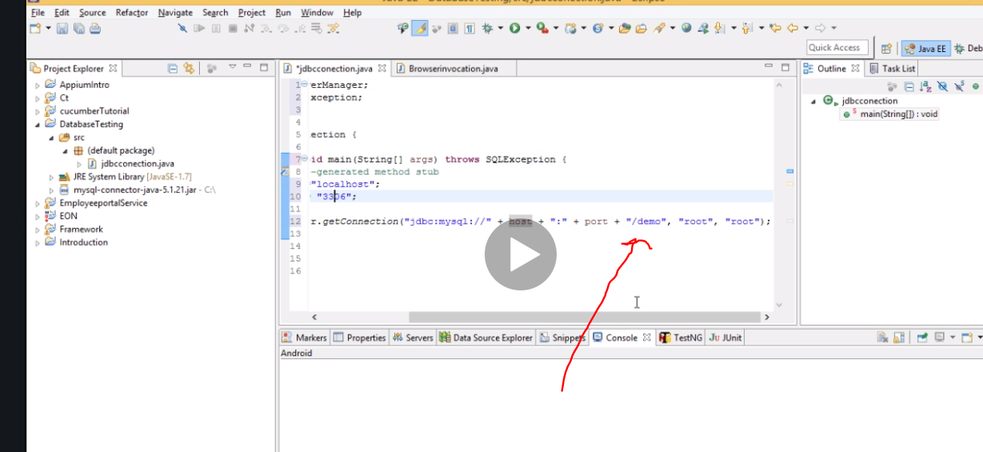

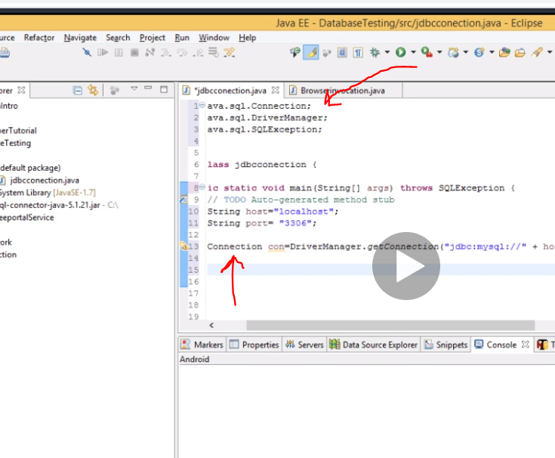

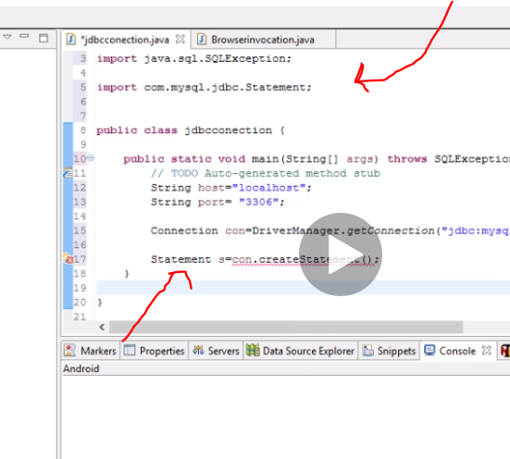

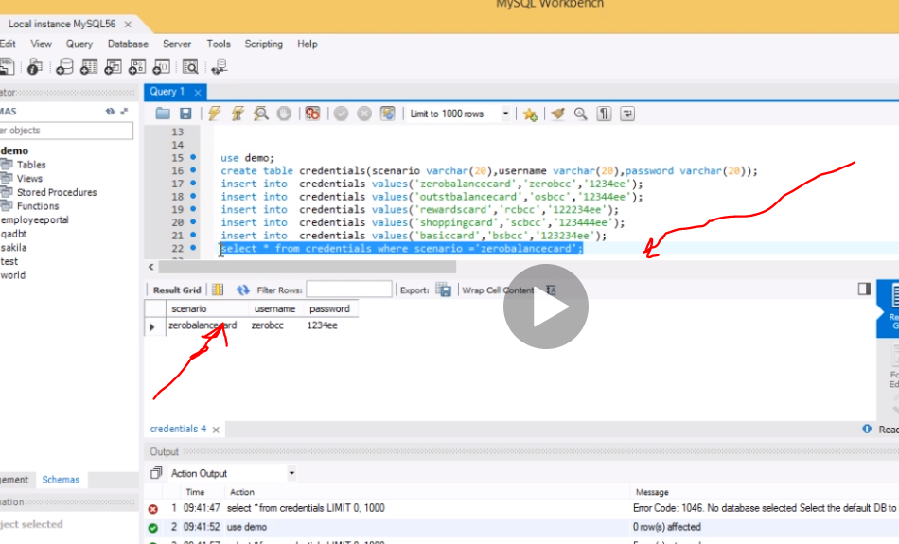

Copy this

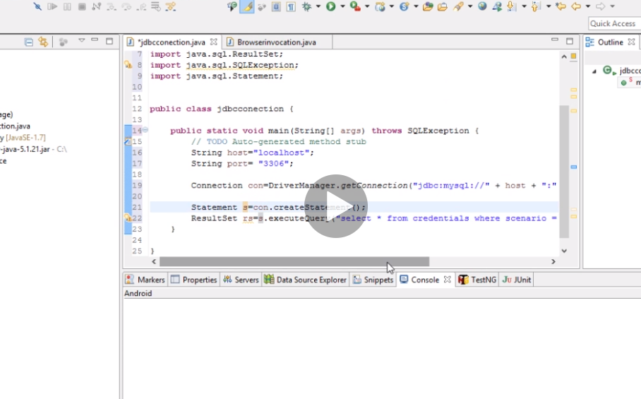

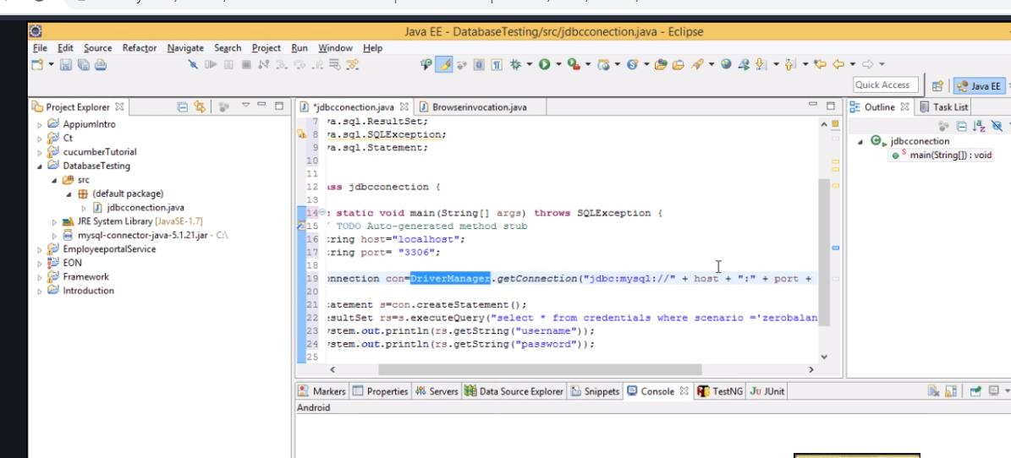

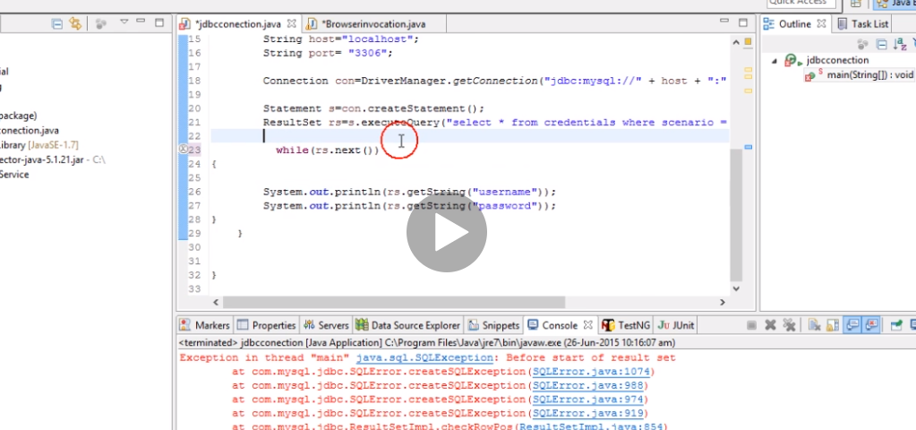

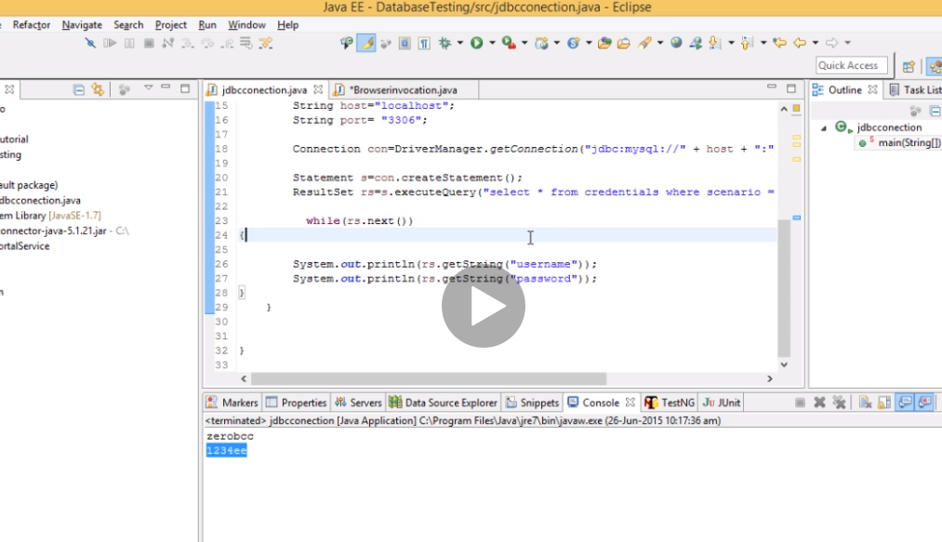

Now go and download the server standalone jar to the project. We intend to get the username and password from the database and then use it to log in in another website.

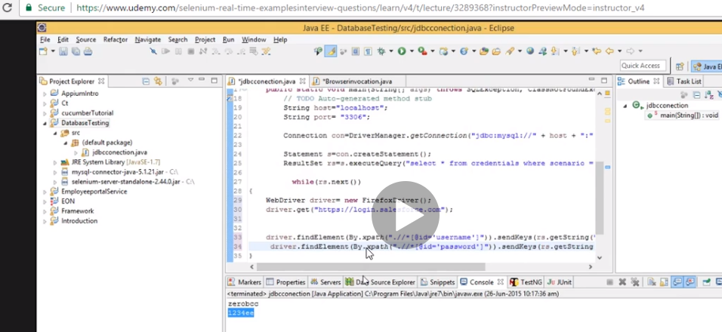

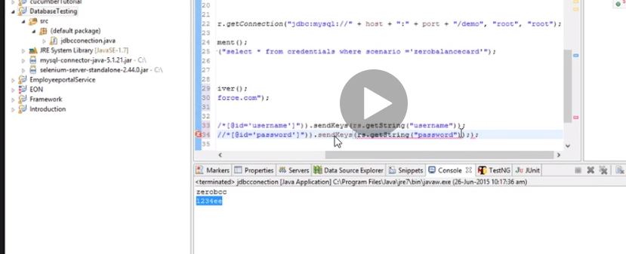

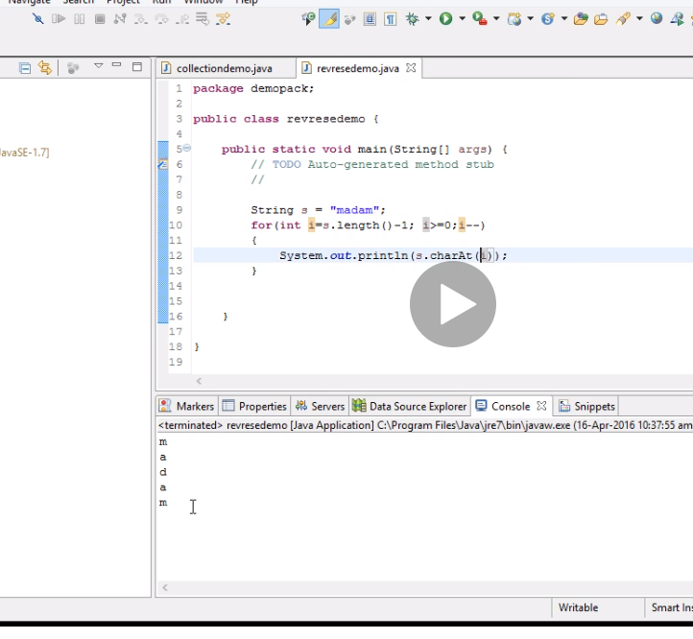

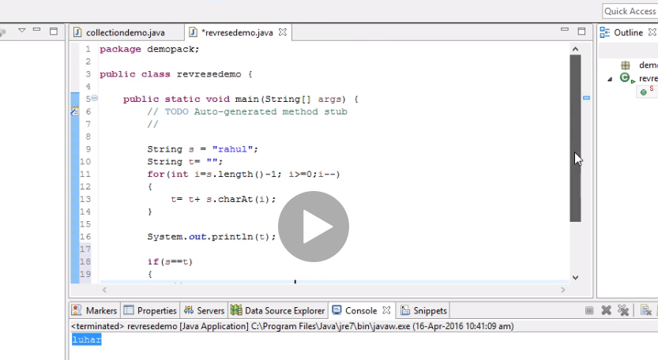

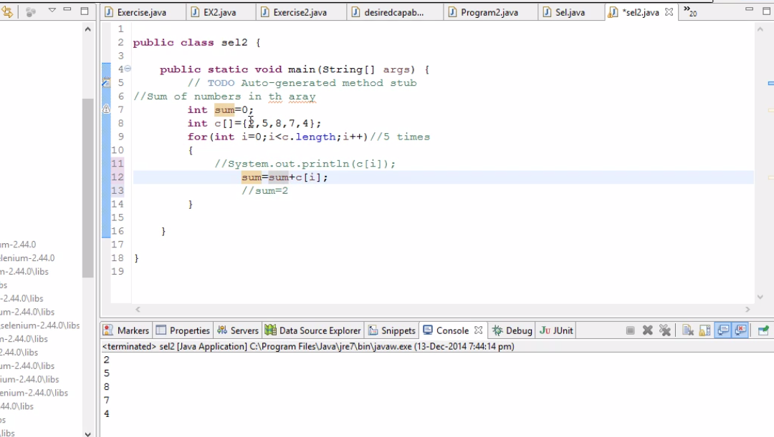

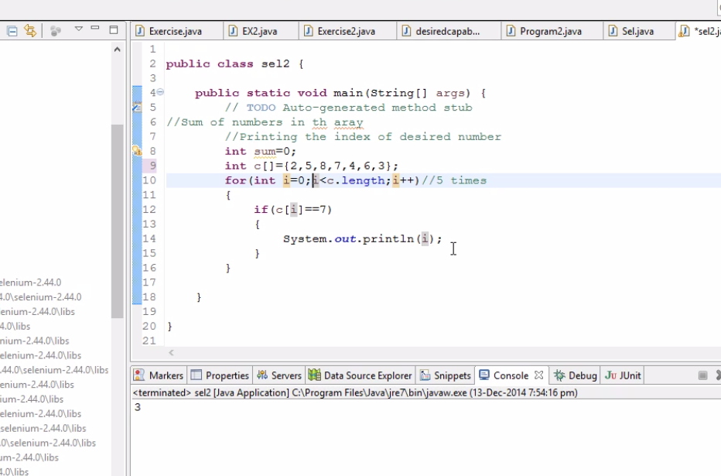

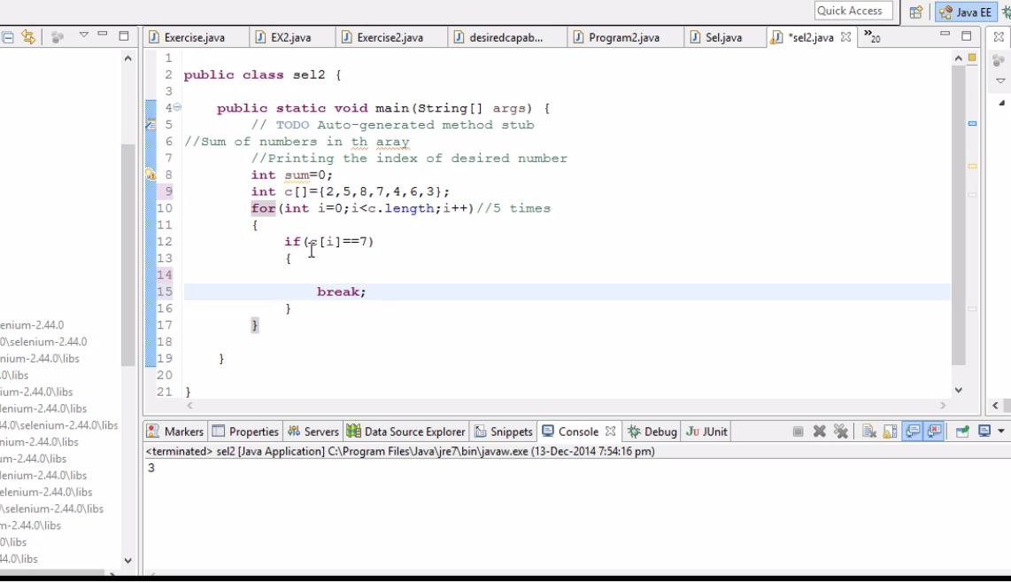

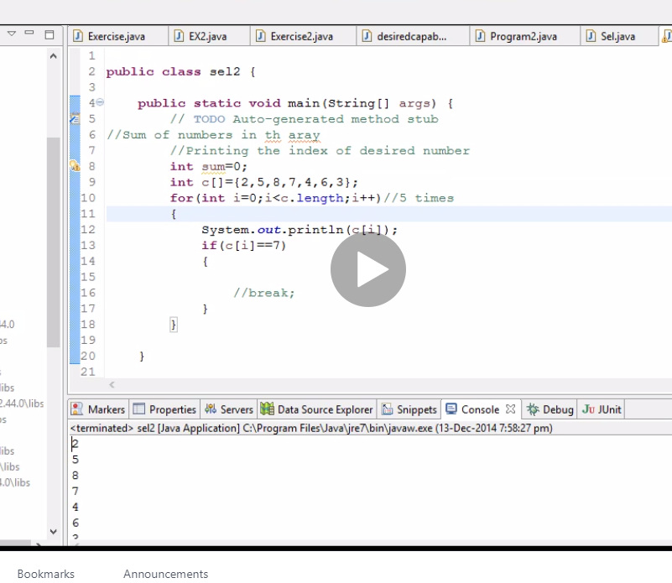

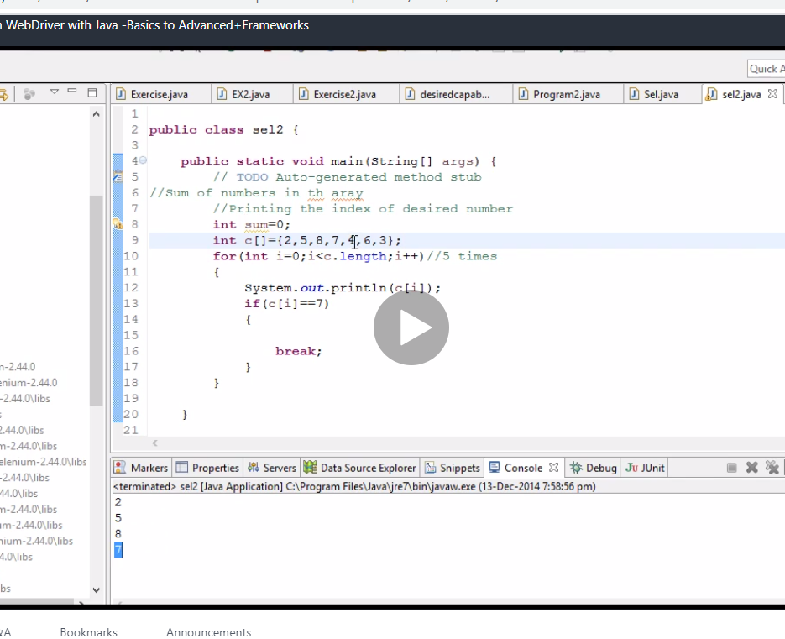

ARRAY LIST

Array list has a dynamic size you can increase and decrease it but array you cant

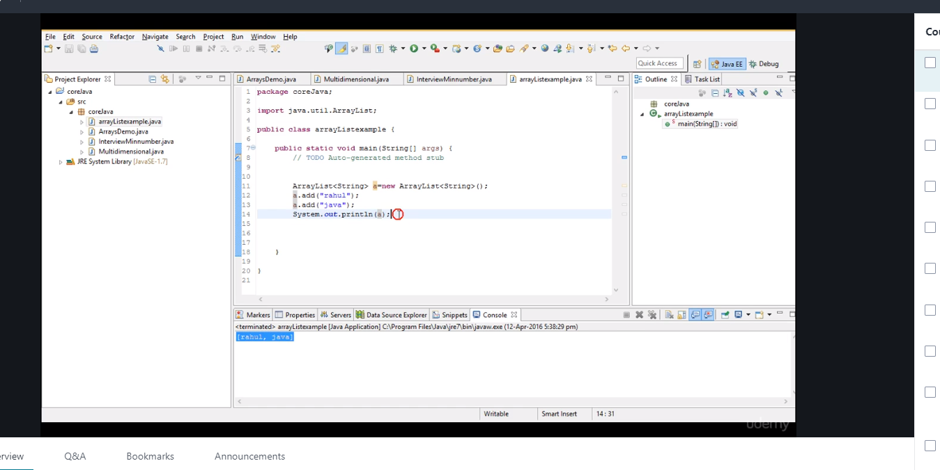

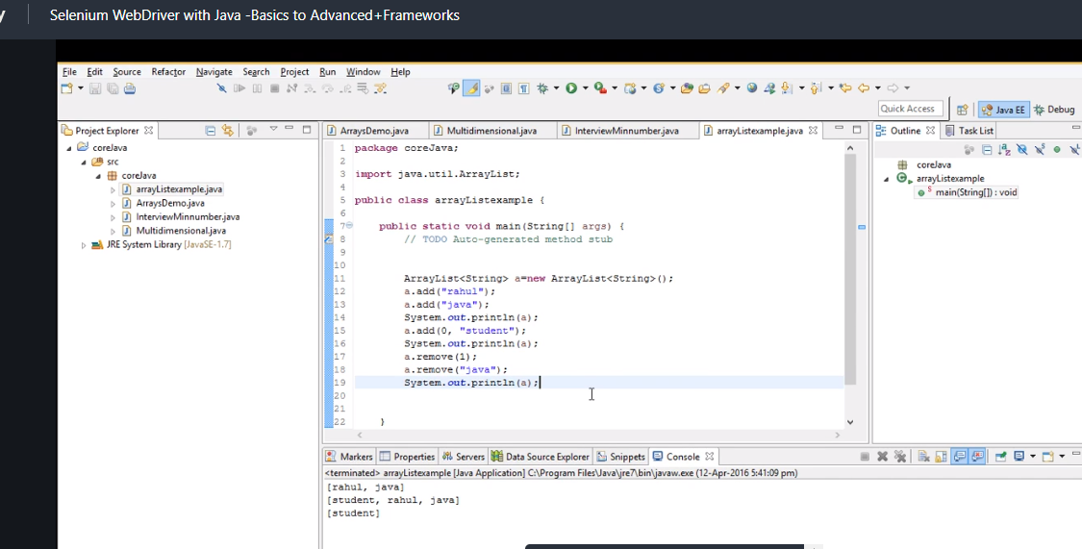

Java dev use this more

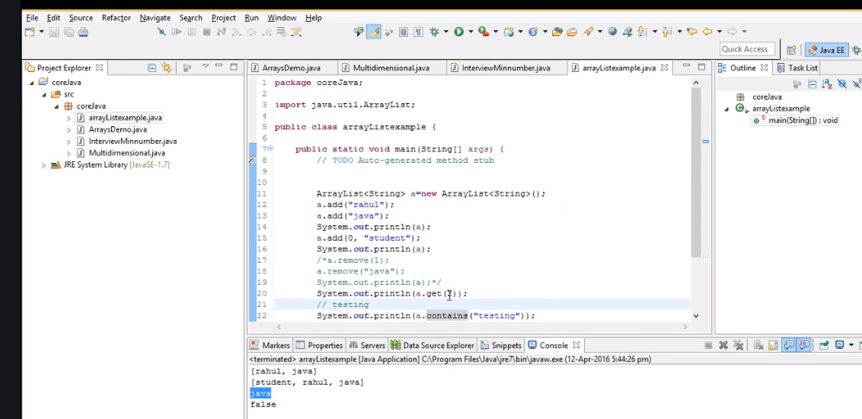

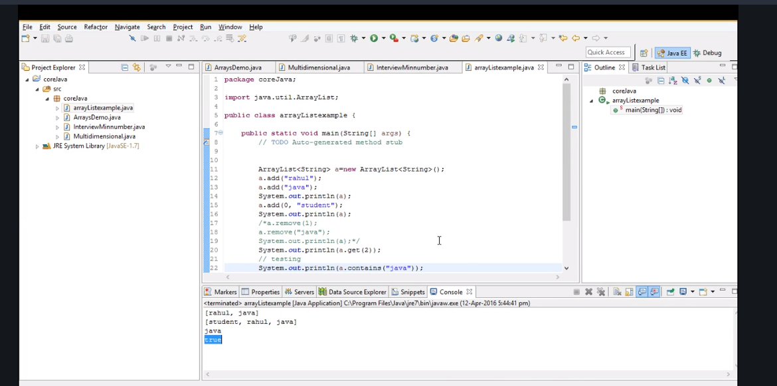

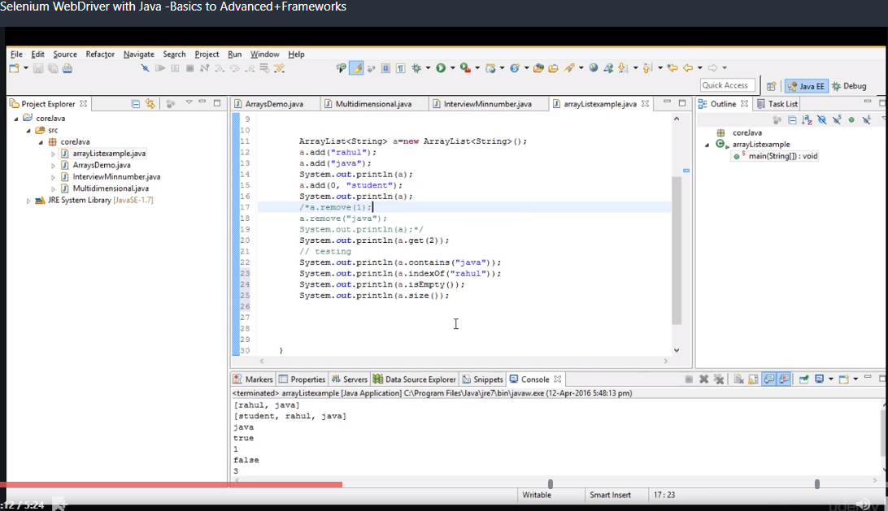

Note array list can accept duplicate values

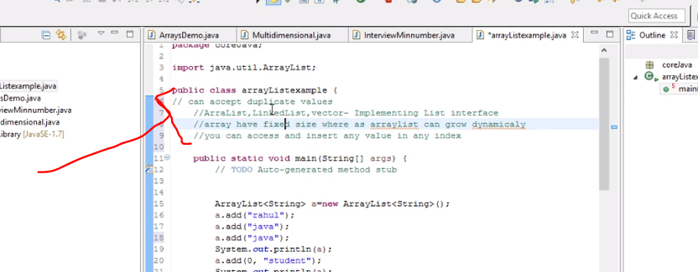

Note, set interface does not accept duplicate …. So you can only do transaction once….. like when u make payment it says done …. Unlike arraylist that can take multiple things in a cart and takes duplicates. In se no guarantee they are stored in a specific order.

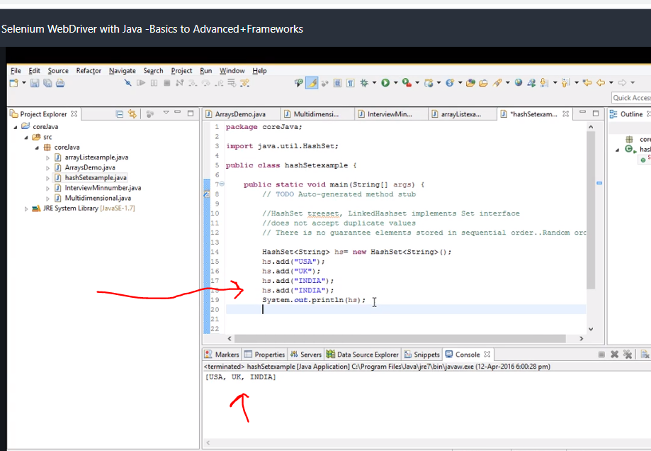

Rejects duplicate india

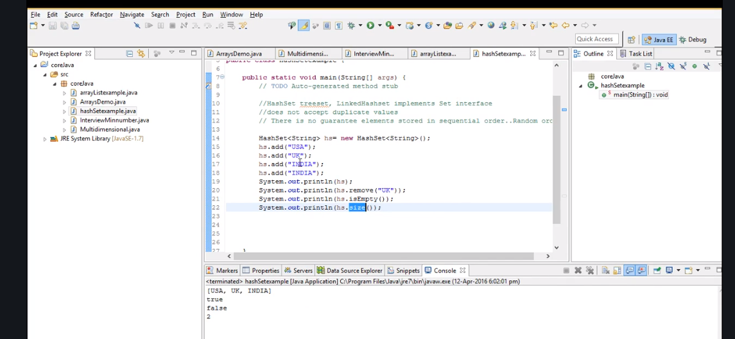

Iterator

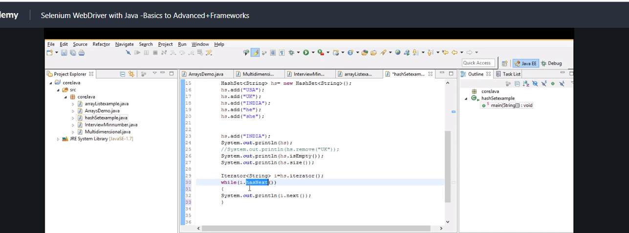

While loop instead of going to check 99 time just use loops

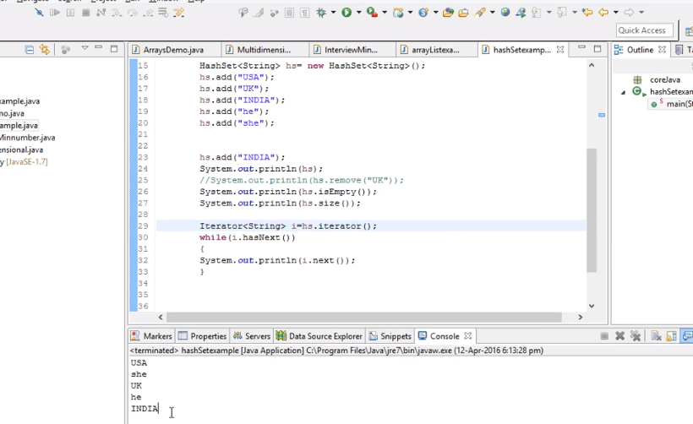

Collection types

Array list or set….. set is random and doesn’t do duplicates while array list is in order and accepts duplicates.

Hashmaps

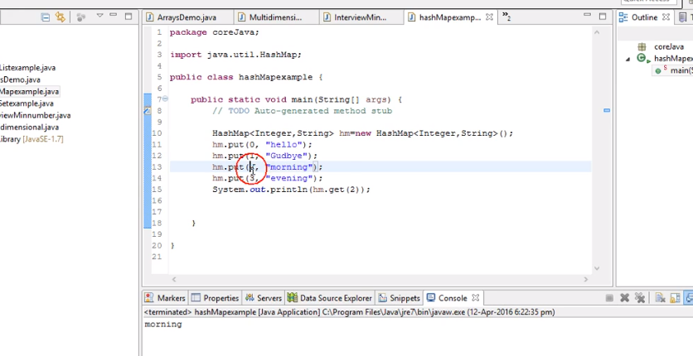

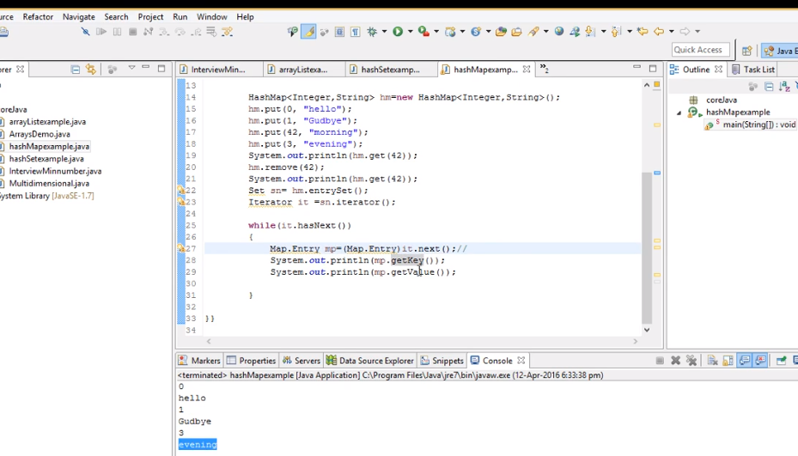

Hashtable

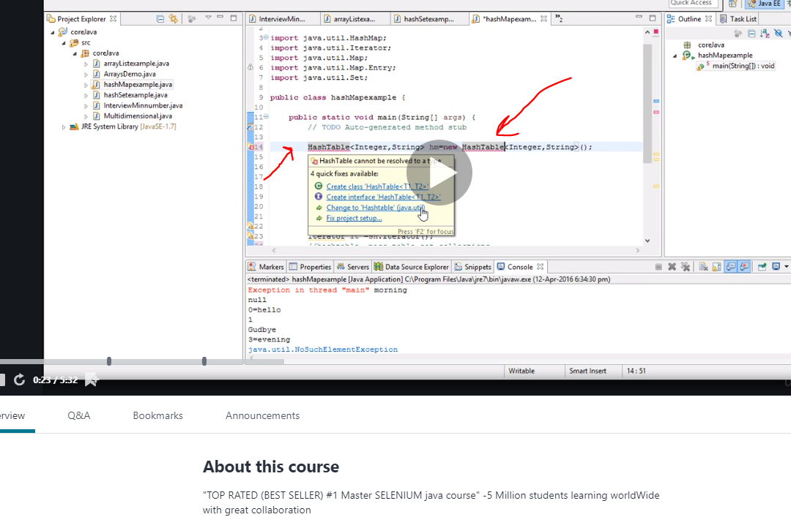

Hashmap accepts null value, hashtable doesn’t. hashmap can have more than one thread while table the thread has to finish before it can be used by any other program.

Code to get unique number not sure what the crap is useful for

package demopack;

import java.util.ArrayList;

public class collectiondemo {

public static void main(String[] args) { // TODO Auto-generated method stub

int a[] ={ 4,5,5,5,4,6,6,9,4}; // Print unique number from the list- Amazon //print the string in reverse ArrayList<Integer>ab =new ArrayList<Integer>(); for(int i=0;i<a.length;i++) { int k=0; if(!ab.contains(a[i])) { ab.add(a[i]); k++; for(int j=i+1;j<a.length;j++) { if(a[i]==a[j]) { k++; } } // System.out.println(a[i]); //System.out.println(k); if(k==1) System.out.println(a[i]+"is unique number"); } } }

}

Cucumber

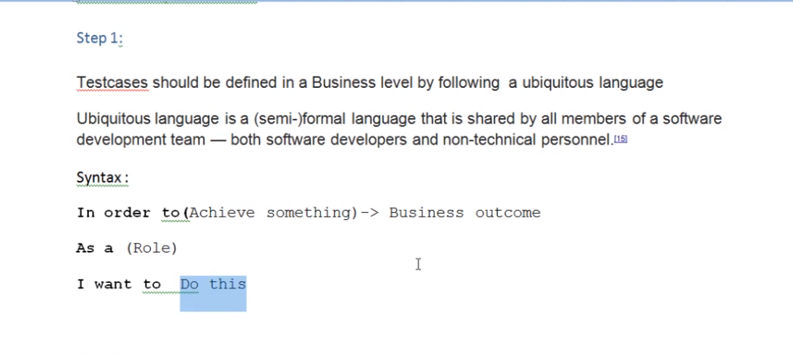

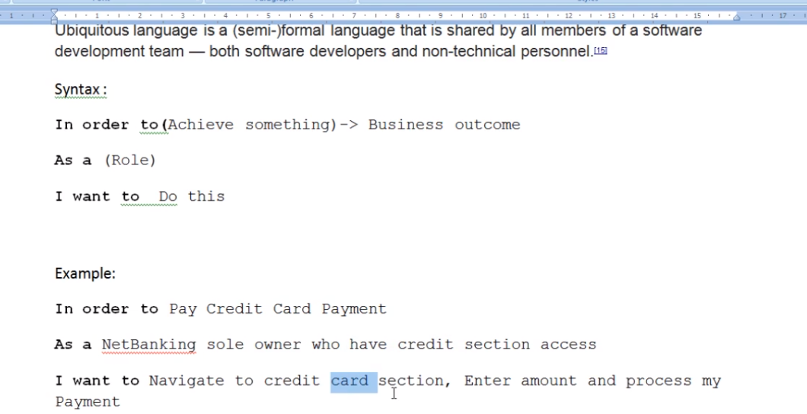

This should be the kind of model we get to start test cases. Now this is a happy flow(happy path)

So this is the scenario we got …… how many test cases can we get I order to satisfy this scenario to production

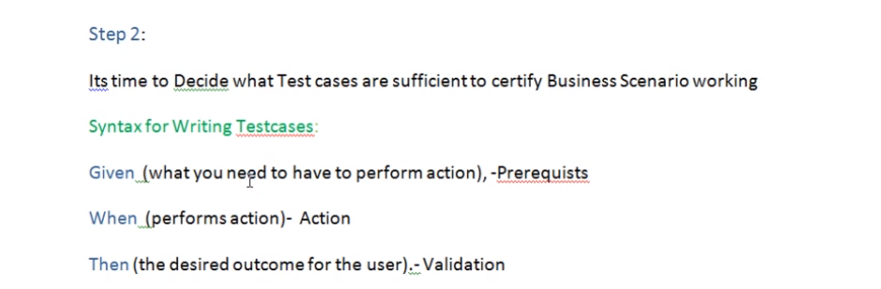

Happy flow is straight forward.

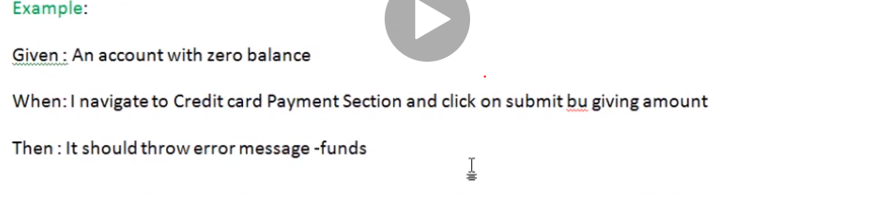

BDD documentation download

TestCases Specifications in Behaviour Driven Development :

Step 1:

Testcases should be defined in a Business level by following a ubiquitous language

Ubiquitous language is a (semi-)formal language that is shared by all members of a software development team — both software developers and non-technical personnel.[15]

Syntax :

In order to(Achieve something)-> Business outcome

As a (Role)

I want to Do this

Example:

In order to Pay Credit Card Payment

As a NetBanking sole owner who have credit section access

I want to Navigate to credit card section, Enter amount and process my Payment

Step 2:

Its time to Decide what Test cases are sufficient to certify Business Scenario working

Syntax for Writing Testcases:

Given (what you need to have to perform action), -Prerequists

When (performs action)- Action

Then (the desired outcome for the user).- Validation

Example:

Given : An account with zero balance

When: I navigate to Credit card Payment Section and click on submit bu giving amount

Then : It should throw error message –fund

Given : An account with sufficent balance who does not have credit card

When: I navigate to Credit card Payment Section

Then :You don't have to access as your are error message

Given : An account with sufficent balance who does not have credit card

When: I navigate to Credit card Payment Section and amount

Then :You don't have to access /error message

Advantages:

This can be used as Standard Template where all QA can stick to one common standards of defining Testcases

Each Scenario reflects a Business Value

We can estimate the Test coverage happened for Each Business outcome by going through Test Cases

We can tag these Annotations to Selenium Automation and execute the Business Testcases

Common Standardised Testcase template for both Manual and Automation testing

Now lets get dirty let download the cucumber [lug in go to help and then go to eclipse market place

Download natural076. By the way this is from eclipse

Now to find quick start org.apache.maven look for quick start

Next put jars from maven repository ….go get cucumber jar

You can also delete that crap “build from the pom” dnt actually shit

We need cucumber java and cucumber junit

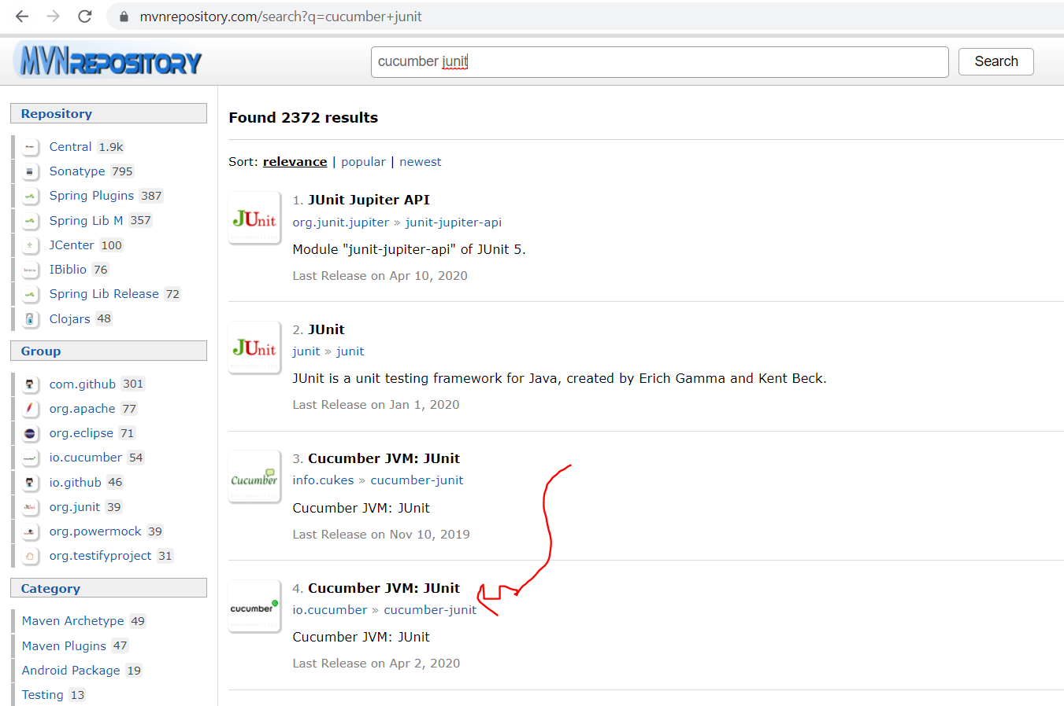do same for cucumber java

<!-- https://mvnrepository.com/artifact/io.cucumber/cucumber-java -->

<dependency>

<groupId>io.cucumber</groupId>

<artifactId>cucumber-java</artifactId>

<version>1.2.6</version>

</dependency>

<!-- https://mvnrepository.com/artifact/io.cucumber/cucumber-junit -->

<dependency>

<groupId>io.cucumber</groupId>

<artifactId>cucumber-junit</artifactId>

<version>1.2.6</version>

<scope>test</scope>

</dependency>

Now let go and create package features

Create this under scr/test java only

Next create a file inside and use

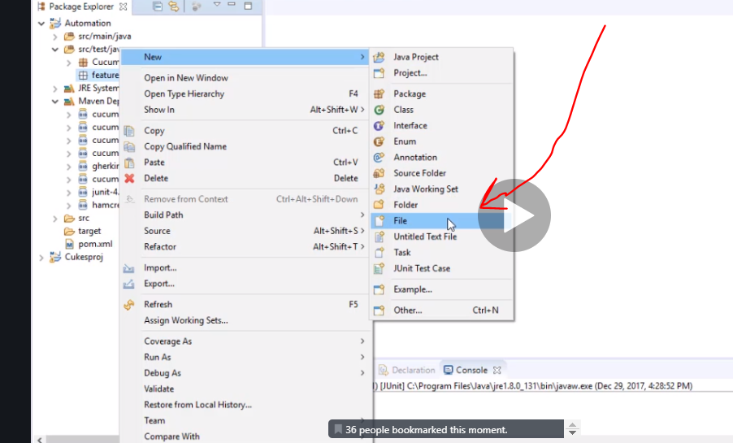

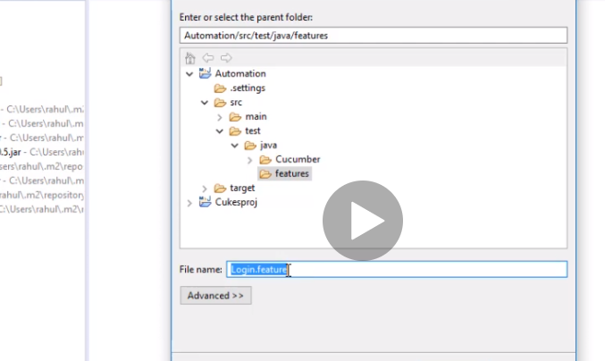

Save the file as .feature

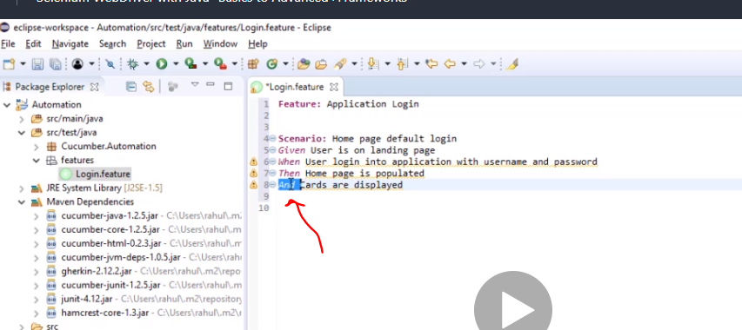

And operator is used for validation

Now still under scr/test/java go and make step definition folder

Now inside we create a class called stepDefinintion

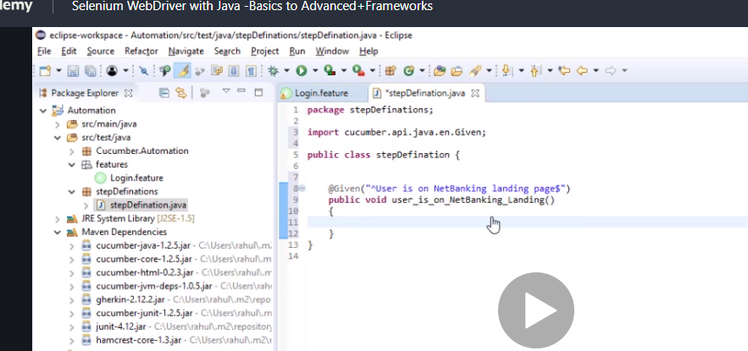

So basically all the methods are put in here. And the feature file goes to step definition and pick the correct method from step definition

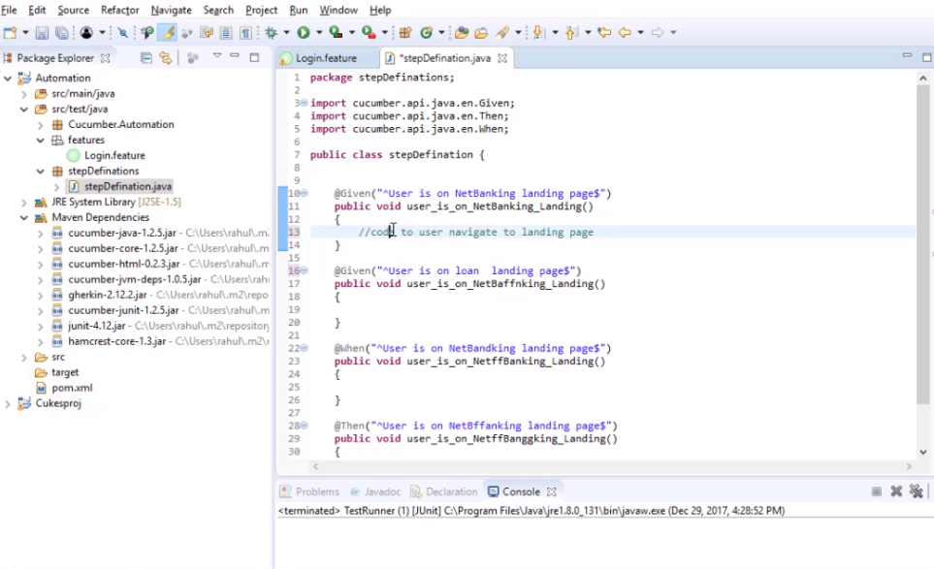

Now we need to generate a plugging called tidygherkhin. It helps generate step definition automatically

It’s a chrome pluggin

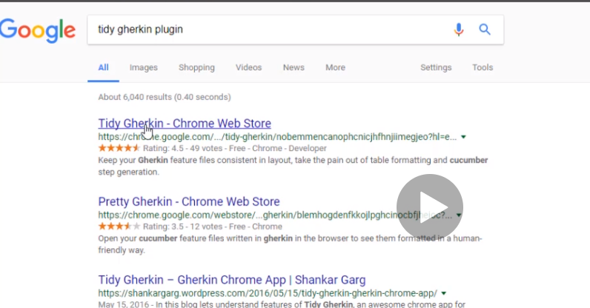

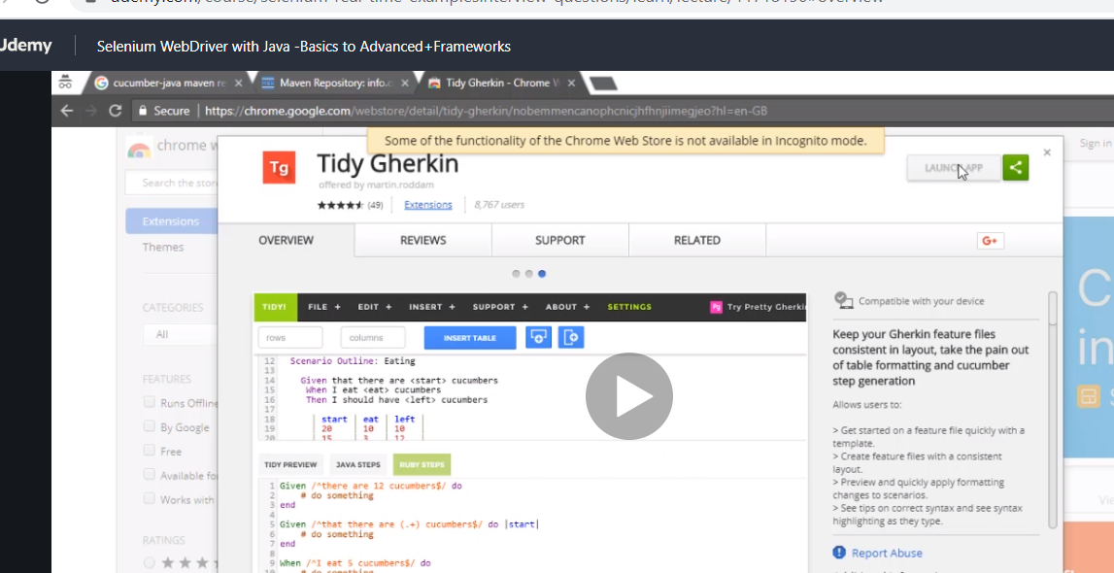

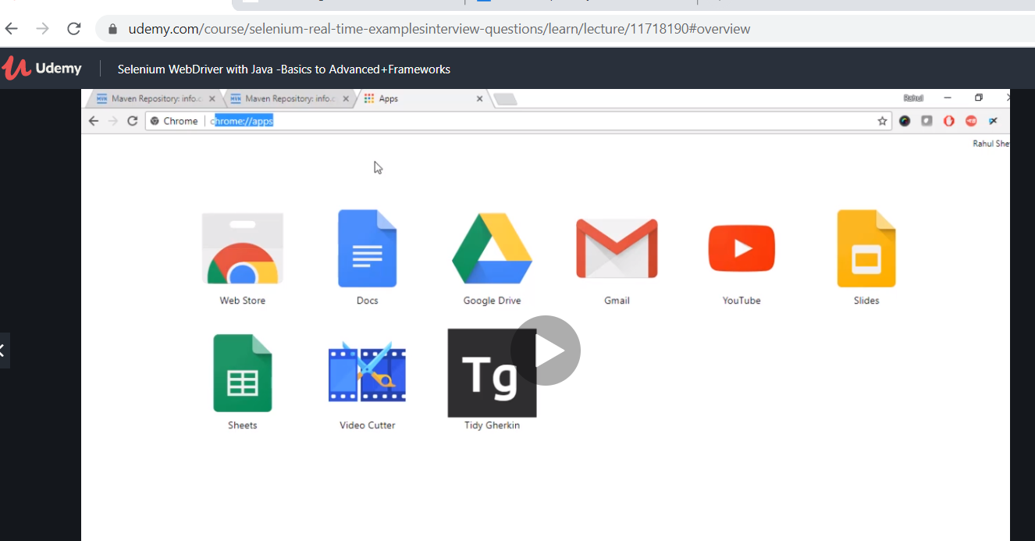

<chrome://apps/>

now click TG

paste the feature file in here and click java steps

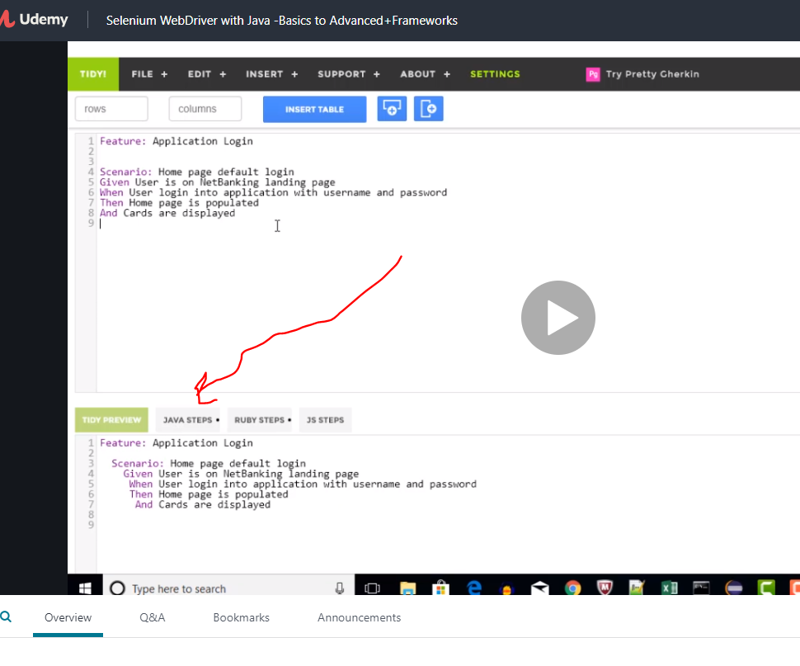

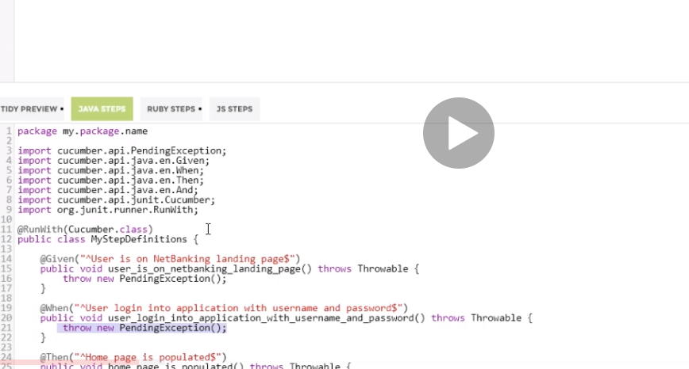

All you have to do after that is put code inside it

So just go back copy everything and paste in your step definisiton but change the class name back . the package and class name change them to be correct and all good

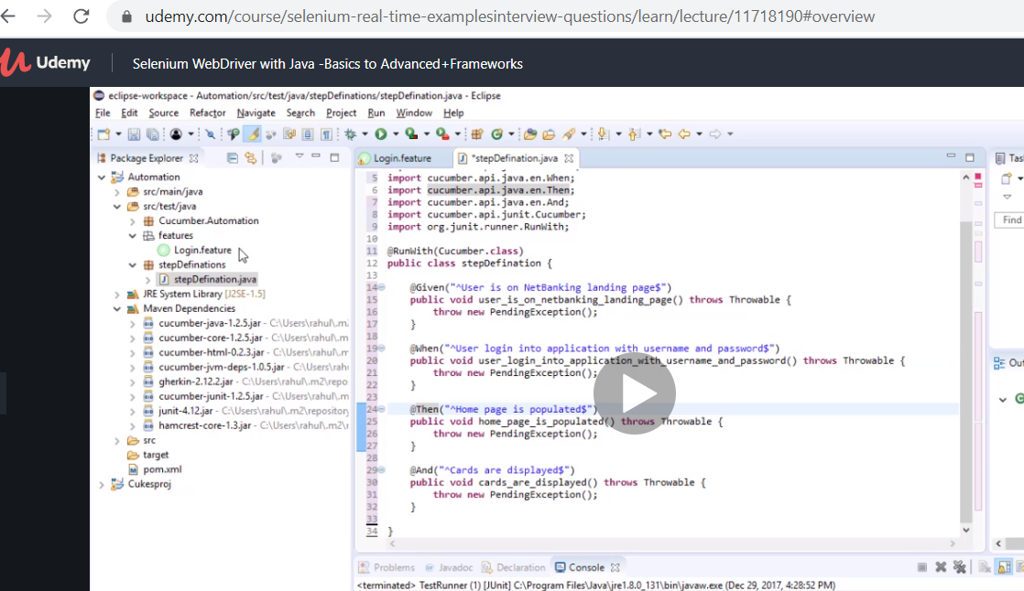

How cool it is….hahaha

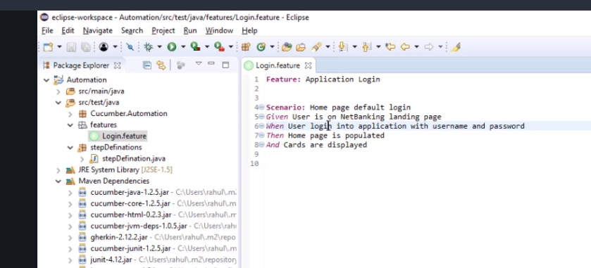

Now brown error is gone because it has been mapped.

I also think if you have feature and step definition if you run the test runner , I think u can actually copy step definition from the console without using the tidyG.

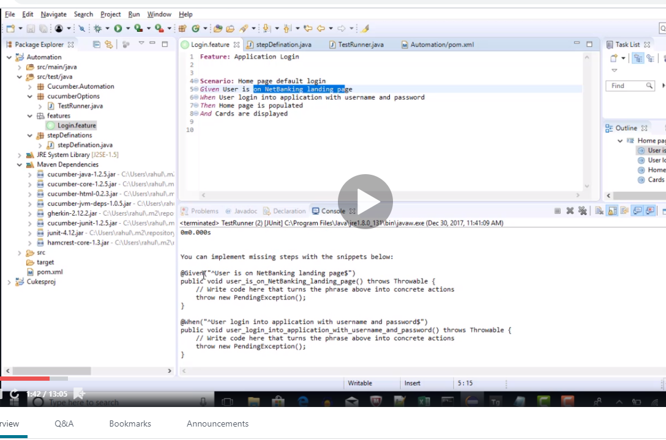

Now create another package under scr/test/java.

This is going to be the test runner. Like smoke/regression

Code here

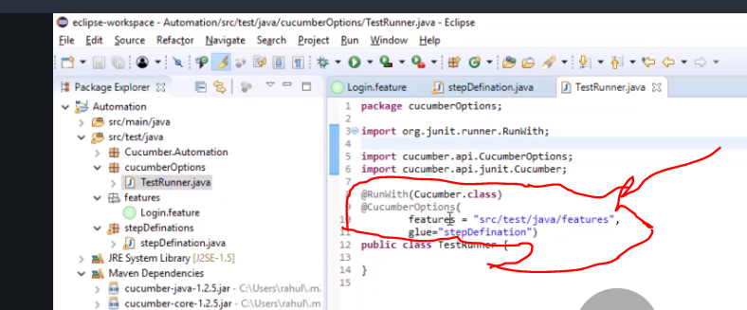

**package** cucumberOptions;

**import** org.junit.runner.RunWith;

**import** cucumber.api.CucumberOptions;

**import** cucumber.api.junit.Cucumber;

@RunWith(Cucumber.**class**)

@CucumberOptions(

features="src/test/java/features",

glue="stepDefinition")

**public** **class** TestRunner {

}

If you want to run everything in feature then you use feature but if a specific case then

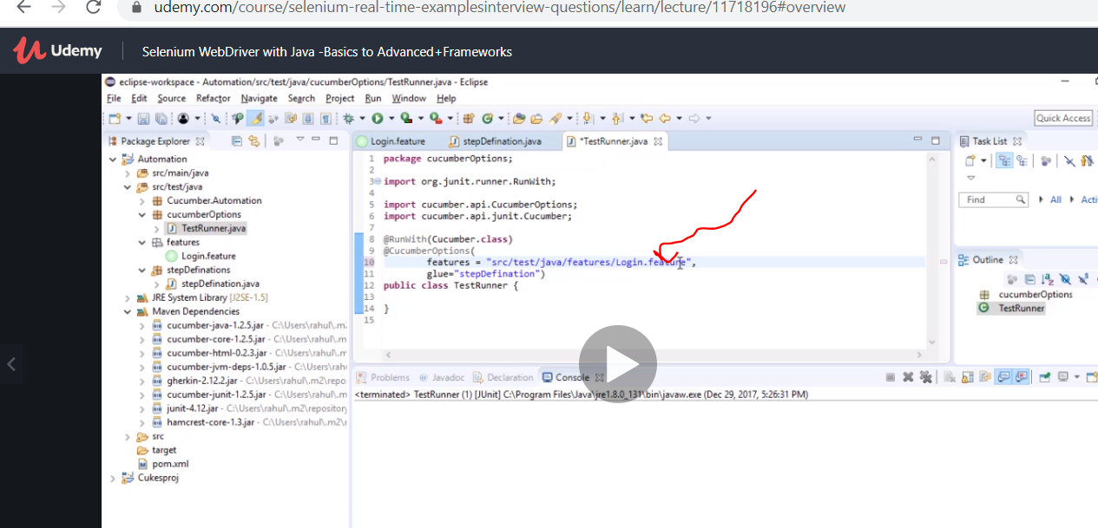

Common testcases

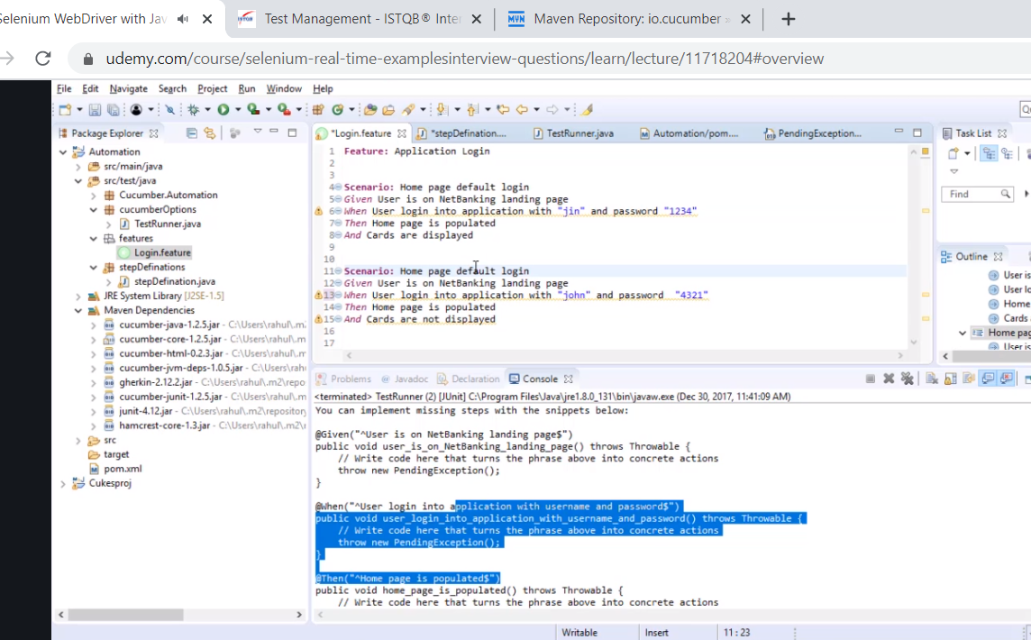

You wnt do step def for it all

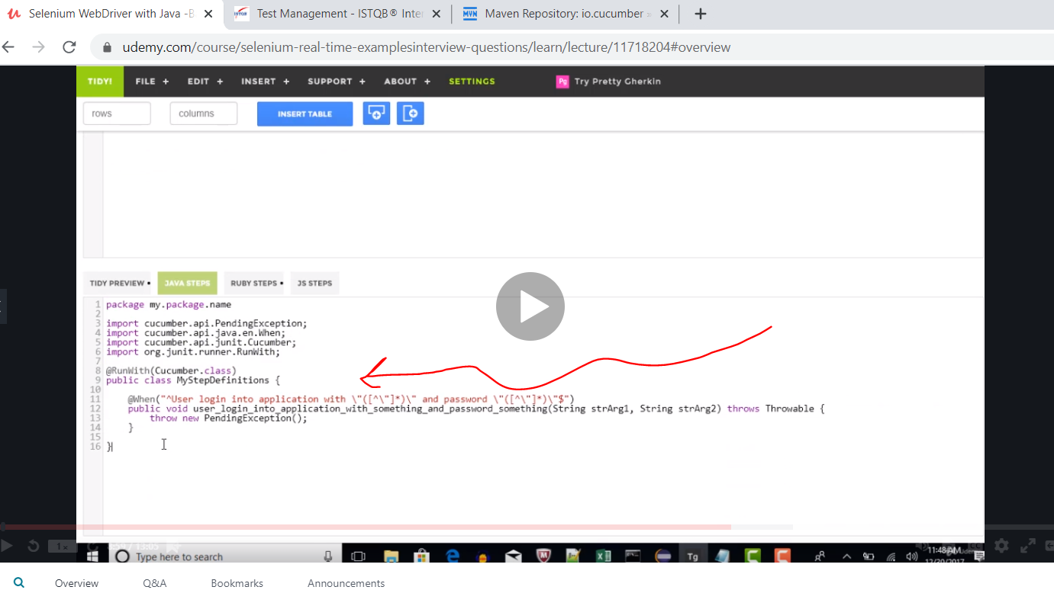

For the passwords

Now u may still see error just close and refresh and sorted.

Double quote means dynamic and changing.

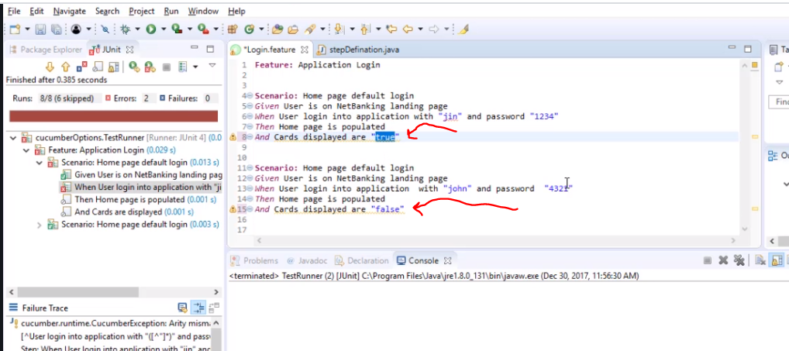

We can use one code now

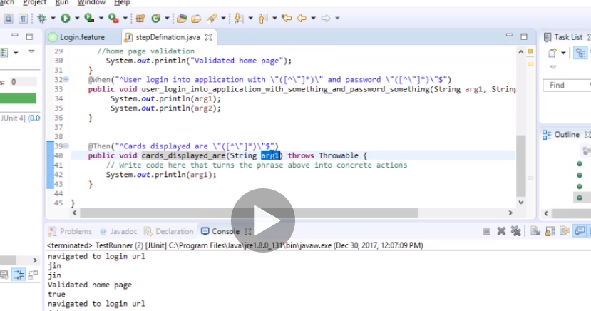

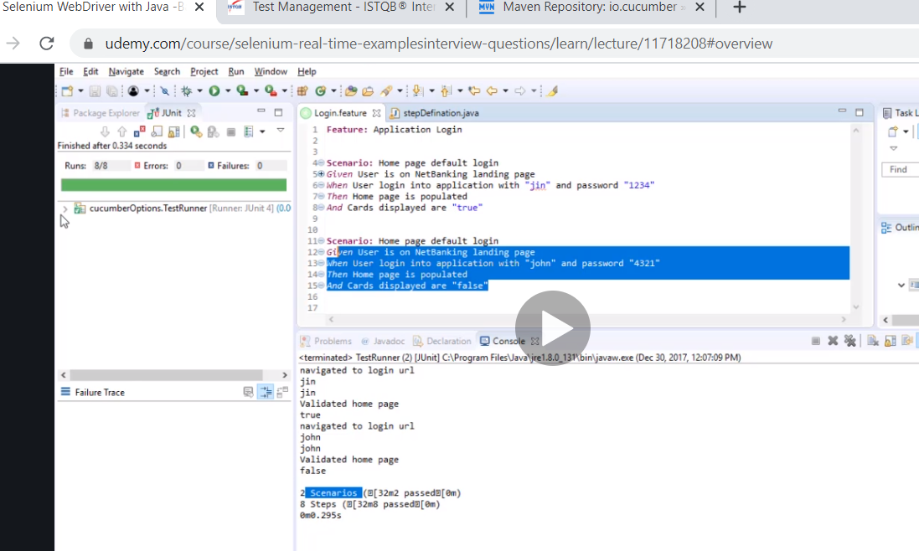

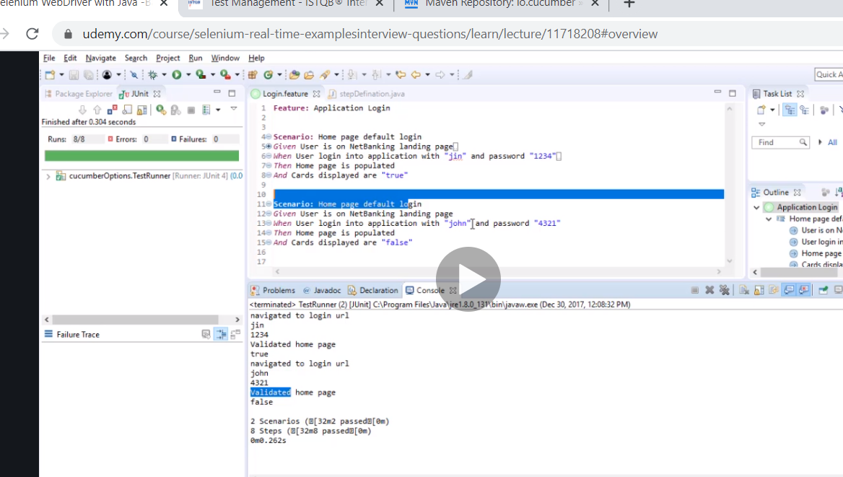

Correct

Now we want to convert the first framework to cucumber framewk

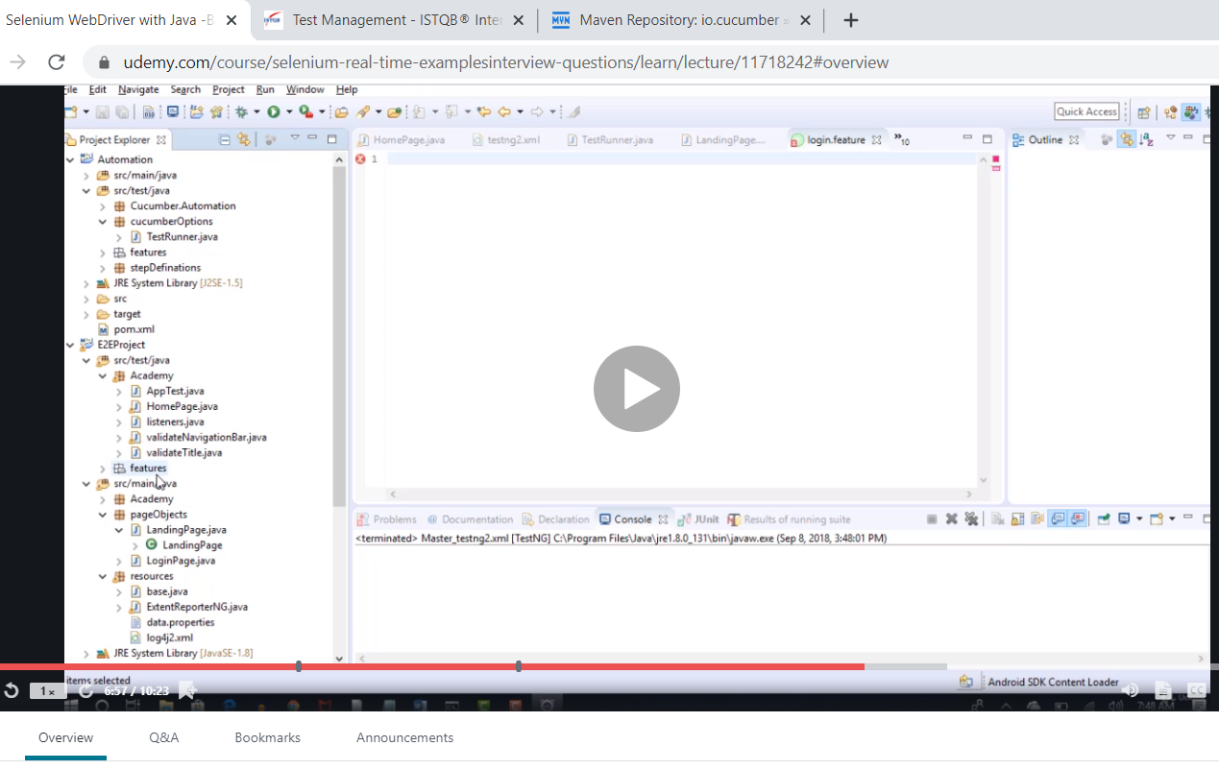

Add folder in scr/test/java

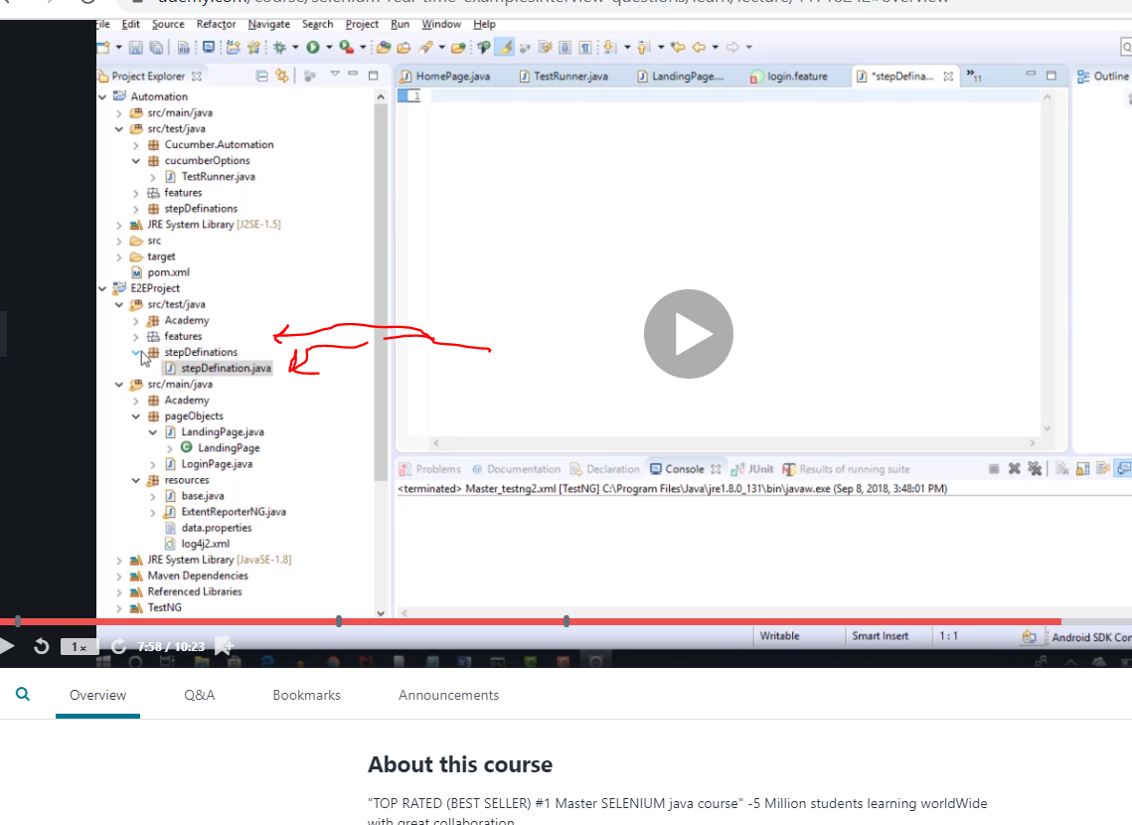

Note if your maven doesn’t work sometimes just update it

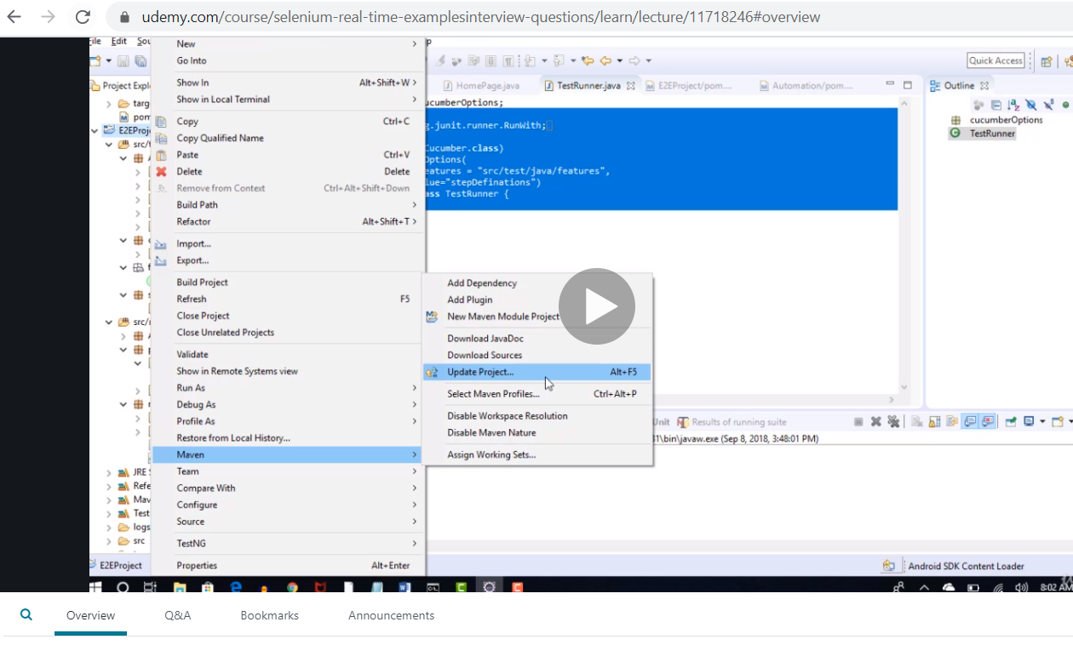

This solves the popup issue he solved it

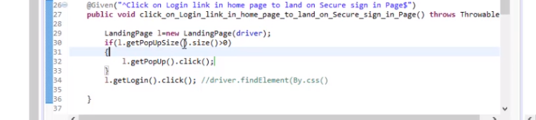

So its there he created a page object model and called it.

Now to parametise your test you use examples and change it to scenario outlines

Then use the verical pipe |username tab |password

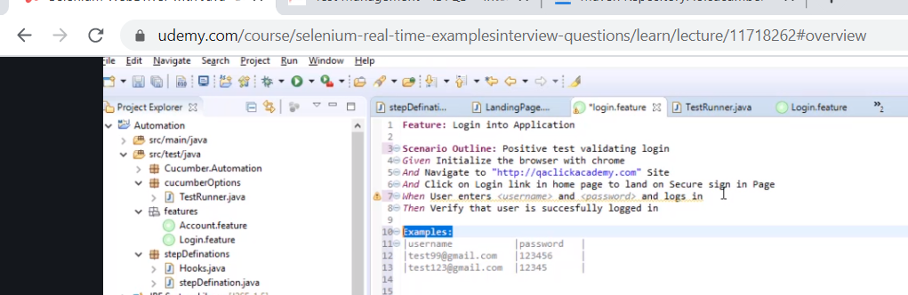

Now we need to create step definition since we just changed it

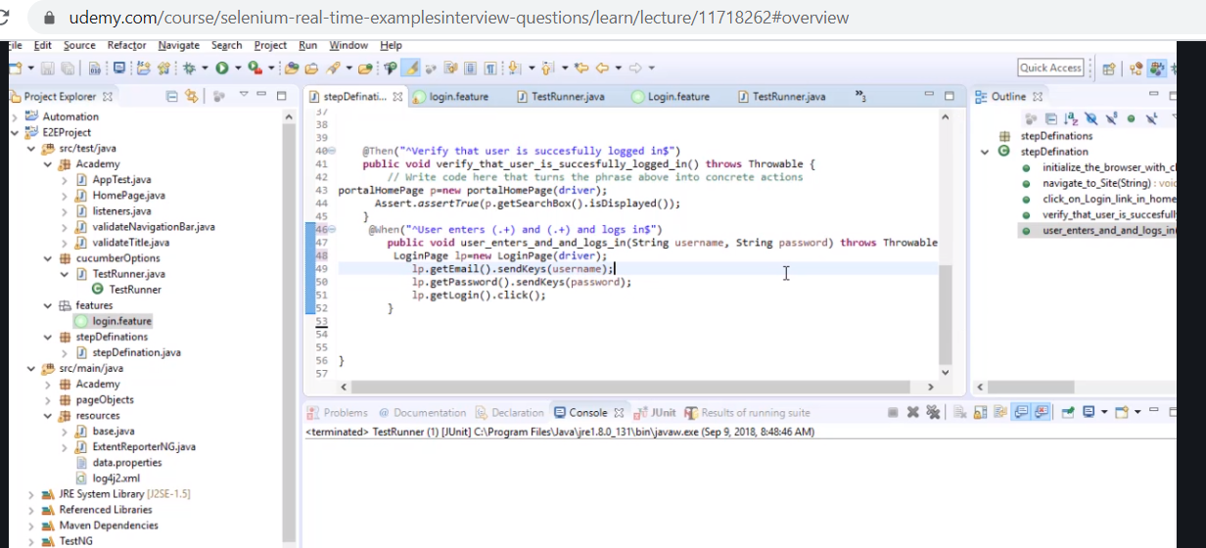

Now we want to integrate with Jenkins

Remember your test runner does not run by testng its using junit

To convert it to testng get a dependency cucumber testng

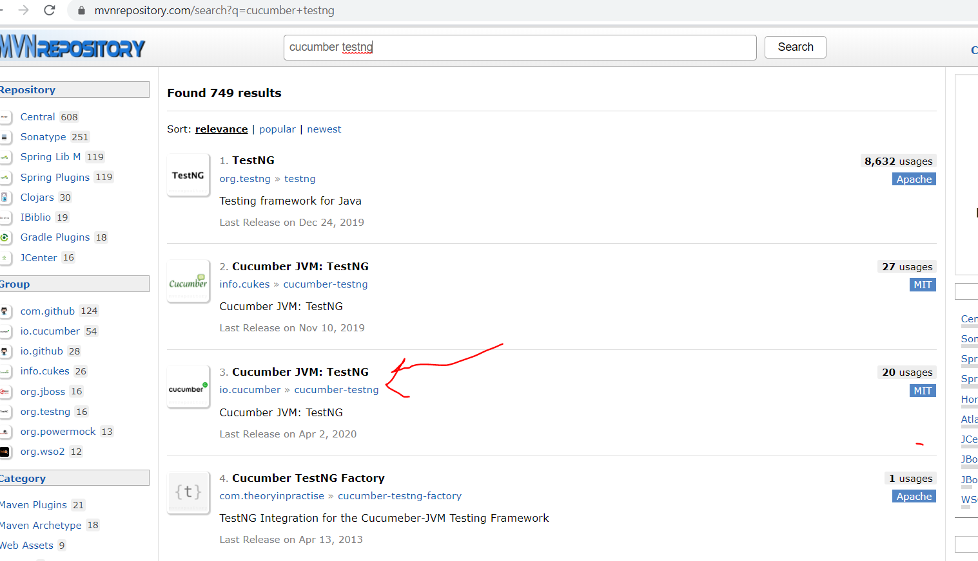

Add to pom

<!-- https://mvnrepository.com/artifact/io.cucumber/cucumber-testng -->

<dependency>

<groupId>io.cucumber</groupId>

<artifactId>cucumber-testng</artifactId>

<version>1.2.6</version>

</dependency>

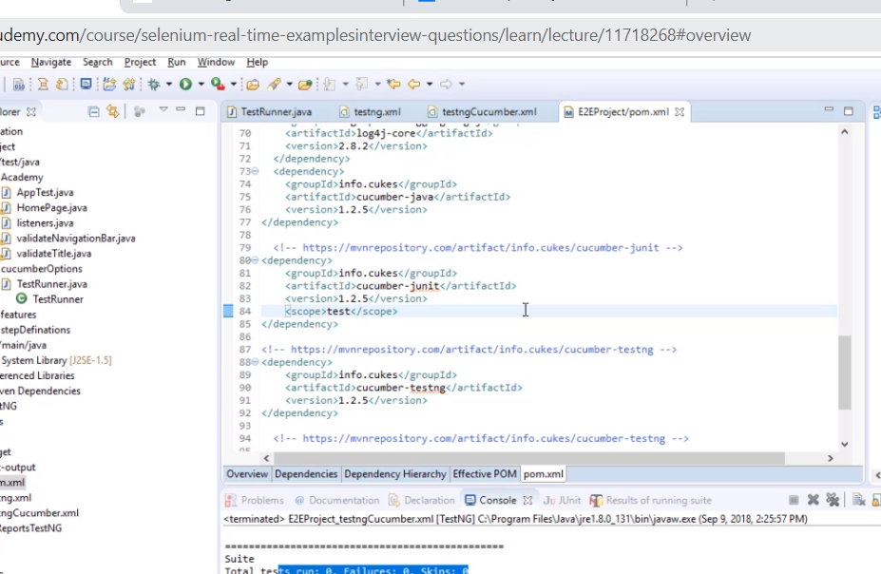

Try make



Try to see they are all sameversion 1.2.6 or 1.2.5

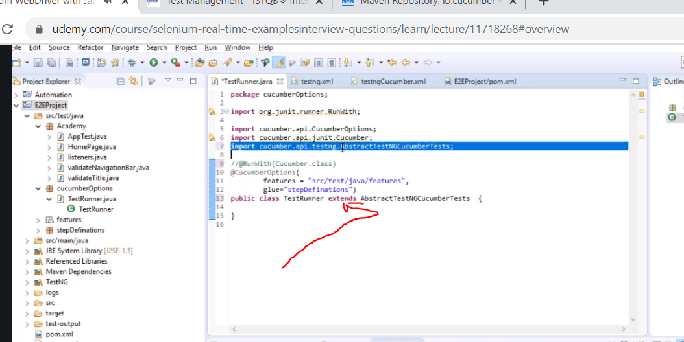

Now this can now be converted

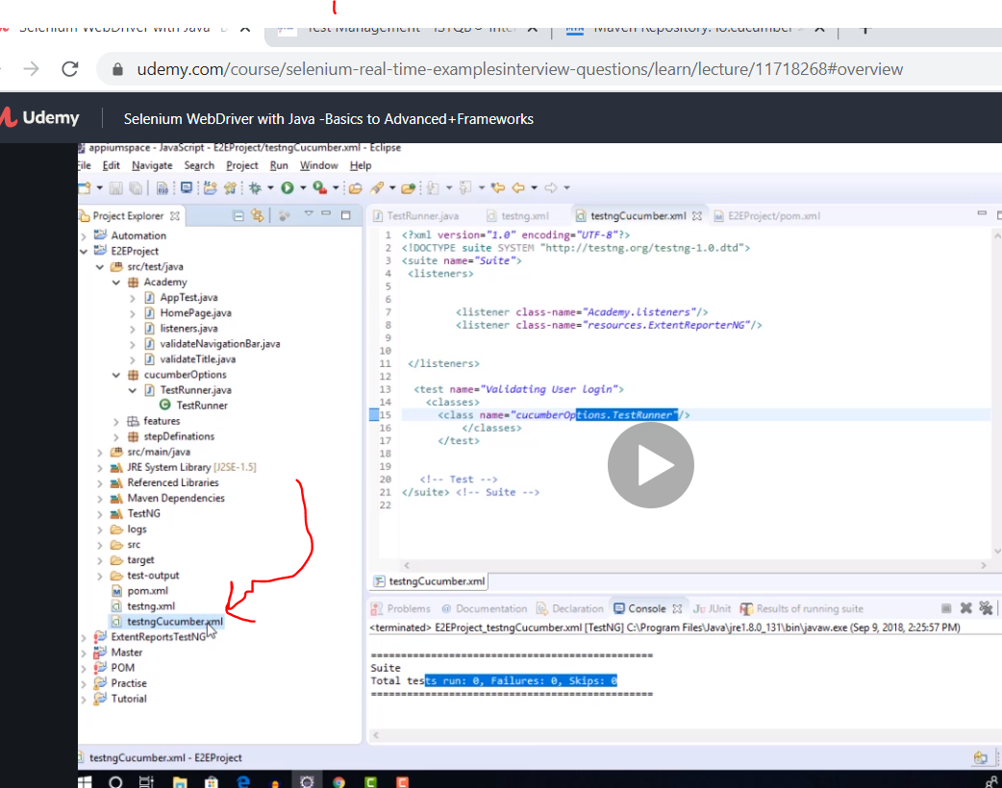

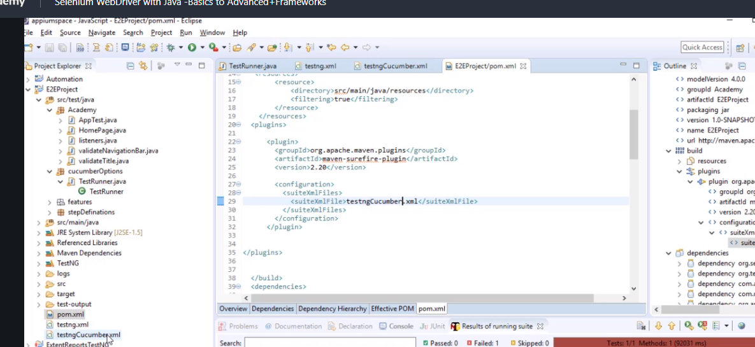

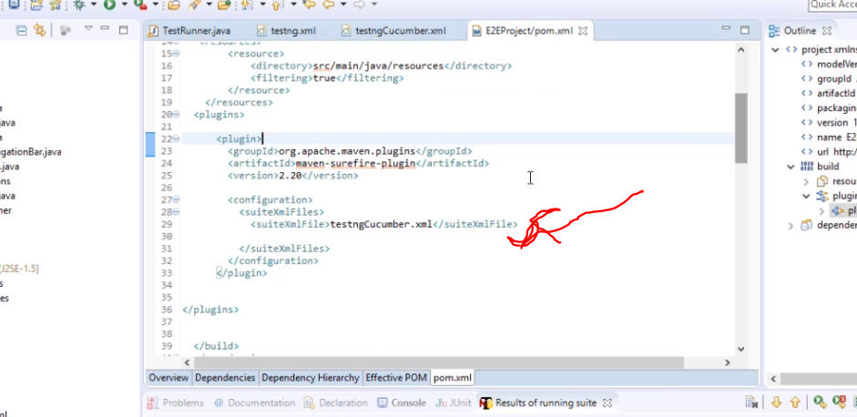

If to run more than one xml just paste it twice in the suite

Also link to study gradle instead of maven

<https://www.youtube.com/watch?v=WINEbkt-w7A>